Supplementary Information
Supplement for Measuring Meme-Family Structure With Contrastive Sparse Features: Canonical Resemblance and Reddit Engagement
This supplement provides additional details on corpus construction, signature estimation, recovery evaluation in the development and held-out-family samples, sensitivity analyses, and the Reddit engagement application. Family-level and post-level results are provided in the accompanying data files where indicated. Reported statistics are linked to the corresponding analysis outputs in the reproducibility materials.
Supplementary Methods
S1. Meme-Family Corpus Construction
Families were defined by entries in Know Your Meme (KYM; knowyourmeme.com), a public reference database that documents meme lineages and their variants. Development-corpus images were retrieved from entry galleries between 12 and 26 May 2026. Family labels therefore follow the source's documented lineages rather than visual groupings constructed for this study.
Retrieval provenance. The development-corpus collection procedure requested paginated Know Your Meme gallery routes that were listed under Disallow in the site's robots.txt. We retained the already collected development corpus for provenance but did not repeat that retrieval procedure. Subsequent held-out-family collection used only routes permitted by robots.txt, which limited retrieval to the first gallery page and produced shallower candidate families. For that reason, the held-out design does not assume approximately 50 variants per family and includes explicit family-size sensitivity analyses.
After deduplication, the development corpus contained 680 variants across 31 documented families. Thirty families, comprising 678 variants, contained at least five members and entered the recovery analysis. The remaining family contained two variants and was excluded by the size threshold. Among the 30 analyzed families, size ranged from 15 to 26 variants, with a median of 24.5.
The 31-family development corpus came from a 41-family candidate pool assembled before collection to include both image-template families and families whose recurring form extended across changes in image, text, layout, or relation. Gallery variants were retrieved for 32 pool families, two of which were subsequently merged; no gallery variants were retrieved for the remaining nine, which were not included. The resulting corpus is purposive and should not be interpreted as a probability sample of meme families or as a natural family-size distribution. The narrow size range also reflects the bounded retrieval procedure and subsequent deduplication. Ambiguous cases followed the family label assigned by the reference source. Images appearing under more than one family label were handled as described in §S2.
Table S1. Meme-family corpus composition. Final deduplicated sample size and recovery-analysis inclusion for each documented family. Per-family retrieval and exact-, near-, and cross-family removal counts are provided in TableS1_corpus_composition.csv and the reproducibility package.
Family | Final n | In recovery
american chopper argument | 18 | yes
coffin dance | 26 | yes
disaster girl | 21 | yes
distracted boyfriend | 20 | yes
doge such x much y very z | 25 | yes
drake hotline bling drakeposting | 19 | yes
expanding brain galaxy brain | 21 | yes
hide the pain harold | 23 | yes
is this a pigeon | 25 | yes
lolcats i can has cheezburger lolspeak | 25 | yes
loss is this loss | 25 | yes
mocking spongebob | 25 | yes
most interesting man (i don't always x) | 2 | no
nobody literally no one | 26 | yes
npc i support the current thing | 15 | yes
okay boomer | 24 | yes
pepe the frog | 25 | yes
pov you are x | 25 | yes
roll safe | 26 | yes
skill issue git gud cope seethe mald | 25 | yes
stonks meme man series | 22 | yes
surprised pikachu | 18 | yes
they did surgery on a grape | 25 | yes
this is fine | 26 | yes
trade offer | 19 | yes
two buttons daily struggle | 17 | yes
wojak soyjak | 25 | yes
woman yelling at a cat | 22 | yes
x all the y | 23 | yes
y all got anymore of | 17 | yes
yo dawg i heard you like | 25 | yes

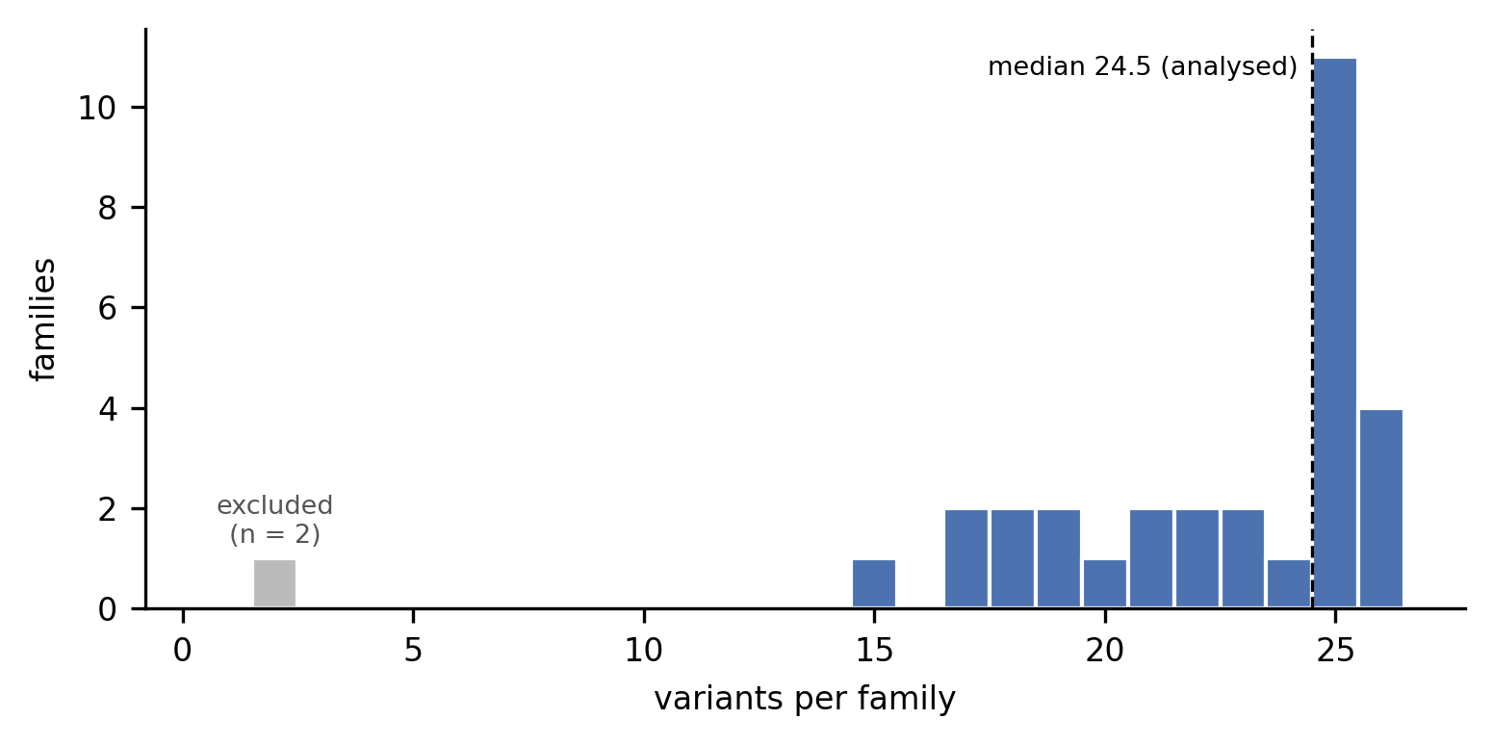
Figure S1. Family-size distribution. Distribution of final family sizes among the 30 analyzed families (15–26 variants; median 24.5), with the excluded two-variant family shown separately. The distribution reflects the bounded retrieval procedure and does not estimate naturally occurring family sizes.
Note. Table S1 and TableS1_corpus_composition.csv report final per-family sample sizes and recovery inclusion for all 31 documented families. Cross-family deduplication reduced the 707-variant within-family-deduplicated corpus to 680 variants (§S2).
S1a. Held-Out-Family Validation Protocol and Dispositions
The held-out-family protocol fixed the sampling frame, eligibility criteria, retrieval and deduplication rules, stopping rule, scoring pipeline, comparison set, and interpretive rules before any held-out family was scored. The protocol was timestamped before scoring. One technical amendment, made before screening resumed, changed only the filename assigned to retrieved images after a file address without an extension caused a processing failure. It did not alter eligibility, screening, image content, deduplication, scoring, or any analysis variable.
- Frame: Know Your Meme confirmed-entry sitemap, snapshot 29 September 2026, screened in seeded random order.
- Strata: random stratum H, filled from the seeded order, and look-alike challenge stratum C, filled using a fixed token rule from entries related to development families, subject to a per-anchor cap.
- Eligibility: Know Your Meme confirmed memes, excluding KYM-gated sensitive content. Gated gallery items were excluded and not decoded.
- Retrieval: first gallery page only, using robots-compliant routes.
- Deduplication: development-corpus rules applied within families, followed by duplicate resolution across held-out families and against the development corpus.
- Analyzability: at least 10 distinct variants after deduplication.
- Scoring: the fixed development pipeline with K = 15, the same comparison methods, and a fused SigLIP2 + DINOv2 whole-image centroid. For the fused baseline, each embedding was L2-normalized and the two representations were concatenated with equal weight. Checkpoints and fusion weights were fixed without tuning.
- Evaluation negatives: for each target family, 200 negatives sampled uniformly from variants of all other families in the 110-family evaluation universe, with adversarial decoys selected from the same universe. The training background comprised the remaining nonmembers, excluding the evaluation negatives and decoys. Because this universe differs from the development evaluation, development and held-out AUROCs are not directly interchangeable (§S7a).
Screening ended under the pre-specified stopping rule after 158 unique entries had been screened, yielding 60 analyzable random-stratum families and 20 analyzable challenge-stratum families.
Table S1a. Screening dispositions.
Disposition | Entries
Analyzable | 80
Too small after deduplication | 29
Challenge-stratum anchor cap reached | 31
Nested development family | 8
No gallery | 7
Development-corpus entry | 3
Screened | 158

S2. Deduplication and Overlap Handling
Exact duplicates were identified by SHA-256 hashes. Near-duplicates were identified with the discrete-cosine-transform perceptual hash implemented in the imagehash library (Zauner, 2010), using hash size 8 and a Hamming-distance threshold of 6 or less. Near-duplicate clustering was transitive at this threshold and was applied first within families and then across families.
This procedure identified visually equivalent files that differed at the byte level and therefore were not detected by cryptographic hashing. Cross-family deduplication reduced the corpus from 707 to 680 variants and from 32 to 31 family labels. Wojak and Soyjak, which showed near-total cross-family overlap, were merged into one documented family for analysis. One comic-book image appearing under four otherwise unrelated family labels was excluded.
Table S2. Deduplication and overlap handling. Methods, thresholds, and outcomes for exact- and near-duplicate removal within and across families.
Stage | Method | Threshold | Outcome
Within-family exact | SHA-256 hash | identical bytes | incorporated into the 707-variant within-family-deduplicated baseline
Within-family near-duplicate | DCT perceptual hash (size 8) | Hamming ≤ 6 | incorporated into the 707-variant within-family-deduplicated baseline
Cross-family exact | SHA-256 hash | identical bytes | 23 Wojak/Soyjak duplicates; labels merged into one family
Cross-family contamination | manual review | image assigned to four unrelated labels | one comic image excluded
Net effect |  |  | 707 → 680 variants; 32 → 31 family labels

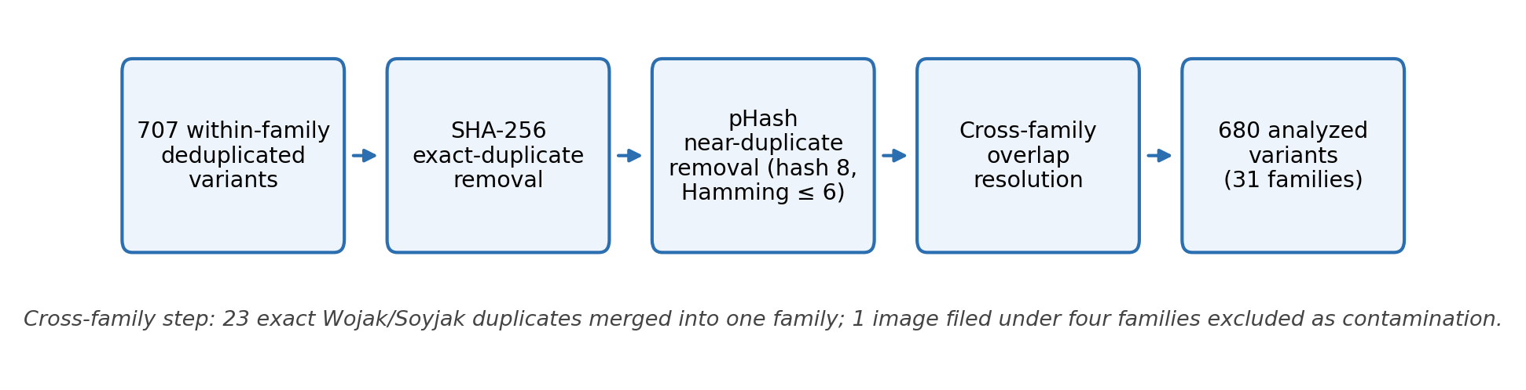
Figure S2. Deduplication procedure. Schematic of exact-duplicate, near-duplicate, and cross-family overlap decisions.
S3. Representation and Sparse-Autoencoder Details
Images were encoded with OpenAI CLIP ViT-L/14, producing 768-dimensional whole-image embeddings after standard CLIP preprocessing at 224-pixel input resolution. Embeddings were retained without unit normalization when passed to the sparse autoencoder and unit-normalized for centroid-based whole-image similarity.
Sparse representations were generated with the hierarchical Matryoshka multimodal sparse autoencoder described by Zaigrajew et al. (2025), checkpoint WolodjaZ/MSAE. The representation contains 6,144 latent dimensions with top-k activation at k = 64.
As a reproducibility check for the Reddit application, re-encoding all 4,263 Reddit images reproduced the stored raw signature scores to the reported precision: correlation 1.000000 and 100% agreement in the best-fit family.
Analyses used Python 3.9 with NumPy 2.0.2, pandas 2.3.3, scikit-learn 1.6.1, PyTorch with open_clip, imagehash 4.3.2, and ocrmac. Recovery negative sampling used seed 20260512. Engagement cross-validation and bootstrap point estimates used seed 0, with seed sensitivity reported in Table S5a.
Table S3. Computational environment. Models, checkpoints, preprocessing settings, software packages, versions, and random seeds.
Component | Value
Image encoder | OpenAI CLIP ViT-L/14 (768-dim; 224-pixel preprocessing)
Sparse autoencoder | Matryoshka multimodal SAE (Zaigrajew et al., 2025), checkpoint WolodjaZ/MSAE
Latent dimensions | 6,144, top-k activation at k = 64
Held-out dense baseline | SigLIP2 and DINOv2 image encoders (fixed checkpoints), equal-weight fused centroid
Language | Python 3.9 (macOS / Darwin)
Core libraries | NumPy 2.0.2; pandas 2.3.3; scikit-learn 1.6.1; PyTorch with open_clip; imagehash 4.3.2; ocrmac
Random seeds | recovery negative sampling = 20260512; cross-validation and bootstrap = 0 for reported point estimates (seed sweeps in Table S5a)

S4. Formal Signature Definition
For family f, let M_{f} denote the member set and N_{f} the nonmember training background used for estimation. The training background is disjoint from evaluation negatives and adversarial decoys. Let z_{i} denote the sparse activation vector for image i.
The feature-wise member-minus-background contrast is
$d_{f} = \frac{1}{|M_{f}|}∑_{i ∈ M_{f}}z_{i} − \frac{1}{|N_{f}|}∑_{j ∈ N_{f}}z_{j}.$
Let T_{f} denote the K = 15 features with the largest positive entries in d_{f}. Their signature weights are
$w_{f} = max(d_{f}[T_{f}], 0), w_{f} ∈ ℝ_{+}^{15}.$
For candidate c, let z_{c}[T_{f}] be its activation vector on the 15 retained features. Raw resemblance to family f is
$r(c, f) = cos(z_{c}[T_{f}], w_{f}).$
The raw signature score is the largest resemblance over the family bank,
$\max_{f} r(c, f),$
and the specificity margin is the difference between the largest and second-largest family resemblance scores.
The family-calibrated fit standardizes raw resemblance relative to the corresponding family's nonmember distribution:
$CalibratedFit(c, f) = \frac{r(c, f) − μ_{N_{f}}}{σ_{N_{f}}},$
where μ_{Nf} and σ_{Nf} are the mean and standard deviation of nonmember resemblance scores for family f.
The recurrence baseline instead retains sparse features that are active among a high proportion of family members and exceed the 95th percentile of the training-background activation distribution.
Three downstream quantities are analyzed separately:
1. Raw signature resemblance: uncalibrated cosine resemblance to a family signature.
2. Family-calibrated fit: resemblance standardized relative to a family's nonmember score distribution.
3. Classifier score: the maximum one-versus-rest predicted probability. Using the maximum decision score produces the same downstream result.
These quantities are evaluated separately because they encode different information and are not interchangeable measures of family membership.
S5. Signature Sensitivity and Stability
Number of Retained Features
Mean recovery AUROC increased gradually over the evaluated values of K and changed little between K = 25 and K = 50 (Table S4). K = 15 was selected during development as a compact specification that retained most of the recovery observed at the larger settings. It was then held fixed in the held-out-family and downstream analyses.
Negative-Pool Sensitivity
Because signature weights are estimated from member-minus-background contrasts, recovery can depend on the sampled nonmember pool. We therefore repeated the evaluation-negative draw with ten seeds. In the development corpus, mean contrastive recovery ranged from 0.895 to 0.898. The mean contrastive-minus-sparse-centroid difference ranged from +0.073 to +0.077, while the contrastive-minus-CLIP-centroid difference ranged from +0.049 to +0.056. This development-corpus advantage did not replicate in the random held-out families: across the same ten redraws in H, the contrastive-minus-CLIP-centroid difference ranged from −0.0021 to −0.0001.
Table S4. Sensitivity to the number of retained features. Development-corpus mean recovery AUROC under the leave-one-variant-out protocol as a function of K.
K | Mean recovery AUROC
5 | 0.878
10 | 0.893
15 (used) | 0.899
25 | 0.906
50 | 0.907

Table S5. Sensitivity to evaluation-negative sampling. Range across seeds 1–10 of the mean paired method difference.
Comparison | Development corpus | Random held-out stratum H
Contrastive − recurrence | +0.099 to +0.111 | +0.044 to +0.049
Contrastive − sparse centroid | +0.073 to +0.077 | +0.026 to +0.028
Contrastive − sparse nearest neighbor | +0.083 to +0.087 | +0.029 to +0.032
Contrastive − CLIP centroid | +0.049 to +0.056 | −0.0021 to −0.0001
Contrastive − fused SigLIP2 + DINOv2 centroid | not part of the original development analysis (§S7a) | −0.0071 to −0.0040

Table S5a. Seed sensitivity across analyses. Main-text point estimates use seed 0 for the engagement analyses and seed 20260512 for recovery negative sampling. Community-grouped folds are deterministic.
Analysis | Seeds | Result
Label-permutation control, engagement decomposition | 0–3 | Monte Carlo p = 0.030, 0.035, 0.030, 0.045
Magnitude-adjusted increment, lower 95% interval bound | 0–3 | −0.0010, 0.0002, −0.0014, −0.0017
Repeated cross-validation, median continuous increment | 1–20 | random +0.046; perceptual-hash cluster +0.046; best-fit family +0.072
Recovery evaluation-negative redraws | 1–10 | Table S5

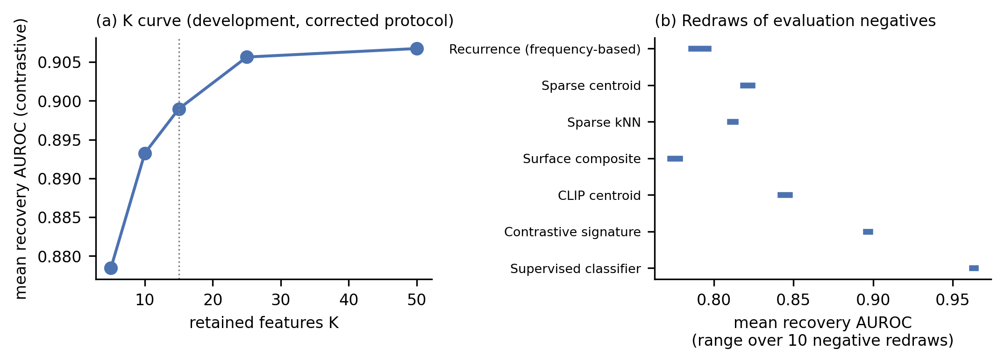
Figure S3. Signature sensitivity. (a) Mean recovery AUROC as a function of the retained-feature count K. (b) Range of each method's mean recovery AUROC across ten evaluation-negative redraws.
Supplementary Recovery Results
S6. Full Method Specifications
All recovery methods were evaluated within a common leave-one-variant-out procedure. For each target family, 200 evaluation negatives were sampled from variants belonging to other families, including the two-variant family excluded from the recovery set. These evaluation negatives were never used to estimate a comparison method. Each method instead used a disjoint training background drawn from the remaining nonmembers, with a mean of 435 and a minimum of 428 observations per target family. Adversarial decoys were likewise excluded from all training backgrounds. Each method, including the supervised classifier, was fitted using the same n−1 target-family members within the same leave-one-variant-out loop. AUROC was computed within each fold before averaging.
The comparison set comprised:
- frequency-based recurrence baseline
- whole-image CLIP centroid
- sparse-space centroid
- sparse-space nearest-neighbor rule
- contrastive signature with K = 15
- regularized one-versus-rest logistic classifier using the sparse representation
- character n-gram TF-IDF similarity based on macOS Vision OCR text
- DCT perceptual-hash similarity
- template similarity
- fixed composite surface measure
- per-family oracle surface comparator
- fused SigLIP2 + DINOv2 whole-image centroid in the expanded held-out-family evaluation only, which also re-scored the development families (§S7a)
Hyperparameters. No hyperparameter search was performed for these comparisons. The recovery logistic classifier used L2 regularization with C = 1.0 and balanced class weights. Engagement ridge models used α = 1.0, and engagement logistic models used C = 1.0. Predictors were standardized within each training fold. K = 15 was selected on the development corpus and then fixed for all held-out and downstream analyses; the K-curve is reported as a sensitivity (Table S4). The 0.02 descriptive head-to-head margin and the recurrence baseline's 95th-percentile background threshold were also fixed before the held-out analysis.
Recovery protocol. Every method is fitted within one leave-one-variant-out loop. Training backgrounds are disjoint from evaluation negatives and adversarial decoys. The supervised classifier uses the same folds as the other methods, all methods are evaluated against the same negative samples, and AUROC is computed within folds before averaging.
Recurrence thresholds are estimated only from the training background, and surface measures are fitted within each training fold. The fixed composite surface measure has mean recovery 0.779, below the oracle surface comparator's 0.812.
Text similarity uses cosine similarity between character n-gram TF-IDF representations of macOS Vision OCR text (Pedregosa et al., 2011). Perceptual-hash similarity uses the DCT-based method described by Zauner (2010). The oracle surface comparator selects the best-performing surface measure separately for each family and is reported only as a deliberately favorable descriptive benchmark.
The logistic classifier operates on the full 6,144-dimensional sparse representation and is not constrained to a 15-feature prototype. The contrastive signature retains exactly 15 positive features per family. The difference in representational form should therefore be considered separately from their difference in recovery accuracy.
Table S6. Full method definitions and hyperparameters.
Method | Definition
Frequency-based recurrence baseline | features active in a high proportion of members and above a 95th-percentile training-background threshold
Whole-image CLIP centroid | cosine similarity to the unit-normalized mean CLIP embedding
Sparse-space centroid | cosine similarity to the mean sparse activation vector
Sparse-space nearest neighbor | maximum sparse-space cosine similarity to a family member
Contrastive signature | 15 largest positive member-minus-background contrast features
Logistic classifier | one-versus-rest L2 logistic regression on the 6,144 sparse features C = 1.0, balanced class weights; maximum predicted probability used in the reported analysis
Text similarity | character n-gram TF-IDF cosine similarity on macOS Vision OCR text (Pedregosa et al., 2011), fitted within each fold
Perceptual-hash similarity | DCT perceptual-hash similarity (Zauner, 2010)
Template similarity | template-match similarity, fitted within each fold
Fixed surface composite | fixed combination of surface measures defined without selection on evaluation performance
Oracle surface comparator | best-performing surface measure for each family; descriptive only
Fused SigLIP2 + DINOv2 centroid (expanded held-out evaluation) | each embedding L2-normalized and concatenated with equal weight; cosine similarity to the normalized mean of the n−1 training members

S7. Complete Family-Recovery Results: Development Corpus
Table S7 reports family-level recovery AUROC for all 30 analyzed development families under the leave-one-variant-out protocol. Main-text Table 2, Panel 2A reports the method means, and Table S8 reports paired family-level comparisons.
Across leave-one-family-out checks, mean contrastive recovery ranged from 0.896 to 0.905. Family size was essentially unrelated to the contrastive signature's advantage over the sparse centroid in the development corpus (r = −0.05).

Table S7. Family-level recovery matrix, development corpus. Within-family recovery AUROC under the leave-one-variant-out protocol, sorted by contrastive recovery. The same values are provided in TableS7_family_recovery_matrix.csv.
Family | n | Recur | Whole-img | Surface comp. | Sp.cent | Sp.kNN | Contrast | Classif
hide the pain harold | 23 | 0.90 | 0.81 | 0.70 | 0.74 | 0.78 | 0.99 | 0.99
two buttons daily struggle | 17 | 0.98 | 0.94 | 0.86 | 0.93 | 0.92 | 0.99 | 1.00
expanding brain galaxy brain | 21 | 0.92 | 0.98 | 0.89 | 0.95 | 0.91 | 0.99 | 1.00
skill issue git gud cope seethe mald | 25 | 0.86 | 0.90 | 0.91 | 0.88 | 0.86 | 0.99 | 0.99
pepe the frog | 25 | 0.99 | 1.00 | 0.54 | 1.00 | 0.99 | 0.98 | 1.00
lolcats i can has cheezburger lolspeak | 25 | 0.98 | 0.92 | 0.53 | 0.94 | 0.81 | 0.98 | 0.99
x all the y | 23 | 0.95 | 0.88 | 0.86 | 0.89 | 0.79 | 0.97 | 0.99
doge such x much y very z | 25 | 0.97 | 0.89 | 0.58 | 0.79 | 0.75 | 0.97 | 0.99
stonks meme man series | 22 | 0.80 | 0.92 | 0.98 | 0.93 | 0.91 | 0.96 | 0.98
they did surgery on a grape | 25 | 0.77 | 0.88 | 0.80 | 0.85 | 0.86 | 0.95 | 0.99
disaster girl | 21 | 0.68 | 0.77 | 0.80 | 0.83 | 0.73 | 0.95 | 0.97
american chopper argument | 18 | 0.89 | 0.94 | 0.89 | 0.94 | 0.91 | 0.94 | 1.00
coffin dance | 26 | 0.55 | 0.89 | 0.45 | 0.89 | 0.86 | 0.93 | 0.97
y all got anymore of | 17 | 0.85 | 0.96 | 0.98 | 0.89 | 0.88 | 0.93 | 0.97
okay boomer | 24 | 0.72 | 0.70 | 0.90 | 0.76 | 0.77 | 0.92 | 0.94
trade offer | 19 | 0.79 | 0.88 | 1.00 | 0.85 | 0.85 | 0.92 | 1.00
this is fine | 26 | 0.70 | 0.83 | 0.87 | 0.77 | 0.72 | 0.91 | 0.94
roll safe | 26 | 0.83 | 0.88 | 0.86 | 0.83 | 0.90 | 0.89 | 0.96
woman yelling at a cat | 22 | 0.68 | 0.65 | 0.71 | 0.70 | 0.69 | 0.88 | 0.94
surprised pikachu | 18 | 0.76 | 0.86 | 0.74 | 0.80 | 0.80 | 0.87 | 0.95
drake hotline bling drakeposting | 19 | 0.71 | 0.72 | 0.81 | 0.75 | 0.76 | 0.86 | 0.93
loss is this loss | 25 | 0.73 | 0.77 | 0.65 | 0.75 | 0.74 | 0.85 | 0.95
pov you are x | 25 | 0.79 | 0.64 | 0.92 | 0.81 | 0.79 | 0.84 | 0.90
npc i support the current thing | 15 | 0.65 | 0.80 | 0.86 | 0.70 | 0.79 | 0.83 | 0.92
is this a pigeon | 25 | 0.78 | 0.85 | 0.95 | 0.81 | 0.74 | 0.83 | 0.93
nobody literally no one | 26 | 0.77 | 0.83 | 0.93 | 0.82 | 0.77 | 0.80 | 0.92
wojak soyjak | 25 | 0.81 | 0.89 | 0.47 | 0.80 | 0.81 | 0.80 | 0.98
yo dawg i heard you like | 25 | 0.50 | 0.64 | 0.73 | 0.60 | 0.68 | 0.79 | 0.94
distracted boyfriend | 20 | 0.71 | 0.83 | 0.46 | 0.68 | 0.76 | 0.74 | 0.95
mocking spongebob | 25 | 0.71 | 0.82 | 0.71 | 0.81 | 0.85 | 0.73 | 0.94

Table S8. Paired family-level method comparisons, development corpus. Mean paired family-level differences with 95% family-bootstrap intervals. The final column reports the number of families for which the contrastive-minus-comparator difference exceeds 0.02, except for the classifier row, where the direction is reversed.
Comparison | Mean difference | 95% interval | Families > 0.02
Contrastive − recurrence | +0.109 | [0.076, 0.146] | 23/30
Contrastive − sparse centroid | +0.075 | [0.051, 0.102] | 24/30
Contrastive − nearest neighbor | +0.086 | [0.058, 0.114] | 25/30
Contrastive − CLIP centroid | +0.056 | [0.025, 0.088] | 19/30
Contrastive − surface composite | +0.120 | [0.061, 0.182] | 23/30
Contrastive − oracle surface | +0.087 | [0.037, 0.138] | 21/30
Contrastive − classifier | −0.064 | [−0.085, −0.045] | classifier higher by > 0.02 in 21/30

Note. The development-corpus contrastive advantage over the CLIP centroid did not replicate in the random held-out families.
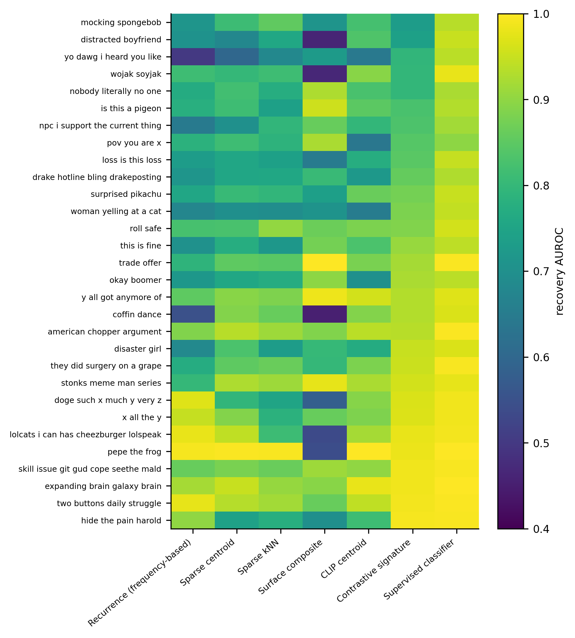
Figure S4. Family-level recovery across methods. Recovery AUROC for all 30 analyzed development families and all comparison methods under the leave-one-variant-out protocol, except the per-family oracle surface comparator (Table 2, Panel 2A).
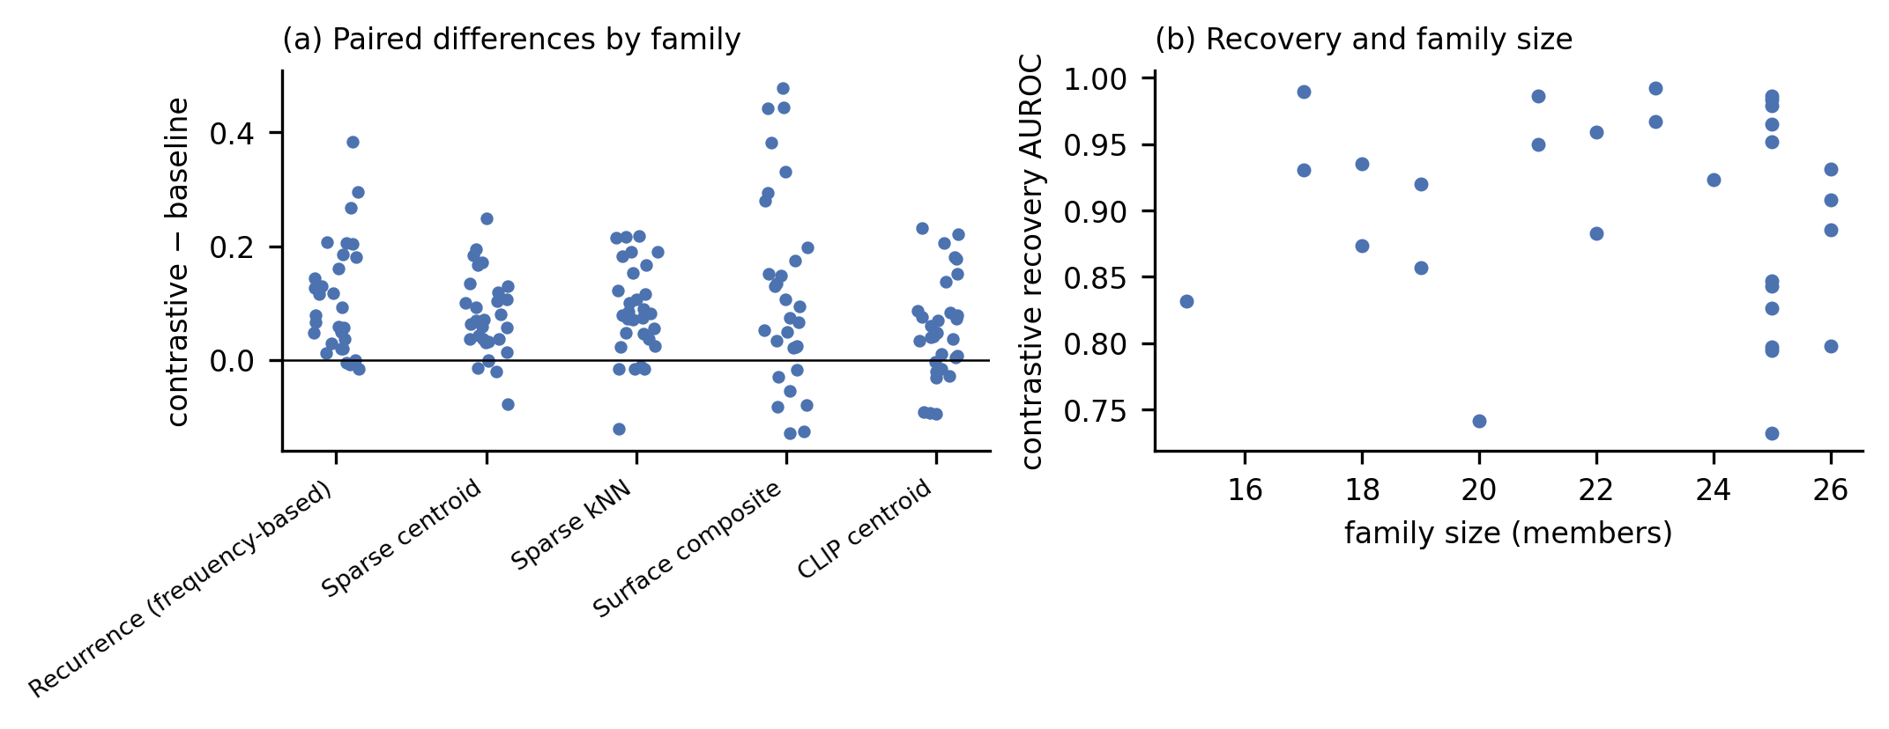
Figure S5. Paired recovery differences and family size. (a) Contrastive-minus-comparator differences by family. (b) Recovery AUROC in relation to family size.
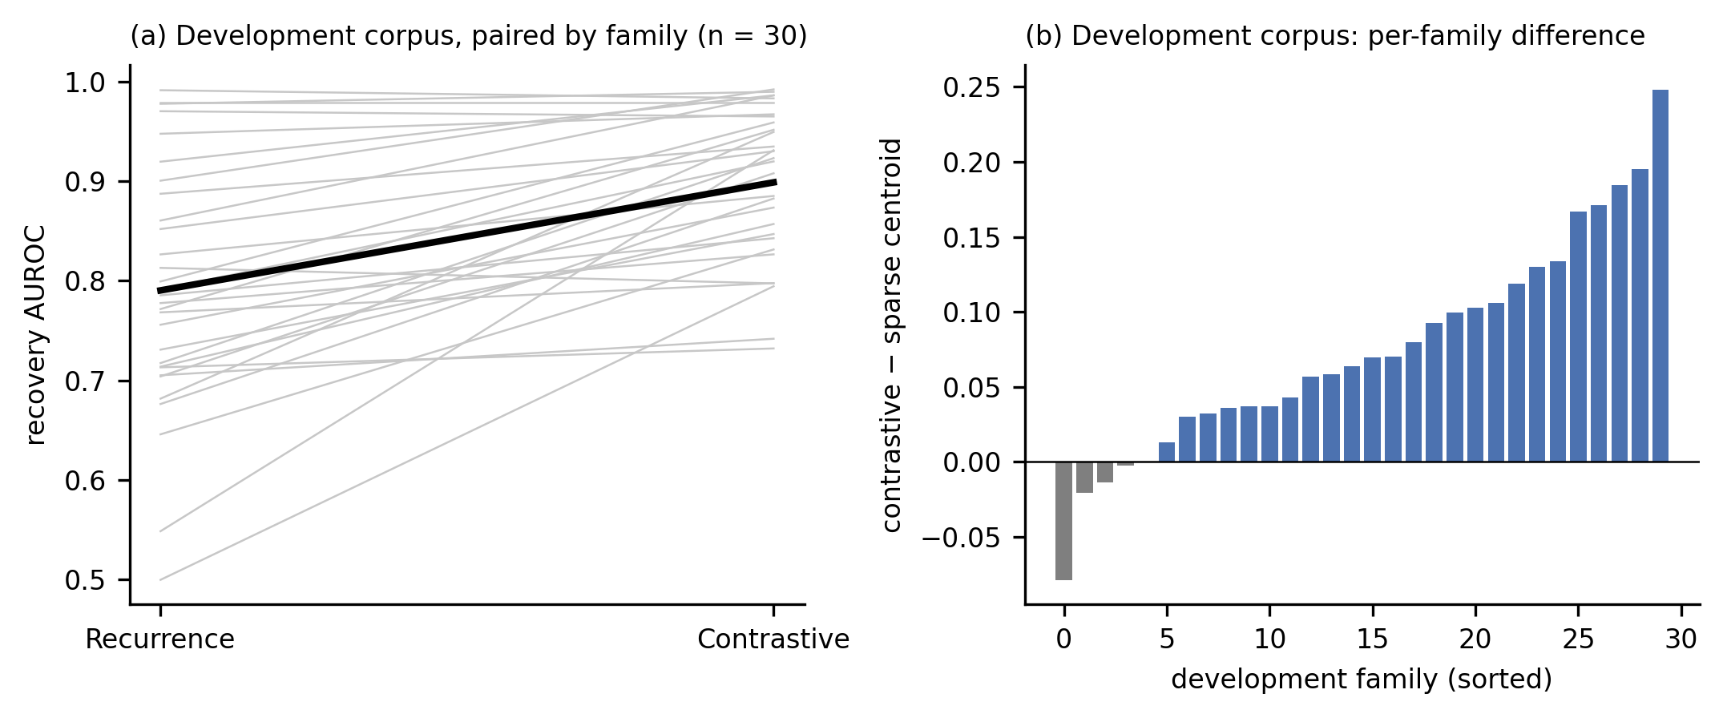
Figure S13. Development-corpus recovery diagnostics. (a) Recurrence and contrastive recovery AUROC paired within each of the 30 development families; the heavy line connects the method means. (b) Sorted family-level contrastive-minus-sparse-centroid differences. These panels describe the development corpus only; main Figure 3a reports the held-out-family comparisons.
S7a. Held-Out-Family Results
Main-text Table 2, Panel 2B reports the principal held-out-family comparisons. This section reports pre-specified sensitivity analyses and additional descriptive comparisons.
Family-size sensitivity. Capping every family, development families included, at 10 or 15 members did not change the qualitative recovery result in random stratum H. The contrastive-minus-CLIP-centroid difference was +0.001 [−0.012, 0.013] at a cap of 10 and −0.002 [−0.013, 0.008] at a cap of 15.
Table S7a. Size-capped sensitivity in random held-out stratum H. Paired contrastive-minus-method recovery AUROC difference with 95% family-bootstrap interval.
Method | Cap 10 | Cap 15
Frequency-based recurrence baseline | +0.057 [0.038, 0.077] | +0.051 [0.034, 0.070]
Sparse centroid | +0.030 [0.015, 0.044] | +0.027 [0.016, 0.039]
Sparse nearest neighbor | +0.034 [0.016, 0.054] | +0.033 [0.019, 0.047]
Surface composite | +0.177 [0.113, 0.243] | +0.172 [0.111, 0.234]
Oracle surface | +0.126 [0.077, 0.174] | +0.123 [0.078, 0.170]
Whole-image CLIP centroid | +0.001 [−0.012, 0.013] | −0.002 [−0.013, 0.008]
Fused SigLIP2 + DINOv2 centroid | −0.003 [−0.023, 0.018] | −0.005 [−0.020, 0.010]

Development-to-held-out difference. When development and held-out families were re-evaluated within the same 110-family comparison universe, the development families showed a mean contrastive-minus-CLIP-centroid difference of +0.037 [0.009, 0.066], compared with −0.002 in random held-out stratum H. The +0.037 estimate differs from the +0.056 reported in main-text Table 2, Panel 2A because the evaluation universe differs; the two estimates therefore do not come from otherwise identical runs. In a regression of the family-level contrastive-minus-CLIP difference on stratum and log family size, the held-out-minus-development coefficient was −0.038. Because no held-out family had 20 or more variants, this adjustment cannot separate family size from development status. In the same expanded evaluation, the development families showed no clear contrastive advantage over the fused SigLIP2 + DINOv2 centroid (−0.008 [−0.033, 0.015]); the fused centroid was not part of the original development analysis.
Table S7b. Paired differences by family-size band across all strata. Descriptive only.
Size band | Families | Contrastive − CLIP centroid | Contrastive − fused centroid | Contrastive − sparse centroid
10–14 | 38 | −0.003 | −0.008 | +0.023
15–19 | 49 | −0.005 | −0.019 | +0.032
≥ 20 | 23 | +0.042 | −0.003 | +0.067

Fold-local decoy selection. Selecting LAION-CLIP decoys separately within each fold produced a contrastive-minus-CLIP-centroid difference of +0.072 [0.040, 0.107] in random held-out stratum H, compared with +0.073 [0.041, 0.108] when the decoys were selected against the full member set.
Exploratory fused-centroid comparison. After the held-out-family results had been examined, we additionally compared the contrastive signature with the fused SigLIP2 + DINOv2 centroid under encoder-selected decoys. The paired contrastive-minus-fused difference was +0.074 [0.034, 0.115] in H, with a fold-local estimate of +0.071 [0.030, 0.113]. In challenge stratum C, the corresponding difference was −0.045 [−0.115, 0.025]. Because this comparison was added after inspection of the held-out results, it is treated as exploratory rather than as part of the pre-specified held-out claim. Pooled 110-family result (descriptive only). Pooling all 110 families (the 30 development families, the random held-out families in H, and the purposively selected challenge families in C) gives a contrastive-minus-fused-centroid difference of −0.0121 [−0.0243, −0.0002]. This pooled quantity combines a development sample, a random held-out stratum, and a purposive challenge stratum. It is therefore reported only as a descriptive summary and is not an overall validation estimate. Random stratum H remains the relevant generalization sample.
S8. Adversarial-Decoy Analyses
For each family, adversarial decoys were the 12 nearest nonmembers under two separate selection criteria. True family members were excluded from the candidate pools, and cross-family near-duplicates were removed before selection. Selected decoys were then scored with the primary representation. The main specification selected decoys against the full member set. Selecting them separately within each leave-one-out fold is reported as a sensitivity analysis (below and §S7a).
The encoder-selected condition used a separate CLIP model trained on LAION data to identify visually similar nonmembers. In the development corpus, mean discrimination AUROC was 0.836 for the contrastive signature and 0.654 for the CLIP centroid, a paired difference of +0.181 [0.128, 0.237]. Fold-local decoy selection produced +0.181 [0.127, 0.237]. For comparison, CLIP-centroid discrimination fell to 0.446 when decoys were selected using the primary encoder itself. That condition has direct dependence between the criterion used to choose difficult cases and the representation subsequently scored and is included only as a dependent reference.
The second condition used perceptual hashing as a non-CLIP selector. Mean discrimination AUROC was 0.889 for the contrastive signature and 0.854 for the CLIP centroid. The main-specification contrastive-minus-CLIP interval included zero, +0.036 [−0.001, 0.074], so we do not infer a clear contrastive advantage under this decoy-selection rule. The fold-local interval, [0.0015, 0.076], is reported as a sensitivity and is not used to reverse that interpretation.
Table S9. Adversarial discrimination by method and decoy-selection criterion, development corpus. Mean discrimination AUROC using the 12 nearest nonmembers per family under each selector.
Decoy selector | Contrastive signature | CLIP centroid | Sparse centroid | Sparse nearest neighbor | Fixed surface composite | Recurrence baseline | Logistic classifier
Encoder-selected (separately trained LAION CLIP) | 0.836 | 0.654 | 0.745 | 0.676 | 0.833 | 0.727 | 0.904
Perceptual-hash-selected (non-CLIP) | 0.889 | 0.854 | 0.812 | 0.802 | 0.676 | 0.776 | 0.956
Primary-encoder-selected (dependent reference) | 0.830 | 0.446 | 0.719 | 0.481 | 0.813 | 0.691 | 0.909

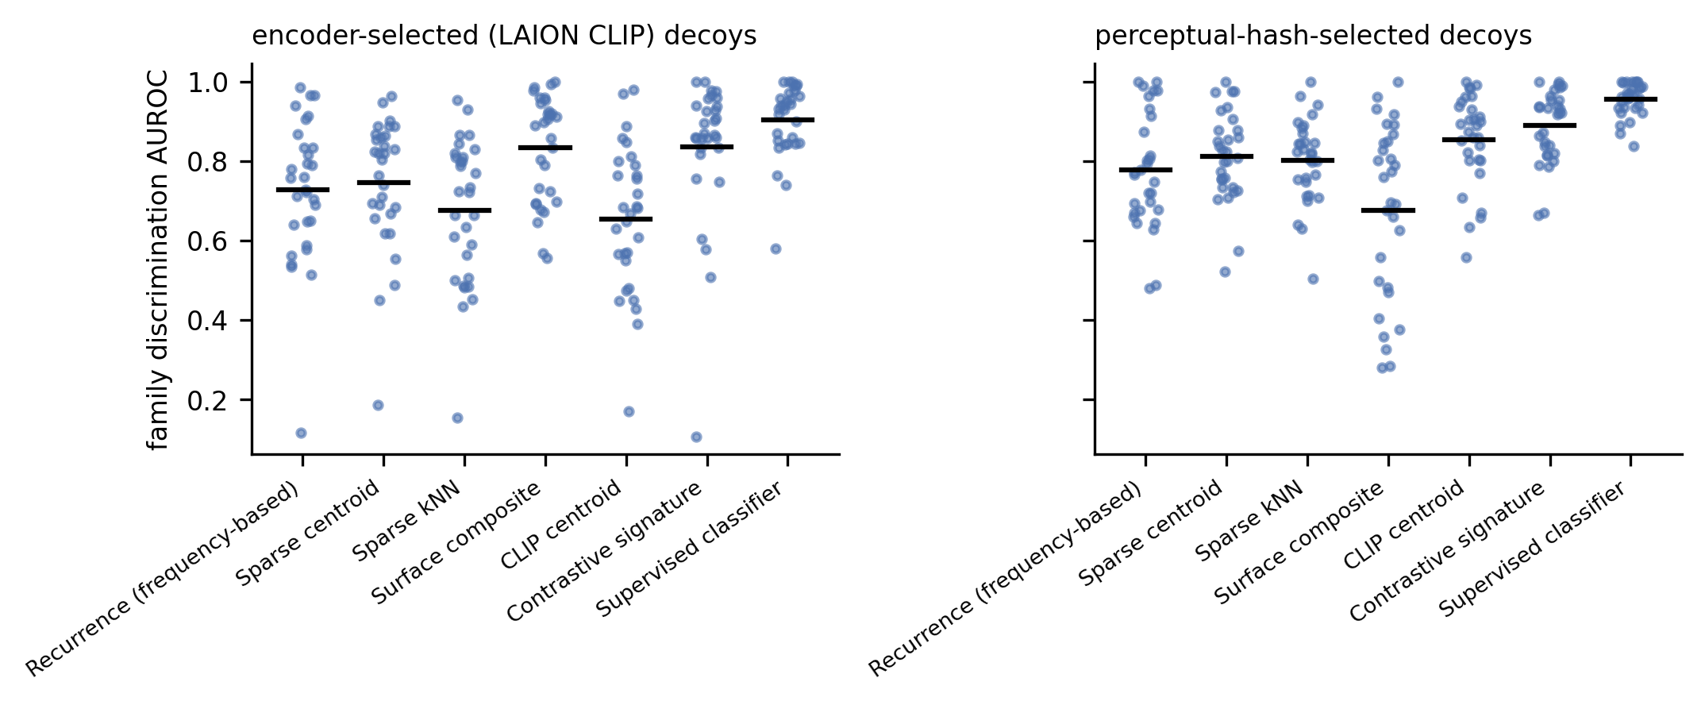
Figure S6. Family-level adversarial discrimination. Per-family discrimination AUROC by method under encoder-selected and perceptual-hash-selected decoys in the development corpus.
S9. Signature Inspection and Illustrative Cases
The family signatures can be inspected through their retained feature indices and weights and by identifying the member and nonmember images that most strongly activate those features. Main-text Figure 2b uses trade offer as the worked example because it was the development family with the median development-corpus contrastive recovery AUROC (family AUROC 0.920; median 0.922). The family was selected by this rule before its signature was inspected.
Additional illustrative cases were selected by rules specified before the cases were viewed and then applied to the development-corpus recovery results: (i) the family with the largest contrastive-minus-CLIP-centroid discrimination difference under encoder-selected decoys, pov you are x (+0.480); (ii) the family with the smallest such difference, wojak soyjak (−0.063); (iii) the family with the largest classifier-minus-contrastive recovery difference, distracted boyfriend (+0.208); and (iv) for each, the single top-ranked encoder-selected decoy. Figure S7 instead displays the highest-scoring nonmember under the family's contrastive signature, drawn from the stored signature export, rather than the encoder-selected decoy named in (iv). All illustrated families come from the development corpus; no held-out family is shown.
These materials are inspection aids rather than semantic validation. The sparse features have not been independently established as human-interpretable concepts, so a retained feature index should not be read as a validated semantic label.
For each example, the accompanying data provide:
- the 15 retained feature indices and weights
- identifiers for the highest-activating member exemplars
- identifiers for the highest-activating nonmember exemplars
- development-family recovery performance
- corresponding classifier performance
An exploratory typology classifies development families as structural, character/style, lexical, or template-based. These assignments were not established through blinded human annotation and are used only for descriptive exploration.
Table S10. Exploratory family-type coding. Descriptive typology only. Per-family assignments are provided in the reproducibility package.
Type | Basis of the family
Structural | recurring spatial or compositional structure
Character/style | recurring character or distinctive visual style
Lexical | recurring text or phrasal template
Template-based | fixed image-macro template

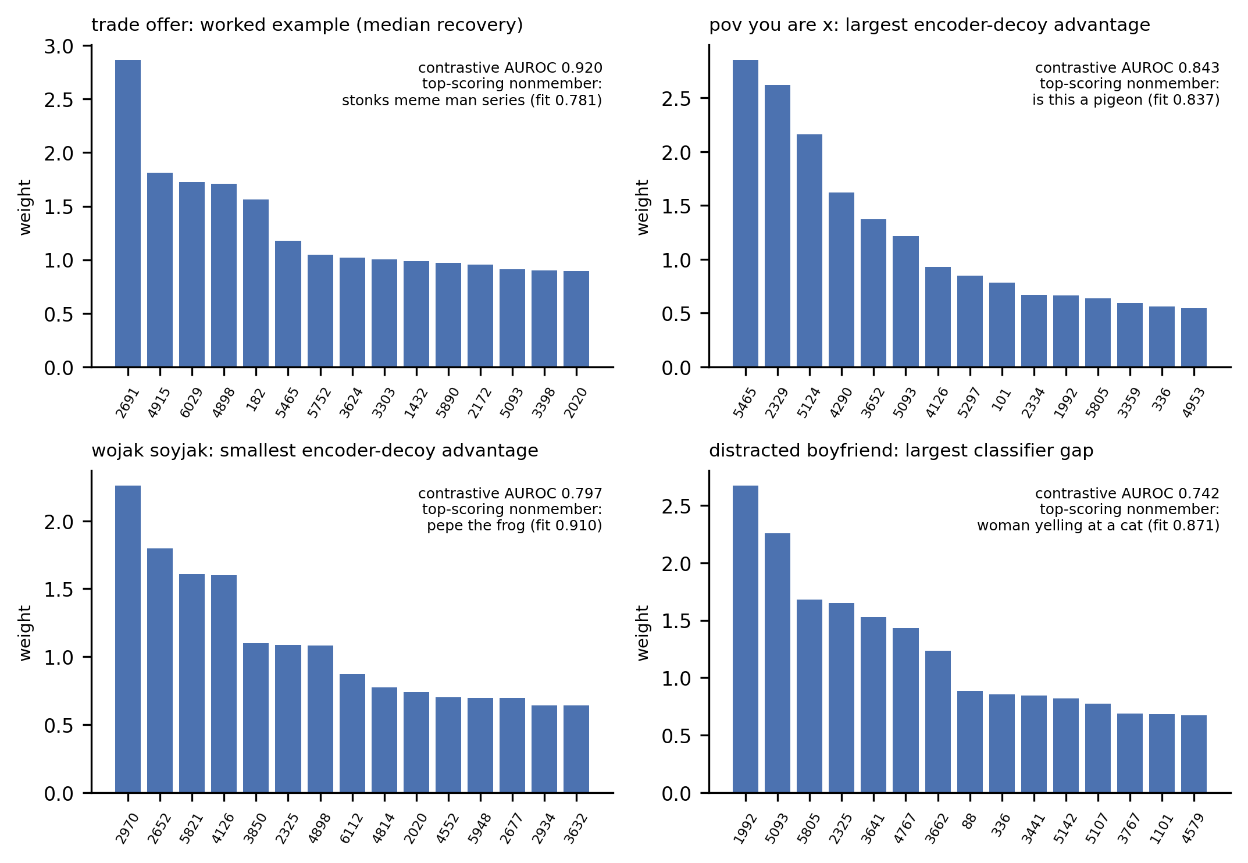
Figure S7. Family-signature inspection examples. The rule-selected worked example and additional cases are shown through the 15 retained contrastive feature weights, the family's contrastive recovery AUROC, and the source family and signature fit of the highest-scoring nonmember under that family's signature. Meme images are not reproduced. Retained features are not assigned semantic labels. Feature indices and identifiers for the highest-activating member and nonmember exemplars are provided in interpretability_signatures.csv.
Reddit Supplement
S10. Collection and Sample Flow
Public Reddit image posts were collected from the new listings of seven communities: r/dankmemes, r/memes, r/meme, r/whenthe, r/historymemes, r/shitposting, and r/me_irl. Top and hot listings were queried separately to construct the selected-listing contrast. The rising listing was queried after the new listing but contributed no additional posts once previously observed post identifiers were removed.
Collection occurred from April 26 to May 27, 2026. Images were deduplicated by perceptual hash before analysis. The denominator sample contained 4,263 posts: 749 from r/dankmemes, 726 from r/memes, 711 from r/meme, 585 from r/whenthe, 573 from r/historymemes, 562 from r/shitposting, and 357 from r/me_irl. The analyzed selected-listing contrast contained 348 posts. Four additional posts retrieved from hot listings were included in neither analytic sample. All 4,263 denominator-sample images were available locally and are included in the full-sample analyses (§S16).
Time-invariant content features were computed once for each post.
Table S11. Sample flow by community. Denominator-sample counts after perceptual-hash deduplication.
Community | Denominator posts
r/dankmemes | 749
r/memes | 726
r/meme | 711
r/whenthe | 585
r/historymemes | 573
r/shitposting | 562
r/me_irl | 357
Total | 4,263

Note. The analyzed selected-listing contrast contained 348 posts. Four additional hot-listing posts were included in neither analytic sample.
S11. Engagement-Outcome Construction
The primary continuous outcome was
$\log_{10}(score + 1).$
Comment engagement was analyzed separately as
$\log_{10}(comments + 1).$
Posting-age windows were defined within each community using quartiles of post age in days. For the binary outcome, a post was classified as high engagement when its log₁₀(score + 1) was at or above the 75th percentile within its community-by-age-window bin. Bins with fewer than four observations received no threshold. Within cross-validation, binary-outcome thresholds were recomputed using only the training fold.
Table S12. Engagement variables and outcome definitions.
Variable | Definition
Continuous score outcome | log₁₀(score + 1)
Comment engagement | log₁₀(comments + 1)
Upvote ratio | post upvote ratio
Binary high-engagement outcome | 1 if log₁₀(score + 1) is at or above the 75th percentile within the post's community-by-age-window bin
Age windows | quartiles of post age in days, defined within each community
Threshold rule | bins with fewer than four observations receive no threshold; binary thresholds recomputed using the training fold only

Under best-fit-family-grouped validation, adding the raw signature score and specificity margin produced the outcome-specific increments shown in Table S13.
Table S13. Outcome-specific incremental performance. Continuous-outcome incremental R² under best-fit-family-grouped validation.
Outcome | Incremental R²
log₁₀(score + 1) | +0.072
log₁₀(comments + 1) | +0.016
Upvote ratio | +0.076

Note. The log₁₀(score + 1) row uses the same model as the "Raw signature score + specificity" row of the ablation analysis in §S12.
The point increment was larger for score and upvote ratio than for comment count.
S12. Model Specifications and Validation Designs
The control model included whole-image similarity, perceptual-hash similarity, template similarity, OCR-based text similarity, log posting age, and community indicators. The full model added the raw signature score and specificity margin.
Continuous outcomes were modeled using ridge regression with α = 1.0. The binary outcome used regularized logistic regression with C = 1.0. Predictor scaling was estimated separately within each training fold. No data-dependent predictor selection was performed, and the regularization penalties were fixed in advance.
The historical Reddit score bank contained 31 family signatures, including the family excluded from the recovery analysis because it had only two development variants. Rescoring with the matched 30-signature bank produced a raw-score increment of +0.0680, compared with +0.0683 using all 31 signatures.
Best-fit-family groups were highly unequal in size. “Nobody / literally no one” was the best fit for 1,701 of 4,263 posts (39.9%) and “mocking spongebob” for 1,195; together the two largest groups contain 67.9% of posts, and under best-fit-family grouping each forms a fold by itself. The same signature was the best fit for 409 of the 427 posts in the top decile of raw scores. Because raw scores are not calibrated across families, this concentration may partly reflect differences in raw-score scaling across families.
Four cross-validation schemes were evaluated. Each places a different restriction on how test observations relate to training observations, and none is designated as primary:
1. random five-fold cross-validation
2. perceptual-hash-cluster-grouped cross-validation using Hamming distance ≤ 10
3. community-grouped cross-validation, which with seven communities is leave-one-community-out
4. best-fit-family-grouped cross-validation
Chronology of the validation designs. The original engagement analysis used random folds and a leave-one-community-out classification analysis on 27 May 2026. On 13 July 2026, before the perceptual-hash-cluster analysis was run, an internal analysis plan designated perceptual-hash-cluster grouping as the intended primary design. That analysis could not be executed at the time because the required per-post hash variable was absent. Four schemes were run that day instead (random folds, random folds with within-fold outcome labels, community grouping, and best-fit-family grouping), after which best-fit-family grouping was labeled primary. That designation followed observation of the results, and best-fit-family grouping produced the largest increment among the schemes run. We subsequently executed the previously specified perceptual-hash-cluster design, obtaining ΔR² = +0.046 with a 95% interval of [0.034, 0.058]. All four validation schemes are therefore reported without designating one as primary.
Perceptual-hash grouping should be interpreted mainly as a near-duplicate control rather than as comprehensive template grouping. At Hamming distance ≤ 10, 95.6% of posts belong to singleton clusters, so broader template siblings are generally not forced into the same fold.
Table S14. Validation-design matrix. Grouping unit, generalization question, and remaining dependence for each cross-validation scheme. See also main-text Table 3.
Scheme | Grouping unit | Generalization question | Remaining dependence
Random five-fold | none (shuffled) | new posts from the sampled population | template siblings may share folds
Perceptual-hash cluster (Hamming ≤ 10) | perceptual-hash cluster | new near-duplicate groups | broader template siblings generally not grouped
Community grouped (= leave-one-community-out) | community | community absent from training | within-community template reuse
Best-fit-family grouped | best-fit family signature | posts assigned to a held-out best-fit-signature group | residual template structure across signature groups

Table S15. Control and full-model performance across validation schemes.
Panel A. Absolute model performance.
Scheme | R² control | R² full | ΔR² | AUROC control | AUROC full | ΔAUROC
Random 5-fold | 0.107 | 0.153 | +0.046 | 0.513 | 0.596 | +0.083
Perceptual-hash cluster | 0.106 | 0.152 | +0.046 | 0.518 | 0.601 | +0.082
Community grouped (= LOCO) | −0.018 | 0.035 | +0.052 | 0.547 | 0.617 | +0.070
Best-fit-family grouped | 0.057 | 0.129 | +0.072 | 0.525 | 0.620 | +0.094

The larger increments under some grouped designs partly reflect weaker control-model performance. For the continuous outcome, control-model R² was 0.107 under random folds, 0.057 under best-fit-family grouping, and −0.018 under community-grouped validation.
Panel B. Raw-signature and specificity ablation, best-fit-family-grouped validation.
Added predictors | ΔR²
None | 0.000
Raw signature score | +0.068
Specificity only | −0.005
Raw signature score + specificity | +0.072

The incremental association was concentrated in raw signature resemblance. Specificity contributed little additional predictive information.
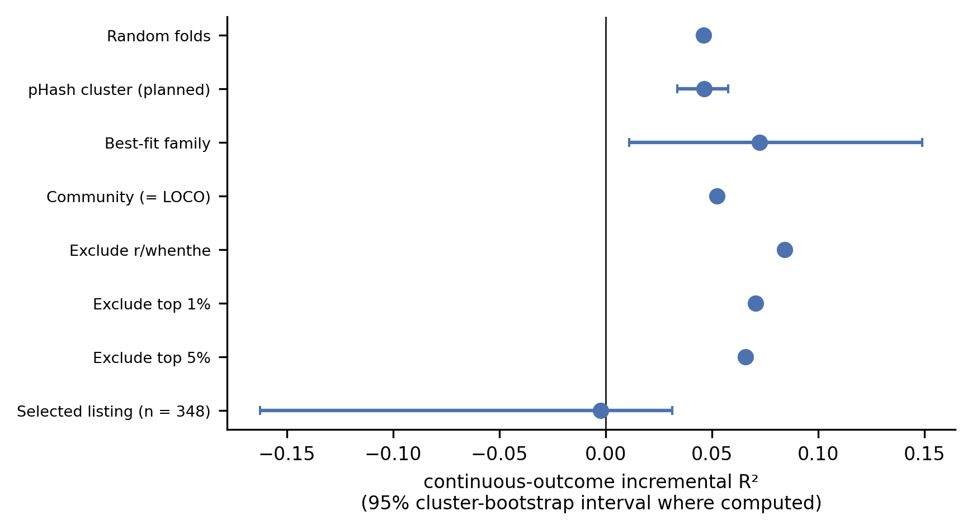
Figure S9. Engagement increment across validation designs and sensitivity analyses. Continuous-outcome ΔR² for each validation scheme, the community- and engagement-tail-exclusion sensitivities, and the selected-listing contrast. Points are increments; horizontal bars show 95% cluster-bootstrap intervals where those intervals were estimated. Scheme rows add the raw signature score and specificity margin; exclusion rows add raw resemblance alone (full-sample reference increment 0.068).
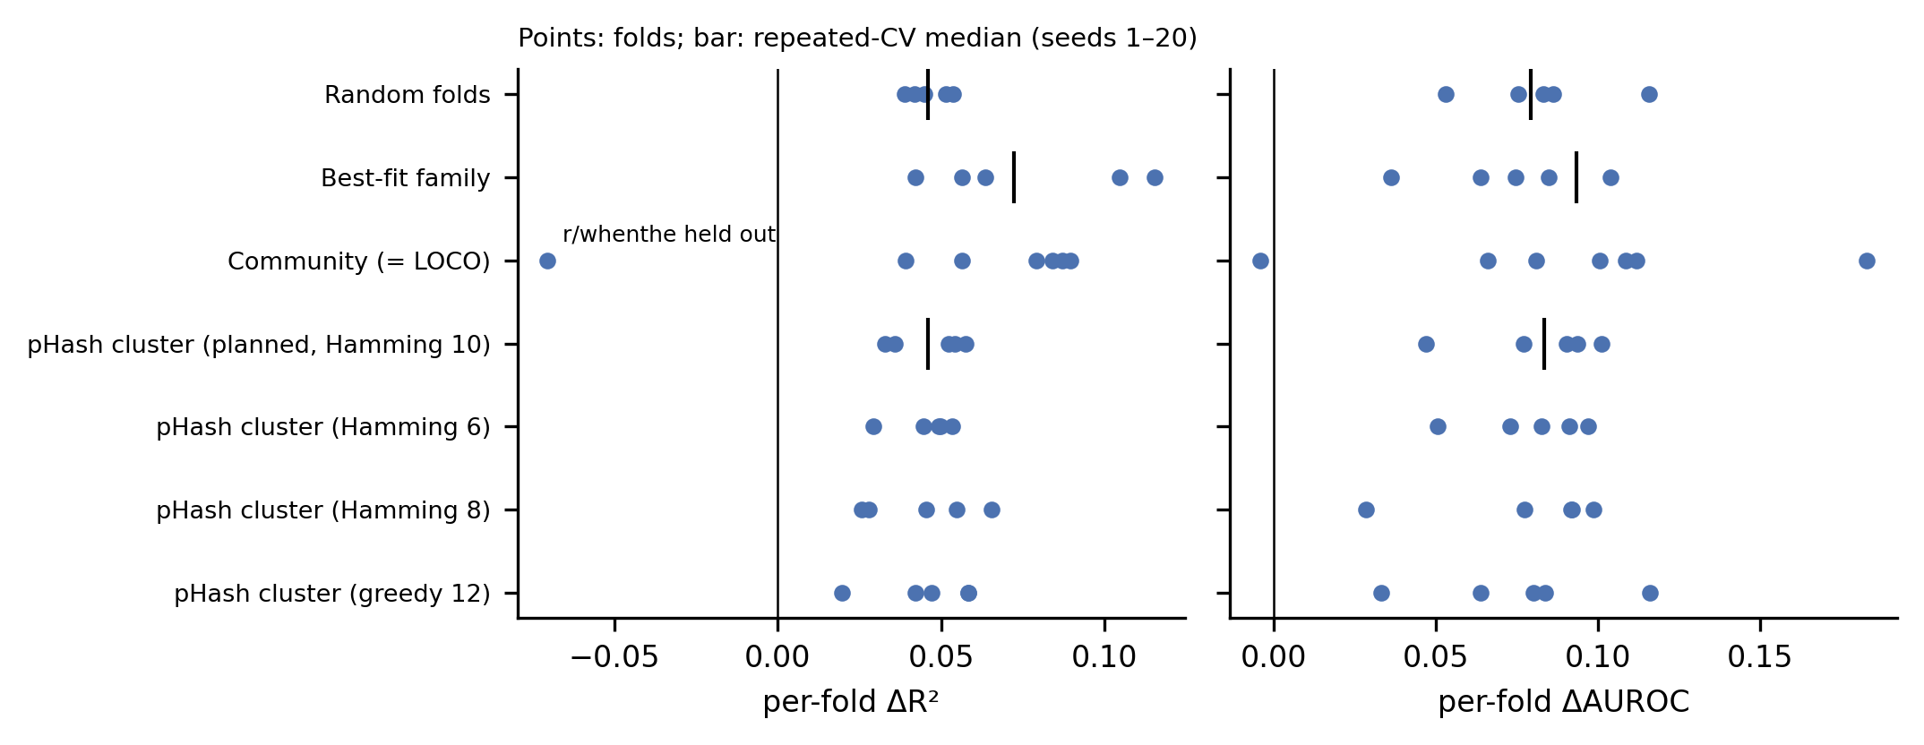
Figure S12. Per-fold engagement increments. Paired fold-level ΔR² and ΔAUROC for each validation scheme from g2_per_fold.csv, with the median across repeated cross-validation seeds 1–20 marked. The additional perceptual-hash-cluster specifications (Hamming thresholds 6 and 8, and greedy-leader clustering at 12) are cluster-definition sensitivities specified in the internal analysis plan before the perceptual-hash-cluster analysis was run. The r/whenthe fold is labeled; in leave-one-community-out validation the increment is negative when r/whenthe is held out.
S13. Bootstrap and Uncertainty
Uncertainty for grouped engagement increments was evaluated with 2,000 cluster-bootstrap iterations over the relevant grouping units (Cameron et al., 2008). Whole groups were sampled with replacement. If a group was drawn more than once, all copies of that draw were assigned to the same cross-validation group so that duplicated observations could not appear in both training and test sets. Intervals use bootstrap percentiles.
For the continuous outcome under best-fit-family grouping, the observed ΔR² was 0.072 with a 95% interval of [0.011, 0.149]. Across the 2,000 bootstrap draws, 99.7% of increments were above zero. Under perceptual-hash-cluster grouping, the 95% interval was [0.034, 0.058].
Repeated draws. When a group is drawn more than once, all of its copies share one cluster identity, so copies of the same observations never appear on opposite sides of a train/test split. Under this procedure, the best-fit-family interval is [0.011, 0.149].
These intervals quantify variation across the resampled grouping units. They do not simultaneously incorporate dependence associated with community, collection period, and residual template structure. The proportion of bootstrap increments above zero is reported descriptively and is not treated as a hypothesis-test p-value.
S14. Community and Sensitivity Analyses
The correlation between raw signature resemblance and log engagement varied across communities (Table S16).
Table S16. Community-specific associations. Correlation between raw signature resemblance and log engagement.
Community | Correlation
r/meme | +0.339
r/memes | +0.322
r/shitposting | +0.299
r/dankmemes | +0.167
r/me_irl | +0.163
r/historymemes | +0.157
r/whenthe | +0.020

The point estimate was positive in all seven communities and close to zero in r/whenthe.
Leave-one-community-out validation produced an incremental R² of +0.052. Under best-fit-family grouping with raw resemblance added to the control model, the continuous-outcome increment remained positive after excluding r/whenthe (+0.084; n = 3,678), after excluding the top 1% of posts by engagement (+0.070), and after excluding the top 5% (+0.066).
In the selected-listing contrast (n = 348), the incremental R² was −0.002 with a cluster-bootstrap 95% interval of [−0.163, 0.031]. This contrast uses the historical score block available for the selected-listing sample, entered as stored raw resemblance and specificity. Its point estimate is near zero, and its interval includes zero. The association observed in the new-listing denominator was therefore not reproduced in this selected-listing sample. Interpretation is limited by the smaller sample and by selection into already surfaced posts, which may restrict the available engagement variation.
Two negative controls were conducted. Permuting raw signature resemblance within community-by-age bins reduced the incremental performance to approximately zero. Models fitted after randomly shuffling the outcome performed at chance.
Table S17. Sensitivity analyses and negative controls. Continuous-outcome incremental R² under best-fit-family-grouped validation unless otherwise noted.
Analysis | Incremental R²
Community grouped (= leave-one-community-out) | +0.052
Exclude r/whenthe | +0.084
Exclude top 1% of posts by engagement | +0.070
Exclude top 5% of posts by engagement | +0.066
Selected-listing contrast (n = 348) | −0.002, 95% [−0.163, 0.031]
Negative control: permute score within community-by-age bins | 0.000
Negative control: randomly shuffled outcome | +0.000 (full-model AUC 0.489)

Note. The community exclusions, engagement-tail exclusions, and negative controls add raw signature resemblance alone to the control model. The selected-listing contrast uses the historical two-predictor block of stored raw resemblance and specificity. All values in this table were computed on all 4,263 posts (the selected-listing contrast on its 348 posts); the generating script is listed in Table S22. The selected-listing interval uses the cluster bootstrap described in §S13.
Cross-source overlap sensitivity. We assessed overlap between the development meme-family corpus and the 4,263-post Reddit denominator using the same 64-bit DCT perceptual-hash criterion used for corpus deduplication, Hamming distance ≤ 6. The number of Reddit posts byte-identical to a development-corpus image was 0. Under the perceptual-hash criterion, 14 Reddit posts (0.33% of the denominator) were near-duplicates of 14 development images spanning 9 families.
Excluding exactly these 14 posts produced continuous ΔR² estimates of 0.047 under random folds, 0.046 under perceptual-hash-cluster grouping, 0.053 under community grouping, and 0.072 under best-fit-family grouping. The representation-magnitude-adjusted residual was 0.012 with a 95% interval of [−0.002, 0.044] and remained small and uncertain. These estimates show no material dependence of the reported Reddit result on the identified cross-source near-duplicates.
S15. Signal Decomposition
Signal-decomposition analyses use all 4,263 denominator posts. Unless otherwise noted, estimates use best-fit-family-grouped validation and compare the control model with a model that adds the indicated score (Table S18).
Score definitions. On all 4,263 posts, the magnitude-adjusted increment is 0.013 [−0.001, 0.046], with seed sensitivity in Table S5a. The classifier score is the maximum one-versus-rest predicted probability; the maximum decision score gives the same increment (Table S18). Community-grouped validation is leave-one-community-out and is reported once (Table S15).
Table S18. Signal-decomposition models. Incremental R² and correlation with log engagement for each score construction under best-fit-family-grouped validation.
Score construction | ΔR² | Correlation with log engagement
Raw signature resemblance | +0.068 | +0.22
Sparse-centroid resemblance | +0.066 | +0.24
Family-calibrated fit | +0.001 | −0.01
Classifier score (maximum predicted probability) | −0.002 | +0.00
Classifier maximum decision score | −0.002 | +0.00
Sparse-activation norm | +0.039 | +0.16
Whole-image embedding norm | +0.035 | −0.07
Random-feature signature maximum | +0.002 | +0.08
Raw signature over generic-magnitude block | +0.013, 95% interval [−0.001, 0.046] | —

Raw signature resemblance and sparse-centroid resemblance produced similar point increments (difference not tested). The full-sample downstream association therefore cannot be attributed specifically to the contrastive construction. Family-calibrated fit and both classifier-score constructions contributed essentially no incremental performance. Sparse-activation and whole-image embedding magnitude each carried smaller positive increments.
Randomization Tests
Table S19. Randomization-test results, all 4,263 posts, seed 0. Null distributions of incremental R² and Monte Carlo p-values calculated as (b + 1)/(B + 1) for the observed increment of 0.068.
Null construction | Banks | Null mean | Null 95th percentile | Null maximum | Observed | Monte Carlo p
Random-feature signatures | 500 | +0.001 | +0.010 | +0.047 | +0.068 | 0.002
Label-permutation signatures | 200 | +0.039 | +0.062 | +0.080 | +0.068 | 0.030

None of the 500 random-feature banks reached the observed increment. Maximizing over an arbitrary collection of sparse feature vectors was therefore insufficient to reproduce the observed downstream association under this randomization.
The label-permutation procedure preserved the empirical sparse representation while breaking the documented family assignments used to estimate the signatures. These permuted signatures retained, on average, 58% of the observed increment. The observed increment exceeded this null, with Monte Carlo p = 0.030–0.045 across four seeds (Table S5a).
Adding sparse-activation norm, whole-image embedding norm, and text length to the control block reduced the raw-signature increment from 0.068 to 0.013, with a 95% interval of [−0.001, 0.046]. The remaining increment is small and uncertain.
Together, these analyses indicate that much of the downstream association resides in broad structured resemblance within the sparse representation and in representation magnitude. Evidence specifically linking the association to correct documented-family identity is limited. We use canonical resemblance to documented meme forms as shorthand for this broader empirical pattern rather than as a separately validated cultural construct.
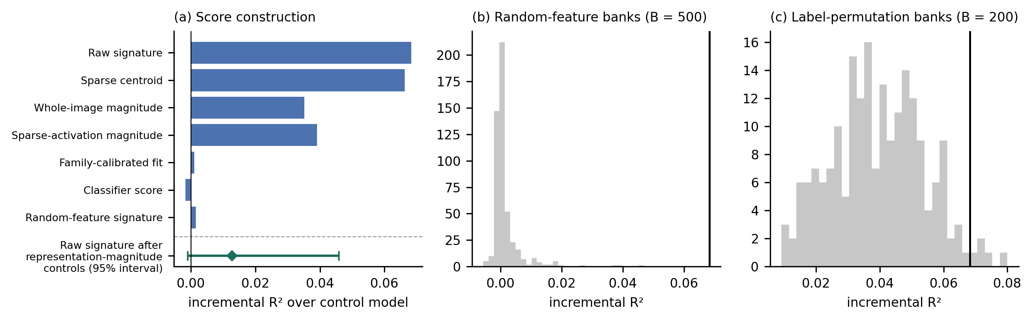
Figure S10. Signal decomposition and randomization controls. (a) Incremental R² by score construction. (b) Distribution across 500 random-feature signature banks. (c) Distribution across 200 label-permutation signature banks. The observed raw-signature increment is marked in panels (b) and (c). All panels use the 4,263-post denominator sample.
S16. Image Re-Encoding for the Decomposition Analyses
All 4,263 Reddit images were re-encoded for the decomposition analyses. Re-encoding reproduced the stored raw signature scores to the reported precision, with correlation 1.000000 and 100% agreement in best-fit family. The decomposition analyses therefore use all 4,263 posts from the seven communities (§S15).
S17. Prospective Engagement Analysis
A separate cohort was scored at initial collection and revisited to test whether raw signature resemblance predicted subsequent engagement after initial engagement was included in the model. A total of 1,398 posts were observed at each of three completed waves: initial collection, +4 hours, and +8 hours.
Planned observations at +24 hours, +72 hours, and +7 days could not be collected. Beginning 29 May 2026, Reddit returned HTTP 403 responses at the IP level to the unauthenticated public endpoints used for collection. Authenticated access through Reddit's Data API required a registration and approval process. An access request submitted through Reddit's request form in May 2026 received no response during the study window.
Among posts with complete model data, the incremental continuous-outcome R² was −0.002 at +4 hours (n = 1,366) and −0.002 at +8 hours (n = 1,354). The completed short-window waves therefore provide no clear evidence of incremental prediction beyond initial engagement.
Longer-horizon prospective prediction remains unevaluated.
Table S21. Prospective-wave design and completed analyses. A total of 1,398 posts were observed at each completed wave. Model sample sizes reflect complete-data availability.
Wave | Status | Incremental R² after initial engagement (n)
Initial collection (t₀) | completed | baseline
+4 hours | completed | −0.002 (1,366)
+8 hours | completed | −0.002 (1,354)
+24 hours | not collected (HTTP 403 from 29 May 2026) | —
+72 hours | not collected (HTTP 403 from 29 May 2026) | —
+7 days | not collected (HTTP 403 from 29 May 2026) | —

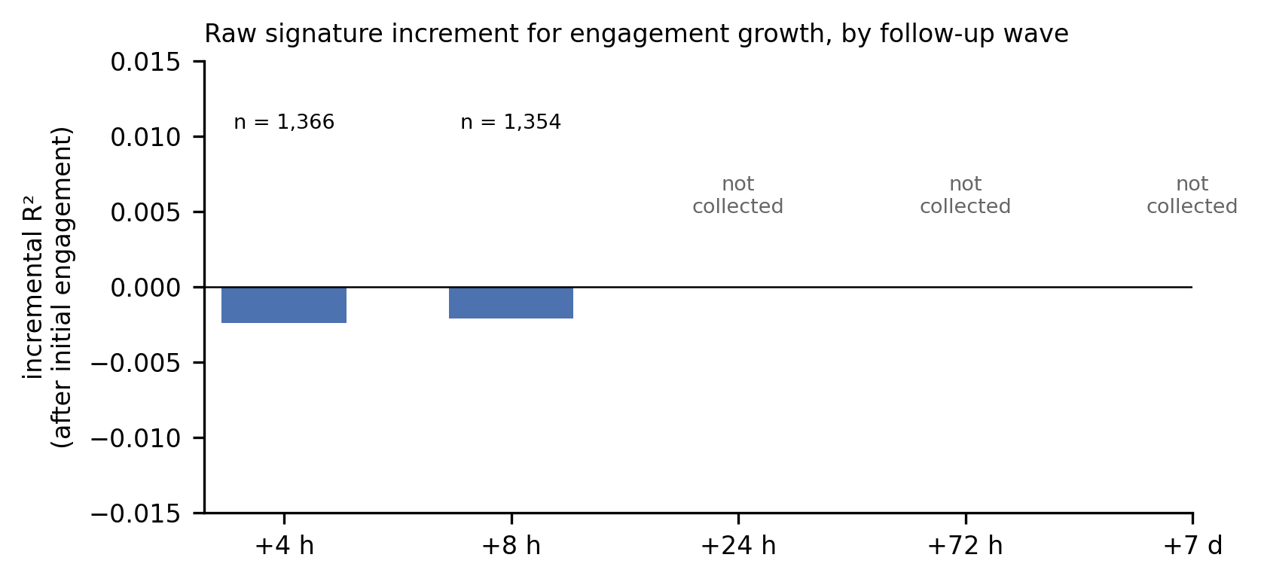
Figure S11. Short-window prospective analysis. Incremental continuous-outcome R² associated with raw signature resemblance after adjustment for initial engagement at the completed +4-hour and +8-hour waves. Model n is shown for each wave. The planned +24-hour, +72-hour, and +7-day waves are included for design context but were not collected.
S17a. Blinded Author-Coded Human Check
We conducted a blinded author-coded check to examine whether Reddit posts receiving different raw signature scores could be classified against the documented family bank by a human coder. A stratified random sample of 60 unique posts was drawn, with 10 posts from each of six strata spanning the observed raw-score distribution. Sampling, coding, and analysis rules were fixed before the sample was drawn.
One of the authors coded the posts using only the image and a fixed offline reference sheet containing exemplars from the 31 documented families. For each presentation, the coder selected one listed family, "none," or "uncertain." The raw score, score stratum, model-nominated family, community, title, engagement, and repeat status were hidden during coding. In addition, 10 posts were presented a second time, at least 20 presentations after their first appearance and without indication that they were repeats. Coding labels were fixed before the hidden model information was linked back to the responses.
Among the 60 unique posts, 0 were assigned to the model-nominated family, 3 to another listed family, 6 to none of the listed families, and 51 were coded uncertain. The two presentations of a repeated post received the same response in 10 of 10 cases.
The coder had developed the measure and is not a specialist in meme history or internet culture. Because most judgments were uncertain, the exercise did not yield a determinate human criterion of family membership, and we do not treat it as a validation benchmark. The absence of confirmed model nominations is not evidence that the nominations were incorrect, and the repeat agreement indicates consistency in the coder's responses, including uncertainty, rather than substantive validity. No additional coders were introduced after the result was observed.
Table S21a. Human-check responses by raw-score stratum. Unique posts per stratum (strata span the observed raw-score distribution from lowest, B1, to highest, B6), by coder response, with the most frequent model-nominated family in each stratum.
Stratum (raw score) | Posts | Model-nominated family | Another listed family | None | Uncertain | Most frequent nomination
B1 (lowest) | 10 | 0 | 0 | 2 | 8 | mocking spongebob (4)
B2 | 10 | 0 | 0 | 1 | 9 | nobody literally no one (6)
B3 | 10 | 0 | 0 | 1 | 9 | mocking spongebob (7)
B4 | 10 | 0 | 2 | 1 | 7 | nobody literally no one (9)
B5 | 10 | 0 | 0 | 0 | 10 | nobody literally no one (7)
B6 (highest) | 10 | 0 | 1 | 1 | 8 | nobody literally no one (9)

The pre-specified comparison of the two lowest-score strata (B1–B2) with the two highest (B5–B6) found 0 of 20 versus 0 of 20 confirmed nominations (difference 0.00; Newcombe 95% interval [−0.16, 0.16]). In the highest strata, “nobody literally no one” was the nomination for 7 of 10 posts in B5 and 9 of 10 in B6.
Reproducibility Appendix
S18. Software, Code, and Data Manifest
Analyses were conducted on macOS (Darwin) using Python 3.9. Core software dependencies included NumPy 2.0.2, pandas 2.3.3, scikit-learn 1.6.1, PyTorch, open_clip, imagehash 4.3.2, and ocrmac. Images were encoded using OpenAI CLIP ViT-L/14. Sparse representations used the multimodal sparse autoencoder described by Zaigrajew et al. (2025), checkpoint WolodjaZ/MSAE, with 6,144 latent dimensions. Recovery negative sampling used seed 20260512. Engagement cross-validation and bootstrap point estimates used seed 0, with seed sensitivities reported in Table S5a.
Table S22 maps the principal reported results to their generating scripts and stored outputs; scripts whose results were superseded are listed in the final row. REPRODUCIBILITY_MANIFEST.csv provides the expanded file-level manifest, including script and output checksums and reproduction commands.
Table S22. Reproducibility manifest.
Result | Script | Output
Development recovery, leave-one-variant-out protocol (Table 2, Panel 2A; Tables S4, S5, S7–S9) | analysis/g3_recovery/ | g3_results.json, g3_family_table.csv
Fold-local decoy sensitivity (§S8) | analysis/repair/ | decoys_foldlocal.json
Held-out-family validation (Table 2, Panel 2B; §§S1a, S7a) | analysis/heldout/ | heldout_results.json, screening_summary.json
Exploratory decoy comparison with the fused centroid (§S7a) | analysis/heldout/exploratory/x1_hard_decoys_vs_fused.py | exploratory_x1_decoys_vs_fused.json
Engagement validation schemes (Tables 3, 4, S15; Figure S12) | analysis/g2_template_cluster/ | g2_results.json, g2_per_fold.csv
Full-sample decomposition and randomization analyses (Figure 5; Tables S18, S19) | analysis/g1_full_sample/ | g1_results.json, identity_check.json
Corrected bootstrap intervals and Monte Carlo p-values | analysis/repair/ | bootstrap_samelabel.json, repair_cheap.json
Rule-based case selection (Figure 2b, Figure S7, §S9) | analysis/revision_selections/select_cases.py | revision_selections.json
Recomputed sensitivity values (Tables S13, S17; Figure S9) | analysis/legacy_values/recompute_legacy.py | legacy_values.json
Top-decile engagement-rate comparison (RQ3 scale interpretation) | analysis/r1_7_decile/decile_lift.py | decile_lift.json
Signature export used by Figures 2b and S7 | analysis/figure_inputs/export_signatures.py | signatures_submitted_export.json
Best-fit signature concentration (§S12; Results scale anchor) | analysis/concentration/export_bestfit_concentration.py | bestfit_concentration.json
Development-corpus counts (§S1; Figure S1) | analysis/corpus/export_corpus_counts.py | corpus_counts.json
Cross-source overlap and exclusion sensitivity (§S14) | analysis/m12_overlap/ | m12_overlap.json, m12_exclusion_sensitivity.json
Prospective short-window analysis (§S17; Table S21; Figure S11) | analysis/prospective/export_prospective.py | prospective.json
Blinded author-coded human check (§S17a) | analysis/human_check/ | hc_results.json, hc_summary.json
Figures 1–5 and S1–S13, plotting only | revision/build/figures/make_figures_r1.py | revision/build/out/figures/
Superseded scripts: RUN_m2m4_full.py, RUN_e2_bootstrap.py, RUN_downstream_embed_score.py (subset filter), RUN_save_nulls.py (raw exceedance p) | — | replaced by the generating sources above

Raw meme images and raw Reddit content are not redistributed where source or platform terms restrict redistribution. The reproducibility package instead provides derived features, analysis outputs, and permitted post identifiers. Access instructions for any restricted review materials are supplied separately with the submission.
S19. Ethics and Data Handling
The study analyzed publicly accessible Reddit posts and publicly available meme-reference materials and involved no intervention with users. Usernames were removed from the analysis data. Post identifiers were retained where required for reproducibility and linkage. Posts that had been deleted or were unavailable when collection occurred were not included in the analyzed sample.
The development-corpus collection procedure requested paginated Know Your Meme gallery routes that were listed under Disallow in the site's robots.txt. The already collected development corpus was retained for provenance, but that retrieval procedure was not repeated. Held-out-family retrieval used only routes permitted by robots.txt and was limited to the first gallery page. The resulting held-out families are therefore shallower than the development families, and the analysis reports explicit family-size sensitivities rather than assuming similar retrieval depth.
Data collection and retention were limited to materials needed for the reported analyses. Redistribution of raw images and raw Reddit content is subject to source and platform terms. Derived datasets remove usernames while retaining permitted identifiers needed for reproducibility. A supplementary coding check was carried out by one of the authors, who labelled a sample of public Reddit images against a reference sheet. No other persons took part, and no ethics review was sought.
Supplementary References
Cameron, A. C., Gelbach, J. B., & Miller, D. L. (2008). Bootstrap-based improvements for inference with clustered errors. The Review of Economics and Statistics, 90(3), 414–427.
Pedregosa, F., Varoquaux, G., Gramfort, A., Michel, V., Thirion, B., Grisel, O., Blondel, M., Prettenhofer, P., Weiss, R., Dubourg, V., Vanderplas, J., Passos, A., Cournapeau, D., Brucher, M., Perrot, M., & Duchesnay, É. (2011). Scikit-learn: Machine learning in Python. Journal of Machine Learning Research, 12, 2825–2830.
Zauner, C. (2010). Implementation and benchmarking of perceptual image hash functions [Master's thesis, Upper Austria University of Applied Sciences].
Zaigrajew, V., Baniecki, H., & Biecek, P. (2025). Interpreting CLIP with hierarchical sparse autoencoders. Proceedings of the 42nd International Conference on Machine Learning, 267, 73918–73956.

