*Date: 29 December 2019*

**Should the Government promote or control developments**

**in machine learning and AI?**

DS7001 Coursework / Student No. 1720146

Chung Hoi Chiu

**Abstract:** The essay tries to define AI clearly by first adopting an existing definition and then augmenting it by additions derived from two machine learning mini-projects. The essay then argues that, since the importance of AI to human beings is commensurate with that of electricity and steam power, the British Government should accordingly allocate efforts to AI commensurate with its importance. The essay then discusses how the Government should deal with selected aspects of AI that are related to ethics and regulations with which I am relatively familiar.

**1. Introduction**

**1.1 What are machine learning and AI?**

To answer the title question, I need first to clarify what machine learning and AI (Artificial Intelligence) mean in this essay. There are many different definitions of AI. However, I first to use the following concise definition contained in a governmental white paper on industrial strategy:

Technologies with the ability to perform tasks that would otherwise require human intelligence, such as visual perception, speech recognition, and language translation.

(Department for Business, Energy and Industrial Strategy [DBEIS], 2017, p. 37)

This concise definition was also adopted by the Artificial Intelligence Committee (16 April 2018, HL 100: para 10) in its report on AI.However, the report makes an addition:

Our one addition to this definition is that AI systems today usually have the capacity to learn or adapt to new experiences or stimuli. (para 11)

I would also like to add the following two additions:

1. AI is a component or components of a technological system (AI system or more precisely an AI-enabled system) (Cath et al., 2018).
2. An AI system is not just able to perform tasks that require human intelligence, it can surpass the performance of human intelligence (Hall and Pesenti, 2018, p. 8).

Last year, I conducted two self-initiated mini-projects to understand what AI and machine learning are. I will use these two mini-projects to illustrate the definition mentioned above.

The procedure of the first mini-project was as follows:

1. I installed the open source big data software Apache Spark in my personal computer.
2. I then downloaded into my personal computer several years of daily bike sharing data (total size about 600MB) of a company called Capital Bikeshare which is located in Washington DC, historic weather data from the website of the observatory there, and historic public holiday data from the website of the local government there.
3. The aim of the mini-project is to form an AI system (In this mini-project, it just means a bundle of computer programmes) the core of which is a machine learning element. This system can predict the number of bike sharing transactions of every hour of a day by feeding into the system weather information of the day, together with the date and the day of the week of the day, and whether it is a public holiday, etc.
4. Apache Spark contains four sub-packages: Spark Core, Spark SQL, Spark MLlib and GraphX. I wrote code with Scala, the background language of Apache Spark, Spark Core, and Spark SQL, to inputting and to trim data, and also to arrange output data in a proper format.
5. I also wrote code with Scala and the machine learning sub-package Spark MLlib to receive the cleansed data mentioned in d. and then used part of the data to train the machine learning algorithms embedded in the programme and part of the data to test the performance of the algorithms.
6. I tried different regression analysis methods, test methods and selecting the best result methods, which were contained in the Spark MLlib sub-package, to maximise the performance of my code.
7. I then arranged for another open source software, Apache Zeppelin, which specialises in visualization of data, to visualise results (i.e. to visualise predictions).
8. I found that the accuracy of predictions increased as more years of data were used.

The second mini-project is simpler than the first. I purchased several software packages from Matlab and installed them in my personal computer. The software packages together could enable me to perform convolutional neural network (CNN, one of several kinds of deep learning algorithms) image classifications. I then downloaded the famous image dataset CIFAR-10, which has 10 sets of 32x32 pixels images (aeroplane, automobile, bird, cat, deer, door, frog, horse, ship and truck). Each set has 5000 training images and 1000 test images. CNN consists of layers of multidimensional partial differentiation equations, which are usually joined with layers of nodes called neurons or perceptrons. There are also layers called activation function layers, softmax function layers, etc. By properly arranging the layers, making fine tuning, adding devices for avoiding adverse events such as overfitting, stranded in local optima, etc. by trial and error, I eventually achieved an accuracy rate of about 85% when the system was trained with training sets of images of a bird, a cat, a deer and a horse, and tested with test sets of the same. However, developing the system is very time consuming, taking two to six hours to perform just a training trial, because the training set images need to be fed to the system consecutively and repeatedly more than a million times. I then tested the system with images of a bird, a cat, a deer and a horse obtained from other sources including my smartphone and found that the accuracy remined at higher than 80% even when the size of the images was reduced to 25x25 pixels. With such small images, I usually could not distinguish whether the image was a deer or a horse. I also found that, if I reduced the number of training images used or reduced the number of training, the accuracy rate reduced accordingly.

The above two mini-projects illustrate all aspects of the definition of AI mentioned at the beginning of this section as follows:

1. Computers can learn from data and then predict or classify images, which otherwise require human intelligence to perform.
2. The performance of an AI system can surpass that of human intelligence in one particular aspect, which is, in each of the two mini-projects, the ability to analyse 600MB of data in a couple of seconds then predict, and the ability to recognise whether a very small image is a deer and not a bird, a cat or a horse.
3. If more data are used to train an AI system, the system will become more accurate.
4. Although the AI system is developed with four sets of images (bird, cat, deer and horse), it can also be used to classify other images such as, for example, other sets of images contained in CIFAR-10 (aeroplane, automobile, ship, etc.).
5. Although AI formed the core of the AI systems of the mini-projects, the systems also contain non-AI components, such as components for input or output data, for cleaning and reorganising data, and for visualizing data.

Machine learning is a branch of AI technologies. The above two mini-projects used machine learning technologies. The regression methods used by the first mini-project belong to the traditional branch of machine learning methods. The CNN method used by the second mini-project belongs to a new branch of machine learning methods, which is called deep learning methods or artificial neural network methods. For the definitions of machine learning and deep learning, please refer to Artificial Intelligence Committee, 2018, Box 1. Other branches of AI technologies include expert systems, fuzzy logic and robotics.

The definition of AI discussed in this subsection should be borne in mind when reading the remainder of this essay. Furthermore, machine learning, as it is a branch of AI, will not be discussed separately in the remainder of this essay.

The term ‘Government’ hereinbelow means the British Government.

**1.2 The Government should promote developments in AI**

According to a report prepared by McKinsey in 2018 for the whole world, AI can ‘deliver additional economic output of around US$13 trillion by 2030, boosting global GDP by about 1.2 percent a year’ (Bughin et al., 2018, p. 3). According to an independent report commissioned by the Department for Business, Energy and Industrial Strategy and Department for Digital, Culture, Media and Sport and published in 2017, ‘AI could add an additional USD $814 billion (£630bn) to the UK economy by 2035, increasing the annual growth rate of GVA from 2.5% to 3.9%.’ (Hall and Pesenti, 2017, p. 2). A report prepared by the Select Committee on AI of the House of Lords in 2017 even equates AI's effect on human beings to that of electricity and steam power (Artificial Intelligence Committee, 2018, para. 3). AI is very important. Therefore, there is a general attitude that the Government should, in commensurate with the importance of AI, place sufficient efforts to support it:

Artificial intelligence’s potential is an opportunity the Government is embracing. The Government’s recent enthusiasm and responsiveness to artificial intelligence in the UK is to be welcomed.

(Artificial Intelligence Committee, 2018, para. 366)

It is also a general belief that Britain should be one of the leading players in AI. However, ‘questions still remain regarding Britain’s distinctive role in the wider world of AI’ (Artificial Intelligence Committee, 2018, para. 392). My opinion is that Britain's strength in AI is on its invention and innovation abilities. Evidence:

1. The question ‘Can machines think?’ is raised by and the famous Turing Test is contained in the British AI pioneer Alan Turing's seminal paper *Computing Machinery and Intelligence* (Turing A. M., 1950). This paper is generally acknowledged as the starting point of AI.
2. The ‘Godfather of Deep Learning’, Geoffrey Hinton, although now residing in Canada, was born and educated in Britain. The deep learning computer vision system designed by his student Alex Krizhevsky in 2012, the Alexnet, triggered the frenetic development of computer vision technologies, including the controversial face recognition technologies.
3. The method (trained deep learning model + Monte-Carlo search algorithm) used to beat the world champion of the most complicated chess game, Go, in 2017 was invented by the British company DeepMind.

Britain should be weak at labour intensive parts of the AI industry, such as data-labeling.

In the subsequent sections, I will discuss how the Government should deal with those aspects of AI I have certain special ideas. These aspects are related to ethics and regulations with which I am relatively familiar.

**2. Promote ANI and carefully control funding for AGI**

AI technologies can be divided into two categories, artificial general intelligence (AGI) and artificial narrow intelligence (ANI). The Government should treat them differently. McKinsey provided a succinct definition of AGI and ANI: ‘[Artificial narrow intelligence] performs one narrow task, while artificial general intelligence seeks to be able to perform any intellectual task that a human can do. Narrow AI is already here, while AGI has yet to arrive.’ (Bughin et al., 2018, p. 14)

The destination of the development of AGI is scary as described in the following passage:

Let an ultraintelligent machine be defined as a machine that can far surpass all the intellectual activities of any man however clever. Since the design of machines is one of these intellectual activities, an ultraintelligent machine could design even better machines; there would then unquestionably be an ‘intelligence explosion,’ and the intelligence of man would be left far behind. Thus the first ultraintelligent machine is the last invention that man need ever make, provided that the machine is docile enough to tell us how to keep it under control.

(Good, 1966, p. 33)

The destination or other similar very long-term vision inspired the production of so many science fiction stories and films. On the other hand, they indicate that the success of AI might mean the end of the human race. This gloomy future vision scared quite a significant number of people and led them to oppose the development of AI. Government decision-makers should not be influenced by these very long-term and hence unrealistic visions. They should allocate only a small portion of funding to support research and development in this territory, that is, AGI.

Government decision-makers should focus on ANI technologies, which are already here and urgently need to be improved and capable of rapid improvement. The borderline between ANI and AGI is not easy to draw. One example of ANI is the computer vision mini-project mentioned in Section 1 above. After training, the AI system can surpass the ability of a human and identify the content of a tiny 25x25 pixel image. The correspondent AGI example may be as follows: If a three-year-old child has been shown once a picture of a tortoiseshell cat and told that it is a cat, it is likely that, when she sees a real white cat, she can tell you that it is a cat. We still know very little about how many different aspects of human intelligence this child utilized to perform this classification. Careful examination of whether research projects on these kinds of AGI are too unrealistic or are too ambitious is necessary prior to granting funds to them.

Too much unrealistic and too ambitious expectations on AI have led to several periods of so-called AI winters since the 1960s. During these ‘winters’, funding on AI was cut, and research and development were in stagnation (Hendler, 2008 and Hall and Pesenti, 2017, p. 19). We should be wary of these lessons.

**3. Control research and development of lethal autonomous weapon systems (LAWS): But it is not an easy task**

The first set of AI ethics policies, the so called ‘Asimov's three laws of robotics’, is contained in a short story *Runaround* published in 1942. They are as follows:

1. A robot may not injure a human being, or through inaction, allow a human being to come to harm.
2. A robot must obey orders given to it by human beings, except where such orders would conflict with the First Law.
3. A robot must protect its own existence as long as such protection does not conflict with the First or Second Law.

(Requoted from Clarke, 1993, p. 55)

Although in the past 77 years, these three laws have been discussed by hundreds of publications, no one country or organisation has adopted them.

But development and deployment of LAWS should be a great threat to human beings. Therefore, dozens of diplomats, scholars, etc. have already made public appeals urging the complete banning of LAWS, one of which is the message below made by the UN General Secretary António Guterres in March of 2019:

[M]achines with the power and discretion to take lives without human involvement are politically unacceptable, morally repugnant and should be prohibited by international law.

(Guterres, 2019)

However, for the sake of retaliation, it is unlikely that the Government will unilaterally stop research and development of this branch of AI technologies, until doing so is effectively and universally banned, for example, by annexation of an additional protocol to the UN Convention on Certain Conventional Weapons.

Although at present banning research and development of LAWS is not feasible, all relevant law-enforcing departments of the Government should subject it to very strict control. However, this is not an easy task for the following reasons (Michael, 2019):

1. A function can be secretly embedded in the software of an AI system (for example, a semi-autonomous lethal weapon) such that activating the function will turn the system into an LAWS.
2. A plug-and-play device can turn an AI system into an LAWS.
3. A cyber attack can turn a less cyber-attack-proof AI system (for example, a self-driving car) into an LAWS.

Government decision-makers should always bear in mind other issues concerning LAWS, for example:

1. The application of LAWS would reduce military casualties, which might prompt Government decision-makers to initiate wars rashly.
2. If the massive annihilation effect of nuclear weapons would force Government decision-makers to use their best endeavour to solve conflicts peacefully, would the reduction of military casualty effect of LAWS inducing Government decision-makers to solve conflicts by war?

**4. Avoid producing guidelines casually**

When an AI system goes wrong or cannot cope with the complicated situation it faces, and it makes a mistake, who should be accountable for the resulting impact, the manufacturer or the user of the AI system? There is an even more complicated situation. An AI system can diagnose certain diseases more accurately than a doctor. Then, should a doctor be held liable if he does not use the AI system and makes a wrong diagnostic? Should he be held liable if he does use the AI system, but he applies his professional judgement and decides not to adopt the AI system's diagnostic, and the AI system's diagnostic is correct? Should he be held liable if he does use the AI system and does adopt the AI system's diagnostic, but this time the AI system's diagnostic is wrong?

There are many complicated questions of this kind in the fields of exchange trading, finance, medicine, self-driving, etc. that touch different issues of AI technologies. In addition to the issue of accountability touched by the questions contained in the previous paragraph, another heatedly discussed issue is bias. A question arising from this issue is whether the AI-enabled credit risk rating systems of banks should be subject to statutory audit to avoid them having algorithms that can provide unfair and unreal ratings based on gender, ethnic, nationality, surname, etc. of loan applicants.

After reading several governmental, NGO and private sector reports, and journal articles (Artificial Intelligence Committee, 2018; Bughin et al., 2017; DBEIS, 2017; Marchant, 2019 and Hall and Pesenti, 2017), I found that people generally propose tackling these issues with non-legally binding but persuasive codes, guidelines, policies, recommendations, regulations, etc. (collectively referred to below as guidelines). Such guidelines are persuasive, so that, although they are not legally binding, they would affect insurers, judges, tenderees, etc. Methods for producing and maintaining such guidelines are in general proposed as follows:

1. The guidelines should be produced by relevant professional bodies. If no such a body exists, one should be established.
2. Since guidelines from different sources may overlap or may conflict with each other, a council (called ‘AI Council’ in Artificial Intelligence Committee 2018, para 367) should be established to oversee the production of these guidelines and to solve conflicts between existing guidelines.
3. The Government should facilitate the processes mentioned above.

These proposed solutions reflect the common attitude that AI industry should be subject to proper governance and regulations and that the Government should facilitate their realisation. They also reflect that, in view of the rapid pace of development in AI, people prefer to use guidelines that are softer and easier to be mended to govern AI industry as opposed to statutes.

However, we should be wary that AI systems are very different from other tools that human beings have invented so far. Existing AI systems perform various aspects of human cognitive ability, the core ability of human beings. When producing guidelines, this special feature should always be considered. We should not casually produce guidelines one by one.

I also noted that the report of Artificial Intelligence Committee on AI (16 April 2018, HL 100: para 374) recorded that the Law Society of England and Wales has told the committee the following:

… there is no obvious reason why the growth of AI and the use of data would require further legislation or regulation … AI is still relatively in its infancy and it would be advisable to wait for its growth and development …

Perhaps the EU Parliament’s suggestion to the European Commission in 2017 (Committee on Legal Affairs, European Parliament, 2017), akin to imbuing corporate personality to limited liability companies, of imbuing electronic personality into AI systems is going too far (‘creating a specific legal status for robots in the long run, so that at least the most sophisticated autonomous robots could be established as having the status of electronic persons responsible for making good any damage they may cause, and possibly applying electronic personality to cases where robots make autonomous decisions or otherwise interact with third parties independently’ (at p. 18)), a 2018 Royal Society article does suggest forming, cautiously, new forms of accountability and liability for the activities of AI systems (Pagallo, 2018). It suggests doing so through experiments. Two experiments are suggested in this article:

1. Learning from Japan to designate certain areas as special zones (called ‘Tokku’ in Japanese), in which self-driving cars can operate on public roads (in 2015, Japan already had five such special zones located in five different cities).
2. Letting different jurisdictions enact different policies first and implementing the best one over all jurisdictions when the time is ripe.

**5. Make British law the leading law in AI**

Britain has a well-established legal system (more precisely three systems, one for England and Wales, one for Northern Ireland and one for Scotland), which is also very adaptive to change. This system should be the most valuable and promising strength of Britain. London is also one of the busiest arbitration centres in the world. Furthermore, the British legal system is a case law based common law system, which means that the system can evolve gradually, cautiously and adaptively, through the rationes decidendi and obiter dicta of judgments. This feature of British law should make it suitable to guide the development of AI. The Government should be aware of these merits of British law and aim to develop British law to become the leading law in the world on AI and promoting London (or another city in Britain) the leading arbitration centre for solving disputes related to AI. Therefore, in addition to training more AI engineers, scientists and technicians, as suggested by numerous publications (for example, Hall and Pesenti 2017, pp. 50-55), the Government should also consider:

1. providing double major degrees in AI and law;
2. encouraging AI practitioners to take such law courses as Common Professional Examinations / Diploma in Law, the Legal Practical Course and the Bar Professional Training Course; and
3. encouraging legal practitioners to take courses in AI such as MSc in AI and well-established online certification courses in AI.

I hope that, in the future, it is a common phenomenon that a contract related to AI, although not signed in Britain, is prepared by a British law firm, and has a clause that stipulates that the contract is governed by the Law of England and Wales (or Northern Ireland or Scotland) and that any dispute arising out of the contract shall be referred to and finally resolved by arbitration under the rules of an arbitration institution located in Britain or that the contract is subject to the jurisdiction of the courts of England and Wales (or Northern Ireland or Scotland). (It is a common phenomenon in, for example, aircraft leasing agreements.)

If British law is the leading law in the world on AI, AI companies and talents worldwide should be attracted to come here, and AI companies founded here will have more chance to stay here even if they are acquired by overseas companies (DeepMind's headquarters is still located at King's Cross, London, although it was acquired by Google in 2014).

**6. Conclusion**

The effect of AI on human beings is as profound as that of electricity and steam power. Britain is also a leading player in AI in the world. Therefore, the Government should place sufficient efforts on promoting AI commensurate with its importance.

However, AI systems are different from other tools that human beings have invented so far. They can replace or even surpass certain aspects of human cognitive ability, which is the core ability of human beings. Therefore, the Government should on one hand facilitate proper control on the use and development of AI and, on the other hand, should not impose or encourage imposing restrictions on the use and development of AI lightly.

The Government should also seize opportunities that arise from the development of AI, such as making British law the leading law of the world on AI.

**References**

Artificial Intelligence Committee (2018) *AI in the UK: ready, willing and able?* 16 April, HL 100 2017-18.

Bughin J. et al. (2018) *Notes from the AI frontier: modelling the impact of AI on the world economy*, McKinsey Global Institute. Available at: https://www.mckinsey.com/~/media/McKinsey/Featured%20Insights/Artificial%20Intelligence/Notes%20from%20the%20frontier%20Modeling%20the%20impact%20of%20AI%20on%20the%20world%20economy/MGI-Notes-from-the-AI-frontier-Modeling-the-impact-of-AI-on-the-world-economy-September-2018.ashx (Accessed: 19 December 2019)

Cath, C. et al. (2018) ‘Artificial intelligence and the ‘good society’: the US, EU, and UK approach’, *Science and Engineering Ethics*, 24(2), pp. 505-528.

Clarke, R. (1993) ‘Asimov's laws of robotics implications for information technology-Part I’, *Computer*, 26(12), pp. 53-61.

Committee on Legal Affairs, European Parliament (2017) *Report with recommendations to the Commission on civil law rules on robotics*. Available at: http://www.europarl.europa.eu/doceo/document/A-8-2017-0005_EN.pdf (Access: 19 December 2019).

Department for Business, Energy and Industrial Strategy (2017) *Industrial strategy: building a Britain fit for the future* (Cm 9528). Available at: https://assets.publishing.service.gov.uk/government/uploads/system/uploads/attachment_data/file/730048/industrial-strategy-white-paper-web-ready-a4-version.pdf (Accessed: 19 December 2019).

Good, I. J. (1966) ‘Speculations concerning the first ultraintelligent machine’, *Advances in Computers*, 6, pp. 31-88.

Guterres A. (2019) *Secretary-General’s message to meeting of the group of governmental experts on emerging technologies in the area of lethal autonomous weapons systems*, 25 March. Available at: https://www.un.org/sg/en/content/sg/statement/2019-03-25/secretary-generals-message-meeting-of-the-group-of-governmental-experts-emerging-technologies-the-area-of-lethal-autonomous-weapons-systems (Accessed: 19 December 2019).

Hall, W. and Pesenti, J. (2017) *Growing the artificial intelligence industry in the UK*, UK: Department for Business, Energy & Industrial Strategy and Department of digital, Culture, Media and Sport. Available at: https://www.gov.uk/government/publications/growing-the-artificial-intelligence-industry-in-the-uk (Accessed: 19 December 2019).

Hendler, J. (2008) ‘Avoiding Another AI Winter’, *IEEE Intelligent Systems*, 23(2), pp. 2-4

Marchant, G. (2019) ‘“Soft Law” Governance of Artificial Intelligence’, *AI PULSE Papers*, UCLA: The Program on Understanding Law, Science, and Evidence (PULSE). Available at: https://escholarship.org/uc/item/0jq252ks (Accessed: 23 December 2019).

Michael J. B. (2019) ‘Trustworthiness of Autonomous Machines in Armed Conflict’, *IEEE Security & Privacy*, 17(6), pp. 4-6. doi: 10.1109/MSEC.2019.2938195.

Pagallo, U. (2018) ‘Apples, oranges, robots: four misunderstandings in today’s debate on the legal status of AI systems’, *Philosophical transactions. Series A, Mathematical, physical, and engineering sciences*, 376(2133). doi:10.1098/rsta.2018.0168.

Turing A. M. (1950) ‘Computing machinery and intelligence', *Mind*, 59(236), pp. 433-460.

**Part 2: Portfolio of results**

**Output from Worksheet 1**

On-line Resources:

UEL subscription journals:

ACM Digital Library

<https://dl.acm.org/dl.cfm?coll=portal&dl=ACM>

IEEE Xplore

<https://ieeexplore.ieee.org/Xplore/home.jsp>

Open Access journals

DataScience Journal

<https://datascience.codata.org/>

Big Data Analytics

<https://bdataanalytics.biomedcentral.com/>

Blogging/resources sites

Medium: Data Science

<https://medium.com/topic/data-science>

Kaggle | Data Science News — No Free Hunch

<http://blog.kaggle.com/>

Data resources

Kaggle datasets

<https://www.kaggle.com/datasets>

DATA.GOV

<https://www.data.gov/>

R tutorial/textbook

Programming with R

<http://swcarpentry.github.io/r-novice-inflammation/>

The R Project for Statistical Computing

<https://www.r-project.org/>

**Output from Worksheet 2**

Comparison of High-tech clusters: Cambridge vs Reading

Cambridge:

1. Cambridge is the birthplace of the first personal computer produced in the UK, Sir Clive Sinclair's ZX80 computer (Company name: Sinclair Research). The computer went into the market in 1980 at price of £99.95. Sinclair's computers used cassette tape to store data. Therefore, in the early 1980s, radio stations would from time to time broadcasted computer game signals in small hours for the public to download.
2. The inventor of the BBC Micro series computers (the ‘British Apples’), Acorn Computers Limited, was also based in Cambridge.
3. Because both Sinclair Research and Acorn were based in Cambridge, the region became known as ‘Silicon Fen’ in the early 1980s by analogy with Silicon Valley. The area of the region can be defined by postcode CB or telephone area code 01223.
4. Silicon Fen is a very strong R&D hub. Worldwide famous British high-tech companies located there include Arm, Raspberry Pi, Darktrace and FiveAI (However, the notorious Cambridge Analytica was based in London, not Cambridge).
5. In addition to those well-established large British high-tech companies, Silicon Fen also has thousands of high-tech startups. The failing rate of these startups is high, but so is the founding rate. Therefore, High-tech professionals still would be attracted to and remain there.
6. Silicon Fen is also capable of attracting foreign investments. Arm was acquired by Japan's Softbank in 2016 for £24bn. China's Huawei acquired 550 acres of land there earlier this year upon which to build an R&D hub.

Reading:

1. The main attraction of the Reading high-tech cluster, which include Wokingham, Theale, Bracknell and Henley, is that it is close to London and Heathrow Airport. Therefore, many giant foreign high-tech companies have a presence in Reading, including Microsoft, Oracle, Cisco, Huawei and Symantec.
2. Although Reading is at the proximity of London, the average rental price there is only 57% of that of London and the average of other consumer prices there is only 82% of that of London. Therefore, Reading is also an attractive place for establishing high-tech startups.

**Output from Worksheet 3**

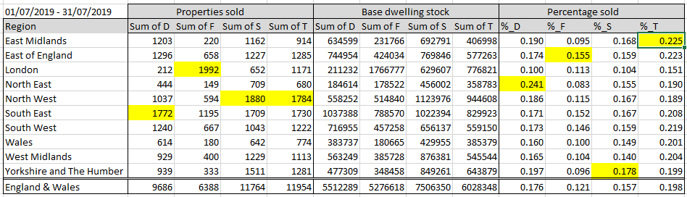

(produced on 29 October 2019)

**Output from Worksheet 4**

Spurious correlation



Data captured using the R API gtrendsR from the command plot

*(Please see next page)*

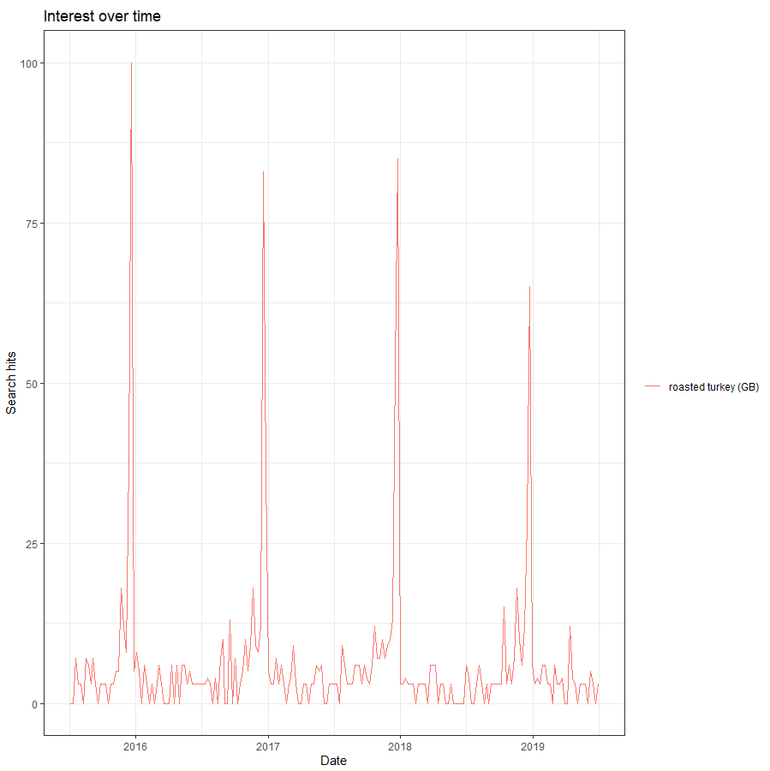

**Output from Worksheet 5**

Notes:

1. The time of R API twitterR is accurate only to date.
2. Very few tweets would have latitude and longitude embedded with them.
3. The Twitter Search API will only return tweets with date specified from the past week or so.

Tweets are collected on 13 November 2019 for tweets sent during the period 2019-11-06 to 2019-11-12 from the area 51.5075N, 0.0651W radius 10 miles:

Trump:

Number of tweets collected with search string 'realDonaldTrump OR "Donald Trump" OR DonaldTrump OR DonaldJTrump OR "Donald J Trump" OR "Donald John Trump" OR "President Trump" OR Trump+US OR Trump+"white house" OR Trump+"Washington" OR "Baby Trump"': 1599

Kim:

Number of tweets collected with the search string: '"Kim Jong-Un" OR KimJongUn OR "Kim Jong Un" OR "Kim JongUn" OR "Official_KJU" OR "Kim-Jong-Un" OR KJU+"North Korea" OR KJU+Pyongyang OR KJU+DPRK': 0

(after the radius was increased to 15mi: 52)

Brexit:

Number of tweets collected with search string 'Brexit': 2798