**PMEM-Monitoring Setup**

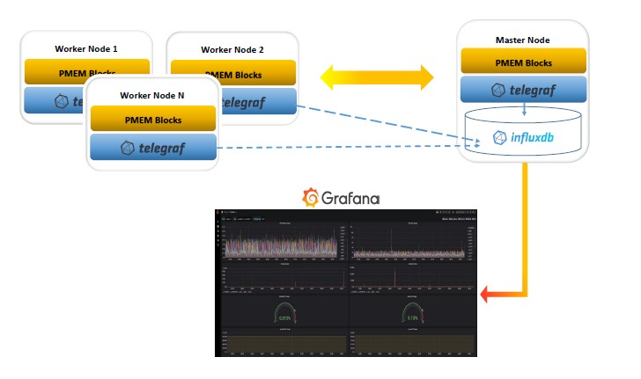

**InfluxDB Setup:**

**At Master Machine**

<https://docs.influxdata.com/influxdb/v1.8/introduction/install/>

wget -qO- https://repos.influxdata.com/influxdb.key | sudo apt-key add -

source /etc/lsb-release

echo "deb https://repos.influxdata.com/${DISTRIB_ID,,} ${DISTRIB_CODENAME} stable" | sudo tee /etc/apt/sources.list.d/influxdb.list

sudo apt-get update && sudo apt-get install influxdb

sudo service influxdb start

**create user:**

CREATE USER ‘<username>’ WITH PASSWORD ‘<password>’ WITH ALL PRIVILEGES

**Create databases:**

CREATE DATABASE “telegraf” (Data from host machines)

CREATE DATABASE “k8s_demo” (Data from kuberenetes cluster)

**Grafana Setup**:

**At Master Machine**

<https://grafana.com/docs/grafana/latest/installation/debian/>

sudo apt-get install -y apt-transport-https

sudo apt-get install -y software-properties-common wget

wget -q -O - https://packages.grafana.com/gpg.key | sudo apt-key add -

sudo add-apt-repository "deb https://packages.grafana.com/oss/deb stable main"

sudo apt-get update

sudo apt-get install grafana

sudo systemctl daemon-reload

sudo systemctl start grafana-server

sudo systemctl status grafana-server

Open browser, go to <grafana host machine ip>:3000 (3000 is default port of grafana service)

**Configure Datasource:**

URL: <IP of influxDB’s host machine>:8086

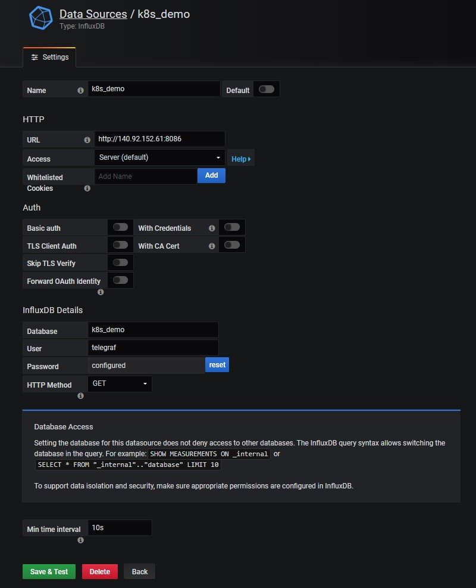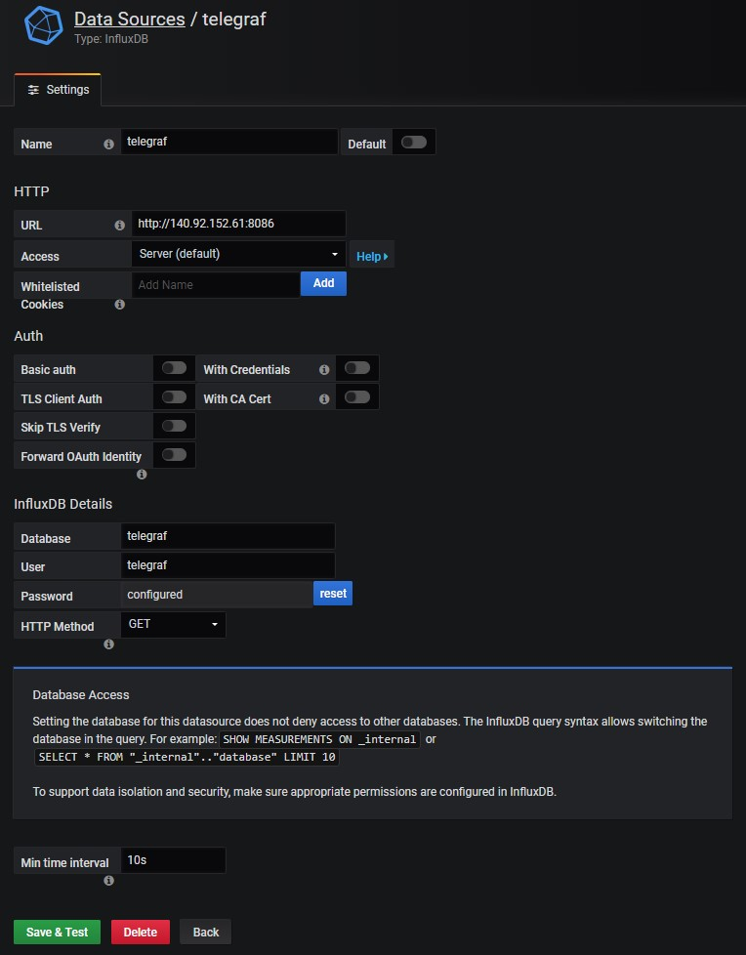

**Add Dashboards:**

Create New Dashboards, go to Dashboard settings/JSON Model. Overwrite the content with the JSON files under ./Grafana/ModelJSON.

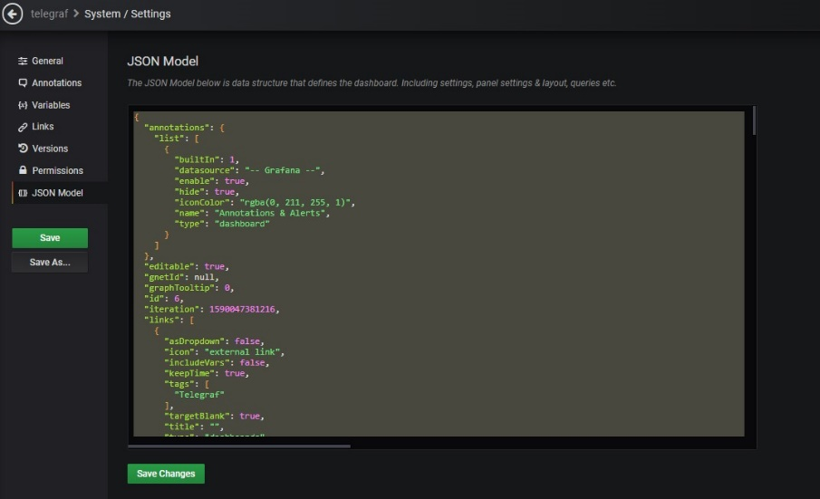

**Telegraf Setup**:

<https://docs.influxdata.com/telegraf/v1.13/introduction/installation/>

**Install:**

wget -qO- https://repos.influxdata.com/influxdb.key | sudo apt-key add –

source /etc/lsb-release

echo "deb https://repos.influxdata.com/${DISTRIB_ID,,} ${DISTRIB_CODENAME} stable" | sudo tee /etc/apt/sources.list.d/influxdb.list

sudo apt-get update && sudo apt-get install telegraf

sudo service telegraf start

Note: Telegraf will use the configuration file at default location(/etc/telegraf/telegraf.conf).

**Specify the config for telegraf:**

telegraf --config path/to/file.conf

**To generate a template config file:**

telegraf config > telegraf.conf

**Configure output location in the config file:**

....

[[outputs.influxdb]]

.....

urls = ["http://<influxDB's IP>:8086"]

database = "database"

....

## HTTP Basic Auth

username = "username"

password = "password"

...

**To use configured config file:**

Copy and paste the /telegraf/telegraf.config to /etc/telegraf.

**Note:**One of telegraf plugins needs permission to access docker socket, you can either:

**1. Run telegraf as root**

sudo telegraf ...

It's not recommended to run telegraf as root.<br>

**2. Add telegraf to docker group (Recommand)**

sudo usermod -aG docker telegraf

(Logout and Login)

Sudo service docker restart

**Collect non-supported metics:**

**Telegraf Setup in Kubernetes**: