Contents
User Guide 1
Technical User Guide 1
Executive Overview 1
Training Handout & Demo Script 1
Mocks Interface & Annotation Guide 1

User Guide
Table of Contents
- Introduction
- What This Application Does
- How the Application Is Organized
- Getting Started
- Using the Application
  - Statistics Dashboard
  - User Management
  - Post Management
- Typical Usage Scenarios
- Data & Safety
- Things Good to Know
- Summary

1. Introduction
This guide explains how to use the Flask Blog Platform in clear, simple terms.
It is designed for clients, product owners, managers, and non-technical stakeholders.
No programming knowledge is required to understand or use this application.

2. What This Application Does
The application is a simple blog management system with an administrative interface.
With it, you can:
- Create and manage users
- Create blog posts and assign them to users
- Publish or keep posts as drafts
- View overall platform statistics

3. How the Application Is Organized
The application has two main parts:
- A web-based admin interface
- A background system that safely stores information
You only interact with the web interface.

4. Getting Started
- Make sure the system is running
- Open the admin page in your browser
- Use the tabs at the top to navigate

5. Using the Application
📊 Statistics Dashboard
Shows:
- Number of users
- Number of posts
- Number of published posts
Used to quickly understand platform activity.

👥 User Management
Allows you to:
- Add new users
- View all users
- Remove users
Deleting a user also removes their posts.

📝 Post Management
Allows you to:
- Create posts
- Choose an author
- Publish or keep as draft
- Remove posts

6. Typical Usage Scenarios
- Create users → create posts → publish
- Draft content → review → publish
- Clean up old users and posts

7. Data & Safety
- Passwords are protected
- Data is saved automatically
- No login system in this version

8. Things Good to Know
- Users must exist before posts
- Statistics help verify actions
- Can be expanded later

9. Summary
A simple, easy-to-use platform for managing blog content.

Technical User Guide
Table of Contents
- Introduction
- System Overview
- Architecture
- Getting Started
- User Interface Overview
  - Statistics Tab
  - Users Tab
  - Posts Tab
- Backend API Overview
- CRUD Workflows
  - User Management
  - Post Management
- Error Handling & Validation
- Data Model Overview
- Security Considerations
- Good to Know / Best Practices
- Side-By-Side guide

1. Introduction
This document is a User Guide for the Flask Blog API Admin Interface.
It is intended for Clients, Product Owners, QA Analysts, and other stakeholders who want to understand how the software works functionally.
The application provides:
- A RESTful backend API (Flask + SQLAlchemy)
- A lightweight admin web interface (HTML + JavaScript)
- Full CRUD operations for Users and Blog Posts
- Global statistics dashboard

2. System Overview
The system is composed of two main parts:
- Backend: Flask REST API connected to a MySQL database
- Frontend: Single-page admin interface communicating via HTTP (JSON)
Typical use cases:
- Create and manage users
- Create, publish, and delete blog posts
- View global platform statistics

3. Architecture
Frontend (Browser)
- HTML + JavaScript
- Uses fetch() to call REST endpoints
- Runs independently from backend
Backend (Flask API)
- Flask + SQLAlchemy ORM
- MySQL database
- CORS enabled for frontend access
Database
- Users table
- Posts table (linked to users)

4. Getting Started
Prerequisites
- Python 3.9+
- MySQL database
- Browser (Chrome, Edge, Firefox)
Backend Startup
- Configure database connection (environment variable or default)
- Run:
python app.py
- Database tables are auto-created on startup
Frontend Startup
- Open index.html in a browser
- Backend must be running at http://localhost:5000

5. User Interface Overview
📊 Statistics Tab
Displays real-time platform metrics:
- Total Users
- Total Posts
- Published Posts
Actions
- Refresh statistics manually
Purpose
- High-level monitoring for stakeholders

👥 Users Tab
Allows full user management.
Features
- Create user (username, email, password)
- View all users
- Delete users
Notes
- Username and email must be unique
- Deleting a user also deletes their posts

📝 Posts Tab
Manages blog posts.
Features
- Create posts
- Assign author (User ID)
- Draft or Published status
- View post list
- Delete posts
Notes
- A user must exist before creating a post
- Only published posts count as public content

6. Backend API Overview
Health Check
GET /api/health
Users
- POST /api/users
- GET /api/users
- GET /api/users/{id}
- DELETE /api/users/{id}
Posts
- POST /api/posts
- GET /api/posts
- GET /api/posts/{id}
- PUT /api/posts/{id}
- DELETE /api/posts/{id}
Statistics
- GET /api/stats

7. CRUD Workflows
User – CRUD Example
Create
POST /api/users
{
"username": "john",
"email": "john@email.com",
"password": "secret"
}
Read
GET /api/users
Delete
DELETE /api/users/1

Post – CRUD Example
Create
POST /api/posts
{
"title": "My First Post",
"content": "Hello world",
"user_id": 1,
"published": true
}
Read
GET /api/posts
Update
PUT /api/posts/1
{
"published": false
}
Delete
DELETE /api/posts/1

8. Error Handling & Validation
- Missing fields → HTTP 400
- Duplicate username/email → HTTP 409
- Resource not found → HTTP 404
- Server error → HTTP 500
All errors return JSON responses.

9. Data Model Overview
User
- id
- username (unique)
- email (unique)
- password_hash
- created_at
Post
- id
- title
- content
- published
- created_at
- updated_at
- user_id (foreign key)

10. Security Considerations
- Passwords are hashed (Werkzeug)
- No authentication layer (admin-only prototype)
- CORS enabled (development mode)
- Not production-ready without auth & HTTPS

11. Good to Know / Best Practices
- Always create users before posts
- Use Statistics tab for smoke testing
- Ideal project for:
  - QA automation practice
  - API testing
  - CRUD validation scenarios
- Can be extended with:
  - Authentication (JWT)
  - Role-based access
  - Pagination & search

12. Side-by-Side Guide
Topic | Client View | QA / Analyst View
Goal | Manage blog content easily | Validate workflows & data
Users | Authors of content | Data entities with constraints
Posts | Articles to publish | CRUD objects
Statistics | Activity overview | Validation checkpoints
Errors | Messages on screen | HTTP status & validation
Security | Passwords protected | Hashing & no auth
Usage | Simple forms | Test scenarios
Extension | Future features | Automation ready

Executive Overview
Purpose
The Flask Blog Platform is a lightweight administrative system used to manage blog users and posts through a simple web interface.
It is designed for demonstrations, internal tools, quality assurance, and prototypes.

What the Platform Delivers
- Centralized management of blog users
- Creation and publication of blog posts
- Real-time activity statistics
- Simple, intuitive interface requiring no technical knowledge

Key Capabilities
- User Management: Add or remove content authors
- Content Management: Create, publish, or draft posts
- Visibility Control: Decide when content is published
- Monitoring: View usage statistics instantly

Intended Audience
- Clients & Executives
- Product Owners
- QA & Test Teams
- Demonstration & Training Purposes

Value for Stakeholders
- Fast onboarding
- Low learning curve
- Ideal for validation and demos
- Easily extensible for future needs

Status: Prototype / Internal Tool
Authentication: Not enabled (can be added later)

Training Handout & Demo Script
Objective
Demonstrate the full usage of the platform in under 15 minutes.

Demo Flow (Suggested)
Step 1 – Open the Platform
- Open the admin interface in the browser
- Point out the three main tabs:
  - Statistics
  - Users
  - Posts

Step 2 – Statistics Tab
- Show current numbers
- Explain this is a real-time overview
- Click "Refresh"
Talking Point:
“This gives a quick snapshot of platform activity.”

Step 3 – Create a User
- Go to Users
- Create a new user
Talking Point:
“Users represent authors of blog posts.”

Step 4 – Create a Post
- Go to Posts
- Select the user
- Create a draft post
- Create a published post
Talking Point:
“Posts can be reviewed as drafts before publishing.”

Step 5 – Review Results
- Return to Statistics
- Confirm numbers changed

Key Messages to Emphasize
- Very easy to use
- No technical skills required
- Ideal for demos and testing workflows

Mocks Interface & Annotation Guide

Mocks have been generated from the code.
Mock 1 – Home / Statistics
Annotations:
- Statistics cards show live data
- Refresh button reloads metrics

Mock 2 – User Management
Annotations:
- User creation form
- User list
- Delete action

Mock 3 – Post Management
Annotations:
- Post creation form
- Author selection
- Draft vs Published status
- Post list

Tip: Use numbered callouts when presenting to clients.

MOCK 1
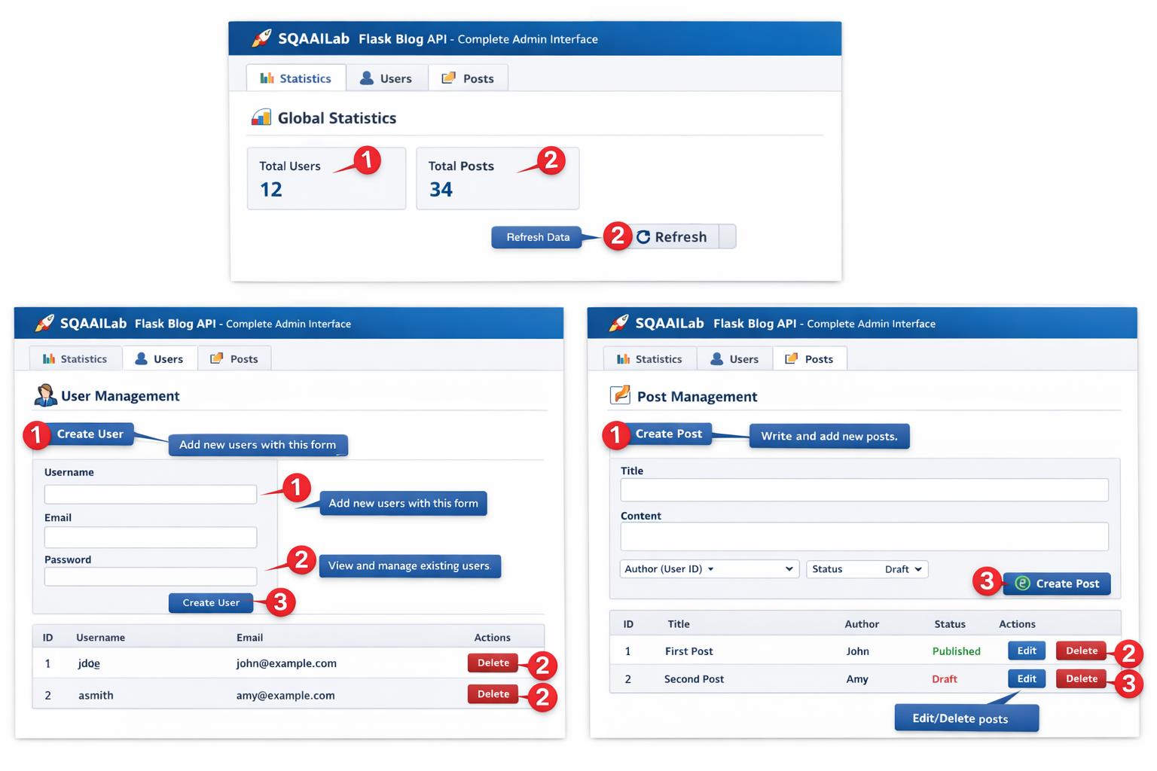
MOCK 2

