HANDS-ON SESSION 7:

SYNTHETIC CONTROL METHOD

Thursday June 29, 11:10am – 12:30pm

Objectives
- Implement the synthetic control method using the Synth package in R to estimate the causal effect of an intervention on a single aggregate unit.
- Understand the types of robustness checks available for the synthetic control method.

Introduction

In today’s lecture, we learned about the synthetic control method, which is used with time series data to estimate the effect of an intervention on a single aggregate unit by comparing the evolution of its outcomes over time to the evolution of a particular weighted average of control units’ outcome trajectories. At the end of this session, you will be able to use the Synth package in R to perform the synthetic control method.

Part I. Causal Inference Question

To gain experience with the synthetic control method, we will replicate an analysis by Giuliani (2022), who investigates the effect of opening schools on subsequent COVID-19 cases in provinces in Italy. The intervention unit is the province of Bolzano, which re-opened schools after the nationwide lockdown earlier than other provinces on September 7, 2020. Provinces that opened later will comprise the comparison units. These provinces re-opened schools on September 14, 2020 or later.

Evolution of COVID-19 in Bolzano, Before and After School Re-Openings
Clearly, after the week of the school re-openings, there is a spike in COVID-19 cases in Bolzano. But is this attributable to the school re-openings, or something else? This moves us to a causal question: what is the effect of early re-opening of schools versus later re-opening of schools on the evolution of new COVID-19 cases in Bolzano?

Dataset & key variables. A summary of key variables in the Italian provinces dataset which will be useful for today’s session is provided below.

1. Identifiers
ID variable | Variable Name | Variable Type | Coding
Province number | numprovince | Categorical | Unique number denoting the province
Province name | provincestring | Character | Province name

2. Time variables
Time variable | Variable Name | Variable Type | Coding
Date | dat | Character | YYYY-MM-DD``
Number week of the year | week | Continuous | Integer

3. Baseline covariates
Covariate | Variable Name | Variable Type | Coding
Total number of COVID-19 cases per 100,000 | totcases_100000 | Continuous | Count
Log total population | logpop | Continuous | Logarithm of count
Population density | density | Continuous | Count/km²
Population of students | popstud | Continuous | Count
Active COVID-19 cases per 100,000 | active_cases_  100000 | Continuous | Count/100,000
New COVID-19 tests per 1000 | new_tests_1000 | Continuous | Count/1,000
Test positivity rate | positivityrate | Continuous | Rate
COVID-19 reproduction number | rt | Continuous | Count

4. Outcome variables
Outcome | Variable Name | Variable Type | Coding
New COVID-19 cases per 100,000 | newnew | Continuous | Count/100,000

We are now ready to use data from the late-opening provinces to estimate the treatment effect in Bolzano using the synthetic control method.

Part II. Estimation and Inference for the Treatment Effect

Recall that the synthetic control method maximizes the similarity between the intervention unit and the weighted control units. Similarity is measured as a weighted covariate distance between the covariate means in the treated unit and the covariate means in the control units, with the weights denoting the relative importance of different covariates. Thus, the method requires two sets of weights: (i) weights for covariates, denoting their importance for fitting well to the intervention unit; and (ii) weights for units, denoting the magnitude of each control unit’s contribution to the treatment effect estimate.

We will use data splitting to find the first set of weights, the variable weights. We will split our pre-treatment time periods in half. For a given set of variable weights, we will find the unit weights that maximize the fit in the first half time period, and then evaluate how well the weighted control units fit the intervention unit in the second half time period. The set of variable weights that results in the best fit in the second half will be selected for our final analysis.

Data Analysis Exercise 1: Estimating Treatment Effects Using the Synthetic Control Method

Find the variable weights by using the time period from week 25 to week 36 of 2020 as the pre-treatment period.
- Use data splitting as described above to find the variable weights, using weeks 25 to 30 as the first half and weeks 31 to 36 as the second half. Maximize the fit of the following covariates: total cases/100000, log population, population density, student population, active cases/100000, new tests/100000, test positivity rate, reproduction number, average new cases weeks 25-26, average new cases weeks 27-28, and average new cases weeks 29-30.
- Inspect the variable weights. Which variables receive a large weight? Which receive small weights? Does this make sense? The lagged outcome averaged over the 3rd and 4th weeks prior to the exposure has the largest weight. Log-population, population density, positivity rate, and the lagged outcome averaged over the 1st and 2nd weeks prior receive moderate weights. Population of students, active cases per 100000, new tests per 1000, reproduction number, and the lagged outcome averaged over the 5th and 6th weeks prior have small weight.

Using these variable weights, run the synthetic control method using weeks 25 to 36 as the pre-treatment period.
- Using the variable weights that we just found, find the unit weights by maximizing the fit of the following covariates: total cases/100000, log population, population density, student population, active cases/100000, new tests/100000, test positivity rate, reproduction number, average new cases weeks 31-32, average new cases weeks 33-34, and average new cases weeks 35-36.
- Inspect the unit weights. Which units are weighted? Which units are not? Does this make sense? Cosenza, Regio di Calabria, L’Aquila, and Sassari receive nonzero weights. The other provinces receive zero weight. The units that receive nonzero weights show a relatively similar evolution to Bolzano before the exposure.
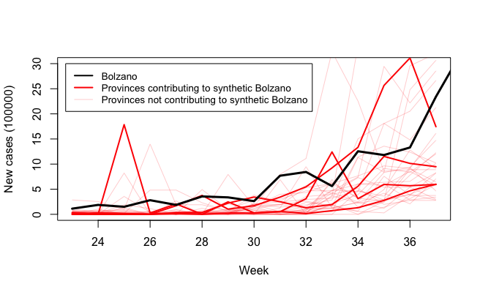
- Plot the evolution of outcomes for Bolzano and its synthetic control. What do you see?
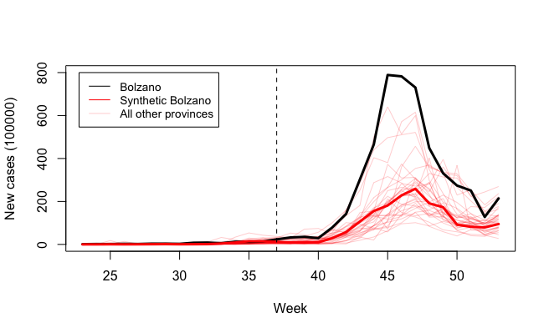
There appears to be a larger increase in cases for Bolzano, indicating a potential effect of re-opening early compared to re-opening later on COVID-19 cases.
- Calculate the root-mean-square prediction error (RMSPE) in the pre-intervention and post-intervention periods. Compare and provide a rough interpretation of these statistics. Do these statistics suggest a treatment effect? Recall calculation of RMSPE:
where is the time period (pre- or post-intervention), Y_{1t} is the intervention unit’s outcome at time t, and w_{j} is the j^{th} control unit’s weight. The pre-intervention RMSPE is 3.32, and post-intervention it is 267.2. This suggests that the evolution of outcomes in the post-intervention period is much more different from the evolution of the synthetic control’s outcomes in the post-intervention period than it is in the pre-intervention period, suggesting an effect of the intervention.

One way to compute a p-value for our effect estimate is to use permutation inference. A simple approach would re-assign the intervention to each of the control units and, for each re-assignment, calculate a new treatment effect on the fake intervention unit using the synthetic control method. We could then compare our observed treatment effect to these fake treatment effects and calculate a p-value.

A problem with this approach is that the synthetic control method may not obtain equally strong pre-treatment fits for all fake intervention units. To account for this, we’ll use the ratio of the post-intervention RMSPE over the pre-intervention RMSPE as our test statistic. That is, for each re-assignment, we’ll calculate the ratio of the post-intervention RMSPE to the pre-intervention RMSPE to obtain a permutation distribution. Then, we’ll compare the observed RMSPE ratio (calculated from Exercise 1) to the permutation distribution to compute a p-value.

Data Analysis Exercise 2: Permutation Inference for the Synthetic Control Method

For each control unit, repeat the analysis from Exercise 1 with that unit as the intervention unit and all other units as the controls. For each analysis, calculate a ratio of the post-intervention RMSPE to the pre-intervention RMSPE. Store these ratios in a vector. (NOTE: this may take a few minutes!)
- Plot the permutation distribution of the RMSPE ratio. What do you see? We see that most RMSPE ratios are less than the observed RMSPE.
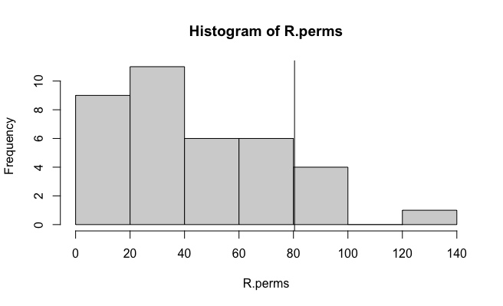
- Calculate a p-value based on this permutation distribution. What does the p-value tell us? The p-value is 0.14, which suggests, with a moderate amount of evidence, an effect of the intervention.

Part III. Running Robustness Checks

The validity of the synthetic control method rests on its ability to reproduce outcomes for the intervention unit in the absence of the intervention. Therefore, it is important to run diagnostic checks to evaluate the credibility of the synthetic control estimates and to use robustness checks to assess the sensitivity of results to changes in the design of the study.

One robustness check is backdating, where the synthetic control method is re-run albeit with the intervention backdated to a date prior to the actual intervention date. If the method can reproduce the trajectory of outcomes for the intervention unit in the period between the backdated date and the true intervention date, then this increases the credibility that the synthetic control method can produce good estimates of the intervention unit’s outcomes in the absence of intervention in the post-intervention period.

Data Analysis Exercise 3: Backdating the Intervention as a Robustness Check

Backdate the intervention to the halfway point of the pre-treatment period, and re-run the synthetic control analysis with this new date as the intervention date.
- How well does the method reproduce the trajectory of outcomes for Bolzano between this backdated date and the true intervention date? What does this tell you? The synthetic control still tracks Bolzano well during the fake post-period, which tells us that the synthetic control is probably tracking the control potential outcomes well in the post-period.
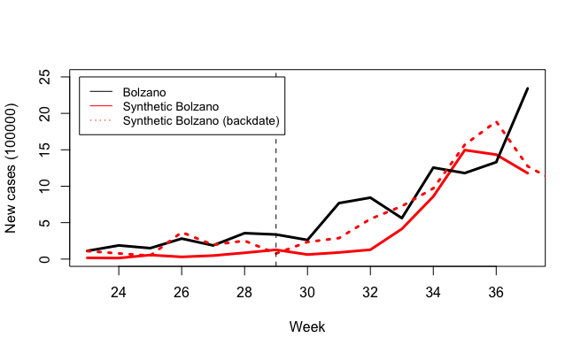
- Calculate a backdated RMSPE ratio: that is, calculate the RMSPE for the pre-backdated date period, and then calculate the RMSPE for the period between the backdated date and the actual intervention date. What does this ratio tell you? The pre- to post- RMSPE ratio is small (2.8), which implies that we have a strong fit in the post-backdated intervention period.

Another robustness check assesses the sensitivity of our estimates to the choice of which units make up the donor pool. We will perform a leave-one-out analysis to implement this robustness check: that is, we will re-run the synthetic control method leaving a different control unit out of the donor pool each time and then compare these results to those obtained by including all control units in the donor pool.

Data Analysis Exercise 4: Leave-One-Out as a Robustness Check

Re-run the synthetic control method several times, leaving a different control unit out of the donor pool each time. Compute the RMSPE ratio test statistic for each of these runs, and store them in a vector. (NOTE: this may take a few minutes!)
- Plot the leave-one-out distribution of the RMSPE ratio. What do you see? Our RMSPE ratio is right in the middle of the leave-one-out distributon, suggesting that our result is not too extreme compared to what we’d get with a slightly different set of donor units.
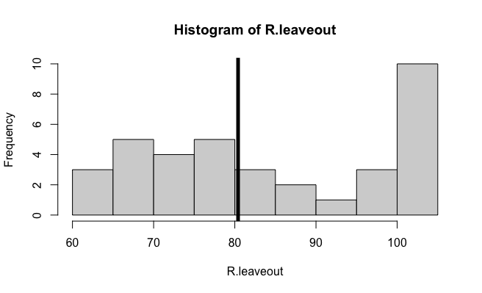
- Are our estimates are sensitive to the choice of what units are included in the donor pool? Why or why not?
It does not seem that way, as 50% of the leave-one-out RMSPE ratios are less than the observed RMSPE ratio and 50% are greater (so observed RMSPE ratio is right in the middle).

Appendix. Bonus Data Analysis Exercise

The augmented synthetic control method is an extension of the synthetic control method that uses a model for the outcome to estimate the bias due to imperfect pre-treatment fit and then debiases the original synthetic control estimate. It can thus produce less biased and more robust estimates than the synthetic control method alone. If you have time, the exercise below is an optional bonus exercise.

Bonus Data Analysis Exercise: The Augmented Synthetic Control Method

Estimate the effect of early school openings on COVID-19 incidence for Bolzano using the augmented synthetic control method using the augsynth package in R.
- How do the results from this analysis compare to those from the original synthetic control method?
The confidence interval produced by the augmented synthetic control method includes 0 for all time points post-intervention, suggesting a non-significant effect.
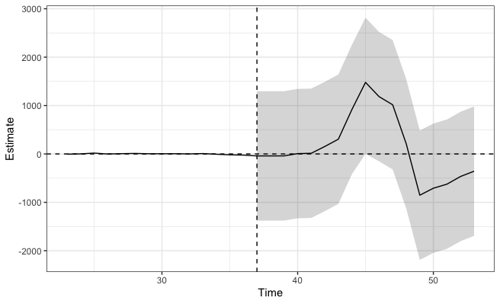

Giuliani, M. (2023). COVID-19 counterfactual evidence. Estimating the effects of school closures. Policy Studies, 44(1), 112–131. https://doi.org/10.1080/01442872.2022.2103527
Ben-Michael, E., Feller, A. & Rothstein, J. (2021). The Augmented Synthetic Control Method. Journal of the American Statistical Association, 116:536, 1789-1803, DOI: 10.1080/01621459.2021.1929245

