Website things to change

1. Prior to login
   1. Navigation don’t need the drop down. Remove all codes involved. ($10)
   2. Make Subscribe Now! Work – connect to MailChimp ($20)
   3. ‘Top Rate Courses’ ($470)
      1. If there are no houses, do not display “Classes available”, instead, Say “There is no class available for this course.”
      2. Classes related to this course under ‘Classes available courses’, activate the ‘Enrol’
         1. Enrol should link to Auth0 to sign user on if user has not signed on.
         2. Once signed in, user should be displayed a form to enroll. Field are:
            1. Enrol As (radio button: Student or Parent)

If Parent

Student Email

Number of places

If Student, no other fields

* + - * 1. Disabled fields:

Currency

Price (= price * number of places)

Description: house.house

* + - 1. Send User to Paypal for payment.
      2. Obtain such information from paypal and send to api:
         1. Transaction id
         2. Amount paid
         3. Currency_code
         4. House_id
         5. User_id
         6. Places_allocated
      3. Display the response from api:
         1. Message
         2. Mastercode
         3. Place allocated

1. After login ($300)
   1. Align spinner to the envelope
   2. Go to the top of the page every time a user logs in
   3. Make all ‘Enrolled Classes’, ‘Class Management’ and ‘Recommended Courses’ all have their own URL
   4. Enrolled Classes (student’s page)
      1. Each class should have its own URL
         1. When class is clicked, should show this, make it mobile responsive:
         2. 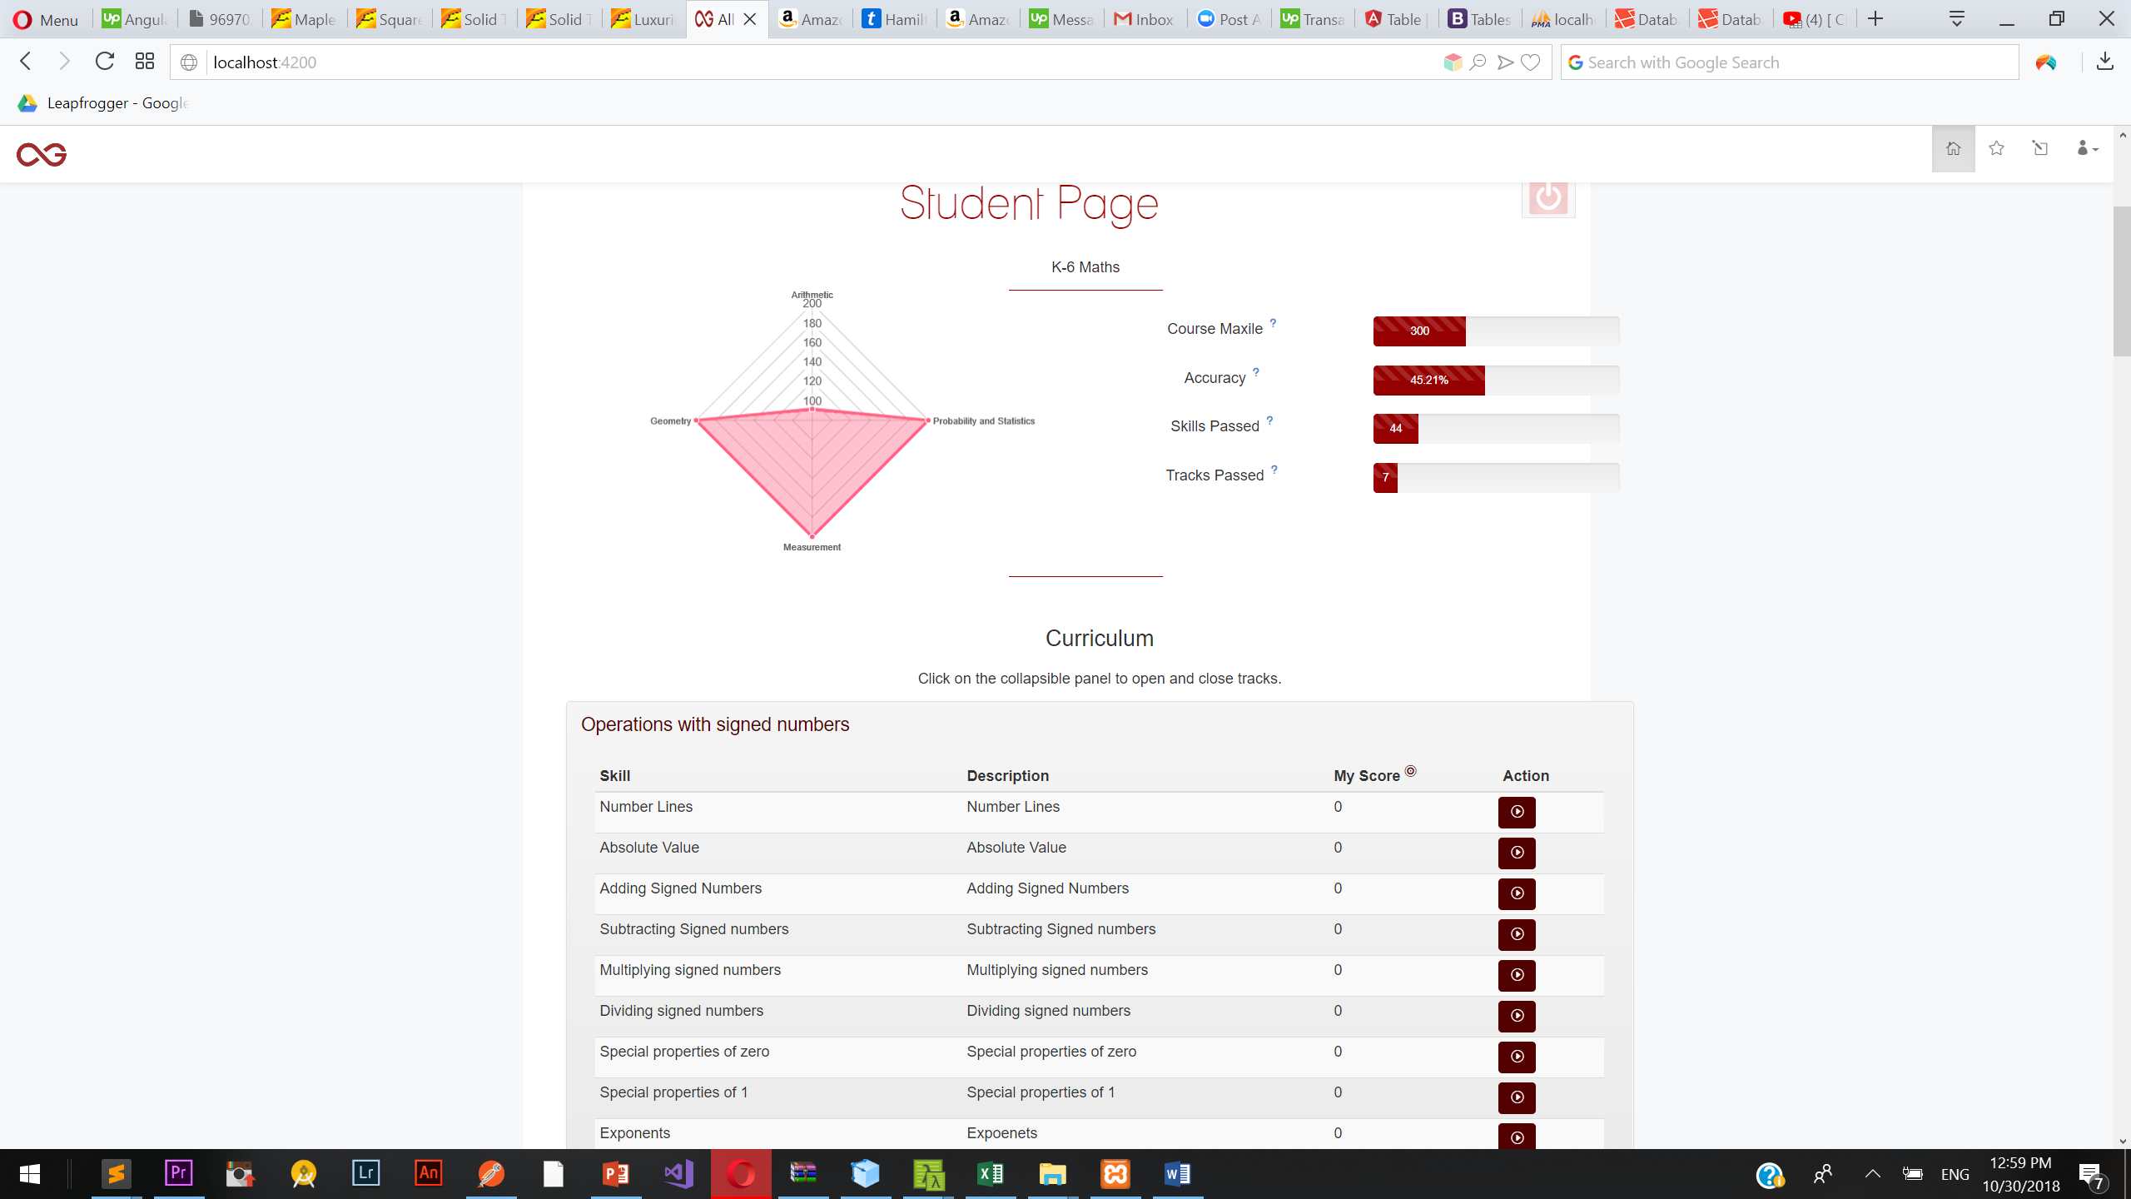
            1. If skill.skill_maxile.skill_maxile >= track.level_id *100, make the row light green. If < and noOfTries>0, make the row light yellow, otherwise, the row should be the default color.
            2. If back button is pressed, go back to the previous page, listing all the courses enrolled in.
   5. Class Management
      1. Should have 2 tabs, one says Student Management, the other Course Management
      2. Student Management
         1. In a new URL
         2. Shows what is in ‘Class Management’ now
         3. Make every column sortable
      3. Course Management
         1. In a new URL
         2. Shows what is in ‘Course Management now
         3. Make sure everything is mobile responsive
         4. Test that CRUD Track and CRUD Skills all work
   6. ‘Recommended Courses’
      1. Do the same as 1(c) ‘Top Rated Courses’
   7. Edit Profile
      1. Allow change of profile picture
         1. Allow the new image to appear during edit so that users can verify.
         2. Add a calendar to send birthdate up.
         3. After update, display message and close form.
2. Clean up all error messages. ($200)