彩色影像處理
作業3：簡化的CNN 數值辨識
M10915045 施信宏
完成了可以隨意指定0~9之間兩類別的比較，若要更改數值，請在下圖地方更改，路徑改成存放位置的地方。其餘程式碼部分已有註解，有疑問再請詳看。
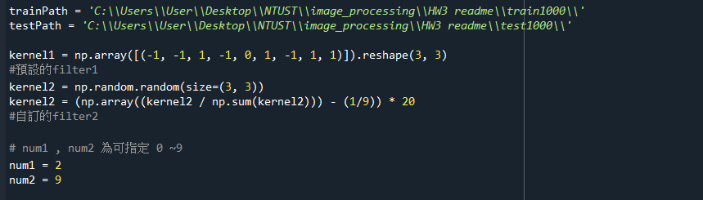
類別 : 2、9
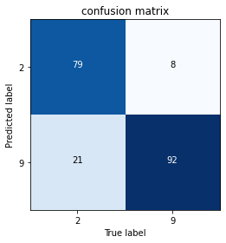
隨機15個影像分類結果

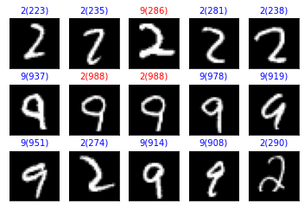

類別 3、7
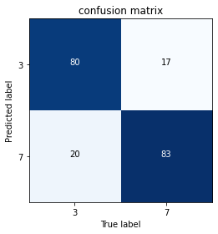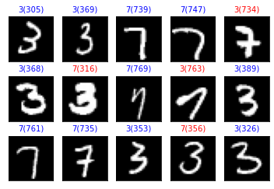

Code :
import numpy as np
import cv2
from sklearn.metrics import classification_report
import itertools
import matplotlib.pyplot as plt
from sklearn.metrics import confusion_matrix
import random

trainPath = 'C:\\Users\\User\\Desktop\\NTUST\\image_processing\\HW3 readme\\train1000\\'
testPath = 'C:\\Users\\User\\Desktop\\NTUST\\image_processing\\HW3 readme\\test1000\\'

kernel1 = np.array([(-1, -1, 1, -1, 0, 1, -1, 1, 1)]).reshape(3, 3)
#預設的filter1
kernel2 = np.random.random(size=(3, 3))
kernel2 = (np.array((kernel2 / np.sum(kernel2))) - (1/9)) * 20
#自訂的filter2

# num1 , num2 為可指定 0 ~9
num1 = 2
num2 = 9

#讀取檔案，只取train的部分即可完成作業需求
def load_image(num1 , num2):

train = []
test = []

num1 = num1 * 100
num2 = num2 * 100

for i in range(num1 , num1 + 100):
img = cv2.imread(trainPath + str(i + 1) + ".png", 0)
train.append(cv2.resize(img, (8, 8)))

for i in range(num2,num2 + 100):
img = cv2.imread(trainPath + str(i + 1) + ".png", 0)
train.append(cv2.resize(img, (8, 8)))

return train

#max pooling
def pooling(inputMap, poolSize=3, poolStride=2, mode='max'):
"""INPUTS:
inputMap - input array of the pooling layer
poolSize - X-size(equivalent to Y-size) of receptive field
poolStride - the stride size between successive pooling squares

OUTPUTS:
outputMap - output array of the pooling layer

Padding mode - 'edge'
"""
# inputMap sizes
in_row, in_col = np.shape(inputMap)

# outputMap sizes
out_row, out_col = int(np.floor(in_row / poolStride)), int(np.floor(in_col / poolStride))
row_remainder, col_remainder = np.mod(in_row, poolStride), np.mod(in_col, poolStride)
if row_remainder != 0:
out_row += 1
if col_remainder != 0:
out_col += 1
outputMap = np.zeros((out_row, out_col))

# padding
temp_map = np.lib.pad(inputMap, ((0, poolSize - row_remainder), (0, poolSize - col_remainder)), 'edge')

# max pooling
for r_idx in range(0, out_row):
for c_idx in range(0, out_col):
startX = c_idx * poolStride
startY = r_idx * poolStride
poolField = temp_map[startY:startY + poolSize, startX:startX + poolSize]
poolOut = np.max(poolField)
outputMap[r_idx, c_idx] = poolOut

# retrun outputMap
return outputMap
#第一層捲積及完成max-pooling
def conv_pool_layer1(img, kernel):
# Conv_and_Pooling
conv_img = cv2.filter2D(img, -1, kernel)
max_img = pooling(conv_img, 2)
return max_img
#第二層捲積及完成max-pooling
def conv_pool_layer2(img, kernel):
# Conv_and_Pooling
conv_img = cv2.filter2D(img[:, :, 0], -1, kernel) + cv2.filter2D(img[:, :, 1], -1, kernel)
max_img = pooling(conv_img, 2)
return max_img

def model_train(num1, num2,train,kernel1,kernel2):

Y = np.zeros(200)
Y[:100] += num1
Y[100:] += num2
X = []
# Y true label , X predict 的結果
#經過兩層conv,max_pooling後的結果加入X
for img in train:
img = np.array([conv_pool_layer1(img, kernel1), conv_pool_layer1(img, kernel2)]).transpose(1, 2, 0)
img = np.array([conv_pool_layer2(img, kernel1), conv_pool_layer2(img, kernel2)]).transpose(1, 2, 0)
img = list(img.reshape(-1))
#平坦化 2*2*2 -> 8
img.append(1)
# 常數項加1
X.append(np.array(img))
X = np.array(X)
try:
A = np.dot(np.linalg.inv(np.dot(X.T, X)), (np.dot(X.T, Y)))
except np.linalg.LinAlgError:
print("LinAlgError")
Yp = np.dot(X, A)
y_pred = np.where(np.abs(Yp - num1) > np.abs(Yp - num2), num2, num1)
#將算出來的結果進行分類
y_true = Y
cnf_matrix = confusion_matrix(y_true, y_pred)
acc = cnf_matrix[0][0] + cnf_matrix[1][1]
print(acc)
return y_true , y_pred
#畫confusion_matrix
def plot_confusion_matrix(cm, classes,
normalize=False,
title='Confusion matrix',
cmap=plt.cm.Blues):
"""
This function prints and plots the confusion matrix.
Normalization can be applied by setting `normalize=True`.
"""
if normalize:
cm = cm.astype('float') / cm.sum(axis=1)[:, np.newaxis]
print("Normalized confusion matrix")
else:
print('Confusion matrix, without normalization')

cm = cm.T
print(cm)

plt.imshow(cm, interpolation='nearest', cmap=cmap)
plt.title(title)
tick_marks = np.arange(len(classes))
plt.xticks(tick_marks, classes)
plt.yticks(tick_marks, classes)

fmt = '.2f' if normalize else 'd'
thresh = cm.max() / 2.
for i, j in itertools.product(range(cm.shape[0]), range(cm.shape[1])):
plt.text(j, i, format(cm[i, j], fmt),
horizontalalignment="center",
color="white" if cm[i, j] > thresh else "black")

plt.tight_layout()

#隨機找15張圖，看其預測結果
def plot_images_labels_prediction(labels, prediction, num1, num2):
# fig = plt.gcf()
# fig.set_size_inches(12, 14)
plt.figure()
for i in range(0, 15):
r = random.randint(0, 199)
png = num1 * 100 + r if r < 100 else (num2 - 1) * 100 + r
img = cv2.imread(testPath + str(png + 1) + ".png", 0)
ax = plt.subplot(3, 5, 1 + i)
ax.imshow(img, cmap='gray')
title = str(prediction[r]) + "(" + str(png) + ")"
if labels[r] == prediction[r]:
color = 'b'
else:
color = 'r'

ax.set_title(title, fontsize=10, color=color)
ax.set_xticks([])
ax.set_yticks([])

def generate_confusion_mat(y_true, y_pred):
target_names = [str(num1), str(num2)]
cnf_matrix = confusion_matrix(y_true, y_pred)
plot_confusion_matrix(cnf_matrix, classes=target_names, normalize=False,
title='confusion matrix')
plot_images_labels_prediction(y_true, y_pred, num1, num2)
plt.show()

if __name__ == '__main__':
train = load_image(num1 , num2)
y_true, y_pred = model_train(num1,num2,train,kernel1,kernel2)
generate_confusion_mat(y_true, y_pred)

