Thomas Zachariah
Eric Dea
CMSI 370.01
9/18/12

Guideline Survey

Generally both devices comply fairly well with the guidelines put forth by the makers of the phone’s respective operating systems. However, since Apple is more involved in the manufacturing of the phone on which iOS is present, the iPhone, it seems to more closely match its guidelines than the Android phones, which are more subject to alterations by the manufacturers and networks of the phone.

For both devices, the guidelines emphasize utilizing text services to add convenient features such as copy/paste and spell checking. They also both push opening up voice-to-text options. As can be seen in Figure 1 (a) & (b), both the iPhone and Android phone utilize texting interfaces that support the spell checking features. In addition, as indicated by the microphone button on each keyboard, both devices support the speech input options. Copy and pasting is also available in each of texting apps.

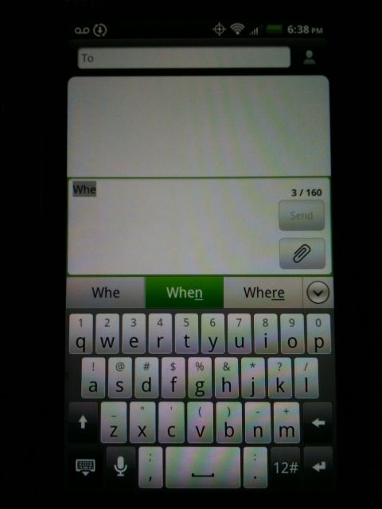
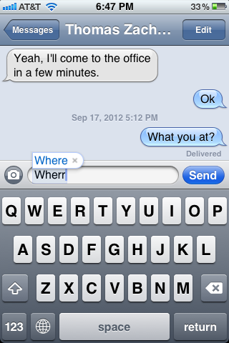
(a) (b)
Fig 1. Both phones demonstrating use of the text service guidelines in the texting app

One guideline that Google is more recently pushing is the elimination of menu buttons, especially hardware defined ones. There should just be buttons that provide direct access to the task, especially the more important ones. This is an idea that Apple has already incorporated fairly well into its UI Element Usage guidelines since its inception. As a result the iPhone has been really compliant with this guideline since the beginning, leaving menus for mostly only more advanced tasks. Also, there is no hardware menu button. The Android phones, again subject to the manufacturer’s choices, do not necessarily yet comply with this guideline. Figure 2 shows how the Android phone contains a hardware button that opens a menu, but it is a drastically reduced menu from older phone menus.

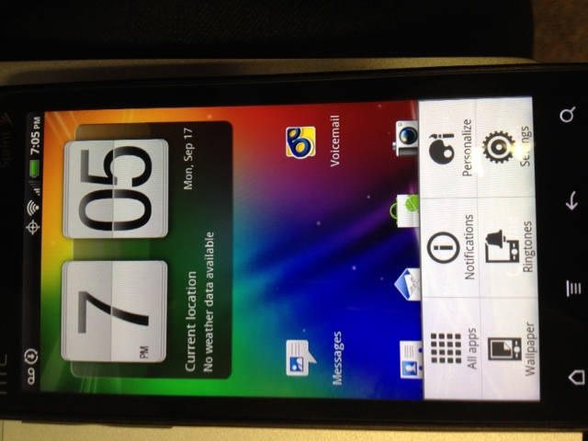

Fig 2. The Android phone opening up a menu when the hardware button (2nd to left) is pressed

In our usability-metrics, we came to the conclusion that the iPhone generally performed better than the Android phone. We did notice that much of the learnability and efficiency for each phone was highly dependent on some of the subtle design choices of the respective devices. When test subjects discussed their satisfaction with the tasks, they pointed out how much harder or nicer it was to perform the given task when they had to use one interface over the other, even though the devices had many similarities in the process of the task. In the end, the iPhone seemed to have a bit more of a streamlined design that more easily and quickly guided the users to accomplish the task. It seems that the iPhone’s more detailed compliance with the guidelines help to produce more natural human interfacing design choices that tend to make working with the device a more satisfying experience.

