Introduction to artificial Intelligence
Intelligence: Definition
- - Its ability to learn or understand or deal with new or trying situations.
- Skilled use of reason.
- It’s the ability to apply knowledge to manipulate one’s environment or to think abstractly as measured by object criteria (as test)

Views of intelligence
- Autonomous movement – Movement of object; Eg Robot intelligently E.g vaucansor (18th Century), Shaker – 1970, Sony Aibo (1998)

- Thinking – Ability to use brain.
  - Eg Deep Blue defeats Garry Kasparov- 1997
  - Eg In Playing games
- Playing Games
A computer may be said to be intelligent if it beats the user.

Types of Intelligence

- Linguistic-Verbal intelligence- Ability to communicate effectively, use of in different forms, sensitive means.
- Logical – Mathematical intelligence – Ability to carry out computations.
- Musical 1 – Playing piano, singing, recognize non verbal.
- Spatial – Ability to work with minimal information provided(scarce information)
- Intrapersonal 1 – Able to understand your self, read others moods, emotions.
- Interpersonal 1 – Ability to relate well with others.
- Bodily kinesthetic Intelligence- body flexibility – acrobatics.

NB:
- The above types are referred to as multiple Intelligence Theory by Howard Gardener.
- People have different strength in each intelligence area. This demonstrates different talents, as people are different in personality & mind.

Definition of Artificial intelligence
NB: No agreed definition of the term A.I. The common proposed definition includes
- Its study in which computer systems are made that they think like human being.
- Its study in which computer systems are made to act like people. Its art of creating computers that performs functions that require intelligence when performed by people.
- Its study of how to make computers do things which at moment people are better at.
- Its study in which computers that rationally think are made.
- Its study of computations that make it possible to perceive reason and act.
- Its study in which systems that can rationally act are made. It is considered to be strictly that seeks to explain and emulate intelligent behavior in terms of computational processes.
- Its branch of computer science that is concerned with automation of intelligent behaviour.

Objectives of A.I
  - Understands how living things behave, think & learn.
  - Engage in experiments by building artificial systems
  - Derive application for robotics and computers.

History of A.I
1943 - Boolean circuit model of brain.
1956 - A.I was coined in meeting – Dartimunth
1966 – Discovery of computational complexity
1969 – 79 – Early development of knowledge based systems
1980 – 88 – Expert system booms
1988 – 93 – Expert system booms
1985 – 95 – Neural networks returns popularity.
1988 – Resurgence of probabilistic & decision theoretic methods rapid increase in technical depth of A.I.

Examples of AI Experiments
Turing Test - Acting Human
- Discussed by Alan Turing in 1950.
- Tried to discuss conditions for considering a machine to be intelligent.
- He tried to understand if:
Can machine think i.e.: Can machine behave intelligently.
Approach used: Operational definition of intelligence
Method: :-He used human investigator to query a human being & A.I system, both placed behind a wall. If the investigator was unable to differentiate between the response of the human being and the A.I system then the machine is said to be intelligent.

- A computer to be referred as AI should poses:
  - Natural language processing – understand natural human languages
  - Knowledge representation – store what it knows and ears.
  - Automated reasoning Machine learning - adapt to new environments and detect change of environment.
Limitations of Turing Test
- The test is not reproducible, constructive, subject to mathematical analysis.
- What about physical interaction with interrogator and environment.
-Total |Turing Test :- Requires physical interaction and needs perception and actuation.

Application of AI
    - ALVINN- Car driving
Involves a car driving at speed of 70mph on public highway. It has camera which takes pictures, sends them to computer for processing then determine the next course of action i.e. if it is near pumps it slows.
-The image processing uses pixels(30 x 32 pixels as input)

2. Knowledge Based System
- Applied in medical diagnosis. A combination of symptoms are able to determine the actual disease.
- Uses combination of rules to determine the possible disease.
E.g In 1971- A program that could diagnose blood infections was developed.
It had combination of 450 rules.

3.Mineral prospecting
-A program that contains geological data.
-It recommends exploratory drilling sites that have substantial molybdenum deposits:

4. Data Mining
  - Application of machine learning Techniques
Solves problems that humans cannot solve, because of data involved is too large or noisy.
i.e. It creates secondary use of data collected – can be used to make decisions on the data. Eg detecting cancer risk molecules.

  - In marketing products
-Can be used in predicting customer behavior in s/marks
What common products they buy, & the combinations of them.
-This is by collecting information from transaction then subjecting it to analysis.

  - Fraud Detections
Eg credit card fraud detection. This is done by trying to understand pattern of usage of card and determine if there is consistency. If the use deviates from the standard norm or procedure then there is there is probability of fraud..

Robots
Includes
- Traditional Robots
- Exploring mars- eg Mars Robots (1996)
- Pipe inspector- Involves sending a robot through a pipe if it is blocked then it returns back.
- Wire repairs – Uses robots to repair electric or telecommunication wires by posts.

Languages
Language capacity.
It is believed that language capacity is equivalent to intelligence. That is they are related. Ability to speak good grammar is associated with intelligence, especially with children eg.
- Use of monkey to test grammar
“Me eat drink more”
“Banana eat me”
- Natural language processing
Trying to develop methods for computers to handle natural language. Language conversion. E.g language conversion.

- Computation linguistics
Why is it so hard computer to understand natural language.
Other Applications:
- Computer vision
- Image recognition

AI as Multidisciplinary Domain

- Engineering – Robotic, vision, expert system, biometric
- Comp. science AI – Language, knowledge representation, algorithms
- Pure sciences – Statistics approaches, neural networks, fuzzy logic
- Linguistic – NLP, computational logistics, phonetics & speech.
- Psychology – Cognitive models, knowledge extraction from experts
- Medicine – Human neural models, neuro – Science

History of AI – Events
Gestation period (1943-56)
- Warm Mclloth Proposed 1st mode of artificial neural network
- Suggested neural network could learn.
- Rule for updating connection strength between neuron so that bearing can occur.
- 1st neural network computer.

Enthusiasm & Expectation provided (1952-1969)
  - Generated by success of logic theorists and later General Problems Solving system
  - Imitated human reasons.
  - ANALOGY program that could solve geometric problems.

Challenges- a dose of reality (1966-1924)
- Advancesthat computer could think, learn,.
- Program did not contain knowledge by themselves -E.g “spirit is willing but flesh is weak”
- Fundamental structures that generate intelligence were limited.
- Also found that perception could learn under some situation.

Knowledge based system (1969-1979)
- Use of knowledge to solve problem in areas of expertise.
- Program that could take formulas eg. C₆H₁₃NO₂ & generate output soon.
- Program that could diagnose blood were developed – used 450 rules performed better.
- PROSPECTOR – Program with geological data.
- Applied in drilling site prone to have substantial deposits.

AI as Industry (1980 – 1988)
- Expert systems were developed.
- Computer used prolog to develop AI systems.

Return of N. Network (1956- Now)
-MYCIN type experts system grew as they need more rules.
-Back propagation learning developed
-Parallel Distributed Processing developed.

Recent events (1987-Now)
- Change in combat & methods of research
- Need to show relevance to real world application

Branches of A.I
  - Machine vision
  - Speech
  - Machine learning
  - Robotics
  - Natural language & understanding
  - Problem solving
  - Game playing

- Machine vision
Vision recognition of objects, camera & sensors are used.
Challenge – Mapping visual realities to representation and that allows easy pattern recognition.
If the discipline is mature can help :
- Computer recognize errors
- Vehicle find way out
- Robots move around the house.

- Speech Synthesis Recognition
Make computers recognize voice input and respond vocally
Challenge – Speech recognition & generation
Aim – Computer to talk, discuss, read articles, talk voice commands.

- Machine learning
Makes computer acquire knowledge, skills and be adaptive
Challenge – Include knowledge acquisition, knowledge representation, learning operators and how to help human beings learn.
Aims – Computer learns from experience, solve problems and be adaptive

- Robotics
Focus on movement and positioning of arms and other parts
Challenge – Arm positioning and locating other parts
Aims – Use robots for additional domestic and industrial applications. Currents used in sorting melody and assembling.

Natural language and understanding
Considers grammar and semantics of language. Understanding text or document translation.
Challenge – Getting uniform grammar and semantics representation and understanding
Aims – Computer to speak in natural languages.

Problem solving
Focused on specialized problem solving – Expert systems
Challenge – Formulating a problem, searches, solutions, representation of knowledge.
Aims – Computer to solve many problems and be used in industrial applications.

Application of AI
- Medicine
  - Use of expert system and neural networks. Applied on diagnostics Drug manufacture, Planning, Monitory and control of enquires
  - Use of rules to define systems and possible combination of cure..
  - Neural l network help understand on how mind work.

- Military
- Use of robots and knowledge based system.
- AI important in matter of nation security e.g commands control, strategic defense and verification.
- Computer could be used to decipher (decode/crack/interpret) codes for others monitor bombings.
- Used to construct thermo- nuclear bomb.
- Modeling of simulation of fission that triggered chain reaction.
- Possible to manage information on locomotion of warheads.
- Development of semi automated operator weapons – smart weapons

How far is AI Advanced
The areas that have advanced
- Humanoid robots
- Natural language interface
- Expert systems

Areas not much achieved

- Integrations
- Learning

Intelligent agent

Def: Intelligent Agent
It’s anything that can be viewed as perceiving its environment through Sensors and acting upon that environment through its effectors to maximize progress towards its goals.

- The definition consists of PAGE ( Percepts, Actions, Goals, Environment)
- Intelligent agent is task specific and specialized – Well defined goals and environment.
- Agent is made to be a tool for analyzing systems, not an absolute characterization that divides the world into agents and non agents.

NB: Agent interacts with its environment through sensors and effectors.

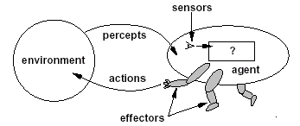

Intelligent Agents & A .I
- Human mind can be viewed as network of thousands or million of agents all working in parallel.
- To produce real AI, this school holds i.e. Build a computer system that can also contain many agents and systems for arbitrating among the agent competing results
Eg; Designing Distributed decision making & control system

effectors
sensors
Agency

Challenges
- Action selection – What next action to choose.
- Conflict resolution

Agent Areas of Research

It can be classified in two main areas.
- Distributed Artificial intelligence (DAI)- Multi-Agent –System(MAS)1980-1990
- Broader notion of “Agent”.
Interface, reactive, mobile, information –1990 – to present

Example : Windscreen agent

Designing agent to wipe windscreen when needed:
Goal – Keep windscreen clean & maintaining good visibility
Percepts – Raining, dirty, clear
Sensor – Camera (moist sensor)
Effectors – Wipers (Left, right, back)
Action – Off, slow, medium, fast
Environment – Nbi city, potholed road, highway, weather

Interacting agents
1.Collision Avoidance Agent (CAD)
Goal – Avoid running in to obstacles
Percepts – Obstacle distance, velocity, trajectory
Sensor – Vision, Proximity, sensing
Effectors – Steering Wheel, accelerator, brakes, Headlights
Action – Steer, Speed up, brakes, blow horn, signals headlights
Environment – Riveroad Nbi

2.Lane keeping Agent
Goal – Stay in current lane
Percepts – Lane center, lane boundaries
Sensor – Vision
Effectors – Steering Wheel, accelerator, brakes
Action – Steer, Speed up, brakes
Environment – Highway

Rational Action –Right thing
It’s the action that Maximizes the expected value of performance measure given the percept sequence to date is
Rationed =Best?
Rationed =Optimal?
Rationed =Omniscience?
Rationed =Successful?

Behavior and Performance of Intelligent Agents

- Perception (sequence) to action mapping i.e. f:P*->A
Ideal mapping – specifies which action an agent needs to take at any point in time.
Description – Look – up Table
- Performances measure – A subjective measure to characterize how successful an agent is ( eg. speed, power usage, accuracy , money)
- Degree of Autonomy – To what extend agent is able to make decision & action on its own

How agent is different from other software
- Autonomous – They act on behalf of the user
- Intelligence – agents contain some level of intelligence, from fixed rules to learning engines that allows them adapt changes in the environment.
- Reactive and proactive – Agents not only act reactive but also proactive –initiate action eg inhibiting behaviors.
- Social ability – Can communicate with the user, system & other agents required.
- Cooperate – They cooperate the other agents to carry out more complex tasks than they themselves can handle.
- Migrate – From one system to another to access remote resources or even meet other agents

Types of Environment
- Accessible Vs Inaccessible
Environment is accessible if sensors detect all aspects that are relevant to the choice of action

- Deterministic Vs non- deterministic
If the next state of the environment is completely determined by the current state and the actions selected by the agents, then we say the environment is deterministic

- Episodic Vs non – episodic
In an episodic environment, the agent’s experience is divided into “episodes.” Each episode consists of the agent perceiving and then acting.

- Static Vs Dynamic
Environment can change while the agent is deliberating ( Dynamic)- it is continually asking agent what it wants to do.
Static-Easy to deal with because agent need not keep looking at the world while deciding on action.
- Discrete Vs Continuous
If there are a limited number of distinct, clearly defined percepts and actions we say that the environment is discrete.
- Hostile Vs Friendly
Depends on agent perceptions

Why Agents are Important
- Information overload – Manager have a lot of work- need help
- Massive bank of information over years a lot of work accumulated –analysis.
- Internet need search engine
- Service support – Needed in network security and E-commerce
- Simplication of distributed computing – Act as intelligent resource
- Overcome user interface problems – Act as personnel assistants adapting to use.

.

Types of Agents
They are:-
- Reflex agents
- Reflex Agents with internal states
- Goal Based Agents
- Utility Based Agents
- Learning Agents
- Mobile agents
- Information agents

  - Reflex Agents
These kinds of Agents Select actions on basis of current percept, ignoring the rest of the percept history. Ignoring percepts history cuts the number of possibilities.
Eg: if driving a car and a car is in front brakes then you should notice and initiate brakes. This connection is known as condition action rule.

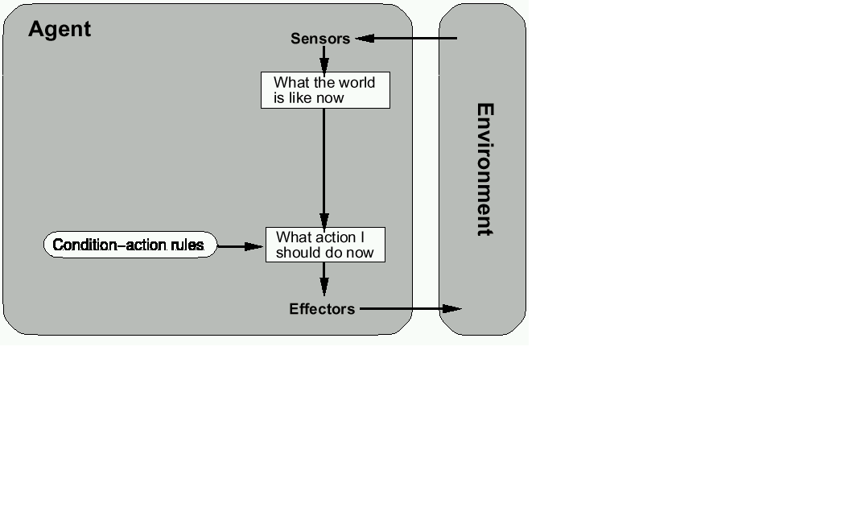

Schematic diagram of a simple reflex action

- The figure is general program in schematic form, showing how condition action rules allow the agent to make connection from percepts to actions.
- Rectangle denotes current internal state of agent decision process.
- Ovals represents background information used in the process.

- Simple reflex agents are simple by nature, but of limited intelligence. Eg the above agent will work only if correct decision can be made on the basis of the current percept. I.e. If only the environment is fully observable. Even a little unobservability can cause some trouble. Eg In car braking, it assumes that the car in front is mounted with brake lights, which are fitted with video image. If no brake light, the driver driving would brake unnecessary or fail to brake at all.
- It is also known as reactive Agent

Features
- Do not have internal symbolic models
- Act by stimulus – response to current state of environment
- Each reactive agent is simple and interacts with others in a basic way.
- Complex patterns of behavior emerge from their interaction.

Advantages
- Robustness
- Fast response time
Challenge
- Scalability- not very intelligent
- Not easy to debug such programs.

2.Reflex Agent with state / Model based reflex Agent
Involves keeping track of the part of the world that can’t be seen. I.e. Agent has to maintain some sort of internal state that depends on Percept history and thereby reflect at least some of unobserved aspects of the current state.
Eg In braking problem – Internal state is just the previous frame from the camera – allowing agent to detect when two red lights at edge of vehicle go on or off simultaneously.
- For changing lane the agent needs to keep track of where other cars are if can’t be seen.
- Updating the internal information require two kinds of knowledge:
  - How world evolve independent of Agents Eg Overtaking car generally will be closer behind than it was ago.
  - How agent own actions effects the world –Eg on turning steering wheel clockwise, car turns to right.
This knowledge about “how world works” is known as Model

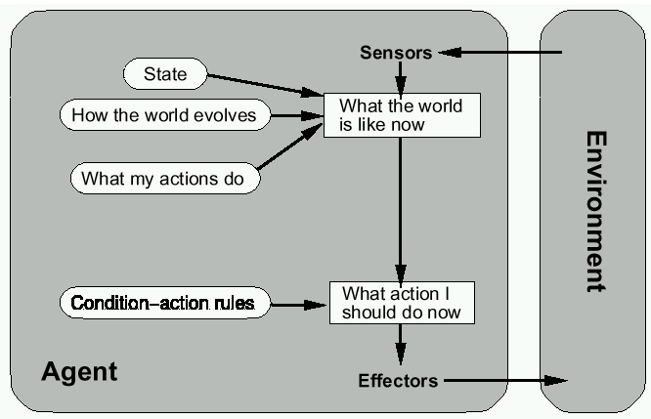

  - Goal Based Agents
- The agent requires some sort of goal information that describes the situation that is desirable Eg being at passenger destination
- Agent should know the objective desired to achieve.
- The agent program combines goal information with information about results of possible action (Same information used to update internal/state) in order to choose action that achieve goals.
- Sometimes goal based action is straight found when goal satisfaction results immediately from single action. Some times require sequence of twists and turns.

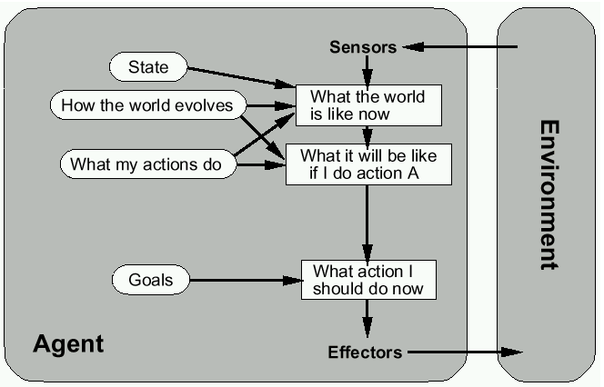

Notice that condition – Action – Rule is replaced with goals

- Utility Based Agents
It Aims to maximize the results i.e. aims to make the most rational decision, apart from just aiming at attaining the goal. Provides which option gives the best. Eg Measure of degree of happiness but not just being happy.
Utility based agent aims to generate high quality behavior in the environment.

A model based, utility based Agent – It uses a model of world, along the utility function that measures its preferences among states of the world. It chooses action that leads to the best expected utility, where expected utility is computed by averaging overall possible outcome states, right by the probability of the outcome.

5. Learning Agent
Involves exposing the agent into unknown environment, & becomes more competent than its initial knowledge alone might allow.
Learning agent is divided into conceptual/ components.
The major two are:-
- Learning Element – Responsible for making improvements
- Performance Element – responsible for selecting external actions. It takes percepts and decides the action
- The learning element uses feedback from critics on how the agent is doing to determine how the performance should be modified to do better in the future.
- The design of learning element depends much on design of the performance element.
- Critic tells the learning element how well he agent is doing with respect to fixed performance standards.
- Last component is Problem generator – is responsible for suggesting actions that will lead to new and informative experiences.
- If the performance element is left on its way, it keeps doing actions that are best, given what it knows.
- The problem generator’s job is to suggest exploratory actions – carry experiments.

Mobile Agents
- Those are programs that can migrate from one machine to another
- They execute in a platform – independent execution environment.
- They require agent execution environment(places)
- Mobility not necessary or sufficient condition for agent hood.

- Practical but non functional advantages.
  - Reduced communication cost.
  - Asynchronous computing
Two types
- One – Hope mobile Agent (migrate to another place)
- Mult-hope mobile agents( roam to network from place to place)

Applications
- Distributed information retrieval
- Telecommunication network routing.

Information agents
- Manage the explosive growth of information.
- Manipulate or collate information from many distributed sources.
- Information agents can be mobile or static.
- Examples:
  - BargainFinder comparison shops among Internet stores for CDs
  - FIDO the Shopping Doggie (out of service)
  - Internet Softbot infers which internet facilities (finger, ftp, gopher) to use and when from high-level search requests.
- Challenge: ontologies for annotating Web pages (e.g., SHOE).

