**Human computer interface**

There are three ‘use’ words that must all be true for a product to be successful; it must be:

Useful – accomplish what is required: play music, cook dinner, format a document;

Usable – do it easily and naturally, without danger of error, etc.;

Used – make people want to use it, be attractive, engaging, fun, etc.

THE HUMAN

OVERVIEW

Humans are limited in their capacity to process information. This has important implications for design. Information is received and responses given via a number of input and output channels: – visual channel – auditory channel – haptic channel – movement.

Information is stored in memory: – sensory memory – short-term (working) memory – long-term memory.

Information is processed and applied: – reasoning – problem solving – skill acquisition – error.

Emotion influences human capabilities. n Users share common capabilities but are individuals with differences, which should not be ignored.

**INTRODUCTION**

The human is the user, is, after all, the one whom computer systems are designed to assist. The requirements of the user should therefore be our first priority.

**COGNITIVE PSYCHOLOGY**

**Cognitive psychology** is the scientific investigation of human cognition, that is, all our mental abilities – perceiving, learning, remembering, thinking, reasoning, and understanding. Fundamentally, cognitive psychology studies how people acquire and apply knowledge or information.  In order to design something for someone, we need to understand their capabilities and limitations. We need to know if there are things that they will find difficult or, even, impossible. It will also help us to know what people find easy and how we can help them by encouraging these things. We will look at aspects of cognitive psychology which have a bearing on the use of computer systems: how humans perceive the world around them, how they store and process information and solve problems, and how they physically manipulate objects.

**MODEL HUMAN PROCESSOR**

A simplified view of the human processing involved in interacting with computer systems.

The model comprises three subsystems: **the perceptual system**, handling sensory stimulus from the outside world, **the motor system**, which controls actions, and the **cognitive system**, which provides the processing needed to connect the two.

Each of these subsystems has its own processor and memory, although obviously the complexity of these varies depending on the complexity of the tasks the subsystem has to perform. The model also includes a number of principles of operation which dictate the behavior of the systems under certain conditions.

*Input–output, memory and processing.*

We will use the analogy of the user as an information processing system, but in our model make the analogy closer to that of a conventional computer system. Information comes in, is stored and processed, and information is passed out. We will therefore discuss three components of this system: **input–output, memory and processing.**

**INPUT–OUTPUT CHANNELS**

There are five major senses: sight, hearing, touch, taste and smell.

Of these, the first three are the most important to HCI. Taste and smell do not currently play a significant role in HCI, and it is not clear whether they could be exploited at all in general computer systems, although they could have a role to play in more specialized systems (smells to give warning of malfunction, for example) or in augmented reality systems.

Similarly there are a number of effectors, including the limbs, fingers, eyes, head and vocal system. In the interaction with the computer, the fingers play the primary role, through typing or mouse control, with some use of voice, and eye, head and body position.

**1. Vision**

Human vision is a highly complex activity with a range of physical and perceptual limitations, yet it is the primary source of information for the average person.

**The human eye**

Vision begins with light. The eye is a mechanism for receiving light and transforming it into electrical energy. Light is reflected from objects in the world and their image is focused upside down on the back of the eye. The receptors in the eye transform it into electrical signals which are passed to the brain

**Visual perception**

This is concerned with how users perceive size and depth, brightness and color, each of which is crucial to the design of effective visual interfaces

1. Perceiving size and depth

The visual angle indicates how much of the field of view is taken by the object.

If two objects are at the same distance, the larger one will have the larger visual angle. Similarly, if two objects of the same size are placed at different distances from the eye, the furthest one will have the smaller visual angle.

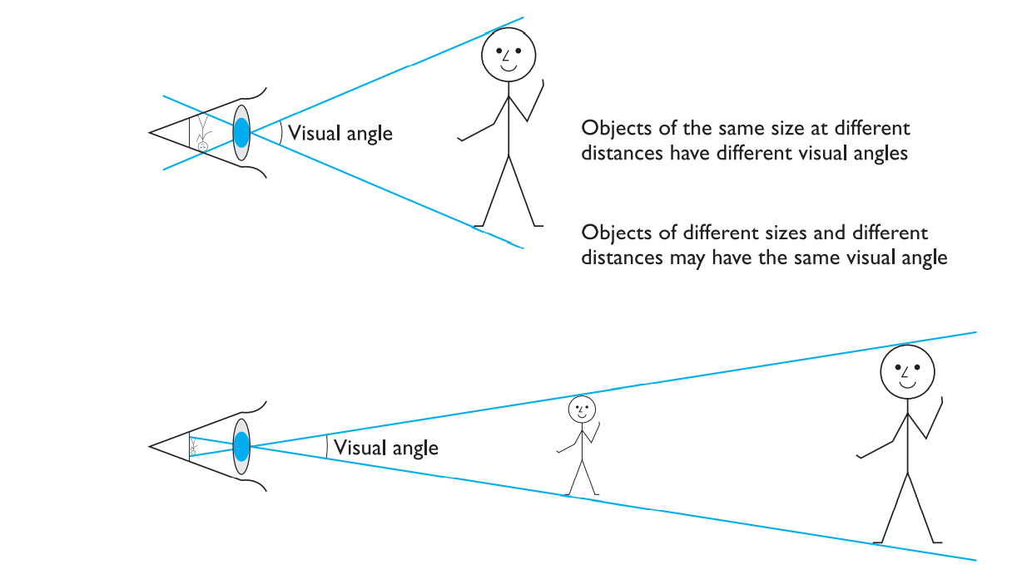

1. Perceiving brightness

A second aspect of visual perception is the perception of brightness. Brightness is in fact a subjective reaction to levels of light. It is affected by luminance which is the amount of light emitted by an object. The luminance of an object is dependent on the amount of light falling on the object’s surface and its reflective properties.

1. Perceiving color

A third factor that we need to consider is perception of color. Color is usually regarded as being made up of three components: hue, intensity and saturation. Hue is determined by the spectral wavelength of the light. Blues have short wavelengths, greens medium and reds long.

Intensity is the brightness of the color, and saturation is the amount of whiteness in the color.

By varying these two, we can perceive in the region of 7 million different colors. However, the number of colors that can be identified by an individual without training is far fewer (in the region of 10). The eye perceives color because the cones are sensitive to light of different wavelengths.

There are three different types of cone, each sensitive to a different color (blue, green and red).

Finally, we should remember that around 8% of males and 1% of females suffer from color blindness, most commonly being unable to discriminate between red and green

**Uses of vision in design**

Visual design is a vital part of your work as a designer. Visual design is used to create and organize elements to

A) Lead the user’s eye to an item’s functionality, and

B) Make the aesthetics consistent.

Note: With vision we get the user’s first impression of or gut reaction to a design. If they don’t like what you show them in those critical moments, they will leave.

**2. HEARING**

The sense of hearing is often considered secondary to sight. The auditory system can convey a lot of information about our environment through the human ear.

Fun Activity: Close your eyes for a moment and listen. What sounds can you hear? Where are they coming from? What is making them? As I sit at my desk I can hear cars passing on the road outside, machinery working on a site nearby, the drone of a plane overhead and bird song. But I can also tell where the sounds are coming from, and estimate how far away they are. So from the sounds I hear I can tell that a car is passing on a particular road near my house, and which direction it is traveling in. I know that building work is in progress in a particular location, and that a certain type of bird is perched in the **tree in my garden.**

1. **THE HUMAN EAR**

Hearing begins with vibrations in the air or sound waves. The ear receives these vibrations and transmits them, through various stages, to the auditory nerves.

**Processing sound**

Sound has a number of characteristics which we can differentiate.

**Pitch** is the frequency of the sound. A low frequency produces a low pitch, a high frequency, a high pitch.

**Timbre** relates to the type of the sound: sounds may have the same pitch and loudness but be made by different instruments and so vary in timbre.

Sound can convey a remarkable amount of information in interface design.

Mostly it is more confined to **warning sounds and notifications.**

The exception is multimedia, which may include music, voice commentary and sound effects e.g. in video games.

**Uses of sound in design:**

* Attention – to attract the user’s attention to a critical situation or to the end of a process, for example
* Status information – continuous background sounds can be used to convey status information. For example, monitoring the progress of a process (without the need for visual attention).
* Confirmation – a sound associated with an action to confirm that the action has been carried out. For example, associating a sound with deleting a file.
* Navigation – using changing sound to indicate where the user is in a system.

**Worked exercise:**  Suggest ideas for an interface which uses the properties of sound effectively.

Answer

*Note: You might approach this exercise by considering how sound could be added to an application with which you are familiar. Use your imagination*

Speech sounds can obviously be used to convey information. This is useful not only for the visually impaired but also for any application where the user’s attention is divided (for example, power plant control, flight control, etc.). Uses of non-speech sounds include the following:

* Attention – to attract the user’s attention to a critical situation or to the end of a process, for example
* Status information – continuous background sounds can be used to convey status information. For example, monitoring the progress of a process (without the need for visual attention).
* Confirmation – a sound associated with an action to confirm that the action has been carried out. For example, associating a sound with deleting a file.
* Navigation – using changing sound to indicate where the user is in a system.

**3. TOUCH**

The third and last of the senses that we will consider is touch or haptic perception. Although this sense is often viewed as less important than sight or hearing, imagine life without it. Touch provides us with vital information about our environment.

**It also provides us with feedback**. Consider the act of picking up a glass of water. If we could only see the glass and not feel when our hand made contact with it or feel its shape, the speed and accuracy of the action would be reduced. This is the experience of users of certain **virtual reality games**: they can see the computer-generated objects which they need to manipulate but they have no physical sensation of touching them. Watching such users can be an informative and amusing experience!

Touch is therefore an important means of feedback, and this is no less so in using computer systems. Feeling buttons depress is an important part of the task of pressing the button.

**Also, we should be aware that, although for the average person, haptic perception is a secondary source of information, for those whose other senses are impaired, it may be vitally important. For such users, interfaces such as braille may be the primary source of information in the interaction.**

**We should not therefore underestimate the importance of touch.**

MENTAL MODELS

Mental models play an important role in Human-Computer Interaction (HCI) and [interaction design](https://www.interaction-design.org/literature/topics/interaction-design). They relate to the way that a user perceives the world around them and are based in belief as opposed to being a factual concept. However, if you can understand your users' [mental models](https://www.interaction-design.org/literature/topics/mental-models), you can simulate these models within your designs to make them more usable and intuitive.

Mental models are an artefact of belief. They are the beliefs that a user holds about any given system or interaction. In most instances, the belief will – to a certain extent – resemble the real life model. This is important because users will plan and predict future actions within a system based on their mental models.

Designers can tap into users mental models so that their products communicate their function through their form. However, they can only do this successfully if they truly understand their users' mental models. It is an all too common failing of designs for designers to base their ideas on their own mental models; their models are often too complete and detailed to bear any relationship with a user’s model. This in turn leads to failure in UI where the user does not find their mental model and is left confused and frustrated.

PRACTICE QUESTION:

What are mental models, and why are they important in interface design?