# **CHAPTER THREE**

# **METHODOLOGY**

## **3.0 Overview**

A system for assisting in the management of industrial attachment in universities and colleges will be developed in this research. The new system will aim to. The chapter outlines the manner in which the study will be conducted. The key components are research design, population and sampling, data collection methods, development tools and material, system development methodology, system design and data processing and analysis.

## **3.1 Research design**

The research design is the conceptual structure within which research is conducted; it constitutes the blueprint for the collection, measurement and analysis of data. (Kothari, C. R. 2004).The study will be conducted using experimental design. It will be appropriate for developing the industrial attachment management system since data will be collected from both primary and secondary data sources available. The data will be collected through interview with students and lecturers and through questionnaires. Data will also be collected from secondary sources such as online articles.

## **3.2 Population and sampling**

## **3.3 Data collection methods**

### **3.3.1 Interviewing**

Alshenqeeti (2014) defines Interview as data collection technique because the researcher will be able to obtain the information needed to find facts, verify facts, clarify facts, generate enthusiasm, and identify ideas and opinions.

A set of interview questions was prepared in order to ask the interviewee to respond to a series of questions. The interview is divided into open and closed-ended questions to ensure that enough information is gathered.

### **3.3.2 Questionnaire**

Questionnaires will be used as a data collection technique where group of people were asked about their attitude towards a product, service, concept, and an idea in a questionnaire form.

### **3.4 Development Tools**

**3.4.1 Hardware tools required:**

* The computer should have at least 2.0.60 GHz and higher.
* Memory RAM of should be at least 4 GB, upgradable for future changes (Updates).
* Hard Disk Space - The capacity should be at least 500 MB, upgradable for future expansion.
* Keyboard, Mouse and Monitor**.**

**3.4.2 Software requirements.**

* Windows 10 operating system or Ubuntu 18.04LTS.
* Microsoft Office 2016 or higher versions for documentation.
* Sublime Text to be used as a platform for coding.
* Visual Studio code for coding assistance and Django for programming.

## **3.5 System Development Methodology**

The development methodology method to be used in this project is waterfall model since it provides a step-by-step flow of development. This is advantageous since for a certain phase in the project life cycle to begin one has to finish the previous phase first (Golodetz et al,.2014). The methodology is also simple to understand and also saves on time.

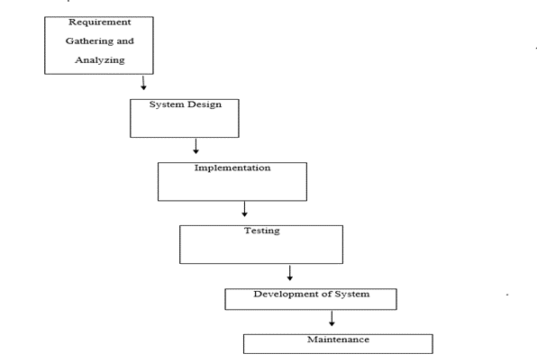

## **3.6 System design tools**

### **3.6.1 Flow charts**

Flow charts will be used to depict the data flow within the system. Because they are simple, flow charts are simple to draw and interpret. They can be used to simulate the flow of data as the user enters it.

### **3.6.2 Use case diagrams**

Display a visual representation of the user's interaction with the system, including specification and association relationships. The use of a case diagram can depict the various types of system users and the various ways in which they interact with the system. This type of diagram is frequently used in conjunction with a textual use case and is frequently accompanied by other types of diagrams.

### **3.6.3 Ethical consideration**

In my social research, confidentiality, integrity and avoiding deception were the key aspects in my research. The letter of authority was written and the purpose of the project was explained in order to carry out the research confidently and honestly**.**

## **3.8 References**

1. Golodetz, S. M., Nicholls, C., Voiculescu, I. D., & Cameron, S. A. (2014). Two tree-based methods for the waterfall. *Pattern recognition*, *47*(10), 3276-3292.
2. Alshenqeeti, H. (2014). Interviewing as a data collection method: A critical review. *English linguistics research*, *3*(1), 39-45.