Eric Dishmon

6/14/2021

**Business Case:**

As the owner of a restaurant, providing the best experience for my patrons is on the forefront of my mind when making decisions. Considering different factors from the ambience, to the food, to the overall price of a meal, customer satisfaction is very important. That is why I want to perform graph analytics on the Wine Reviews dataset to be able to provide my patrons the best wines in terms of highest ratings and lowest price. It will also be interesting to see where these wines are grown to be on the lookout for other wines from this area or to try to establish a relationship with the specific wineries. Increasing customer satisfaction will translate into more brand awareness, customer loyalty, and higher sales.

**Data Model:**

The data model for the Wine Reviews dataset keeps most attributes only two hops away from each other. The long chain of location based nodes can be rolled up into one node based on how granular the location needs to be. This will help keep the scope of the location flexible depending on future needs. I have also color coded the nodes of importance while leaving the other nodes monotone so that it is easier to identify key nodes when viewing the data.

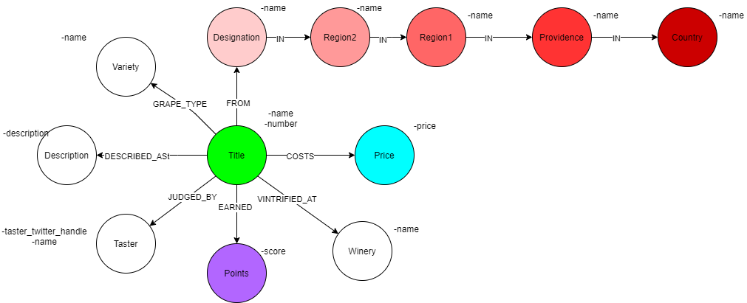

**Projections:**

For the projections, I have included three monopartite examples from the data model covering the three nodes of importance. I chose the Region 1 node to focus on because it allows for a more granular look at where the grapes are grown without being hyper specific to locality. The Points and Price nodes are also projected as monopartite with the Title node because it could be important to analyze the weights of how similarly priced and scored wines are to each other to determine the best valued wine. The Price node may need to be changed into larger buckets because of the large amount of variation in prices, but that will be determined once modeling begins.

