|  |  |  |  |  |
| --- | --- | --- | --- | --- |
| **Table 1. Baseline characteristics (weighted) of Study Population in the NHANES 2013-2014 by periodontal disease status.** | | | | |
| **Periodontal Disease** | | | | |
|  | **Stage 1** | **Stage 2** | **Stages 3-4** | **p-value** |
| **Variables** | **(n=358)** | **(n=1532)** | **(n=939)** |  |
| Age (years) | 45.2 ± 9.1 | 50.7 ± 13.4 | 56.2 ± 15.3 | <0.0001 |
| Male | 36.0% | 49.7% | 59.9% | <0.0001 |
| Non-Hispanic white | 81.0% | 70.9% | 58.9% | <0.0001 |
| Marital Status (not-currently) | 25.3% | 33.3% | 42.9% | 0.0001 |
| High School or less | 19.8% | 27.5% | 52.5% | <0.0001 |
| Annual household income | | | | <0.0001 |
| < $20,000 | 6.3% | 11.3% | 22.5% |  |
| $20,000-$34,999 | 8% | 14.3% | 21.8% |  |
| $35,000-$54,999 | 12% | 17.4% | 24.6% |  |
| $55,000 to $74,999 | 6.8% | 7.7% | 6.7% |  |
| ≥ $75,000 | 66.9% | 49.3% | 24.4% |  |
| BMI (kg/m2) | 28.6 ± 6 | 29.5 ± 6.7 | 30 ± 8 | 0.1154 |
| SBP (mmHg) | 117 ± 13.7 | 121.8 ± 15.8 | 127 ± 20.5 | <0.0001 |
| DBP (mmHg) | 71.3 ± 8.6 | 71.2 ± 11.3 | 71.4 ± 14.2 | 0.9625 |
| Coronary artery disease and stroke | 1% | 4.4% | 8.8% | <0.0001 |
| Current cigarette smoker | 10.4% | 14.2% | 27.5% | <0.0001 |
| Diabetes mellitus | 5.2% | 9.4% | 17.9% | 0.0003 |
| Hypertension | 19.8% | 29.7% | 38% | <0.0001 |
| Hyperlipidemia | 29.5% | 44.1% | 36.4% | 0.0213 |
| Total cholesterol (mg/dL) | 195.8 ± 36.9 | 195.5 ± 39.4 | 191.9 ± 43.3 | 0.3072 |
| LDL-cholesterol (mg/dL) | 114.8 ± 30.2 | 117 ± 34.6 | 115.3 ± 38.5 | 0.6482 |
| HDL-cholesterol (mg/dL) | 56 ± 14.7 | 52.8 ± 15.2 | 53.4 ±20 | 0.2270 |
| Triglycerides (mg/dL) | 128.1 ± 110.2 | 131.5 ± 97.1 | 117.3 ± 87.1 | 0.0721 |
| Chronic kidney disease | 1.4% | 1.9% | 3.5% | 0.1518 |
| Any alcohol use | 80.8% | 79.3% | 77.2% | 0.6079 |
| Continuous variables were presented as mean ± SD, all other as %. BMI = body mass index; DBP = diastolic blood pressure; HDL = high-density lipoprotein; LDL= low-density lipoprotein; SBP = systolic blood pressure; SD = standard deviation. | | | | |

|  |  |  |
| --- | --- | --- |
| **Table 2. Univariable analysis for the association between gum health and cardiovascular disease in the 2013-2014 NHANES Study Participants.** | | |
| **Variables** | **Odds Ratio** | **p-value** |
| Self-rated oral health |  | 0.0507 |
| Excellent |  |  |
| Very Good | (Reference) |  |
| Good | 0.96 (0.34 – 2.67) |  |
| Fair | 1.37 (0.74 – 2.55) |  |
| Poor | 2.16 (0.80 – 5.84) |  |
| Periodontal disease | 2.93 (1.17 – 7.35) | 0.0006 |
| Stage 1 |  |  |
| Stage 2 | (Reference) |  |
| Stage 3-4 | 4.63 (1.68 – 12.76) |  |
| Age ≥ 65 | 9.78 (3.35 – 28.57) | <0.0001 |
| Male | 7.06 (4.73 – 10.54) | 0.4793 |
| Non-Hispanic white | 1.32 (0.58 – 3.02) | 0.0001 |
| Marital Status (not-currently married) | 2.04 (1.51 – 2.76) | 0.7841 |
| High school graduate or less | 1.03 (0.81 – 1.32) | 0.0102 |
| Annual household income | 1.84 (1.18 – 2.87) | 0.0003 |
| < $20,000 |  |  |
| $20,000-$34,999 | 4.25 (2.38 – 7.61) |  |
| $35,000-$54,999 | 3.13 (1.73 – 5.66) |  |
| $55,000 to $74,999 | 4.08 (1.92 – 8.68) |  |
| ≥ $75,000 | 3.45 (1.44 – 8.24) |  |
| BMI (kg/m2) | (Reference) | 0.221 |
| Current cigarette smoker | 1.02 (0.99, 1.06) | 0.131 |
| Diabetes Mellitus | 1.67 (0.84, 3.30) | <0.0001 |
| Hypertension | 5.21 (3.43, 7.90) | <0.0001 |
| Hyperlipidemia | 4.74 (2.92, 7.69) | 0.0008 |
| Chronic kidney disease | 3.79 (1.93, 7.44) | <0.0001 |
| Any alcohol use | 8.46 (4.47, 16.01) | 0.5240 |
| BMI = body mass index; CI = confidence interval; OR = odds ratio. | | |

|  |  |  |
| --- | --- | --- |
| **Table 3. Multivariable analysis for the association between periodontal disease and cardiovascular disease in the 2013-2014 NHANES Study Participants.** | | |
| **Variables** | **Adjusted OR [95% CI]** | **p-value** |
| Periodontal disease |  | 0.1017 |
| Stage 1 | (Reference) |  |
| Stage 2 | 2.61 (0.97 – 7.01) | 0.0558 |
| Stage 3-4 | 3.69 (1.16 – 11.72) | 0.0295 |
| Age ≥ 65 | 4.55 (2.91 – 7.10) | <0.0001 |
| Male | 1.28 (0.48 – 3.37) | 0.5968 |
| Non-Hispanic white | 2.16 (1.46 – 3.20) | 0.0008 |
| Marital Status (not-currently married) | 0.69 (0.48 – 1.00) | 0.0515 |
| High school graduate or less | 1.23 (0.73 – 2.09) | 0.4054 |
| Annual household income |  | 0.1455 |
| < $20,000 | 2.74 (1.29 – 5.80) | 0.0119 |
| $20,000-$34,999 | 2.02 (1.09 – 3.73) | 0.0279 |
| $35,000-$54,999 | 2.30 (1.00 – 5.27) | 0.0495 |
| $55,000 to $74,999 | 2.29 (0.91 – 5.75) | 0.0756 |
| ≥ $75,000 | (Reference) |  |
| BMI (kg/m2) | 1.01 (0.96 – 1.06) | 0.7531 |
| Current cigarette smoker | 2.69 (1.40 – 5.14) | 0.0054 |
| Diabetes mellitus | 2.73 (1.55 – 4.82) | 0.0018 |
| Hypertension | 1.99 (1.01 – 3.91) | 0.0476 |
| dyslipidemia | 2.20 (0.96 – 5.04) | 0.0616 |
| Chronic kidney disease | 3.28 (1.34 – 8.02) | 0.0125 |
| Any alcohol use | 1.04 (0.61 – 1.78) | 0.8821 |
| BMI = body mass index; CI = confidence interval; OR = odds ratio. | | |

|  |  |  |
| --- | --- | --- |
| **Table 4. Multivariable analysis for the association between self-rated overall gum health and cardiovascular disease in the 2013-2014 NHANES Study Participants.** | | |
| **Variables** | **Adjusted OR [95% CI]** | **p-value** |
| Self-rated oral health |  | 0.1416 |
| Excellent | (Reference) |  |
| Very Good | 1.05 (0.35 – 3.13) | 0.9303 |
| Good | 1.07 (0.48 – 2.40) | 0.8581 |
| Fair | 2.14 (0.66 – 6.99) | 0.1900 |
| Poor | 2.38 (0.76 – 7.44) | 0.1265 |
| Age ≥ 65 | 5.28 (3.22 – 8.66) | <0.0001 |
| Male | 1.41 (0.54 – 3.72) | 0.4571 |
| Non-Hispanic white | 2.28 (1.56 – 3.33) | 0.0003 |
| Marital Status (not-currently married) | 0.71 (0.51 – 0.99) | 0.0438 |
| High school graduate or less | 1.22 (0.69 – 2.17) | 0.4700 |
| Annual household income |  | 0.3101 |
| < $20,000 | 2.48 (1.07 – 5.77) | 0.0363 |
| $20,000-$34,999 | 1.94 (1.01 – 3.72) | 0.0472 |
| $35,000-$54,999 | 2.18 (0.91 – 5.18) | 0.0751 |
| $55,000 to $74,999 | 2.11 (0.81 – 5.50) | 0.1191 |
| ≥ $75,000 | (Reference) |  |
| BMI (kg/m2) | 1.01 (0.96 – 1.06) | 0.8295 |
| Current cigarette smoker | 2.61 (1.38 – 4.95) | 0.0060 |
| Diabetes mellitus | 2.73 (1.54 – 4.86) | 0.0021 |
| Hypertension | 2.10 (1.11 – 3.95) | 0.0251 |
| Dyslipidemia | 2.28 (1.00 – 5.19) | 0.0493 |
| Chronic kidney disease | 3.08 (1.29 – 7.38) | 0.0149 |
| Any alcohol use | 1.04 (0.59 – 1.83) | 0.8898 |
| BMI = body mass index; CI = confidence interval; OR = odds ratio. | | |

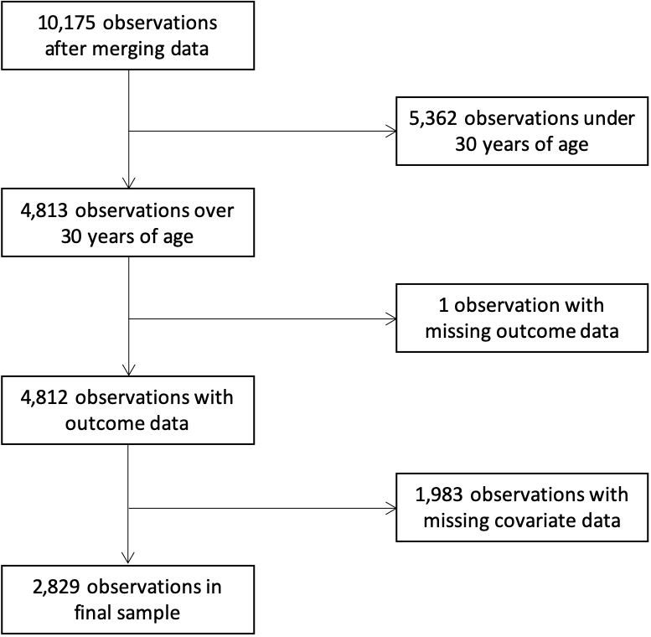

**Figure 1. Flowchart showing selection of study subjects**