SOFTWARE DESIGN DOCUMENT

MascotRender
  - Procedural C++ Mascot and Sticker Rendering Engine
Project: Wahalao Smart Chat Stickers
Document status: Draft for technical and product review
Version: 0.1
Date: 13 July 2026
Prepared for: Product, C++ Platform, Web, Design, QA, and Content Operations
Core design decision
Local-first procedural generation
MascotRender will generate original, consistent sticker assets from structured specifications, reusable vector mascot parts, expression presets, poses, effects, and deterministic variation. It will not depend on OpenAI, Gemini, or any paid image-generation service. Runtime chat suggestions will select prebuilt assets locally; they will not generate artwork per keystroke.
Confidentiality: Internal product and engineering design draft.

Document Control
Field | Value
Document title | MascotRender Software Design Document
Product area | Wahalao Chat / Smart Sticker Suggestions
Version | 0.1
Status | Draft for review
Owner | Product Management
Technical owner | TBD — C++ Graphics/Platform Lead
Reviewers | Web Lead, Technical Artist, QA Lead, Security/Privacy, Content Operations
Target release | MVP after design validation and implementation planning

Revision History
Version | Date | Author/Owner | Summary
0.1 | 13 Jul 2026 | Product Management | Initial SDD based on the target typing-to-sticker experience and the no-paid-inference architecture decision.

Contents
- 1. Executive Summary
- 2. Product Context and Reference Experience
- 3. Goals, Non-Goals, and Scope
- 4. Stakeholders and User Personas
- 5. Requirements
- 6. System Architecture
- 7. Component Design
- 8. Data Design
- 9. Algorithms and Runtime Behavior
- 10. Interfaces
- 11. Quality Attributes and Performance Targets
- 12. Test Strategy
- 13. Deployment and Operations
- 14. Security, Privacy, and Intellectual Property
- 15. Project Delivery Plan
- 16. Risks and Mitigations
- 17. Acceptance Criteria
- 18. Roadmap
- 19. Open Decisions
- Appendices

1. Executive Summary
MascotRender is a local-first, deterministic C++20 engine that converts structured sticker definitions into a coherent library of original mascot-based chat assets. Its purpose is to let Wahalao create hundreds or thousands of stickers without paying a per-image inference fee and without accepting the spelling, style, licensing, or availability risks of a remote generative-image service.
The engine is deliberately procedural rather than open-ended. A technical artist defines one or more mascot packs containing vector body parts, anchors, expressions, poses, accessories, palettes, text frames, and effects. Content authors then describe each sticker in CSV or JSON. MascotRender compiles those inputs into exact, reproducible WebP/SVG assets, thumbnails, a catalogue, a trigger dictionary, and a quality report.
At runtime, the React chat composer does not render new artwork. It performs phrase-aware lookup against a locally cached dictionary and shows a tray of prebuilt sticker IDs. The Drogon edge service only distributes versioned manifests and assets. No network request is made on each keystroke.
Recommended MVP boundary
Build-time generation is in scope. Runtime selection and message attachment are in scope. Open-ended prompt-to-image generation, photorealistic scenes, user face cloning, and full 3D character animation are not in scope for the MVP.

1.1 Success Definition
- A content operator can generate a versioned pack of at least 1,000 static stickers from structured input on a normal developer workstation.
- The same sticker ID and pack version produce byte-identical or visually deterministic output across supported build environments.
- Displayed wording is rendered by the text engine exactly as authored; no model can misspell it.
- The React client resolves suggestions locally with no per-keystroke network dependency.
- The asset library uses an original Wahalao visual system and avoids third-party characters, celebrity likenesses, or copied sticker artwork.

2. Product Context and Reference Experience
The supplied reference screens demonstrate a chat composer that changes sticker suggestions while the user types. The target behavior is not merely a static emoji picker. It is a contextual, low-friction suggestion surface that responds to the active word or phrase immediately above the keyboard.
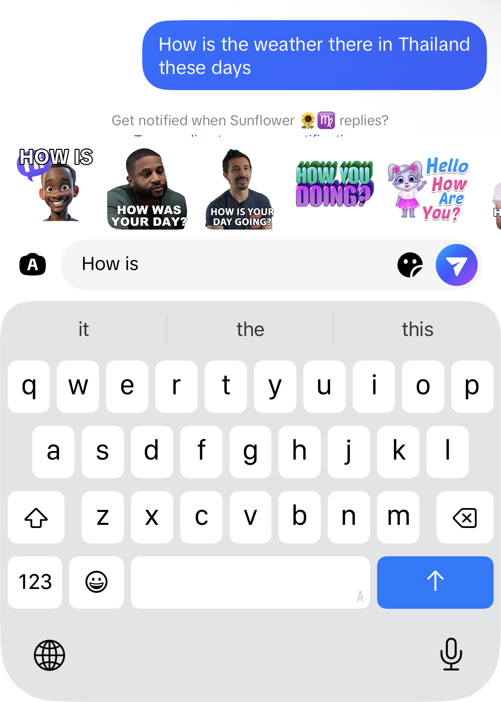 | 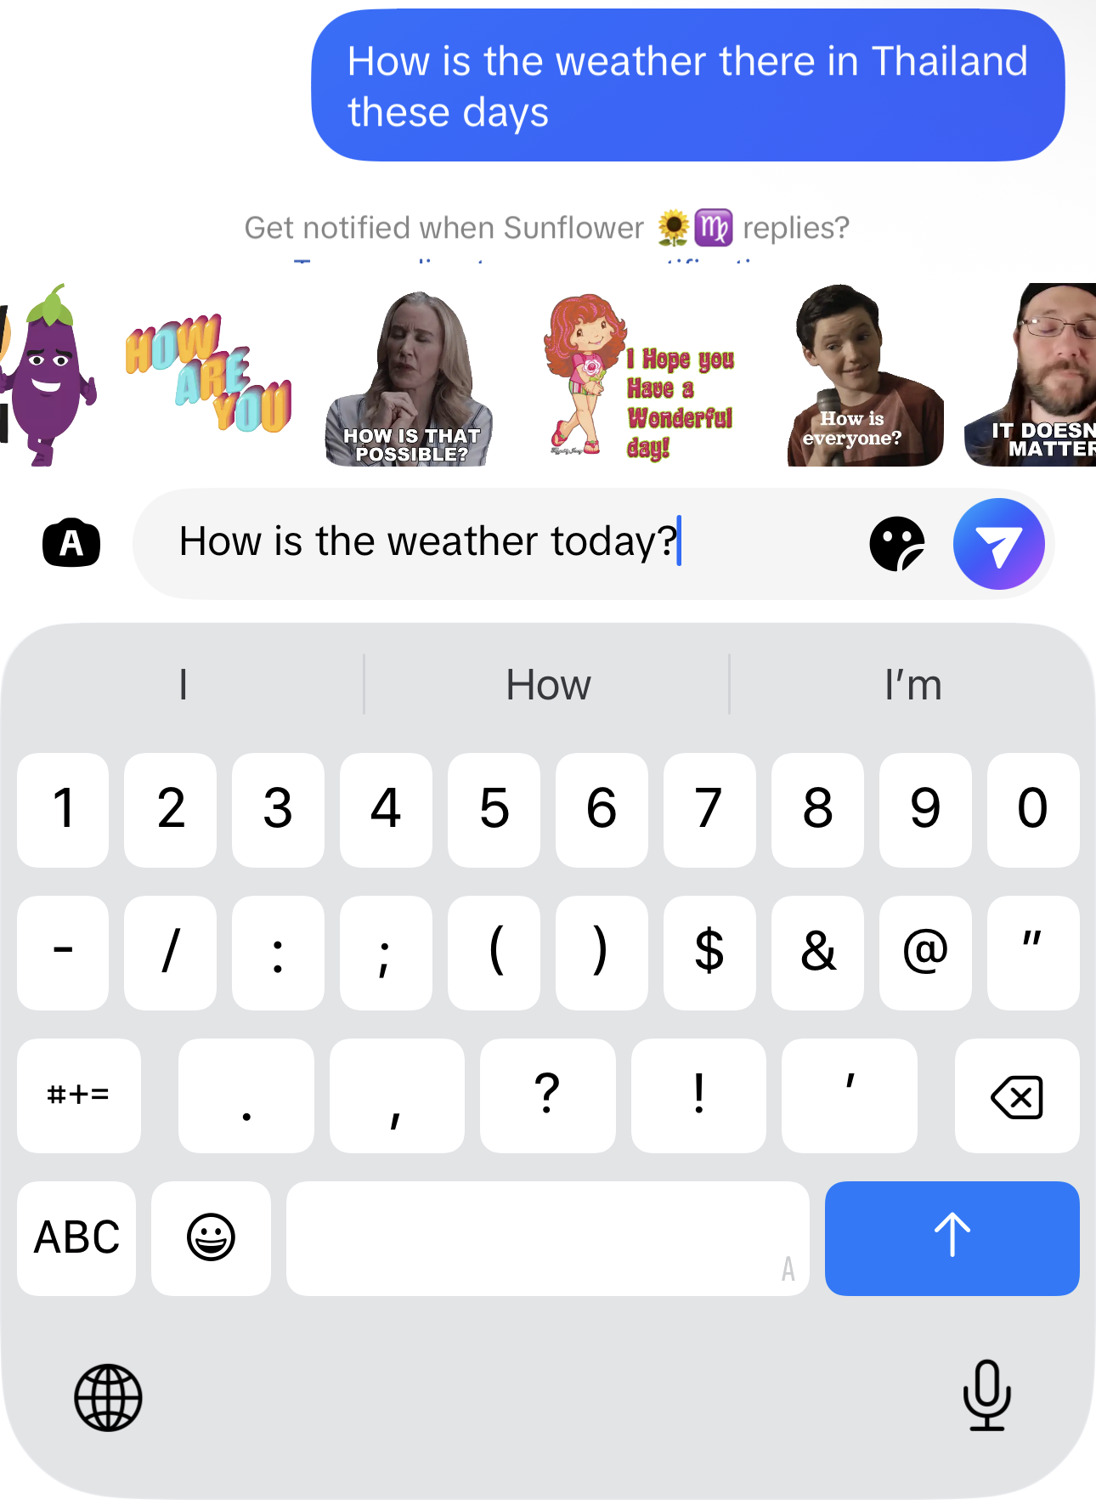
Reference A — Suggestions after the partial phrase “How is”. | Reference B — Suggestions re-ranked after the longer weather question.

2.1 UX Observations
- The tray is anchored immediately above the composer, so suggestions remain in the user’s visual focus.
- Suggestions change as the active phrase becomes more specific. A matcher must therefore understand trailing phrases, not only the last token.
- The tray can contain different visual classes: mascot art, text-only typography, illustrated characters, and reaction cut-outs. MascotRender will initially standardize on original Wahalao mascot and typography templates.
- The user can tap a suggestion without leaving the conversation. Selection should remove or preserve the trigger text according to a product rule and attach the selected sticker ID to the outgoing message.
- Any design that sends a network request for every keystroke would be too fragile and is explicitly rejected.

2.2 Product Interpretation
MascotRender is the content-production engine behind this experience. The Smart Sticker Suggestion feature is the runtime consumer. Keeping these as separate subsystems lets the C++ engine evolve independently from React while preserving a simple contract: sticker IDs, asset URLs, trigger rules, and version metadata.

3. Goals, Non-Goals, and Scope

3.1 Product Goals
- Eliminate per-image API cost and vendor lock-in for routine chat sticker production.
- Create a recognizable Wahalao mascot identity across stickers, onboarding, badges, and later animated reactions.
- Turn a compact art system into a large content catalogue through controlled combinations and deterministic variation.
- Guarantee exact text, stable IDs, repeatable builds, and auditable source metadata.
- Support English first while preserving the architecture for Pidgin, Korean, and other locales.
- Make content updates deployable as versioned data and assets without requiring a full client release.

3.2 Non-Goals for MVP
- A general text-to-image model that invents arbitrary scenes from unrestricted prose.
- Photorealistic people, celebrity likenesses, or extraction of people from third-party media.
- User-generated custom mascots or face cloning.
- A complete 2D animation authoring application; animation export is a later phase.
- On-device generation of a brand-new sticker during every chat session.
- Semantic search based on a large neural model; MVP uses curated phrase rules, exact matching, and prefix matching.

3.3 MVP Scope
In Scope | Out of Scope / Later
C++20 library and CLI | Full graphical authoring studio
Original layered vector mascot pack | 3D rendering and physics
Static WebP/SVG output and thumbnails | Real-time animated character rendering
Expressions, poses, accessories, effects, palettes | Open-ended scene generation
Exact text layout and multilingual shaping foundation | All languages at launch
CSV/JSON input, manifest, dictionary, build report | Public marketplace for third-party packs
Drogon distribution and React local suggestion integration | Server-side per-keystroke search

4. Stakeholders and User Personas
Role | Primary Need | Responsibility
Product Manager | A scoped, measurable feature with controlled cost and release gates. | Own priorities, acceptance criteria, rollout, and analytics policy.
C++ Graphics Engineer | A clear rendering contract and bounded dependency set. | Implement engine, renderer abstraction, packaging, performance, and determinism.
Technical Artist / Illustrator | A reusable rig and predictable preview loop. | Create original mascot parts, anchors, expressions, poses, effects, and art rules.
Frontend Engineer | Small, stable runtime schemas and low-latency lookup. | Integrate catalogue, phrase extraction, ranking, tray UI, and message attachment.
Drogon / Edge Engineer | Immutable, cacheable delivery paths. | Serve manifests/assets, version endpoints, ETag, and rollback.
QA / Content Operations | Automated validation plus efficient visual review. | Review generated packs, reject defects, approve releases, and manage trigger quality.
End User | Relevant, immediate, non-intrusive sticker suggestions. | Type naturally, select a sticker, and send it without leaving the composer.

4.1 Primary User Stories
- As a content operator, I can add a row to a CSV and rebuild only the affected sticker and manifests.
- As a technical artist, I can add a new expression or pose without changing the engine source code.
- As a frontend engineer, I can load the dictionary once and resolve suggestions locally as the user types.
- As a user, I see suggestions that match the phrase I am typing and do not appear for unrelated substrings.
- As a release manager, I can roll back to the previous sticker-pack version without redeploying the chat client.

5. Requirements

5.1 Functional Requirements
ID | Priority | Requirement
FR-01 | MUST | Ingest CSV and JSON sticker specifications with schema validation and human-readable errors.
FR-02 | MUST | Preserve explicit sticker IDs and generate collision-free IDs when an ID is omitted.
FR-03 | MUST | Load a versioned mascot pack containing vector parts, anchors, palettes, poses, expressions, text frames, and effects.
FR-04 | MUST | Compile a sticker scene from reusable layers using deterministic z-order and transforms.
FR-05 | MUST | Render authored wording exactly, including punctuation and apostrophes, without model-generated text.
FR-06 | MUST | Fit text into approved frames using line wrapping, font-size search, safe margins, stroke, and contrast rules.
FR-07 | MUST | Support emotion, pose, effect, accessory, palette, text style, locale, and deterministic seed fields.
FR-08 | MUST | Export transparent 512×512 WebP assets and 256×256 thumbnails; optional SVG source export.
FR-09 | MUST | Generate catalogue.json, dictionary.json, build-report.json, content hashes, and pack version metadata.
FR-10 | MUST | Perform incremental builds and skip assets whose source inputs and dependency hashes have not changed.
FR-11 | MUST | Validate bounds, alpha, text safe area, dimensions, file size, duplicate similarity, and missing assets.
FR-12 | MUST | Expose CLI commands for build, validate, preview, inspect, and package.
FR-13 | MUST | Support exact-token and multi-word phrase triggers with configurable prefix behavior.
FR-14 | MUST | Reject unsafe overbroad triggers by default, including one- and two-character English triggers and substring-only matches.
FR-15 | MUST | Allow React to resolve suggestions locally and return ordered sticker IDs without a per-keystroke request.
FR-16 | MUST | Package runtime assets under an immutable, versioned directory suitable for CDN/Drogon delivery.
FR-17 | SHOULD | Generate multiple deterministic variations from one spec while maintaining the same mascot identity.
FR-18 | SHOULD | Support multiple locales and text shaping through a locale-aware font fallback configuration.
FR-19 | SHOULD | Produce a static HTML or contact-sheet review page for content approval.
FR-20 | SHOULD | Compile an optional compact binary Trie/FST for future WebAssembly or native clients.
FR-21 | COULD | Export APNG, animated WebP, or Lottie-compatible animation descriptions in a later release.

5.2 Non-Functional Requirements
ID | Attribute | Requirement
NFR-01 | Offline operation | The build engine must operate without a paid cloud inference service. Network access is not required for rendering.
NFR-02 | Determinism | The same pack version, source files, build options, and seed must produce reproducible visual output.
NFR-03 | Performance | A 1,000-sticker static build should complete within the agreed benchmark target on an 8-core workstation; see Section 11.
NFR-04 | Latency | Local trigger lookup should complete in under 2 ms at p95 on a representative mid-range mobile browser.
NFR-05 | Portability | The CLI should support Linux first and preserve a path to macOS and Windows builds through CMake.
NFR-06 | Maintainability | Rendering backends, pack formats, QA rules, and exporters must be interface-separated and unit-testable.
NFR-07 | Security | The engine must sanitize file paths and reject active content in imported SVG assets.
NFR-08 | Accessibility | Sticker alt text and visible text metadata must be included in the catalogue for screen-reader clients.
NFR-09 | Licensing | Every mascot part, font, and effect must have recorded license provenance suitable for commercial distribution.
NFR-10 | Observability | Each build must emit structured logs, timing metrics, warning counts, failures, and content hashes.

6. System Architecture
MascotRender is designed as a build-time content compiler plus a thin runtime integration contract. This avoids putting graphics generation in the critical path of chat composition while allowing the content catalogue to evolve independently of app releases.
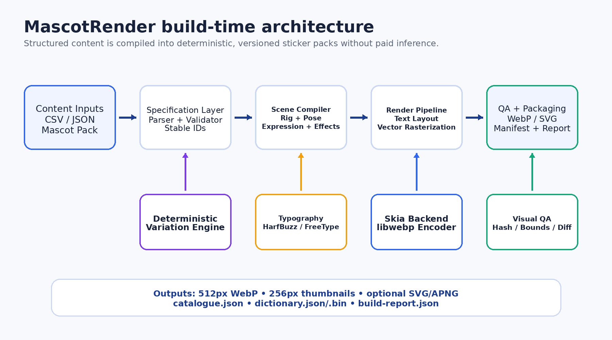
Figure 1 — Build-time architecture and generated outputs.

6.1 Build-Time Boundary
- Inputs are human-authored specifications and an original mascot pack, not free-form user prompts.
- The scene compiler resolves references, constructs a layer tree, applies a deterministic variation seed, and passes the scene to the rendering backend.
- The renderer produces transparent raster output and optional vector output. The QA stage either approves, warns, or fails the asset.
- The package builder writes immutable files and a report that can be reviewed in CI before publishing.

6.2 Runtime Boundary
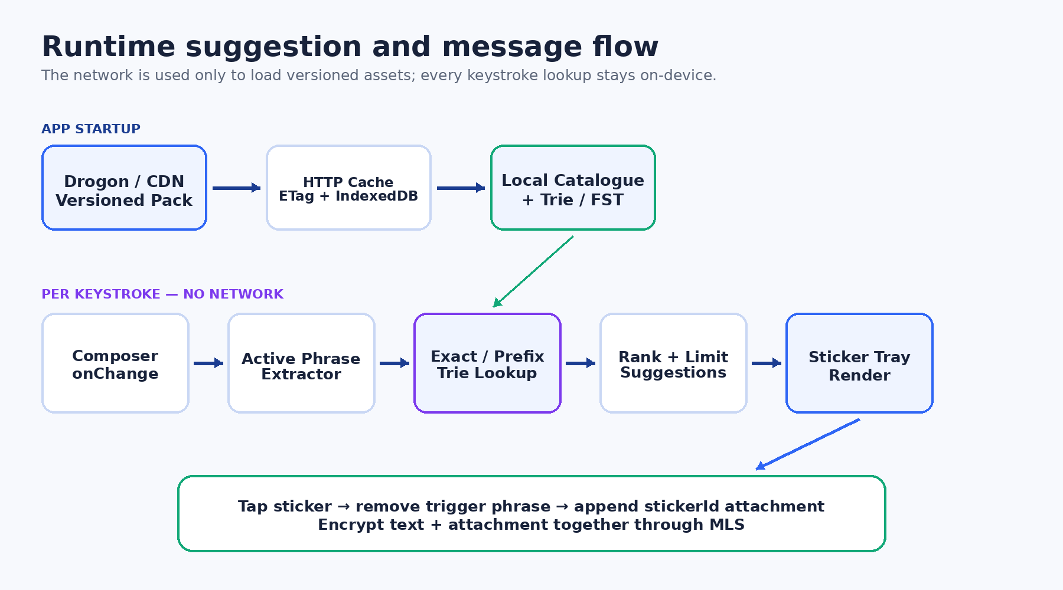
Figure 2 — App startup, local lookup, suggestion tray, and MLS attachment flow.

6.3 Recommended Technology Baseline
Area | Recommendation | Reason
Language / Build | C++20 and CMake | Modern type safety, performance, broad tooling, and fit with Wahalao’s platform stack.
CLI | CLI11 or equivalent | Subcommands, validation, help text, and config-file support.
Vector / Raster | Backend abstraction; Skia as recommended first implementation | Robust paths, transforms, filters, text integration, and cross-platform headless rendering.
Text shaping | HarfBuzz + FreeType | Correct glyph shaping, fallback, metrics, and future multilingual support.
WebP export | libwebp | Direct control of alpha, quality, method, lossless/lossy modes, and metadata.
JSON | simdjson or nlohmann::json | Schema/config parsing and manifest generation; performance is not expected to be a bottleneck at MVP scale.
Image QA | OpenCV as an optional QA dependency | Perceptual hash, edge analysis, alpha bounds, similarity, and contact sheets.
Tests | GoogleTest or Catch2 | Unit, integration, golden-image, and deterministic build tests.

7. Component Design

7.1 Sticker Specification Loader
The loader parses CSV or JSON into a canonical StickerSpec. It validates required fields, normalizes locale and trigger values, verifies referenced assets, and computes a source fingerprint. Parsing errors must include file name, row number, column, bad value, and remediation guidance.
struct StickerSpec {
std::string id;
std::string text;
std::vector<std::string> triggers;
std::string locale{"en"};
std::string emotion;
std::string pose;
std::string effect;
std::string accessory;
std::string palette;
std::string textStyle;
std::uint64_t seed{0};
int priority{100};
bool enabled{true};
};

7.2 Mascot Pack and Rig
A mascot pack is a versioned collection of original vector assets plus declarative metadata. The MVP uses a layered 2D rig rather than a continuous skeletal mesh. Each part exposes named anchors and allowed transforms. Poses define transforms for the parts; expressions select or deform eyes, brows, mouth, cheeks, and optional tears/sweat.
- Core parts: body, head, hair/hat, eyes, brows, mouth, left arm/hand, right arm/hand, legs, foreground accessory, background effect.
- Named anchors: headCenter, mouth, leftHand, rightHand, chest, topText, bottomText, effectOrigin.
- Z-order is declared in the pack and can be overridden only by approved pose/effect rules.
- Asset imports must use a sanitized SVG subset; scripts, external URLs, embedded HTML, and remote fonts are rejected.

7.3 Expression, Pose, Effect, and Accessory Libraries
Library | Examples | Implementation
Expressions | happy, laughing, furious, shocked, sad, suspicious, sleepy, proud | Select part variants plus bounded scale/rotation/deformation parameters.
Poses | neutral, waving, hands-up, facepalm, pointing, hugging-heart, running, bent-laughing | Named transforms applied to rig parts and anchors.
Effects | tears, hearts, sparkles, fire, confetti, sweat, question marks, motion lines | Procedural vector primitives or reusable vector templates placed from anchors.
Accessories | party hat, phone, umbrella, coffee, lock, gift, sunglasses | Optional foreground/background assets with safe bounds and z-order.

7.4 Scene Compiler
The scene compiler resolves the StickerSpec against the mascot pack and emits a backend-neutral scene graph. It owns composition rules, safe-area calculations, deterministic variation, z-order, transforms, and effect placement. The render backend must not contain product-specific decisions.
struct SceneNode {
NodeType type;
Transform2D transform;
float opacity{1.0F};
int zIndex{0};
std::variant<VectorAsset, TextRun, ProceduralEffect> payload;
};
struct CompiledScene {
int width{512};
int height{512};
std::vector<SceneNode> nodes;
SafeArea safeArea;
std::string sourceFingerprint;
};

7.5 Typography and Text Layout
The engine, not the artwork generator, renders all sticker wording. This guarantees spelling and makes localization auditable. The layout service shapes glyphs, applies fallback fonts, measures the result, and searches for the largest valid font size within the configured text frame.
- Maximum lines are template-specific; two lines is the default for short reaction stickers and three lines for longer phrases.
- The layout algorithm first tries approved break opportunities, then balanced line lengths, then controlled font-size reduction.
- Text must remain within the safe area after stroke, shadow, rotation, and outline expansion.
- A contrast rule chooses text/stroke colors from the approved palette; content authors do not specify arbitrary colors by default.
- Locale-specific font fallback is configured in metadata. Fonts are packaged or referenced only when commercial distribution rights are confirmed.

7.6 Deterministic Variation Engine
Variation expands a limited art system without making builds random or unreviewable. A seeded pseudo-random generator is initialized from the sticker ID, mascot-pack version, and explicit seed. It can select only from the variation ranges approved by the technical artist.
seed = Hash64(sticker.id + mascotPack.version + std::to_string(sticker.seed));
Allowed variation examples:
- horizontal mascot offset: ±12 px
- head rotation: approved set {-6°, 0°, +6°}
- effect arrangement: template variant 0..3
- palette: one of the category-approved palettes
- accessory variant: one of the spec-approved options

7.7 Render Backend
The first implementation should expose an IRenderBackend interface and use Skia as the recommended production backend. The backend receives a CompiledScene and produces RGBA output. libwebp then performs final encoding. The separation permits a smaller alternative backend later without changing content or scene-compilation logic.
class IRenderBackend {
public:
virtual ~IRenderBackend() = default;
virtual Result<PixelBuffer> render(const CompiledScene& scene) = 0;
};
class WebPExporter {
public:
Result<EncodedAsset> encode(
const PixelBuffer& rgba,
const ExportOptions& options
) const;
};

7.8 Validation and Quality Gate
Validation is part of the build, not a separate manual afterthought. Every asset receives a pass, warning, or failure state. The build can be configured to fail on warnings in release mode.
Rule | Default Result | Purpose
Missing/unknown expression, pose, effect, or asset | Fail | Prevents incomplete or silently substituted stickers.
Visible pixels outside safe bounds | Fail | Prevents clipped art and text.
Text frame overflow or unreadable minimum size | Fail | Protects exact wording and legibility.
No alpha channel or excessive opaque background | Fail | Ensures sticker-like transparent output.
Perceptual similarity above configured threshold | Warn/Fail | Detects duplicate or near-duplicate variations.
File size above target | Warn | Flags delivery cost without blocking early development.
Trigger collision or forbidden trigger | Fail | Prevents irrelevant suggestion spam.
Unlicensed font/asset metadata missing | Fail in release | Protects commercial distribution rights.

7.9 Package Builder
The package builder writes a versioned directory, atomically finalizes manifests, and records hashes for every input and output. A release is considered publishable only after validation and review status are complete.
dist/v1.0.0/
stickers/512/stk_lol_001.webp
thumbs/256/stk_lol_001.webp
source-svg/stk_lol_001.svg # optional
catalogue.json
dictionary.json
dictionary.bin # optional phase 2
build-report.json
licenses.json
review/index.html # optional contact sheet

8. Data Design

8.1 Authoring CSV
The existing CSV is extended rather than replaced. The first six columns remain understandable to non-engineers; advanced columns may be left blank and resolved from category defaults.
id,text,triggers,locale,category,emotion,pose,effect,accessory,palette,text_style,seed,priority,enabled
stk_lol_001,LOL,lol|lmao|laugh,en,laughter,laughing,bent_laughing,tears,,sunny,bold_bubble,101,100,true
stk_weather_001,HOW IS IT?,how is|weather|how is the weather,en,greeting,curious,thinking,question_marks,,blue,comic,202,90,true
stk_no_wahala_001,NO WAHALA,no wahala|no problem|all good,en-NG,reassurance,calm,waving,sparkles,,green,rounded,303,95,true

8.2 Mascot Pack Metadata
{
"id": "wahalao-default",
"version": "1.0.0",
"canvas": {"width": 512, "height": 512, "safeMargin": 24},
"parts": {"head": "parts/head.svg", "body": "parts/body.svg"},
"anchors": {"leftHand": [142, 276], "rightHand": [370, 276]},
"expressions": {"laughing": "expressions/laughing.json"},
"poses": {"waving": "poses/waving.json"},
"effects": {"sparkles": "effects/sparkles.json"},
"textStyles": {"bold_bubble": "text/bold_bubble.json"},
"palettes": {"sunny": "palettes/sunny.json"}
}

8.3 Runtime Catalogue
{
"version": "1.0.0",
"baseUrl": "/assets/stickers/v1.0.0",
"stickers": {
"stk_lol_001": {
"text": "LOL",
"altText": "Mascot laughing with LOL text",
"file": "stickers/512/stk_lol_001.webp",
"thumbnail": "thumbs/256/stk_lol_001.webp",
"locale": "en",
"category": "laughter",
"sha256": "...",
"width": 512,
"height": 512
}
}
}

8.4 Trigger Dictionary and Governance
Triggers are product data and require the same discipline as artwork. They must be token- or phrase-aware. Raw substring matching is prohibited because it creates obvious false positives. For example, a trigger such as “he” must not fire inside “the”, “weather”, or “where”. Likewise, “hello” should not point to a HEHE sticker merely because it begins with “he”.
Rule | MVP Behavior
Normalization | Unicode NFKC, lowercase, apostrophe normalization, collapsed whitespace.
Boundary | Match complete tokens or configured trailing phrases; never arbitrary substrings.
Minimum length | Three characters by default; one- and two-character triggers require an explicit locale-specific exception.
Stop words | Common function words such as “he”, “the”, “is”, and “a” cannot be standalone sticker triggers in English.
Phrase precedence | Longest exact trailing phrase wins over shorter exact tokens.
Prefix mode | Enabled only after a configurable minimum typed length and only for curated triggers.
Collision review | A trigger shared by multiple stickers is permitted only when ranking metadata is present.

9. Algorithms and Runtime Behavior

9.1 Build Algorithm
1. Parse and validate the sticker specification.
2. Resolve the mascot-pack version and all referenced components.
3. Calculate the source fingerprint and check the incremental-build cache.
4. Initialize deterministic variation from sticker ID, pack version, and seed.
5. Compile the rig, pose, expression, accessory, effects, and text into a scene graph.
6. Shape and fit text; fail if it cannot meet the minimum legibility rule.
7. Render RGBA, apply final trim/padding only within approved rules, and export WebP/thumbnail.
8. Run automated QA and calculate content/perceptual hashes.
9. Update catalogue, dictionary, report, and review artifacts atomically.

9.2 Active Phrase Extraction
The client examines the text immediately before the cursor, not the entire message. It extracts up to N trailing tokens, stopping at sentence boundaries or unsupported punctuation. N=5 is the recommended starting value because it captures phrases such as “how is the weather” without scanning an unbounded message.

9.3 Suggestion Matching and Ranking
Candidate order:
1. Longest exact trailing phrase
2. Shorter exact trailing phrase
3. Exact active token
4. Curated prefix match after minimum length
5. Optional category fallback when explicitly enabled
score =
exactPhraseBonus
+ matchedTokenCount * tokenWeight
+ triggerPriority
+ localeBonus
+ localUsageBonus
- recentRepetitionPenalty;

The matcher returns at most eight sticker IDs for the tray. Ranking must be deterministic for a given dictionary and local usage state. In the MVP, there is no fuzzy edit-distance matching because false positives are more damaging than missed suggestions.

9.4 Selection and Message Composition
- The selected sticker ID is appended to the outgoing attachment array.
- Product configuration determines whether the matched trigger text is removed, retained, or replaced with a space.
- The text and attachment metadata are passed together to the existing MLS message-encryption layer.
- Recipients resolve the sticker ID against their local catalogue. Unknown IDs display a safe fallback and schedule a catalogue refresh.

9.5 Incremental Build Cache
Each sticker fingerprint includes the normalized spec, mascot-pack version, hashes of referenced assets, renderer version, font hashes, and export options. If the fingerprint and expected output hashes match, the sticker is skipped. Changing a shared expression invalidates only stickers that reference it.

10. Interfaces

10.1 CLI
mascotrender build \
--input content/stickers.csv \
--mascot assets/mascots/wahalao-default \
--output dist/v1.0.0 \
--jobs 8 \
--strict
mascotrender preview --id stk_lol_001 --open
mascotrender validate --input content/stickers.csv --strict
mascotrender inspect --pack dist/v1.0.0
mascotrender package --input dist/v1.0.0 --zip release/wahalao-stickers-v1.0.0.zip

10.2 C++ Library API
namespace mascotrender {
struct BuildOptions {
std::filesystem::path input;
std::filesystem::path mascotPack;
std::filesystem::path output;
unsigned jobs{std::thread::hardware_concurrency()};
bool strict{false};
};
struct BuildSummary {
std::size_t requested{};
std::size_t rendered{};
std::size_t skipped{};
std::size_t warnings{};
std::size_t failed{};
};
class Engine {
public:
Result<BuildSummary> build(const BuildOptions& options);
Result<ValidationReport> validate(const BuildOptions& options);
Result<EncodedAsset> preview(const StickerSpec& spec);
};
} // namespace mascotrender

10.3 Drogon Endpoints
Endpoint | Purpose | Caching
GET /api/v1/chat/sticker-version | Return active version, ETag, and optional minimum client schema. | no-cache; very small response
GET /api/v1/chat/sticker-catalogue | Return catalogue for the active or requested pack version. | ETag + stale-while-revalidate
GET /api/v1/chat/sticker-dictionary | Return phrase-to-sticker mapping or binary dictionary. | Long-lived cache; versioned URL preferred
GET /assets/stickers/{version}/... | Serve immutable WebP/SVG assets and thumbnails. | public, immutable, one-year max-age

10.4 Outgoing Message Contract
{
"text": "How is the weather today?",
"attachments": [
{
"type": "sticker",
"stickerId": "stk_weather_001",
"packVersion": "1.0.0"
}
]
}

11. Quality Attributes and Performance Targets
Planning targets, not measured results
The figures below are initial engineering targets. They must be validated on the selected renderer, target workstation, CDN, and representative mobile devices before becoming release service-level objectives.
Area | MVP Target | Measurement
Static pack build | 1,000 stickers in ≤10 minutes on an 8-core reference workstation | CI benchmark with warm/cold cache reported separately
Incremental rebuild | One changed sticker in ≤2 seconds excluding process startup | CLI timing and cache-hit report
Peak memory | ≤1.5 GB for a 1,000-sticker build | Process RSS in benchmark job
Runtime dictionary load | ≤150 ms p95 after cached fetch on representative mobile browser | Web performance trace
Per-keystroke lookup | ≤2 ms p95 for 10,000 triggers | Browser microbenchmark
Suggestion UI update | Tray content visible within one animation frame after lookup when assets are cached | React performance trace
Asset dimensions | 512×512 main, 256×256 thumbnail, transparent alpha | Automated validator
Asset size | Target average ≤150 KB for 512px static WebP; category exceptions documented | Build report
Visual defects | Zero clipping, missing layers, unsafe backgrounds, or unreadable text in approved release | Automated QA + human approval

11.1 Determinism Strategy
- Pin renderer, font, and dependency versions in the build image.
- Use explicit color spaces, dimensions, sampling rules, and WebP options.
- Avoid platform-dependent font discovery; fonts are referenced through the pack configuration.
- Use a fixed PRNG algorithm and seed derivation, not std::random_device.
- Store source/output hashes and compare golden assets in CI.

12. Test Strategy
Test Layer | Coverage
Unit tests | CSV/JSON parsing, ID generation, trigger normalization, anchor transforms, text fitting, score/ranking, hashes, cache invalidation.
Golden-image tests | Render representative combinations and compare against approved images with pixel and perceptual tolerances.
Property tests | Long strings, punctuation, Unicode, empty fields, extreme transforms, duplicate IDs, invalid paths, and malformed SVG.
Integration tests | End-to-end CSV → WebP/manifest/dictionary; Drogon cache behavior; React lookup and selection payload.
Performance tests | 1k/10k spec builds, cold/warm cache, memory, dictionary load, and per-keystroke lookup.
Compatibility tests | Supported Linux build images; representative Chrome/Safari mobile clients; WebP alpha and fallback behavior.
Content QA | Contact-sheet review of every release, spelling verification, art consistency, cultural review, and trigger relevance.
Security tests | Path traversal, malicious SVG, oversized input, malformed JSON/CSV, dependency vulnerability scanning.

12.1 Golden Image Policy
Golden-image tests must not make deliberate art changes impossible. A changed output is classified as expected, suspicious, or defective. Expected changes require an updated pack version, review evidence, and approved golden-image replacement. Silent golden updates in CI are prohibited.

12.2 Pilot Content Set
The MVP should begin with approximately 200 high-frequency stickers rather than immediately publishing 1,000. The pilot must cover greetings, agreement, laughter, surprise, support, affection, status, work/school, food/sleep, frustration, celebration, and selected Pidgin expressions. The existing 204-row catalogue is a suitable planning baseline, subject to trigger cleanup and art prioritization.

13. Deployment and Operations

13.1 Build and Release Flow
1. Content change is submitted through version control with CSV/JSON and mascot-pack changes.
2. CI builds the engine or uses a pinned build image, then runs validate and build in strict mode.
3. CI publishes a review artifact containing contact sheets, reports, and manifests.
4. Content Operations and Design approve or reject the pack.
5. Approved assets are uploaded under an immutable semantic version path.
6. The active version pointer is updated only after asset availability checks succeed.
7. Clients discover the version, download/cached manifests, and retain the previous pack for rollback.

13.2 Versioning and Rollback
Mascot packs, manifest schemas, and published content packs are versioned separately. A content-only update can increment the content version without changing the client schema. Rollback changes the active version pointer; immutable old assets remain available for messages that reference older sticker IDs.

13.3 Observability
- Build metrics: duration by stage, rendered/skipped/failed counts, average file size, cache hit rate, duplicate warnings, and text-layout failures.
- Delivery metrics: catalogue fetch success, version mismatch, asset 404s, cache hit rate, and pack download size.
- Product metrics: suggestion impressions, taps, dismissals, trigger misses, and repeated false-positive reports — collected only under the approved privacy policy.

14. Security, Privacy, and Intellectual Property

14.1 Asset and Input Security
- Treat mascot packs as code-adjacent inputs. Imported SVG is parsed through an allowlist and may not load remote resources or execute scripts.
- Canonicalize and sandbox all paths under approved input/output roots to prevent traversal and overwrite attacks.
- Apply maximum sizes to text, trigger lists, files, layer counts, and image dimensions.
- Run the content build in a restricted CI container with no production credentials.

14.2 Messaging Privacy
Keystroke matching happens locally. The server does not receive partial composer text to generate suggestions. If trigger-miss analytics are introduced, they require explicit product/privacy approval, minimization, aggregation, retention limits, and avoidance of raw message content wherever possible.

14.3 Intellectual Property
The supplied screenshots are a behavioral reference only. MascotRender must not copy the depicted people, characters, logos, typography, or individual sticker artwork. Wahalao will create original character assets and record provenance for every shipped component. Font embedding and commercial redistribution rights must be verified before release.

15. Project Delivery Plan
The following is a planning baseline for a small cross-functional team. Durations are estimates and should be re-baselined after the renderer proof of concept and art-system workshop.
Phase | Estimate | Key Deliverables | Exit Gate
Phase 0 — Product & Art Definition | 1 week | Art bible, MVP categories, trigger governance, technical spike plan | Product and Design approve mascot direction and pack schema.
Phase 1 — Engine Foundation | 2 weeks | C++20/CMake project, CLI, parser, pack loader, scene graph, tests | Can parse sample data and emit a debug scene.
Phase 2 — Rendering & Typography | 2 weeks | Skia backend, HarfBuzz/FreeType text, alpha WebP export | Ten golden stickers render with exact text and stable hashes.
Phase 3 — Procedural Libraries | 2 weeks | Initial rig, 12 expressions, 8 poses, 8 effects, deterministic variation | At least 50 visually coherent stickers pass review.
Phase 4 — Packaging & QA | 1 week | Incremental cache, validator, manifest, dictionary, contact sheet | Strict build fails correctly and produces deployable pack.
Phase 5 — Runtime Integration | 2 weeks | Drogon delivery, React phrase matcher, tray, MLS attachment | End-to-end demo from typing through encrypted message payload.
Phase 6 — Pilot & Hardening | 2 weeks | Approximately 200 approved stickers, performance/security tests, rollback | Pilot release criteria met.
Phase 7 — Scale to 1,000 | 2–4 weeks | Expanded art library, content QA, analytics loop, release operations | 1,000-asset pack passes quality and capacity gates.

15.1 Suggested Team
Role | Allocation | Primary Deliverables
Senior C++ Graphics Engineer | 1.0 FTE | Engine architecture, scene compiler, renderer, packaging, determinism, benchmarks.
Technical Artist / Illustrator | 1.0 FTE during pack creation | Original mascot, rig, expressions, poses, effects, art bible, visual QA.
React Engineer | 0.5–1.0 FTE during integration | Phrase extraction, local dictionary, ranking, tray, attachment behavior.
Drogon / Platform Engineer | 0.25–0.5 FTE | Versioned delivery, caching, deployment, monitoring.
QA / Content Operations | 0.5 FTE, increasing during content scale | Automation, contact-sheet review, trigger QA, release approval.
Product Manager | 0.25–0.5 FTE | Scope, prioritization, acceptance, risk, rollout, and cross-team coordination.

15.2 Workstreams / Epics
- EPIC-01: Mascot art system and pack format
- EPIC-02: C++ scene compiler and renderer abstraction
- EPIC-03: Exact typography and localization foundation
- EPIC-04: Procedural expressions, poses, effects, and variation
- EPIC-05: Asset QA, incremental builds, and packaging
- EPIC-06: Trigger dictionary, phrase matching, and ranking
- EPIC-07: Drogon/CDN delivery and release management
- EPIC-08: React composer experience and MLS attachment integration
- EPIC-09: Content production, review, and analytics loop

16. Risks and Mitigations
ID | Risk | Impact | Mitigation
R-01 | Art system cannot produce enough visual diversity | High | Run a 50-sticker art spike before committing to 1,000; expand poses/effects based on contact-sheet review.
R-02 | Technical artist becomes the bottleneck | High | Use reusable anchors/templates, batch preview, category defaults, and prioritize high-frequency content.
R-03 | Short/overlapping triggers cause intrusive suggestions | High | Token boundaries, stop-word policy, minimum length, collision validation, and product QA.
R-04 | Multilingual text clips or shapes incorrectly | Medium/High | HarfBuzz/FreeType, locale test corpus, approved fallback fonts, and language-specific safe areas.
R-05 | Outputs differ across platforms | Medium | Pinned container, fixed fonts/renderer, deterministic PRNG, golden hashes, Linux-first release build.
R-06 | Skia dependency is too large or complex | Medium | Keep IRenderBackend clean; validate a narrower backend only after MVP requirements are proven.
R-07 | Assets look too repetitive | Medium | Deterministic variation, category-specific templates, additional hand gestures/accessories, and diversity score in QA.
R-08 | Third-party art or font licensing issue | High | Original assets, provenance metadata, license review gate, and no copying from reference screenshots.
R-09 | Pack size harms mobile startup | Medium | Thumbnails, category/lazy loading, WebP tuning, immutable caching, and load only top-frequency stickers initially.
R-10 | Animation scope delays static MVP | Medium | Treat animation as a separate roadmap phase with its own technical spike and acceptance criteria.

17. Acceptance Criteria and Definition of Done

17.1 MVP Acceptance Criteria
- A clean build from the pinned environment generates the approved pilot pack without paid API calls.
- At least 200 approved stickers cover the agreed category matrix and use the original Wahalao mascot system.
- Every sticker has a stable ID, exact text, alt text, triggers, category, locale, dimensions, and content hash.
- No approved sticker has clipped text/art, missing alpha, unsafe background, unlicensed asset, or unresolved validation failure.
- The client makes no network request in response to each keystroke.
- The phrase matcher passes the trigger boundary suite, including no match for “he” inside “the” or “weather”.
- Drogon endpoints support ETag, versioning, immutable asset caching, and rollback to the previous pack.
- The selected sticker ID is included in the encrypted outgoing message attachment contract and renders on a receiving client.
- Performance targets are benchmarked and any exceptions are documented and approved.
- Release documentation, license records, build report, and operational rollback steps are complete.

17.2 Definition of Done for a Sticker
Gate | Done When
Specification | ID is unique; text, triggers, locale, category, emotion, pose, and source metadata are valid.
Automated build | Asset renders successfully and incremental fingerprint is recorded.
Automated QA | All blocking checks pass; warnings are dispositioned.
Visual QA | Design/Content Operations approve readability, consistency, cultural fit, and originality.
Runtime QA | Trigger returns the correct ranked suggestion and does not produce known false positives.
Release | Asset and metadata are present under the intended pack version and covered by rollback.

18. Roadmap Beyond MVP
Stage | Capability
Phase 2 | Animated WebP/APNG/Lottie export from pose keyframes and procedural effects.
Phase 2 | Additional original mascot packs and seasonal theme packs.
Phase 2 | Category-based lazy loading and compact binary Trie/FST for very large dictionaries.
Phase 3 | Local offline ML-assisted trigger expansion using approved word embeddings or fastText-style models; no paid inference required.
Phase 3 | WASM build of the scene compiler for browser-based preview or limited dynamic text rendering.
Phase 3 | Avatar personalization through controlled palettes/accessories without face cloning.
Phase 4 | Technical-artist desktop editor built on the same scene graph and pack schema.

19. Open Decisions
ID | Decision | Owner | Needed By
OD-01 | Final mascot visual direction and number of launch mascots | Product + Design | Before Phase 1 exit
OD-02 | Skia as first backend versus a smaller rendering stack | C++ Lead | Renderer spike
OD-03 | Font families and commercial redistribution model | Design + Legal | Before typography implementation
OD-04 | Maximum lines and minimum font size by sticker template | Design + Product | Art bible
OD-05 | Trigger text removal behavior after sticker selection | Product + UX | Before React integration
OD-06 | Use JSON-only dictionary in MVP or also compile binary Trie | Web + C++ Leads | Before packaging implementation
OD-07 | Analytics policy for trigger misses and usage ranking | Product + Privacy | Before pilot telemetry
OD-08 | Pilot category quotas and release approval workflow | Product + Content Ops | Phase 0

Appendix A — Suggested Repository Layout
MascotRender/
CMakeLists.txt
apps/mascotrender-cli/
include/mascotrender/
src/
spec/
pack/
scene/
text/
render/
export/
validate/
package/
tests/
unit/
integration/
golden/
assets/mascots/wahalao-default/
content/stickers.csv
schemas/
tools/contact-sheet/
docs/

Appendix B — Glossary
Term | Definition
Mascot pack | Versioned collection of original vector parts, rig anchors, poses, expressions, effects, text styles, palettes, and license metadata.
StickerSpec | Canonical structured instruction for one sticker.
Scene graph | Backend-neutral ordered set of vector, text, and procedural nodes to be rendered.
Deterministic variation | Seeded selection of approved visual alternatives that produces repeatable output.
Trigger | Normalized word or phrase that can suggest one or more sticker IDs.
Trie/FST | Compact data structure for fast exact/prefix phrase lookup.
Golden image | Approved reference output used to detect unintended visual changes.
Pack version | Immutable release identifier for a catalogue, dictionary, and asset set.

Appendix C — Initial PM Recommendation
Start with a proof of coherence, not a proof of volume
The first executive checkpoint should be a 50-sticker contact sheet produced from one original mascot pack. The decision to scale to 1,000 should be made only after Design, Product, and Engineering agree that the procedural combinations remain expressive, readable, original, and recognizably Wahalao.

