SOFTWARE DESIGN DOCUMENT

MascotRender
  - Procedural C++ Mascot and Sticker Rendering Engine
Project: Wahalao Smart Chat Stickers
Document status: Implementation baseline
Version: 0.2
Date: 13 July 2026
Prepared for: Product, C++ Platform, Web, Design, QA, and Content Operations
Core implementation decisions
Local-first procedural generation; installable C++20 library
MascotRender 0.1 will be a build-time content compiler distributed with Conan 2 and CMake. It will use a private ThorVG software backend and libwebp, accept versioned JSON specifications and trusted curated SVG packs, and generate deterministic static assets and manifests. Runtime chat suggestions consume generated data and remain outside the engine MVP.
Confidentiality: Internal product and engineering design draft.

Document Control
Field | Value
Document title | MascotRender Software Design Document
Product area | Wahalao Chat / Smart Sticker Suggestions
Version | 0.2
Status | Implementation baseline
Owner | Product Management
Technical owner | C++ Graphics/Platform Lead
Reviewers | Web Lead, Technical Artist, QA Lead, Security/Privacy, Content Operations
Target release | Engine 0.1.0 after M0-M5; 50-sticker coherence gate and pilot follow

Revision History
Version | Date | Author/Owner | Summary
0.1 | 13 Jul 2026 | Product Management | Initial SDD based on the target typing-to-sticker experience and the no-paid-inference architecture decision.
0.2 | 13 Jul 2026 | C++ Technical Lead / Project Management | Implementation baseline: separated engine MVP from product pilot; adopted Conan 2, ThorVG, JSON-first authoring, an installable public API, profile-scoped determinism, and milestone exit gates.

Contents
- 1. Executive Summary
- 2. Product Context and Reference Experience
- 3. Goals, Non-Goals, and Scope
- 4. Stakeholders and User Personas
- 5. Requirements
- 6. System Architecture
- 7. Component Design
- 8. Data Design
- 9. Algorithms and Runtime Behavior
- 10. Interfaces
- 11. Quality Attributes and Performance Targets
- 12. Test Strategy
- 13. Deployment and Operations
- 14. Security, Privacy, and Intellectual Property
- 15. Project Delivery Plan
- 16. Risks and Mitigations
- 17. Acceptance Criteria
- 18. Roadmap
- 19. Open Decisions
- Appendices

1. Executive Summary
MascotRender is a local-first, deterministic C++20 engine that converts structured sticker definitions into a coherent library of original mascot-based chat assets. Its purpose is to let Wahalao create hundreds or thousands of stickers without paying a per-image inference fee and without accepting the spelling, style, licensing, or availability risks of a remote generative-image service.
The engine is deliberately procedural rather than open-ended. For engine 0.1, a technical artist defines a trusted versioned JSON mascot pack containing curated SVG parts, anchors, expressions, poses, effects, palettes, text frames, and a licensed font. Content is authored as JSON. MascotRender compiles these inputs into transparent WebP assets, thumbnails, a catalogue, a trigger dictionary, and a build report.
At runtime, the React chat composer does not render new artwork. It performs phrase-aware lookup against a locally cached dictionary and shows a tray of prebuilt sticker IDs. The Drogon edge service only distributes versioned manifests and assets. No network request is made on each keystroke.
Recommended delivery boundary
M0-M5 deliver an installable build-time C++20 engine. M6 validates a 50-sticker art system. M7 delivers the approximately 200-sticker product pilot and runtime integration. CSV, full multilingual shaping, incremental builds, OpenCV QA, advanced authored animation, 2.5D/3D, Drogon, and React do not block engine 0.1.0.

1.1 Success Definition
- An unrelated C++20 application can consume mascotrender/0.1.0 through Conan 2 and link MascotRender::MascotRender.
- A test consumer loads an example pack and produces transparent 512 x 512 and 256 x 256 WebP assets.
- The same source, font files, lockfile, renderer settings, and pinned Conan profiles produce byte-identical output.
- Ten representative stickers render exact English/Pidgin wording or fail with structured diagnostics.
- Public headers expose no renderer, codec, JSON, or CLI dependency types; the installed package passes a separate test_package consumer.

2. Product Context and Reference Experience
The supplied reference screens demonstrate a chat composer that changes sticker suggestions while the user types. The target behavior is not merely a static emoji picker. It is a contextual, low-friction suggestion surface that responds to the active word or phrase immediately above the keyboard.
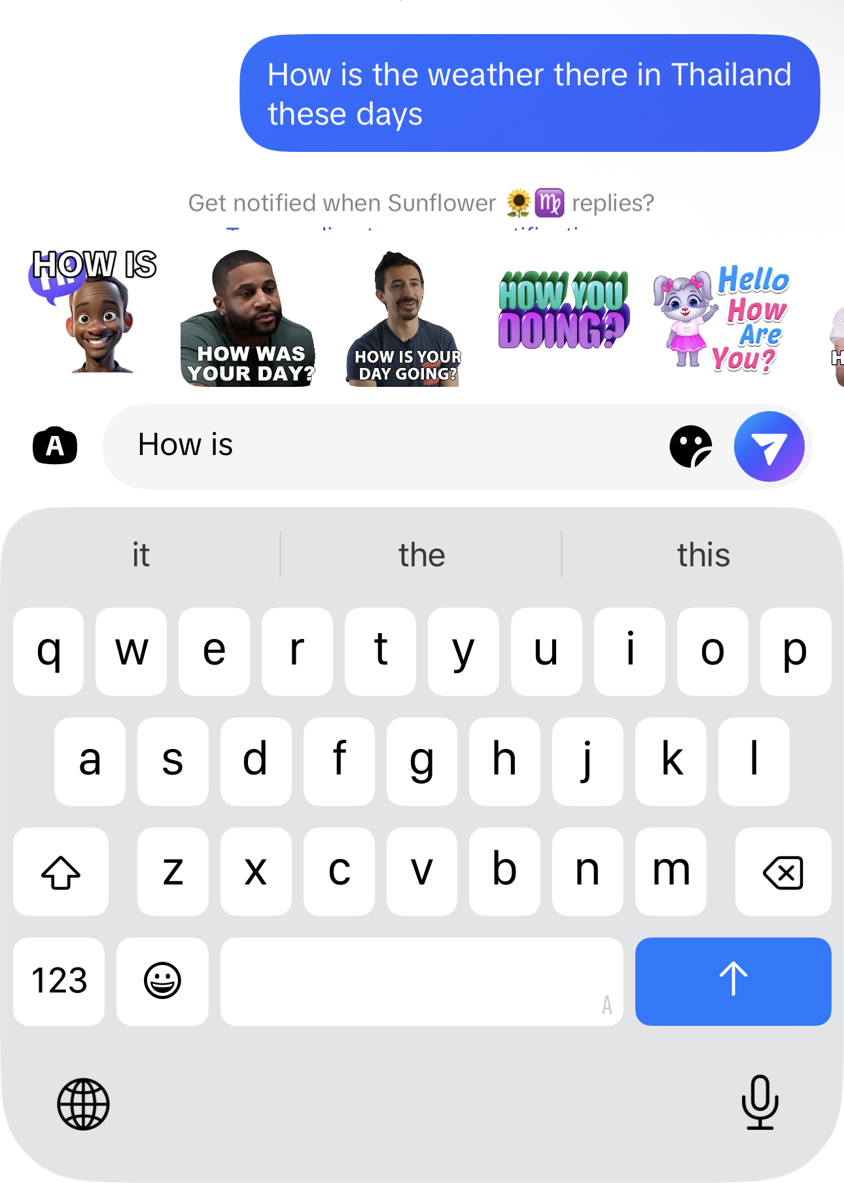 | 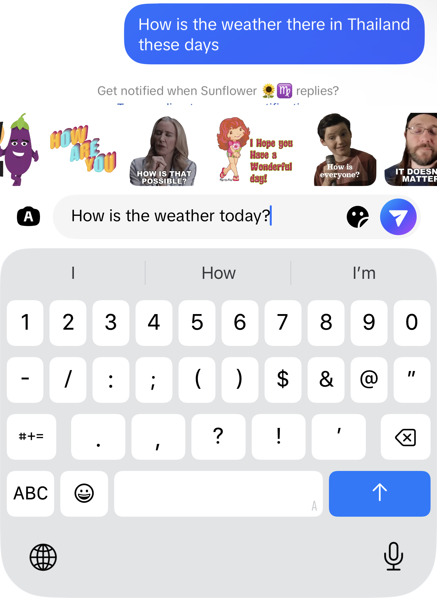
Reference A — Suggestions after the partial phrase “How is”. | Reference B — Suggestions re-ranked after the longer weather question.

2.1 UX Observations
- The tray is anchored immediately above the composer, so suggestions remain in the user’s visual focus.
- Suggestions change as the active phrase becomes more specific. A matcher must therefore understand trailing phrases, not only the last token.
- The tray can contain different visual classes: mascot art, text-only typography, illustrated characters, and reaction cut-outs. MascotRender will initially standardize on original Wahalao mascot and typography templates.
- The user can tap a suggestion without leaving the conversation. Selection should remove or preserve the trigger text according to a product rule and attach the selected sticker ID to the outgoing message.
- Any design that sends a network request for every keystroke would be too fragile and is explicitly rejected.

2.2 Product Interpretation
MascotRender is the content-production engine behind this experience. The Smart Sticker Suggestion feature is the runtime consumer. Keeping these as separate subsystems lets the C++ engine evolve independently from React while preserving a simple contract: sticker IDs, asset URLs, trigger rules, and version metadata.

3. Goals, Non-Goals, and Scope

3.1 Product Goals
- Eliminate per-image API cost and vendor lock-in for routine chat sticker production.
- Create a recognizable Wahalao mascot identity across stickers, onboarding, badges, and later animated reactions.
- Turn a compact art system into a large content catalogue through controlled combinations and deterministic variation.
- Guarantee exact text, stable IDs, repeatable builds, and auditable source metadata.
- Support English first while preserving the architecture for Pidgin, Korean, and other locales.
- Make content updates deployable as versioned data and assets without requiring a full client release.

3.2 Non-Goals for MVP
- A general text-to-image model that invents arbitrary scenes from unrestricted prose.
- Photorealistic people, celebrity likenesses, or extraction of people from third-party media.
- User-generated custom mascots or face cloning.
- A complete 2D animation authoring application; animation export is a later phase.
- On-device generation of a brand-new sticker during every chat session.
- Semantic search based on a large neural model; MVP uses curated phrase rules, exact matching, and prefix matching.

3.3 Engine MVP Scope
In Scope | Out of Scope / Later
C++20 library, build/validate CLI, and Conan 2 package | Full graphical authoring studio
One original trusted layered SVG example pack | Untrusted third-party pack ingestion and marketplace
JSON sticker/pack input; WebP output and thumbnails | CSV authoring workflow and binary Trie/FST
Expressions, poses, effects, palettes, deterministic seed | Filament/GLB rendering, skeletal animation, physics, and layered 2.5D (expansion track)
Exact English/Pidgin text with packaged font and fitting | Full multilingual shaping, fallback, bidi, and Korean launch support
Catalogue, dictionary, build report, validation | Incremental cache, OpenCV similarity, and contact-sheet tooling
Installable API plus external consumer test | Drogon delivery, React tray, MLS integration, and product telemetry

4. Stakeholders and User Personas
Role | Primary Need | Responsibility
Product Manager | A scoped, measurable feature with controlled cost and release gates. | Own priorities, acceptance criteria, rollout, and analytics policy.
C++ Graphics Engineer | A clear rendering contract and bounded dependency set. | Implement engine, renderer abstraction, packaging, performance, and determinism.
Technical Artist / Illustrator | A reusable rig and predictable preview loop. | Create original mascot parts, anchors, expressions, poses, effects, and art rules.
Frontend Engineer | Small, stable runtime schemas and low-latency lookup. | Integrate catalogue, phrase extraction, ranking, tray UI, and message attachment.
Drogon / Edge Engineer | Immutable, cacheable delivery paths. | Serve manifests/assets, version endpoints, ETag, and rollback.
QA / Content Operations | Automated validation plus efficient visual review. | Review generated packs, reject defects, approve releases, and manage trigger quality.
End User | Relevant, immediate, non-intrusive sticker suggestions. | Type naturally, select a sticker, and send it without leaving the composer.

4.1 Primary User Stories
- As a content operator, I can add a row to a CSV and rebuild only the affected sticker and manifests.
- As a technical artist, I can add a new expression or pose without changing the engine source code.
- As a frontend engineer, I can load the dictionary once and resolve suggestions locally as the user types.
- As a user, I see suggestions that match the phrase I am typing and do not appear for unrelated substrings.
- As a release manager, I can roll back to the previous sticker-pack version without redeploying the chat client.

5. Requirements

5.1 Functional Requirements
Unless a row is marked PILOT MUST, MUST refers to engine 0.1.0 (M0-M5). PILOT MUST applies to M6-M7 and does not block the installable engine release.
ID | Priority | Requirement
FR-01 | MUST | Ingest JSON sticker specifications with schema-version validation and human-readable, source-located errors.
FR-02 | MUST | Preserve explicit sticker IDs and generate collision-free IDs when an ID is omitted.
FR-03 | MUST | Load a versioned mascot pack containing vector parts, anchors, palettes, poses, expressions, text frames, and effects.
FR-04 | MUST | Compile a sticker scene from reusable layers using deterministic z-order and transforms.
FR-05 | MUST | Render authored wording exactly, including punctuation and apostrophes, without model-generated text.
FR-06 | MUST | Fit text into approved frames using line wrapping, font-size search, safe margins, stroke, and contrast rules.
FR-07 | MUST | Support emotion, pose, effect, accessory, palette, text style, locale, and deterministic seed fields.
FR-08 | MUST | Export transparent 512 x 512 WebP assets and 256 x 256 thumbnails; SVG source export is optional after engine 0.1.
FR-09 | MUST | Generate catalogue.json, dictionary.json, build-report.json, content hashes, and pack version metadata.
FR-10 | SHOULD | Perform dependency-aware incremental builds during the 50-sticker coherence milestone.
FR-11 | MUST | Validate missing references, path containment, dimensions, alpha, visible bounds, text safe area, and file-size warnings. Perceptual similarity is deferred.
FR-12 | MUST | Expose build and validate CLI commands. Preview, inspect, and package subcommands are later workflow enhancements.
FR-13 | MUST | Support exact-token and multi-word phrase triggers with configurable prefix behavior.
FR-14 | MUST | Reject unsafe overbroad triggers by default, including one- and two-character English triggers and substring-only matches.
FR-15 | PILOT MUST | Allow React to resolve suggestions locally and return ordered sticker IDs without a per-keystroke request.
FR-16 | PILOT MUST | Package runtime assets under an immutable, versioned directory suitable for CDN/Drogon delivery.
FR-17 | SHOULD | Generate multiple deterministic variations from one spec while maintaining the same mascot identity.
FR-18 | SHOULD | Add HarfBuzz/FreeType shaping and locale-aware font fallback after the base English/Pidgin text pipeline is proven.
FR-19 | SHOULD | Produce a static HTML or contact-sheet review page for the 50-sticker coherence gate.
FR-20 | SHOULD | Compile an optional compact binary Trie/FST for future WebAssembly or native clients.
FR-21 | COULD | Export APNG, animated WebP, or Lottie-compatible animation descriptions in a later release.
FR-22 | SHOULD | Add CSV import by converting operator-friendly rows into the canonical JSON/StickerSpec model during M6.
FR-23 | MUST | Distribute mascotrender/0.1.0 with Conan 2 and install a relocatable CMake config exposing MascotRender::MascotRender.
FR-24 | MUST | Provide an in-memory render API and a separate Conan test_package that compiles, links, and renders using only packaged artifacts.
FR-25 | MUST | Support backward-compatible named text slots, explicit placement, and deterministic preference-based automatic placement.
FR-26 | SHOULD | Evolve through a backend-neutral scene graph and typed timeline so static 2D, animated 2D, layered 2.5D, and optional 3D share one semantic recipe.
FR-27 | SHOULD | Render bounded deterministic body-bounce and text-pop overlays to animated WebP while retaining a static poster mode for thumbnails and non-animated consumers.

5.2 Non-Functional Requirements
ID | Attribute | Requirement
NFR-01 | Offline operation | The build engine must operate without a paid cloud inference service. Network access is not required for rendering.
NFR-02 | Determinism | Byte-identical output is required within the same pinned Conan profiles, lockfile, fonts, renderer settings, and inputs. Other supported profiles require visual equivalence.
NFR-03 | Performance | A 1,000-sticker static build should complete within the agreed benchmark target on an 8-core workstation; see Section 11.
NFR-04 | Latency | Local trigger lookup should complete in under 2 ms at p95 on a representative mid-range mobile browser.
NFR-05 | Portability | CMake and Conan must preserve Linux, macOS, and Windows packages. Linux and macOS are initial release gates; Windows is required by M5 unless explicitly waived.
NFR-06 | Maintainability | Rendering backends, pack formats, QA rules, and exporters must be interface-separated and unit-testable.
NFR-07 | Security | Engine 0.1 accepts trusted repository-controlled packs, contains all paths under the pack root, and rejects external URLs. Hostile third-party SVG isolation is a later security milestone.
NFR-08 | Accessibility | Sticker alt text and visible text metadata must be included in the catalogue for screen-reader clients.
NFR-09 | Licensing | Every mascot part, font, and effect must have recorded license provenance suitable for commercial distribution.
NFR-10 | Observability | Each build must emit structured logs, timing metrics, warning counts, failures, and content hashes.

6. System Architecture
MascotRender is designed as a build-time content compiler plus a thin runtime integration contract. This avoids putting graphics generation in the critical path of chat composition while allowing the content catalogue to evolve independently of app releases.
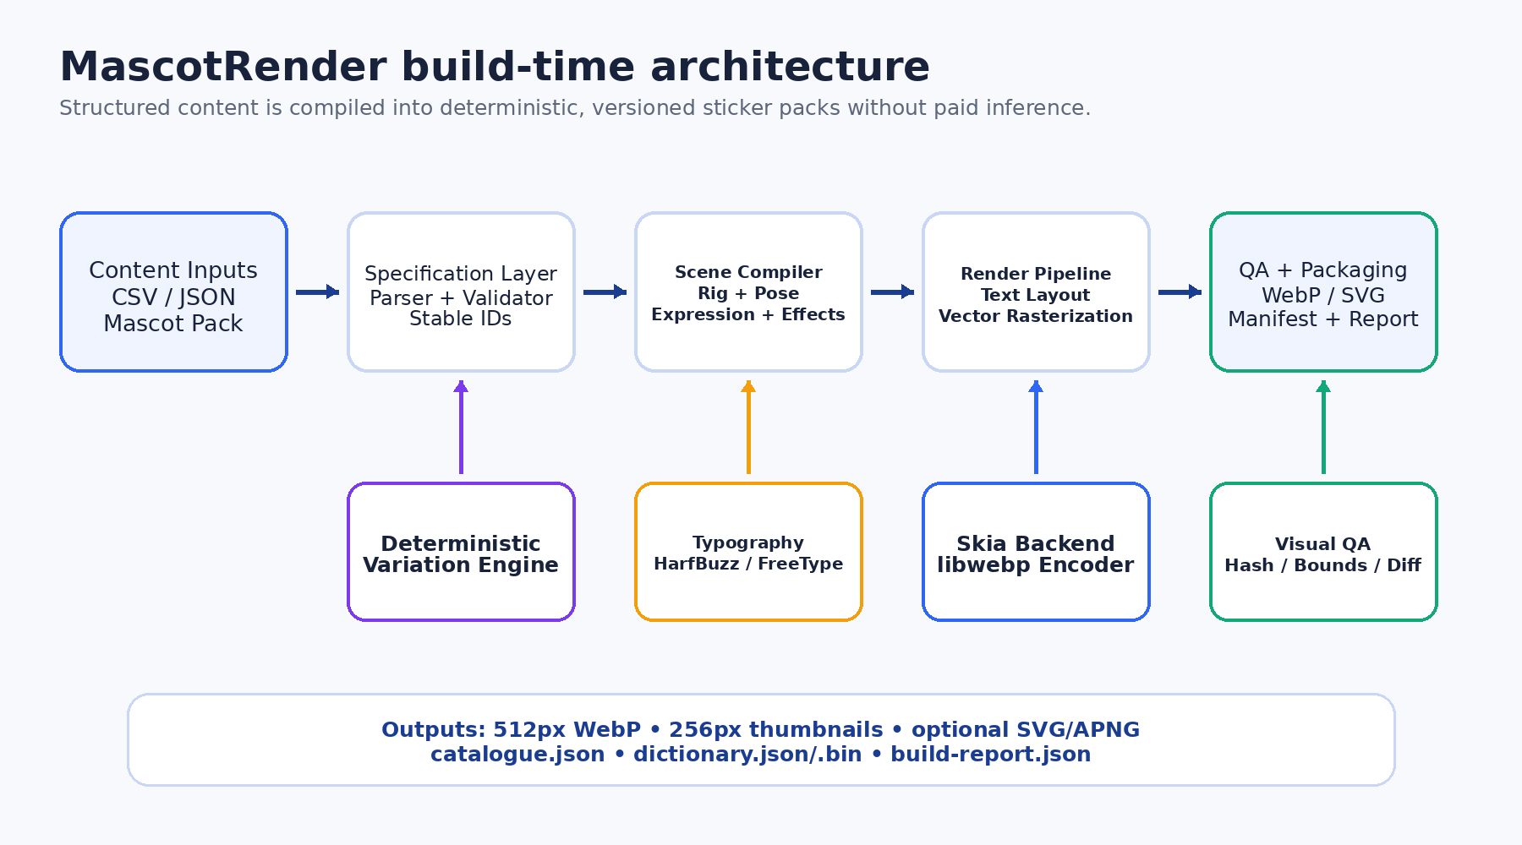
Figure 1 — Build-time architecture and generated outputs.

6.1 Build-Time Boundary
- Inputs are human-authored specifications and an original mascot pack, not free-form user prompts.
- The scene compiler resolves references, constructs a layer tree, applies a deterministic variation seed, and passes the scene to the rendering backend.
- The renderer produces transparent raster output and optional vector output. The QA stage either approves, warns, or fails the asset.
- The package builder writes immutable files and a report that can be reviewed in CI before publishing.

6.2 Runtime Boundary
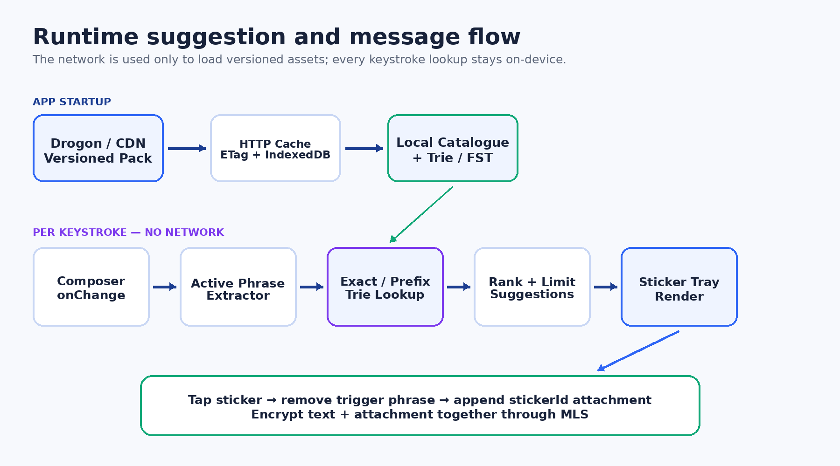
Figure 2 — App startup, local lookup, suggestion tray, and MLS attachment flow.

6.3 Recommended Technology Baseline
Area | Recommendation | Reason
Language / Build | C++20 and CMake | Modern API, broad tooling, and a normal install/export package.
Package manager | Conan 2 | Pinned dependencies, binary package IDs, host/build profiles, lockfiles, and external consumer testing.
CLI | CLI11 | Small subcommand layer; only build and validate block engine 0.1.
Vector / Raster | ThorVG 0.15.16 software backend | Available through Conan Center and sufficient for SVG, vector primitives, transforms, text, and RGBA rendering.
Text | ThorVG text + packaged static TTF for 0.1 | Exact English/Pidgin text, balanced wrapping, largest-valid whole-point fitting, and deterministic outlined glyph passes; shaping and fallback remain deferred.
WebP export | libwebp 1.6.0 | Direct control of alpha and explicit deterministic static and animated encoding settings.
JSON | nlohmann_json | Simple schema/config parsing; parsing throughput is not an MVP bottleneck.
Image QA | Owned basic validators | Bounds, alpha, dimensions, and text checks without OpenCV; similarity analysis follows in M6.
Tests | Catch2 + CTest + Conan test_package | Unit/golden/integration coverage plus proof that installed artifacts are consumable.

6.4 Library Distribution Boundary
The engine is built as an ordinary CMake target and distributed as mascotrender/0.1.0 through Conan 2. The installed package exports MascotRender::MascotRender and contains public headers, library artifacts, licenses, and relocatable CMake config/version files.
- Public headers use only standard-library and MascotRender-owned types; renderer, codec, JSON, and CLI dependencies remain private implementation details.
- A separate Conan test_package must compile, link, run, load an example pack, and render using only packaged artifacts.
- Conan package IDs capture OS, architecture, compiler, runtime, build type, and shared/static configuration. Cross-compiler C++ ABI compatibility is not promised.

7. Component Design

7.1 Sticker Specification Loader
Engine 0.1 parses schema-versioned JSON into a canonical StickerSpec. It validates required fields, normalizes locale and trigger values, verifies referenced assets, and reports the file plus JSON path, bad value, and remediation. A CSV importer is added in M6 and must produce this same model.
struct StickerSpec {
std::string id;
std::string text;
std::vector<std::string> triggers;
std::string locale{"en"};
std::string emotion;
std::string pose;
std::string effect;
std::string accessory;
std::string palette;
std::string textStyle;
std::uint64_t seed{0};
int priority{100};
bool enabled{true};
};

7.2 Mascot Pack and Rig
A mascot pack is a versioned collection of original vector assets plus declarative metadata. The MVP uses a layered 2D rig rather than a continuous skeletal mesh. Each part exposes named anchors and allowed transforms. Poses define transforms for the parts; expressions select or deform eyes, brows, mouth, cheeks, and optional tears/sweat.
- Core parts: body, head, hair/hat, eyes, brows, mouth, left arm/hand, right arm/hand, legs, foreground accessory, background effect.
- Named anchors: headCenter, mouth, leftHand, rightHand, chest, topText, bottomText, effectOrigin.
- Z-order is declared in the pack and can be overridden only by approved pose/effect rules.
- Engine 0.1 accepts only trusted repository-controlled SVG parts, canonicalizes paths under the pack root, and rejects external URLs, embedded HTML, remote fonts, and disallowed references. A hardened untrusted-SVG boundary is later scope.

7.3 Expression, Pose, Effect, and Accessory Libraries
Library | Examples | Implementation
Expressions | happy, laughing, furious, shocked, sad, suspicious, sleepy, proud | Select part variants plus bounded scale/rotation/deformation parameters.
Poses | neutral, waving, hands-up, facepalm, pointing, hugging-heart, running, bent-laughing | Named transforms applied to rig parts and anchors.
Effects | tears, hearts, sparkles, fire, confetti, sweat, question marks, motion lines | Procedural vector primitives or reusable vector templates placed from anchors.
Accessories | party hat, phone, umbrella, coffee, lock, gift, sunglasses | Optional foreground/background assets with safe bounds and z-order.

7.4 Scene Compiler
The scene compiler resolves the StickerSpec against the mascot pack and emits a backend-neutral scene graph. It owns composition rules, safe-area calculations, deterministic variation, z-order, transforms, and effect placement. The render backend must not contain product-specific decisions.
struct SceneNode {
NodeType type;
Transform2D transform;
float opacity{1.0F};
int zIndex{0};
std::variant<VectorAsset, TextRun, ProceduralEffect> payload;
};
struct CompiledScene {
int width{512};
int height{512};
std::vector<SceneNode> nodes;
SafeArea safeArea;
std::string sourceFingerprint;
};

7.5 Typography and Text Layout
The engine, not the artwork generator, renders all sticker wording. Engine 0.1 loads only pack-declared font files and implements exact English/Pidgin measurement, balanced wrapping, largest-valid font-size search, and outline-aware safe-area fitting. HarfBuzz/FreeType shaping, locale fallback, bidirectional text, and Korean coverage are added after the base render pipeline is proven.
- Maximum lines are template-specific; two lines is the default for short reaction stickers and three lines for longer phrases.
- The layout algorithm first tries approved break opportunities, then balanced line lengths, then controlled font-size reduction.
- Text must remain within the safe area after stroke, shadow, rotation, and outline expansion.
- A contrast rule chooses text/stroke colors from the approved palette; content authors do not specify arbitrary colors by default.
- Every font is declared by content hash in the pack and may be packaged only after commercial distribution rights are confirmed. Locale-specific fallback is an M6+ extension.

7.6 Deterministic Variation Engine
Variation expands a limited art system without making builds random or unreviewable. A seeded pseudo-random generator is initialized from the sticker ID, mascot-pack version, and explicit seed. It can select only from the variation ranges approved by the technical artist.
seed = Hash64(sticker.id + mascotPack.version + std::to_string(sticker.seed));
Allowed variation examples:
- horizontal mascot offset: ±12 px
- head rotation: approved set {-6°, 0°, +6°}
- effect arrangement: template variant 0..3
- palette: one of the category-approved palettes
- accessory variant: one of the spec-approved options

7.7 Render Backend
Engine 0.1 uses an internal IRenderBackend implemented by the ThorVG software renderer pinned through Conan. It receives a CompiledScene and produces an owned RGBA buffer; libwebp performs final encoding. Backend types remain private so Skia or another renderer can be evaluated later without changing the public API or content model.
class IRenderBackend {
public:
virtual ~IRenderBackend() = default;
virtual Result<PixelBuffer> render(const CompiledScene& scene) = 0;
};
class WebPExporter {
public:
Result<EncodedAsset> encode(
const PixelBuffer& rgba,
const ExportOptions& options
) const;
};

7.8 Validation and Quality Gate
Validation is part of the build, not a separate manual afterthought. Every asset receives a pass, warning, or failure state. The build can be configured to fail on warnings in release mode.
Rule | Default Result | Purpose
Missing/unknown expression, pose, effect, or asset | Fail | Prevents incomplete or silently substituted stickers.
Visible pixels outside safe bounds | Fail | Prevents clipped art and text.
Text frame overflow or unreadable minimum size | Fail | Protects exact wording and legibility.
No alpha channel or excessive opaque background | Fail | Ensures sticker-like transparent output.
Perceptual similarity above configured threshold | Warn/Fail | Detects duplicate or near-duplicate variations.
File size above target | Warn | Flags delivery cost without blocking early development.
Trigger collision or forbidden trigger | Fail | Prevents irrelevant suggestion spam.
Unlicensed font/asset metadata missing | Fail in release | Protects commercial distribution rights.

7.9 Package Builder
The package builder writes a versioned directory, atomically finalizes manifests, and records hashes for every input and output. A release is considered publishable only after validation and review status are complete.
dist/v1.0.0/
stickers/512/stk_lol_001.webp
thumbs/256/stk_lol_001.webp
source-svg/stk_lol_001.svg # optional
catalogue.json
dictionary.json
dictionary.bin # optional phase 2
build-report.json
licenses.json
review/index.html # optional contact sheet

8. Data Design

8.1 Authoring JSON
Engine 0.1 uses schema-versioned JSON as the canonical authoring and test format. The M6 CSV importer is an adapter for content operators and must not create a second semantic model.
{
"schemaVersion": 1,
"stickers": [
{
"id": "stk_lol_001",
"text": "LOL",
"triggers": ["lol", "lmao", "laugh"],
"locale": "en",
"category": "laughter",
"emotion": "laughing",
"pose": "bent_laughing",
"effect": "tears",
"palette": "sunny",
"textStyle": "bold_bubble",
"seed": 101,
"priority": 100,
"enabled": true
}
]
}

8.2 Mascot Pack Metadata
{
"schemaVersion": 1,
"id": "wahalao-default",
"version": "0.1.0",
"canvas": {"width": 512, "height": 512, "safeMargin": 24},
"font": {"file": "fonts/sticker.ttf", "sha256": "..."},
"parts": {"head": "parts/head.svg", "body": "parts/body.svg"},
"anchors": {"leftHand": [142, 276], "rightHand": [370, 276]},
"expressions": {"laughing": "expressions/laughing.json"},
"poses": {"waving": "poses/waving.json"},
"effects": {"sparkles": "effects/sparkles.json"},
"textStyles": {"bold_bubble": "text/bold_bubble.json"},
"palettes": {"sunny": "palettes/sunny.json"}
}

8.3 Runtime Catalogue
{
"version": "1.0.0",
"baseUrl": "/assets/stickers/v1.0.0",
"stickers": {
"stk_lol_001": {
"text": "LOL",
"altText": "Mascot laughing with LOL text",
"file": "stickers/512/stk_lol_001.webp",
"thumbnail": "thumbs/256/stk_lol_001.webp",
"locale": "en",
"category": "laughter",
"sha256": "...",
"width": 512,
"height": 512
}
}
}

8.4 Trigger Dictionary and Governance
Triggers are product data and require the same discipline as artwork. They must be token- or phrase-aware. Raw substring matching is prohibited because it creates obvious false positives. For example, a trigger such as “he” must not fire inside “the”, “weather”, or “where”. Likewise, “hello” should not point to a HEHE sticker merely because it begins with “he”.
Rule | MVP Behavior
Normalization | Unicode NFKC, lowercase, apostrophe normalization, collapsed whitespace.
Boundary | Match complete tokens or configured trailing phrases; never arbitrary substrings.
Minimum length | Three characters by default; one- and two-character triggers require an explicit locale-specific exception.
Stop words | Common function words such as “he”, “the”, “is”, and “a” cannot be standalone sticker triggers in English.
Phrase precedence | Longest exact trailing phrase wins over shorter exact tokens.
Prefix mode | Enabled only after a configurable minimum typed length and only for curated triggers.
Collision review | A trigger shared by multiple stickers is permitted only when ranking metadata is present.

9. Algorithms and Runtime Behavior

9.1 Build Algorithm
1. Parse and validate the sticker specification.
2. Resolve the mascot-pack version and all referenced components.
3. Calculate the source fingerprint and check the incremental-build cache.
4. Initialize deterministic variation from sticker ID, pack version, and seed.
5. Compile the rig, pose, expression, accessory, effects, and text into a scene graph.
6. Shape and fit text; fail if it cannot meet the minimum legibility rule.
7. Render RGBA, apply final trim/padding only within approved rules, and export WebP/thumbnail.
8. Run automated QA and calculate content/perceptual hashes.
9. Update catalogue, dictionary, report, and review artifacts atomically.

9.2 Active Phrase Extraction
The client examines the text immediately before the cursor, not the entire message. It extracts up to N trailing tokens, stopping at sentence boundaries or unsupported punctuation. N=5 is the recommended starting value because it captures phrases such as “how is the weather” without scanning an unbounded message.

9.3 Suggestion Matching and Ranking
Candidate order:
1. Longest exact trailing phrase
2. Shorter exact trailing phrase
3. Exact active token
4. Curated prefix match after minimum length
5. Optional category fallback when explicitly enabled
score =
exactPhraseBonus
+ matchedTokenCount * tokenWeight
+ triggerPriority
+ localeBonus
+ localUsageBonus
- recentRepetitionPenalty;

The matcher returns at most eight sticker IDs for the tray. Ranking must be deterministic for a given dictionary and local usage state. In the MVP, there is no fuzzy edit-distance matching because false positives are more damaging than missed suggestions.

9.4 Selection and Message Composition
- The selected sticker ID is appended to the outgoing attachment array.
- Product configuration determines whether the matched trigger text is removed, retained, or replaced with a space.
- The text and attachment metadata are passed together to the existing MLS message-encryption layer.
- Recipients resolve the sticker ID against their local catalogue. Unknown IDs display a safe fallback and schedule a catalogue refresh.

9.5 Incremental Build Cache (M6)
Each sticker fingerprint includes the normalized spec, mascot-pack version, hashes of referenced assets, renderer version, font hashes, and export options. If the fingerprint and expected output hashes match, the sticker is skipped. Changing a shared expression invalidates only stickers that reference it.

10. Interfaces

10.1 CLI
mascotrender build \
+ --input content/stickers.json \
+ --mascot assets/mascots/wahalao-default \
+ --output dist/v0.1.0 \
+ --strict
mascotrender validate \
+ --input content/stickers.json \
+ --mascot assets/mascots/wahalao-default \
+ --strict
# preview, inspect, package, and CSV import are M6+ workflow commands

10.2 C++ Library API
namespace mascotrender {
struct Error {
ErrorCode code;
std::string message;
std::filesystem::path source;
std::string location;
};
template<class T> class Result;
struct RenderOptions {
std::uint32_t width{512};
std::uint32_t height{512};
float webpQuality{90.0F};
bool lossless{false};
};
struct EncodedImage {
std::uint32_t width{};
std::uint32_t height{};
std::string mediaType;
std::vector<std::byte> bytes;
};
class Pack;
class MASCOTRENDER_API Engine {
public:
Engine();
~Engine();
Engine(Engine&&) noexcept;
Engine& operator=(Engine&&) noexcept;
Result<Pack> loadPack(const std::filesystem::path& path);
Result<EncodedImage> render(const Pack&, const StickerSpec&,
const RenderOptions& = {});
Result<BuildSummary> build(const BuildRequest&);
private:
class Impl;
std::unique_ptr<Impl> impl_;
};
} // namespace mascotrender

10.3 Drogon Endpoints
Endpoint | Purpose | Caching
GET /api/v1/chat/sticker-version | Return active version, ETag, and optional minimum client schema. | no-cache; very small response
GET /api/v1/chat/sticker-catalogue | Return catalogue for the active or requested pack version. | ETag + stale-while-revalidate
GET /api/v1/chat/sticker-dictionary | Return phrase-to-sticker mapping or binary dictionary. | Long-lived cache; versioned URL preferred
GET /assets/stickers/{version}/... | Serve immutable WebP/SVG assets and thumbnails. | public, immutable, one-year max-age

10.4 Outgoing Message Contract
{
"text": "How is the weather today?",
"attachments": [
{
"type": "sticker",
"stickerId": "stk_weather_001",
"packVersion": "1.0.0"
}
]
}

11. Quality Attributes and Performance Targets
Planning targets, not measured results
The figures below are initial engineering targets. They must be validated on the selected renderer, target workstation, CDN, and representative mobile devices before becoming release service-level objectives.
Area | MVP Target | Measurement
Engine clean batch | 50 representative stickers in <=60 seconds on the reference workstation | M5/M6 CI benchmark
Single sticker render | <=500 ms excluding process startup on the reference workstation | M3 benchmark
Peak engine memory | <=512 MB for the 50-sticker coherence build | Process RSS
Conan package | Clean package plus test_package completes in <=10 minutes on each supported CI profile | M5 package job
Pilot per-keystroke lookup | <=2 ms p95 for 10,000 triggers | Browser microbenchmark in M7
Pilot suggestion UI | Tray updates within one animation frame when assets are cached | React trace in M7
Asset dimensions | 512 x 512 main, 256 x 256 thumbnail, transparent alpha | Automated validator
Asset size | Target average <=150 KB for 512px static WebP | Build report
Visual defects | Zero clipping, missing layers, opaque backgrounds, or unreadable text in approved release | Automated QA plus human review

11.1 Determinism Strategy
- Pin Conan host/build profiles, dependency versions/revisions, options, lockfiles, renderer settings, and font hashes.
- Use explicit color spaces, dimensions, sampling rules, and WebP options.
- Avoid platform-dependent font discovery; fonts are referenced through the pack configuration.
- Use named fixed hash and PRNG algorithms; do not use std::hash, std::random_device, current time, or unordered iteration to determine output.
- Require byte-identical output within the same pinned profile. Across different supported profiles require reviewed visual equivalence rather than identical encoded bytes.

12. Test Strategy
Test Layer | Coverage
Unit tests | JSON parsing, diagnostics, IDs, trigger normalization, transforms, text fitting, deterministic hash/PRNG, path containment, and validators.
Golden-image tests | Ten representative renders compared within one pinned profile; cross-profile review uses explicit visual tolerances.
Property/fuzz tests | Long strings, punctuation, Unicode, empty fields, extreme transforms, duplicate IDs, traversal, external URLs, and malformed JSON/SVG.
Integration tests | End-to-end JSON to WebP/catalogue/dictionary/report and atomic failure behavior.
Package consumer test | A separate Conan test_package locates MascotRender::MascotRender, links, runs, loads a pack, and renders.
Compatibility tests | GCC, Clang/AppleClang, and MSVC package smoke tests across supported Conan profiles.
Performance tests | Single render, ten/50-sticker batch, package time, and peak RSS; 1,000-sticker scale follows M6.
Security/content tests | Trusted-pack boundary, path/URL rejection, size limits, license metadata, exact text, and human art review.

12.1 Golden Image Policy
Golden-image tests must not make deliberate art changes impossible. A changed output is classified as expected, suspicious, or defective. Expected changes require an updated pack version, review evidence, and approved golden-image replacement. Silent golden updates in CI are prohibited.

12.2 Pilot Content Set
After engine 0.1.0, M6 produces a 50-sticker coherence set before scaling. Only after Product and Design approve that contact sheet does M7 produce approximately 200 high-frequency pilot stickers across the agreed categories. The existing 204-row catalogue is planning input, subject to trigger cleanup and art prioritization.

13. Deployment and Operations

13.1 Build and Release Flow
1. Content change is submitted through version control as canonical JSON and mascot-pack changes; the M6 CSV adapter produces the same model.
2. CI builds the engine or uses a pinned build image, then runs validate and build in strict mode.
3. CI publishes a review artifact containing contact sheets, reports, and manifests.
4. Content Operations and Design approve or reject the pack.
5. Approved assets are uploaded under an immutable semantic version path.
6. The active version pointer is updated only after asset availability checks succeed.
7. Clients discover the version, download/cached manifests, and retain the previous pack for rollback.

13.2 Versioning and Rollback
Mascot packs, manifest schemas, and published content packs are versioned separately. A content-only update can increment the content version without changing the client schema. Rollback changes the active version pointer; immutable old assets remain available for messages that reference older sticker IDs.

13.3 Observability
- Build metrics: duration by stage, rendered/skipped/failed counts, average file size, cache hit rate, duplicate warnings, and text-layout failures.
- Delivery metrics: catalogue fetch success, version mismatch, asset 404s, cache hit rate, and pack download size.
- Product metrics: suggestion impressions, taps, dismissals, trigger misses, and repeated false-positive reports — collected only under the approved privacy policy.

14. Security, Privacy, and Intellectual Property

14.1 Asset and Input Security
- Treat mascot packs as code-adjacent inputs. Imported SVG is parsed through an allowlist and may not load remote resources or execute scripts.
- Canonicalize and sandbox all paths under approved input/output roots to prevent traversal and overwrite attacks.
- Apply maximum sizes to text, trigger lists, files, layer counts, and image dimensions.
- Run the content build in a restricted CI container with no production credentials.

14.2 Messaging Privacy
Keystroke matching happens locally. The server does not receive partial composer text to generate suggestions. If trigger-miss analytics are introduced, they require explicit product/privacy approval, minimization, aggregation, retention limits, and avoidance of raw message content wherever possible.

14.3 Intellectual Property
The supplied screenshots are a behavioral reference only. MascotRender must not copy the depicted people, characters, logos, typography, or individual sticker artwork. Wahalao will create original character assets and record provenance for every shipped component. Font embedding and commercial redistribution rights must be verified before release.

15. Project Delivery Plan
M0-M5 are the installable engine MVP; M6-M7 are the product pilot. Estimates assume one senior C++ engineer with art work proceeding in parallel and must be re-baselined after M1 and the M6 coherence review. Detailed issue IDs and exit criteria are maintained in docs/MILESTONES.md.
Phase | Estimate | Key Deliverables | Exit Gate
M0 — Build/package bootstrap | 1-2 days | C++20/CMake, Conan recipe, install/export, test_package, CI smoke | External consumer installs, links, and calls the library.
M1 — First transparent sticker | 2-3 days | ThorVG RGBA path, libwebp, in-memory render API, first golden | Test consumer renders one deterministic transparent WebP.
M2 — Data-driven mascot pack | 3-4 days | JSON schemas, pack loader, transforms, poses/expressions, diagnostics | JSON content reproduces the golden and invalid inputs fail clearly.
M3 — Text/thumbnails/validation | 3-4 days | Packaged font, fitting, main/thumb output, ten goldens | Ten representative stickers pass exact-text and bounds gates.
M4 — Batch compiler/manifests | 2-3 days | build/validate CLI, catalogue, dictionary, report, atomic output | A clean versioned ten-sticker pack is deployable.
M5 — Engine 0.1 release | 2-3 days | Compiler matrix, sanitizers, licenses, profiles/lockfiles, docs | mascotrender/0.1.0 is published and adopted by a second consumer.
M6 — 50-sticker coherence gate | 1-2 weeks | Art expansion, CSV adapter, cache/contact sheet as needed | Product and Design approve 50 coherent stickers.
M7 — 200-sticker product pilot | 2-4 weeks | Drogon/React/MLS integration, runtime QA, rollback, pilot content | End-to-end pilot acceptance criteria pass.

15.1 Suggested Team
Role | Allocation | Primary Deliverables
Senior C++ Graphics Engineer | 1.0 FTE | Engine architecture, scene compiler, renderer, packaging, determinism, benchmarks.
Technical Artist / Illustrator | 1.0 FTE during pack creation | Original mascot, rig, expressions, poses, effects, art bible, visual QA.
React Engineer | 0.5–1.0 FTE during integration | Phrase extraction, local dictionary, ranking, tray, attachment behavior.
Drogon / Platform Engineer | 0.25–0.5 FTE | Versioned delivery, caching, deployment, monitoring.
QA / Content Operations | 0.5 FTE, increasing during content scale | Automation, contact-sheet review, trigger QA, release approval.
Product Manager | 0.25–0.5 FTE | Scope, prioritization, acceptance, risk, rollout, and cross-team coordination.

15.2 Workstreams / Epics
- EPIC-01: Mascot art system and pack format
- EPIC-02: C++ scene compiler and renderer abstraction
- EPIC-03: Exact typography and localization foundation
- EPIC-04: Procedural expressions, poses, effects, and variation
- EPIC-05: Asset QA, incremental builds, and packaging
- EPIC-06: Trigger dictionary, phrase matching, and ranking
- EPIC-07: Drogon/CDN delivery and release management
- EPIC-08: React composer experience and MLS attachment integration
- EPIC-09: Content production, review, and analytics loop

16. Risks and Mitigations
ID | Risk | Impact | Mitigation
R-01 | Art system cannot produce enough visual diversity | High | Run a 50-sticker art spike before committing to 1,000; expand poses/effects based on contact-sheet review.
R-02 | Technical artist becomes the bottleneck | High | Use reusable anchors/templates, batch preview, category defaults, and prioritize high-frequency content.
R-03 | Short/overlapping triggers cause intrusive suggestions | High | Token boundaries, stop-word policy, minimum length, collision validation, and product QA.
R-04 | Multilingual text clips or shapes incorrectly | Medium/High | HarfBuzz/FreeType, locale test corpus, approved fallback fonts, and language-specific safe areas.
R-05 | Outputs differ across platforms | Medium | Pinned container, fixed fonts/renderer, deterministic PRNG, golden hashes, Linux-first release build.
R-06 | Renderer or package dependency blocks portable Conan binaries | Medium | Pin ThorVG 0.15.16 for 0.1, keep backend types private, prove all supported profiles in M0/M5, and adopt a newer/custom recipe only against a measured requirement.
R-07 | Assets look too repetitive | Medium | Deterministic variation, category-specific templates, additional hand gestures/accessories, and diversity score in QA.
R-08 | Third-party art or font licensing issue | High | Original assets, provenance metadata, license review gate, and no copying from reference screenshots.
R-09 | Pack size harms mobile startup | Medium | Thumbnails, category/lazy loading, WebP tuning, immutable caching, and load only top-frequency stickers initially.
R-10 | Animation scope delays static MVP | Medium | Treat animation as a separate roadmap phase with its own technical spike and acceptance criteria.
R-11 | Engine scope expands into the product pilot | High | Treat M0-M5 and M6-M7 as separate release gates; deferred features cannot block engine 0.1 unless an accepted decision changes scope.

17. Acceptance Criteria and Definition of Done

17.1 Engine 0.1 Acceptance Criteria
- conan create . --build=missing succeeds from clean supported profiles and runs the separate test_package.
- An external C++20 consumer links MascotRender::MascotRender without including backend, codec, JSON, or CLI headers.
- The test consumer loads the example JSON mascot pack and renders transparent 512 x 512 and 256 x 256 WebP assets.
- Ten representative stickers render exact authored English/Pidgin text or fail with structured, source-located diagnostics.
- The same pinned Conan profiles, lockfile, inputs, font hashes, renderer settings, and seed produce byte-identical outputs.
- Missing references, duplicate IDs, path traversal, external URLs, text overflow, invalid dimensions, and missing alpha fail validation.
- build and validate produce an atomic versioned directory with catalogue.json, dictionary.json, build-report.json, and content hashes.
- Static Release packages pass Linux and macOS; the agreed compiler/profile matrix passes before publication.
- All dependency and content licenses required for distribution are recorded and shipped with the package or pack.
- No unresolved blocker-level unit, integration, golden, package-consumer, sanitizer, or license failure remains.

17.2 Product Pilot Acceptance Criteria
- A clean build from the pinned environment generates the approved pilot pack without paid API calls.
- At least 200 approved stickers cover the agreed category matrix and use the original Wahalao mascot system.
- Every sticker has a stable ID, exact text, alt text, triggers, category, locale, dimensions, and content hash.
- No approved sticker has clipped text/art, missing alpha, unsafe background, unlicensed asset, or unresolved validation failure.
- The client makes no network request in response to each keystroke.
- The phrase matcher passes the trigger boundary suite, including no match for 'he' inside 'the' or 'weather'.
- Drogon endpoints support ETag, versioning, immutable asset caching, and rollback to the previous pack.
- The selected sticker ID is included in the encrypted outgoing message attachment contract and renders on a receiving client.
- Performance targets are benchmarked and any exceptions are documented and approved.
- Release documentation, license records, build report, and operational rollback steps are complete.

17.3 Definition of Done for a Sticker
Gate | Done When
Specification | ID is unique; text, triggers, locale, category, emotion, pose, and source metadata are valid.
Automated build | Asset renders successfully and incremental fingerprint is recorded.
Automated QA | All blocking checks pass; warnings are dispositioned.
Visual QA | Design/Content Operations approve readability, consistency, cultural fit, and originality.
Runtime QA | Trigger returns the correct ranked suggestion and does not produce known false positives.
Release | Asset and metadata are present under the intended pack version and covered by rollback.

18. Roadmap Beyond MVP
Stage | Capability
M6 | CSV importer, incremental cache, contact-sheet review, optional perceptual similarity, and 50-sticker art-system validation.
M6+ | HarfBuzz/FreeType shaping, fallback fonts, Korean corpus, Unicode normalization, bidi, and locale-specific safe areas.
M7 | Drogon/CDN delivery, React local matching, MLS attachment integration, rollback, and approved pilot telemetry.
E1 | Named/automatic text placement, avoid regions, and backend-neutral parented scene nodes.
E2 | Typed timeline, deterministic 2D animation overlays, and animated WebP with a static thumbnail.
E3 | Layered 2.5D parallax, squash/stretch, shadows, and camera motion on the robot pack.
E4 | Optional Filament/GLB robot proof after the scene and timeline contracts stabilize.

19. Decisions and Remaining Open Items
ID | Decision | Status / Owner | Needed By
OD-01 | Final mascot visual direction and number of launch mascots | Product + Design | Before M2 exit
OD-02 | First renderer is ThorVG software backend; libwebp performs encoding | RESOLVED — C++ Lead | Accepted in v0.2
OD-03 | Font families and commercial redistribution model | Design + Legal | Before M3
OD-04 | Maximum lines and minimum font size by sticker template | Design + Product | Before M3
OD-05 | Trigger text removal behavior after sticker selection | Product + UX | Before M7
OD-06 | Engine 0.1 uses JSON dictionary only; binary Trie is post-pilot | RESOLVED — Web + C++ Leads | Accepted in v0.2
OD-07 | Analytics policy for trigger misses and usage ranking | Product + Privacy | Before M7 telemetry
OD-08 | Pilot category quotas and release approval workflow | Product + Content Ops | Before M6
OD-09 | Supported Conan compiler/profile matrix and internal package remote | C++ Lead + Platform | Before M5

Appendix A — Suggested Repository Layout
MascotRender/
CMakeLists.txt
conanfile.py
conandata.yml
cmake/MascotRenderConfig.cmake.in
include/mascotrender/
src/{spec,pack,scene,text,render,export,validate,package}/
apps/mascotrender/
tests/{unit,integration,golden}/
test_package/
examples/basic/
assets/example-pack/
content/example-stickers.json
profiles/
docs/{MILESTONES.md,DECISIONS.md}/
tools/

Appendix B — Glossary
Term | Definition
Mascot pack | Versioned collection of original vector parts, rig anchors, poses, expressions, effects, text styles, palettes, and license metadata.
StickerSpec | Canonical structured instruction for one sticker.
Scene graph | Backend-neutral ordered set of vector, text, and procedural nodes to be rendered.
Deterministic variation | Seeded selection of approved visual alternatives that produces repeatable output.
Trigger | Normalized word or phrase that can suggest one or more sticker IDs.
Trie/FST | Compact data structure for fast exact/prefix phrase lookup.
Golden image | Approved reference output used to detect unintended visual changes.
Pack version | Immutable release identifier for a catalogue, dictionary, and asset set.

Appendix C — Initial PM Recommendation
Prove installation, then rendering, then coherence, then volume
The first checkpoint is a Conan test consumer that renders one transparent WebP. The engine checkpoint is ten representative stickers and a publishable mascotrender/0.1.0 package. The next executive checkpoint is a 50-sticker contact sheet. Only after Design, Product, and Engineering approve coherence should the team scale toward the approximately 200-sticker pilot or 1,000 assets.

Appendix D — Conan and CMake Package Contract
Canonical Conan reference: mascotrender/0.1.0. Canonical CMake package and target: MascotRender and MascotRender::MascotRender. The recipe owns dependency resolution; the CMake project contains no Conan-specific logic and remains directly installable.
Contract | Engine 0.1 Requirement
Recipe | Conan 2 conanfile.py with library package_type, shared/fPIC options, settings, requirements, layout, build, package, and package_info.
CMake | Install headers, library artifacts, licenses, MascotRenderConfig.cmake, version file, and exported targets using relative relocatable paths.
Consumer | find_package(MascotRender CONFIG REQUIRED) followed by target_link_libraries(app PRIVATE MascotRender::MascotRender).
Proof | test_package is built outside the source target graph and renders using only packaged artifacts.
Determinism | Release artifacts record Conan profile names, lockfile, recipe/dependency revisions, options, renderer settings, and font/content hashes.
ABI | Conan package ID separates compiler, runtime, OS, architecture, build type, and shared/static variants; no cross-compiler ABI promise.

find_package(MascotRender CONFIG REQUIRED)
target_link_libraries(my_app PRIVATE MascotRender::MascotRender)

Appendix E — 0.1 Release Candidate Status
As of 13 July 2026, M0-M4 are implemented locally. The engine renders five deterministic mascot identities and 50 stickers through the C++20 library, with 512px assets, thumbnails, catalogue, dictionary, build report, balanced text, outlined glyphs, avoid-aware text placement, bounded 2D timelines, animated WebP, static poster thumbnails, and a decoded-pixel golden. The AppleClang Release suite passes 24 tests, and external static/shared Conan consumers pass. The 50-sticker render baseline is 6.21 seconds, including 20 animated primary assets and 50 static poster thumbnails, on the recorded macOS arm64 workstation.
The hosted GCC, Clang, MSVC, ASan, and UBSan jobs pass and the project is distributed under the MIT License. The remaining M5 publication gate is selection and authentication of a writable Conan remote. Product and Design approval of the complete generated art set remains the independent M6 coherence gate.

Appendix F — Scene, Animation, and 3D Expansion
MascotRender evolves through one time-sampled, backend-neutral scene contract: sticker recipe to scene compiler, text solver, and typed animation timeline; then ThorVG 2D, layered 2.5D, or optional Filament 3D; then 2D text/effect composition and static or animated WebP encoding. Static rendering is the sample at t = 0 and remains the compatibility baseline.
The first E1/E2 vertical slice is implemented: authored rectangle avoid regions, deterministic collision scoring, bounded frame sampling, body-bounce and text-pop overlays, animated WebP, and stable static poster rendering. Parented nodes, animation-wide alpha occupancy, blink, sparkle, and layered 2.5D remain follow-up work.
Track | Deliverable | Gate
E1 | Named/auto text slots, avoid regions, parented scene nodes, screen and character anchors | Existing static golden remains within tolerance
E2 | Keyframes, easing, overlays, deterministic frame sampling, animated WebP | One current mascot animates with stable text placement
E3 | Layered 2.5D depth, parallax, squash/stretch, shadows, camera motion | Robot 2.5D animation golden passes
E4 | Optional Filament backend and one semantic GLB robot contract | Same recipe renders in 2D, 2.5D, and 3D
Filament is not added before the scene and timeline tests pass. The normal Conan package remains free of 3D dependencies unless the consumer enables the feature. Blender is an offline authoring/validation tool, GLB/glTF 2.0 is the exchange format, and product clients consume pre-rendered animated WebP rather than embedding the 3D runtime.

