Eric Rogers

11/26/2013

Web Programming Fundamentals

Activity: Problem Solving

**A Cat, a Parrot, and a Bag of Seed:**

1. Define the problem
2. The problem in this situation is that the man on the riverbank with a cat, a parrot, and a bag of seed, needs to find a way to transport both the animals and the seed to the other side of the river. The man also has to do this, one at a time, because there isn’t enough room in the boat for more. So, the man has to choose which one to take, and which two to leave behind. Since the parrot would eat the seed, he can’t leave them together. Neither can he leave the cat and parrot together because the cat would eat the parrot.
3. Something that isn’t explained in the word problem is that as the man takes each one to the other side and leaves it, he must keep in mind that he can’t leave the wrong two together on the other side while he gets the third.
4. The overall goal in this case is to get the cat, the parrot, and the seed safely to the other riverbank one at a time without leaving the wrong two together at any time.
5. Break the problem apart
6. The constraints in this problem are:

* The cat must not be left alone with the parrot.
* The parrot must not be left alone with the bag of seed.
* The man only has room in the boat to take one at a time across the river.

1. The sub-goals in this case are:

* Choose the order that the cat, the parrot, and the bag of seed will be transported to keep from leaving the wrong two behind together.
* Choose the order that the cat, the parrot, and the bag of seed will be left on the opposite riverbank to keep from leaving the wrong two together.

1. Identify potential solutions
2. A potential solution for this problem is to make sure that the wrong two are not left together by keeping one of them in the boat during all trips to and from the opposite riverbank.
3. Evaluate each potential solution
4. This solution does meet the goals.
5. This solution will work for all cases.
6. Choose a solution and develop a plan to implement it.
7. First, the man will travel to the other side with the parrot, leaving the cat with the bag of seed. Then, he will leave the parrot on the second riverbank and return to the first riverbank. Next, he will take the cat across and drop it off on the second riverbank. He will then return to the first riverbank with the parrot, leaving only the cat on the second riverbank. Now he will leave the parrot on the first riverbank, and take the bag of seed to the second riverbank. After dropping the bag of seed off with the cat on the second riverbank, he will return to the first riverbank. Finally, he will take the parrot across to the second riverbank and join the cat and bag of seed.
8. The test case I used for this solution is that I took 4 post-it notes and wrote a letter on each of them. C for cat on the 1st one, P for parrot on the 2nd one, B for bag of seed on the 3rd one, and M for man on the 4th one. I then placed a piece of paper on the table to represent the river, and each side of the paper represented the banks. I moved each post-it that represented the cat, the parrot, or the bag of seed, one at a time along with the note for man. I made sure that the letters C and P were never left alone together as well as the letters P and B were never alone together. In the drawing below, you can see step by step how this solution was implemented.

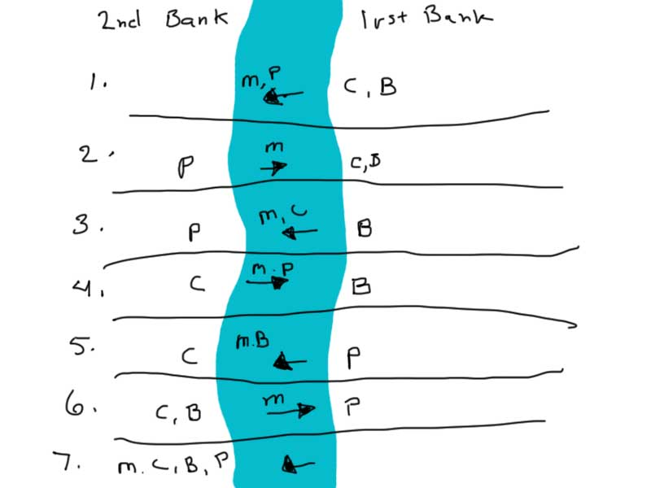

**Socks in the Dark:**

1. Define the problem
2. The problem in this scenario is that there are 20 socks in a drawer. 10 of the socks are black, 6 socks are brown, and 4 socks are white. The room where the drawer is located is dark. I have to decide what the smallest number of socks I would need to blindly select to guarantee getting at least one matching pair of socks. Also, I need to know what the smallest number is that I need to select to guarantee at least one matching pair of each color of socks. I can only check the socks after I have made a selection.
3. This problem can be solved using math.
4. The overall goal is to select the least amount of socks necessary to satisfy the requirements.
5. Break the problem apart
6. The constraints are that I have to make a blind selection, and I cannot check the socks until I finish my selection.
7. The sub-goal is to determine the method for finding the smallest selection possible.
8. Identify potential solutions.
9. Using math, I could determine the smallest amount of socks necessary to fulfill the requirements.
10. Evaluate each potential solution
11. This solution will meet the goals.
12. This solution will work for all cases.
13. Choose a solution and develop a plan to implement it.
14. To select at least one matching pair it is necessary to select 4 socks. There are 3 different colors of socks. If we choose 1 of each color it will give us 3 socks and then the 4th sock that is selected is guaranteed to be a match to one of the 3 chosen colors.
15. To select at least one matching pair of each color of socks, it is necessary to select 18 socks. In order to guarantee that there are 3 different colored pairs, we have to select enough socks to eliminate possibility of leaving one color out of the selection. To do this we add the two largest groups of socks together, black and brown, to get 16 socks. Then, we can select the smallest number needed to make a pair with the 3rd color, which is 2. The total now becomes 18.