**Brief Introduction**There are three folders in the package, including Breakout, Breakout_Dll and Demo.

Breakout is a Unity project, which could be opened with Unity 5.0.1 or higher version.

Breakout_Dll is a Visual Studio project, which could be opened with Visual Studio 2013 or higher version.

There is an android version of game in the folder Demo.

**Technical Specification**

Unity project is created with Unity 5.0.1 and playable scene locates in the folder Scenes.

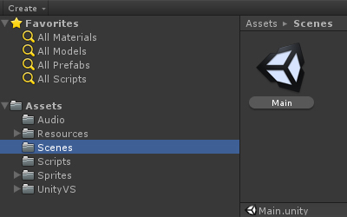

I compile the scripts and place the corresponding Dll file here. More information will be provided in the following Visual Studio project.

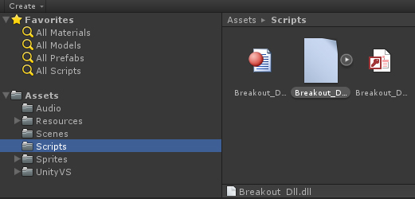

There are two sub-folders in the folder Resources. Prefab contains all the prefabs concerned with gameplay mechanism, such as ball and tile. Xml contains the definition of levels.

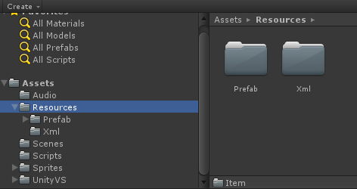

I created a class library project to compile all the scripts into Dll, which is convenient to encrypt the scripts and perform hot patching for game logic on Android platform.

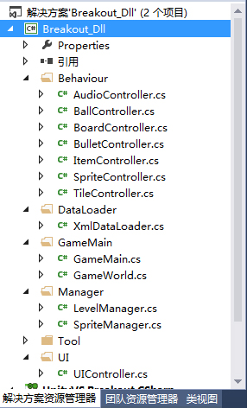

**Gameplay Specification**

You could not only experience the original gameplay mechanism of Breakout, but also enjoy some innovative systems. For example, you could pick up different items to get different effects. When you continuously shoot tiles with bullets, you could find extremely cool Combo system.

