I mentioned previously: for a rigid group of height between n-1 and n, it is required n(n+1) minimum number of segments like:
1 -> 2, 2 -> 6, 3 -> 12, 4 -> 20, 5 -> 30, 6 -> 42, … n -> n(n+1)
It is not quite necessary to have a rigid group. The group is allowed to move/rotate only in something like half of the plane but not entirely (name it a “half-rotated group”).
We may imagine something like:

etc.
They cannot rotate more to the right, but they are allowed to rotate to the left.
Then 2 such mirrored groups linked by a long line may generate the best choice.
For a height between n-1 and n, it is required a smaller minimum number of segments:
1 -> 2, 2 -> 5, 3 -> 10, 4 -> 17, 5 -> 26, … n -> (n-1)n+n+1=n²+1
A more useful fact and rather difficult is to establish the inverse function, the height (that might not be always an integer) as a function of the number of unit segments used for a “half-rotating group”. This interesting function might be something like:
2 -> 1, 5 -> 2, 9 -> 1+, 10 -> 3, 14 -> 2+, 17 -> 4, …
For a larger n, the best choice is a rectangular/trapezoidal shape, of height h.
We know that h(k²+1) = k, and we may approximate h(k) ≈ 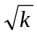( h <).
We may obtain a lower bound by maximizing h(k)(n-2k).
We have to maximize h(n-2(h²+1)) = h((n-2)-2h²) then h = 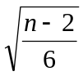 and a rigorous lower bound is: L(n) =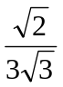(n-2)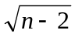= (n-2)^{3/2} ≈ 0.272 (n-2)^{3/2}.
A better lower bound is obtained if we maximize:
f(u) = h((n-2)-2h²) sin u + h² sin u cos u,
cos u is the sub-unitary positive root of:
x² + (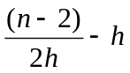) x -  = 0.
cos u = 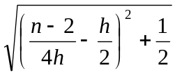 - 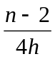+ 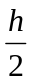 , then sin u and maximize it as a function of h:
( ((n-2)-2h²) + h cos u ) h sin u.
If we make this by approximation we have to maximize (n-2k). We get k ≈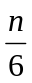and the area is almost like: n= n^{3/2}.
Clearly, we expect something like: A(n) = O(n), where A(n) – maximum area enclosed by a rigid tent made by n unit line segments.
Even I cannot entirely prove it, I conjecture that we have:
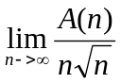 = ≈ 0.272+
If S(n) is the maximized area of a non-rigid tent (half of the regular 2n-gon) then: 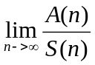 = 0.
For h = 2 and n from 20 to 33:

cos u = 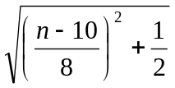 - 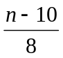
I think there is a miscomputation for 20 to 33 if this kind of tent is used.
At least they may increase with a value which is slightly smaller than 2!
Surely they cannot be in an arithmetical progression with the ratio 2 (starting from 20.472 to 46.472).
We have to maximize:
( 2(n-10) + 4 cos u ) sin u
n = 20: ( 20 + 4 cos u ) sin u & 20.382 and not 20.472
n = 21: ( 22 + 4 cos u ) sin u & 22.349
n = 22: ( 24 + 4 cos u ) sin u & 24.322
n = 23: ( 26 + 4 cos u ) sin u & 26.299
……
n = 30: ( 40 + 4 cos u ) sin u & 40.197
……
n = 33: ( 46 + 4 cos u ) sin u & 46.172 and not 46.472
If the value posted for n = 33 is correct as 46.472 and not 46.172 as I got, then you may have greater values for n = 20 to 32!
It is possible to share how did you manage for n = 20 to 33?
Please correct me if I am wrong!
For h = 4, k = 17 and n from 98 to 102:
n = 98: ( 256 + 16 cos u ) sin u & 256.497
n = 99: ( 260 + 16 cos u ) sin u & 260.489+
n = 100: ( 264 + 16 cos u ) sin u & 264.482
n = 101: ( 268 + 16 cos u ) sin u & 268.475
n = 102 & n-2=100, (n-2)^{3/2} =1000: ( 272 + 16 cos u ) sin u & 272.468
This last value is predicted by the lower bound(n-2)^{3/2} = 1000 ≈ 272.165

