Hello!

We are students at Technion (Haifa, Israel), both lerning at the faculty of Mathematics. Loved your article on N-vex shapes, and were aspecially interested on shapes with infinite spectra. Here are some our modest results and ideas. We will be glad to know, what do you think about them.

An infinite spectrum is a spectrum, that contains infinite number of elements.

- For each 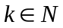 there is a shape with spectrum 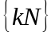. The shape is drawn if Figure 1.
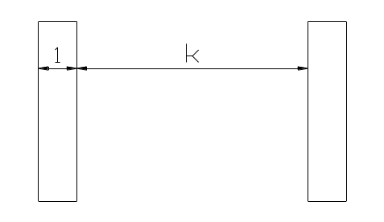
- Figure 1

- Although, the use of unconnected shapes wasn’t the magic wand for all the problems suggested in the article, it is fruitful to consider unconnected shapes.
- For each 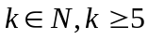 there is a concave –gon with infinite spectrum. The shapes for are presented in Figure 2.
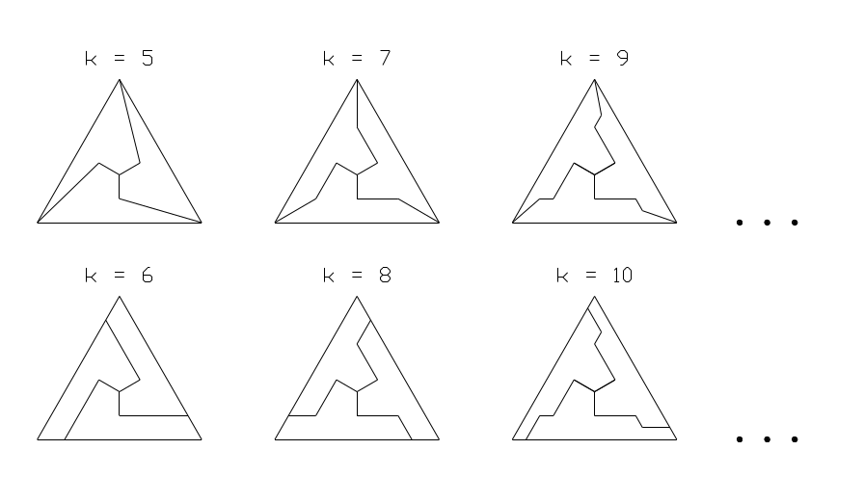
Figure 2

- Conjecture: Every convex 5-gon has a finite spectrum.
- A clue for the proof of the former may be in considering 4-gon’s spectra. For example we were also unable to prove the next conjecture: a 4-gon having 3 angles greater than 90 has a finite spectrum.
- Generally, the task of investigating the spectra of polygons seems to us a possible and important problem, which can lead to general results in the field.

Sincerely Yours,
Gregory Segal and Albert Yankelovich.

