Erika Brandner

Problem of the month (July 2003)

Question: Can you find a way to stack L's of side 1 through 10 so that the stack is 56 units high?

A: Yes; below is one possible solution:
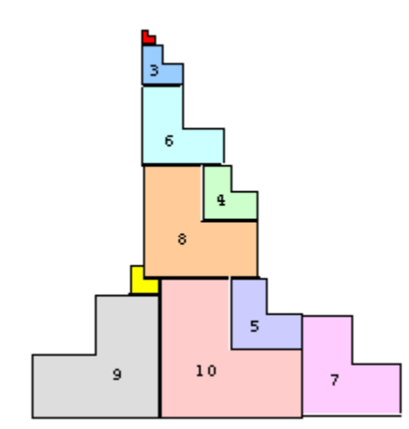
B: What is the highest stack of L's you can create with other numbers of consecutive L's?

1L: (2 units long) 2L: (6 units long) 3L:(8 units long)

4L: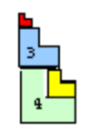 (16 units long) 5L: 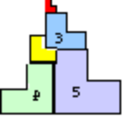 (18 units long)

6L: 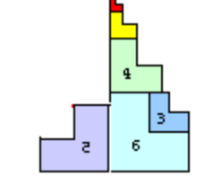(26 units long) 7L: 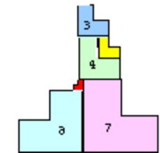 (28 units long)

8L: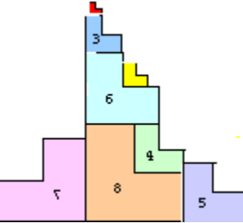 (38 units long) 9L: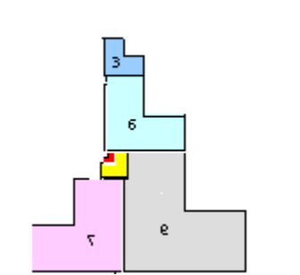(36 units long)

