The numbers in green stands for the findings of A. Cibulis (University of Latvia)
The Compatibility of Tetraiamonds
 |  | 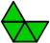 | U |  | I
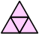 | A | 6 |  | 2
 | I | 2

The Compatibility of Pentiamonds

 |  |  | V |  | J | 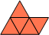 | P
 | I | 2 |  | 2 |  | 2
 | P | 6 |  | 3
 | J | 2

The Compatibility of Tetraiamonds and Pentiamonds
 |  |  | I |  | J |  | P |  | V
 | A | 8 |  | 8 |  | 8
 | I | 4 |  | 4 |  | 4 |  | 4
 | U | 4 |  | 4 |  | 4 |  | 4

The Compatibility of Tetraiamonds and Hexiamonds
 |  | 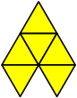 | A |  | C | 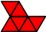 | H | 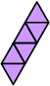 | I |  | J | 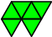 | M |  | O | 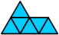 | P |  | S |  | V |  | X | 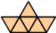 | Y
 | A | 4 |  | 4 |  | 12 |  | 4 |  | 4 |  | 4 |  | - |  | 4 |  |  |  |  |  | -
 | I | 2 |  | 2 |  | 2 |  | 2 |  | 2 |  | 2 |  |  |  | 2 |  | 2 |  | 2 |  | 12 |  | 8
 | U | 6 |  | 4 |  | 2 |  | 2 |  | 2 |  | 4 |  | 2 |  | 4 |  | 2 |  | 2 |  | 6 |  | 2

The Compatibility of Pentiamonds and Hexiamonds
 |  |  | A |  | C |  | H |  | I |  | J |  | M |  | O |  | P |  | S |  | V |  | X |  | Y
 | I | 10 |  | 10 |  | 10 |  | 5 |  | 5 |  | 5 |  |  |  | 5 |  | 10 |  | 10 |  |  |  | 10
 | J | 10 |  | 5 |  | 5 |  | 5 |  | 5 |  | 5 |  | 5 |  | 5 |  | 5 |  | 5 |  |  |  | 10
 | V | 5 |  | 5 |  | 10 |  | 30 |  | 5 |  | 5 |  |  |  |  |  | 10 |  | 5 |  | -
 | P | 5 |  | 5 |  | 5 |  | 5 |  | 5 |  | 5 |  |  |  | 5 |  | 5 |  | 15 |  | 5 |  | 15

The Compatibility of Hexiamonds

 | 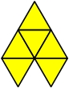 | 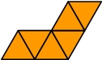 | 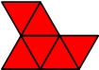 | 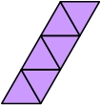 | 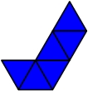 | 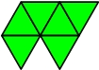 |  | 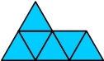 |  |  | 
 | A | C | H | I | J | M | O | P | S | V | X
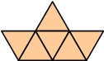 | 3 | 6 | 2 | 3 | 3 | 6 |  | 6 | 4 | 3 | 3
Y
 |  |  | 3 |  | 3 | 6 | - | 2
X
 | 3 | 3 | 2 | 3 | 2 | 2 | 3 | 2 | 2
V
 |  | 3 | 2 | 3 | 3 | 2 | 3 | 2
S
 | 2 | 2 | 2 | 2 | 2 | 2 | 6
P
 | - | 3 | 6 |  | 6 | 6
O
 | 2 | 2 | 2 | 2 | 2
M
 | 3 | 3 | 2 | 3
J
 | 2 | 2 | 3
I
 | 3 | 3
H
 | 2
C

Remark. This table has been constructed independently from that one given in Puzzle Fun by Rodolfo Kurchan (R. M. Kurchan, Puzzle Fun, Parana 960 5”A” (1017), Buenos Aires, Argentina, N6, August 1995) of what I was unaware previously. It turns out that my table is a slight improvement of afore-mentioned table.
The minus sign stand for the incompatibility of the pairs (A, O) and (O, X). These are two improvements. The third improvement is the finding of the smaller common multiple of the pair (S, Y).

