The SP matrices exist in all the sizes m x n which are not m x 1 or 1 x n or 2 x 2. An empirical method described hereafter and based on the calculation of the lowest common multiples of two series of numbers allows to obtain such matrices with a very high level of success.

If we consider the 3 x 2 SP matrix given as an example in the problem, it is natural to write :

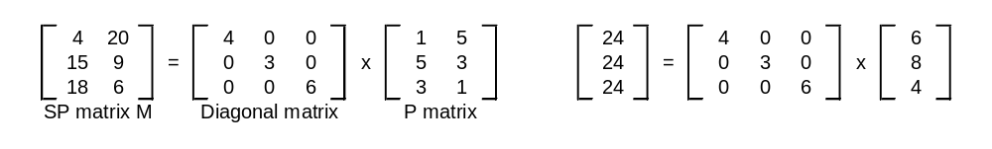
In the P matrix, the product of each column is the same (15) while the sums of the three rows are respectively : 6, 8 and 4 so that the sum 24 of the rows of the matrix M is the LCM of these three numbers. The terms of the diagonal matrix are equal to the ratios LCM/sum of each row of the P matrix.
So if we are able to find a P matrix, we can infer a SP matrix.

What are the characteristics of a P matrix ?
Let a(i,j) the general entry of the i-th row and of the j-th column , s(i) = sum[a(i,j)] for j=1 to n and
p(j)=prod[a(i,j)] for i=1 to m
1)Within any row i , all the entries a(i,j) are different. The sums s(i) can be equal or different but all the ratios p(i,j)/s(i) must be different whatever i=1 to m and j=1 to n.
2) All the products p(j) are equal for j=1 to n

Let’s take an example of a 4 x 3 P matrix.
As whatever i s(i)>=1+2+3=6, it is easy to choose the entries a(i,j) of the three first rows all different within each row in a such way that s(1), s(2) and s(3) are prime numbers or relatively prime numbers.
Therefore, the condition 1) above mentioned will be satisfied.
For example :
a(1,1)=1 a(1,2)=2 a(1,3)=3 s(1)=6
a(2,1)=4 a(2,2)=2 a(2,3)=1 s(2)=7
a(3,1)=6 a(3,2)=1 a(3,3)=4 s(3)=11
The partial products p’(j) = prod[a(i,j)] for i=1 to 3 are respectively equal to :
p’(1)=24 p’(2)=4 p’(3)=12
We check that all these products p’(j) are different. If it was not the case, we would modify ,for example,the entries of the 3rd row.
We calculate the entries a(4,1), a(4,2) and a(4,3) so that p(1)=p(2)=p(3) is the LCM(n°1) of p’(1),p’(2) and p’(3) that is to say 24.
Then a(4,1)=24/24=1 a(4,2)=24/4=6 and a(4,3)=2 ➔s(4)=9 and we check again that the ratios a(4,j)/s(4) for j=1 to 3 are all different of the ratios a(i,j)/s(i) for i=1 to 3 and j=1 to 3. If it was not the case, we would modify again the entries of the 3rd row or of the 2nd one etc…The probability of a quick convergence of the process is very high.
The LCM(n°2) of 6,7,11 and 9 is equal to 2*7*9*11=1386. Then the entries of the diagonal matrix are respectively 231, 198, 126 and 154 and we infer a 4 x 3 SP matrix with sum=1386 and
product=21 300 003 648.

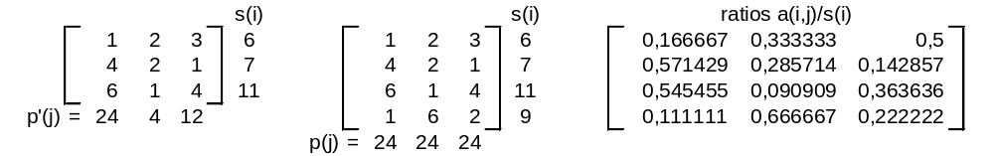

and the 4 x 3 SP matrix is defined by the relation :

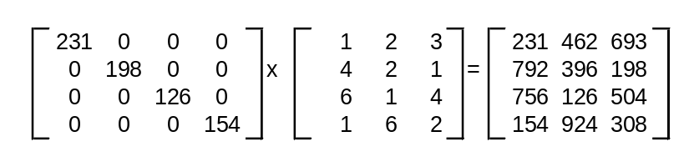
Obviously with this method, we have very little chance to obtain the smallest SP matrices . In order to get this kind of matrices,we have to find the lowest LCM(n°2) that is to say that the sums s(1), s(2),s(3), …s(j) should have the greatest number of common factors with a higher risk that the ratios a(i,j)/s(j) are not different.

Hereafter the smallest SP matrices that I have identified for the values of m=2 and n=4,5,…12, then n=2 and m=4,5,6, then m=3,n=3 m=3,n=4 m=4,n=3 and at last m=4,n=4.
It is worth mentioning that the 2 x12 SP matrix is characterized by the row sums and the column products equal to 1260.

