Solving for and in the parametric ellipse

Given two known vertices of the ellipse, 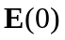 and 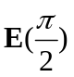, the solution for each component index of and in 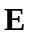involves the solution of two equations for two unknowns.

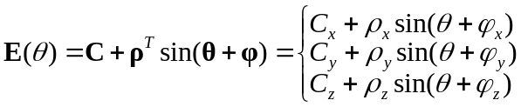 (1)

For each vector component 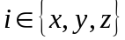, find as:

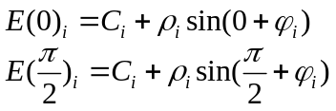 (2)

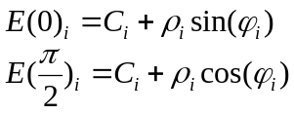 (3)

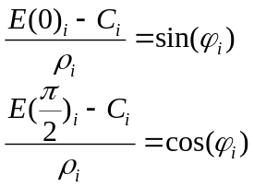 (4)

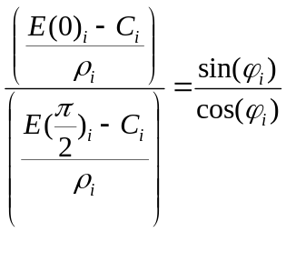 (5)

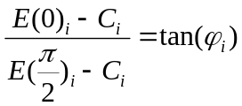 (6)

Finally, solving for :

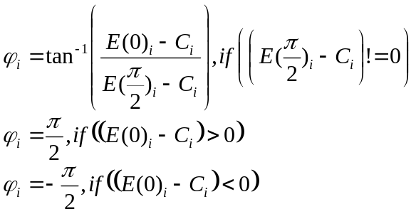 (7)

Once is known, solve for beginning with (4):

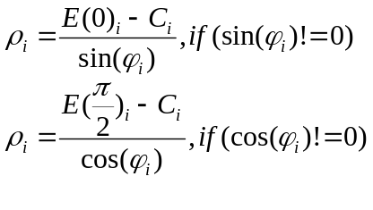 (8)

