ESC Circuits

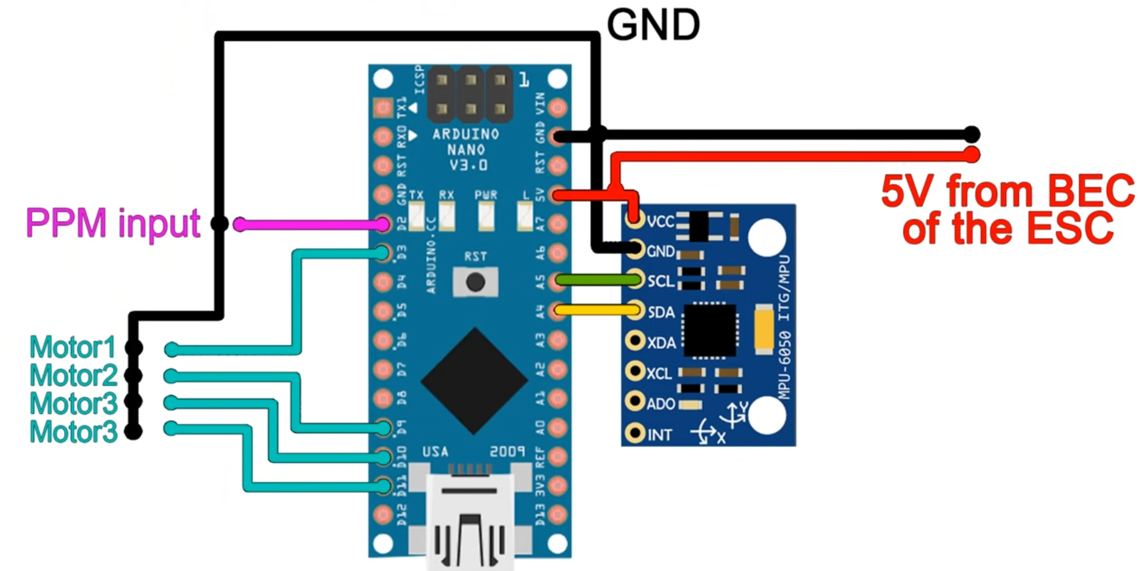

PPM input from NRF24L01 circuit – see next circuit (connects to D2, GND, RST)

Every ESC should be connected in parallel (with MPU6050) to ground

Motor 1, 2, 3, 4 lines are 5V connections to ESCs not directly to motors

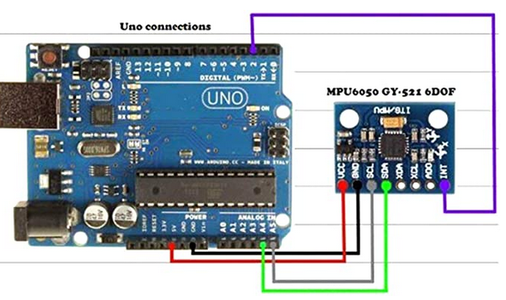

Transceiver Circuits

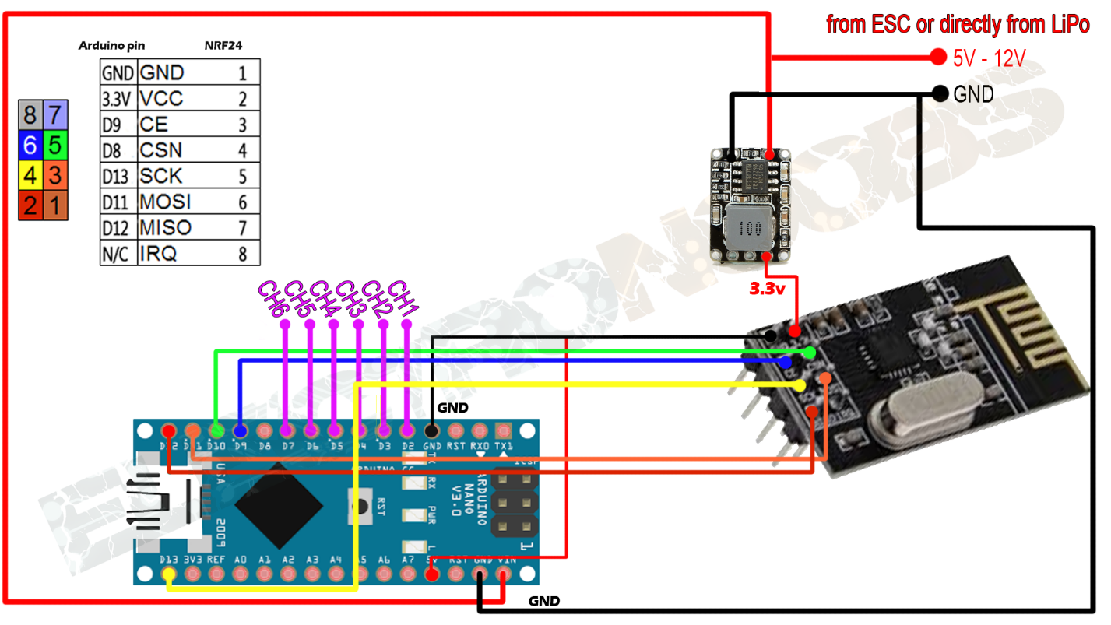

PPM output from flight controller (see previous circuit)

