CPSC 341 Operating Systems and Networks

Spring 2012

Non-credit HW

# No due date

# Written Problems

1. When messages are sent over the Internet, they are divided up into several smaller packets. In this problem, we explore the effect of segmentation has on the delay of transmitting a large message. For this problem, we’ll use the simple network of three links shown below. Each switch uses store-and-forward packet switching. This means that switch must receive and store the entire packet before forwarding it to the next link.

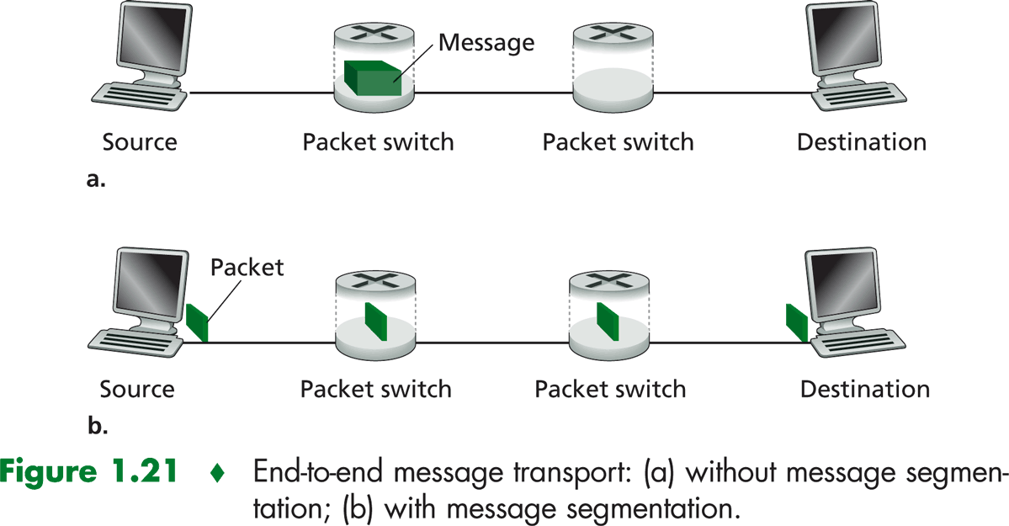

For this problem, consider a message that is 9.0 x 106 bits long. Each link in the figure is 2,000 m long, has bandwidth of 1.5 Mbps (bps = bits per second), and propagation speed of 2.0 x 108 m/s. Ignore propagation and queuing delays.

a. Assume the file is transmitted using one large message (part a in the figure). How long does it take to move the message from the source to the first packet switch?

b. How long will it take to transfer the entire message from the source to the destination if the message is send in one packet?

c. Assume the file is segmented into 6,000 packets, each containing 1,500 bits of the message (part b in the figure). How long does it take to move the first packet from the source to the first switch?

d. How long does it take to transfer the entire message from the source to the destination when the message is divided into 6,000 packets? Compare your answer to that of part b.

2. A disk block is 2 KB and indexed allocation is used. An inode for a file is 128 bytes long, 32 bytes are used for status info. The remaining 96 bytes are used for index entries – 4 bytes per entry.

What is the maximum amount of data that can be stored in a file if the following schemes are used?

a. each index entry is a pointer to a direct block

b. each index entry is a pointer to a single indirect block

c. the first 22 entries are pointers to direct blocks, the 23rd entry is a pointer to a single indirect block, and the 24th entry is a pointer to a double indirect block

3. Read Chapters 15 and 16 in the text on Linux and Windows 7 respectively. Pick any three of the following OS characteristics and describe the key differences between Linux and Windows 7.

* Design Principles
* Process Management
* Scheduling
* Synchronization
* Memory Management
* File Systems
* I/O
* Networking

For each characteristic, your answer should be one to two paragraphs. Be sure your answer specifically highlights the differences – don’t simply give a two paragraph response where one paragraph describes Linux and the other paragraph describes Windows 7.