Chinook salmon in the Sacramento river move with the flow pulses. When these flow pulses Cross the weirs, salmon move into the bypasses as particles. Investigating when the fish are in the system and when floodplain habitat is available is the difference between available habitat and effective habitat.

The rich diversity of the evolutionary significant units (ESUs) of Central Valley Chinook salmon historically led to juvenile salmon using freshwater habitats for migration and rearing throughout the year (Herbold, 2018). Currently, Chinook Salmon juvenile downstream migration and rearing is concentrated in the winter and spring months (Figure XX). Chinook Salmon juveniles move presumably with flow pulse (and day length???) cues. When downstream migration coincides with flow pulses of sufficient magnitude to overtop the flood control weirs along the Sacramento River, juvenile salmon phenotypes (fry, parr, and smolts) are observed in the Sutter and Yolo Bypasses. Due to the design capacity of the constricted channel levees downstream of Colusa, CA and the weir elevations, the Sutter and Yolo Bypass weirs have various activation thresholds resulting in different inundation frequencies. The Yolo Bypass typically floods in nearly 2 out of 3 years, with a flood duration of several days (4 to 10 days) or even extending to 1 or 2 months in higher flood events (Takata et al. 2017; Jeffres et al. 2020). The Sutter Bypass weirs have a lower activation threshold with more frequent and longer inundation compared to the Yolo Bypass. The Sutter Bypass weirs consist of Moulton, Colusa, and Tisdale which generally overtop in the south (downstream) to north order with Tisdale requiring the least activation flow and which has the greatest inundation frequency. Fremont weir is the primary weir to the Yolo Bypass and has a higher activation threshold than the Tisdale or Colusa Weirs, but a similar activation threshold and frequency pattern to Moulton. An operable weir, the Sacramento Weir, is seldom used when extreme flooding conditions threaten the city of Sacramento.

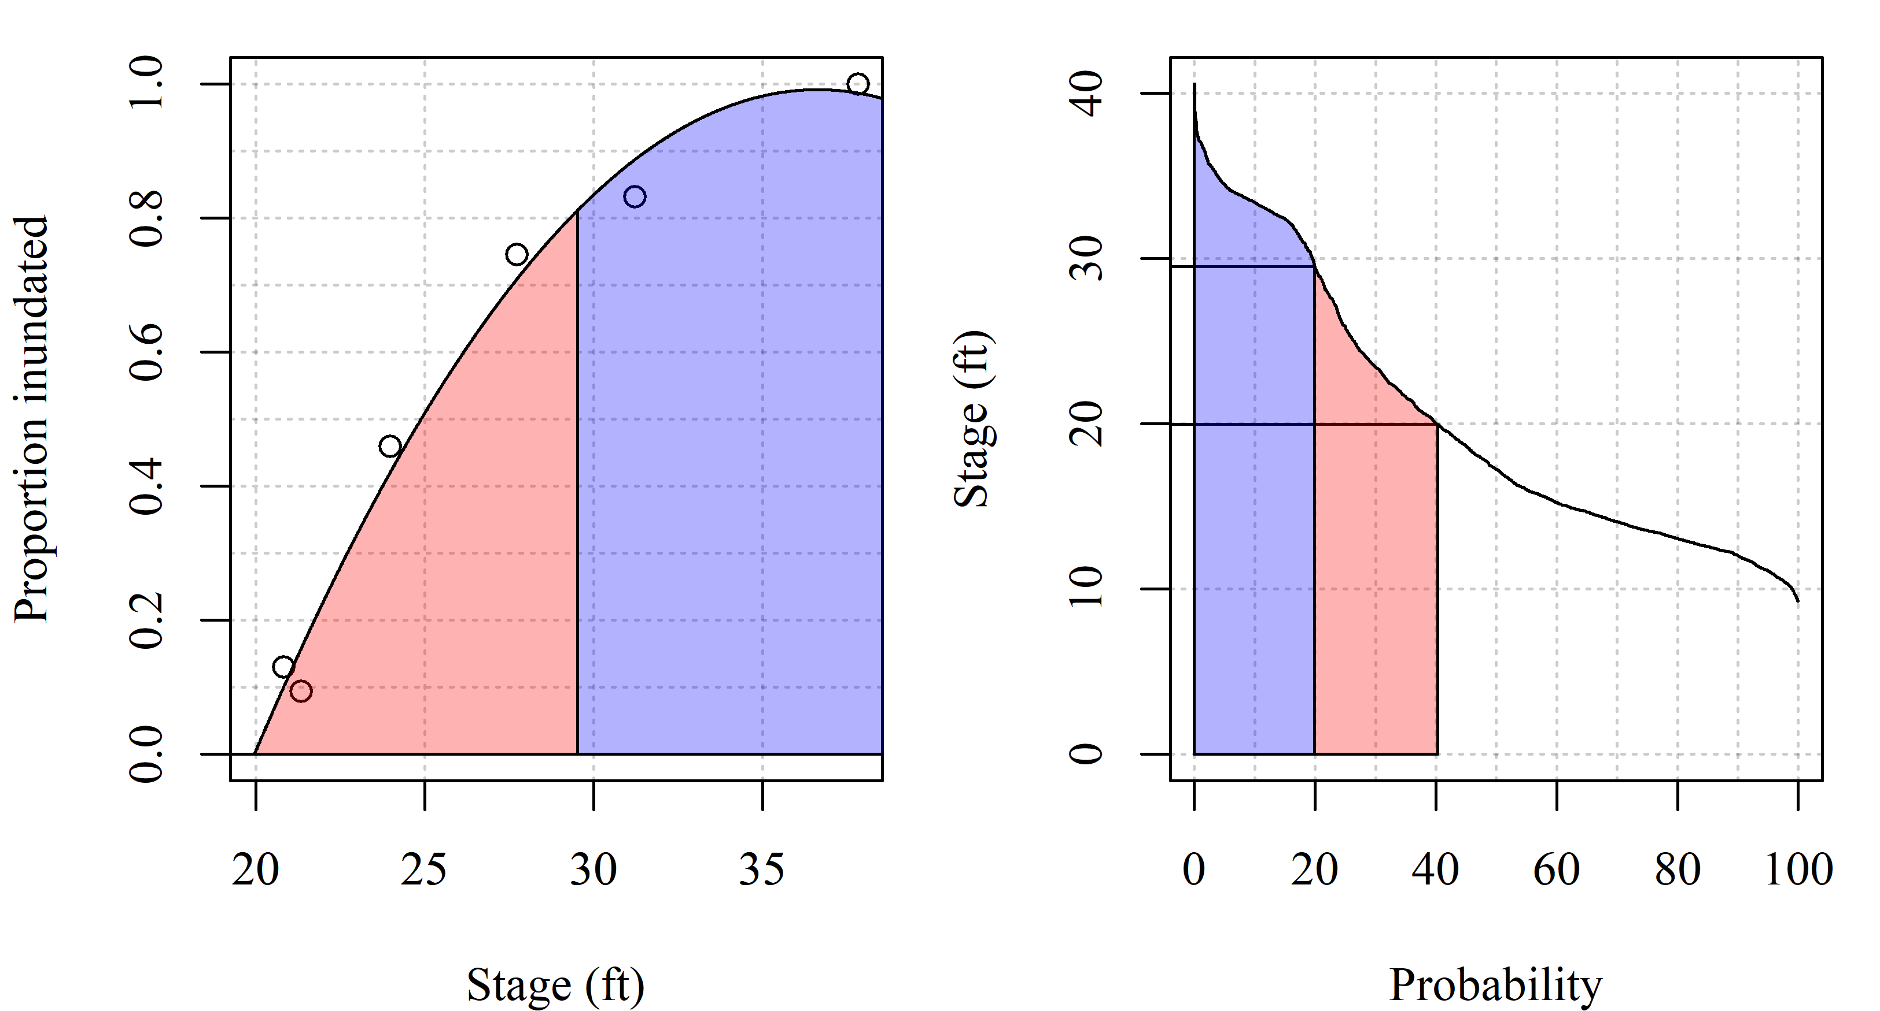

Figure 6. Left panel shows the relationship between the lower Sutter Bypass inundation proportion and river flow at Verona. The right panel is a flow duration curve for river flow data from January to March. Red shading represents flows where the lower Sutter Bypass is inundated up to the approximate flow where Fremont weir spills, above which is shaded in blue.