PROJECT DESCRIPTION DOCUMENT

Team Information
Team Name: GALACTUS99
Team Members: Eric Homiak,
Sam Kelly,
Josh Casteneda

Description of the Business Logic

We need an application that we can use for inventory management. We need to be able to use it to add new games to our inventory, search our current inventory for games, and export a document that shows our current inventory.

Business Requirements

The game store required an application to use as their inventory management system. This application needed to be able to input new inventory, search the inventory for a game by title, and export a .csv file of its current inventory.

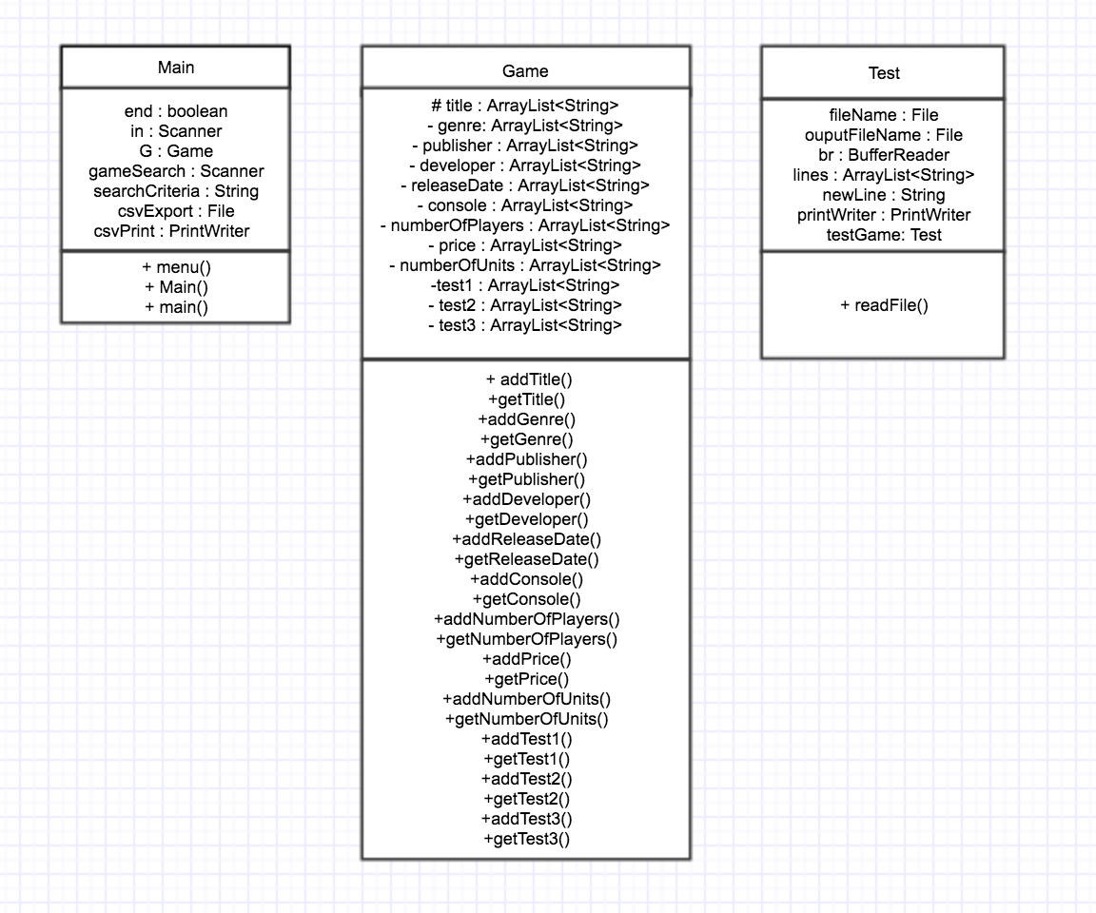
UML Diagram of Class Definitions

Explanation of Using "static members, inheritance, list, queue, linked-list”

We used static members to be able to update variables and reference variables when using the application. Our list and linked list were used to store information into the application during use. We used inheritance in the testing class to test r, e, and I test types.

