Erich Then
Lab 03 Deliverables

Part 1: Authenticated Encryption Analysis

Writing out parameters for myself:
- M = Erich Then does not know which one is Diffie and which is Hellman
- K1 = 801458155801458155801458155801458155801458155801458155801458155
- K2 = 801458155
- IV = ErichThen8014581558014581558014581558 (NOTE: this, as well as the example, has invalid characters for hex; I’m going with the spec and adding digits until 16 bytes.)
SCHEME 1
Note: I am boxing both C and H. I am unsure if we need to box both or just H as C serves kind of as an intermediary, however since Alice sends both, it makes sense to box both.
Note: I am also not going to be putting a box around H, even though Alice sends it, as the spec says only to markup input and output ciphertext, and H is not ciphertext.
[SCREENSHOT] Alice’s side of communication
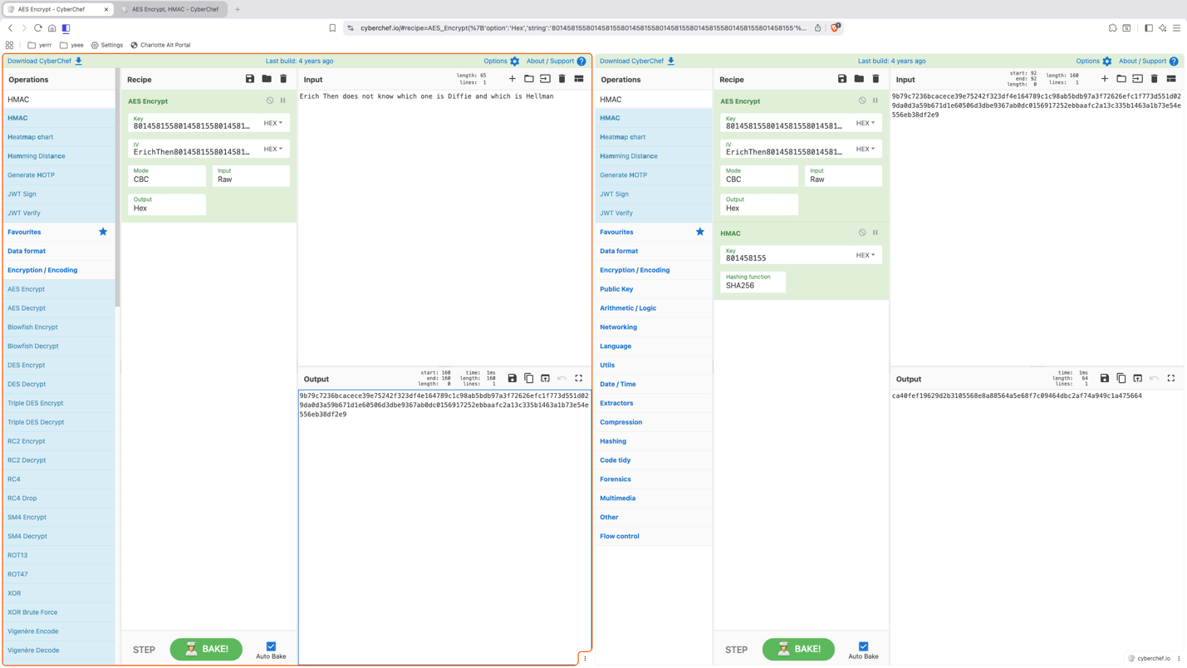
[CAPTION] Ciphertext of M using K1 calculated and sent by Alice (C) on the left; the HMAC of this ciphertext using K2 calculated and sent by Alice (H) on the right.
[SCREENSHOT] Bob’s side of communication
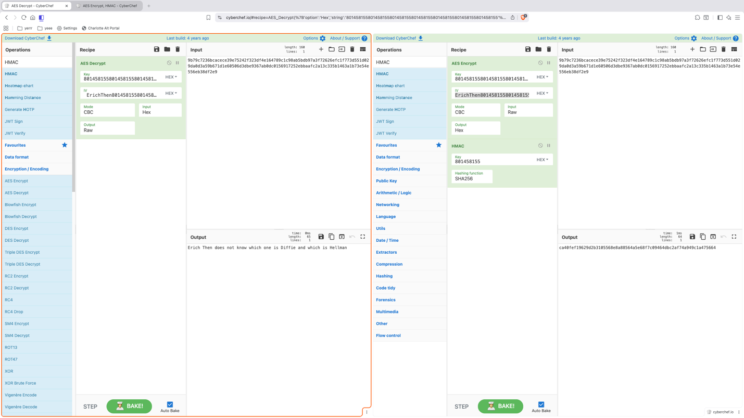
[CAPTION] Ciphertext of M using K1 (C) received by Bob on the left and decrypted using K1, outputting the original plain text input M. Right side not relevant to Bob’s I/O.
---
[CONFIDENTIALITY ANALYSIS]: Yes, the scheme provides confidentiality because the message M is encrypted using AES-CBC with secret key K1, so a passive observer without K1 cannot recover the plaintext.
[INTEGRITY ANALYSIS]: Yes, the scheme provides integrity because H = HMAC(K2, C) allows Bob to detect any modification to the ciphertext; without knowing K2, Mallory cannot forge a valid HMAC for altered data.
NOTE ON CONCLUSION: The title of this scheme, and potentially other schemes though I am unsure, will be highlighted after schemes are done (scheme 1 title will be highlighted then). This is my conclusion section and not needed for each scheme as the highlights will indicate it. I am going with what I believe is intended.
*Continued next page so things fit evenly

[SCHEME 2] -------------------------------
[SCREENSHOT] Alice’s side of communication
Note: The spec is asking to markup the inputted message and outputted ciphertext. Input text M on the right does not result in ciphertext, therefore I highlighted it on the left side only.
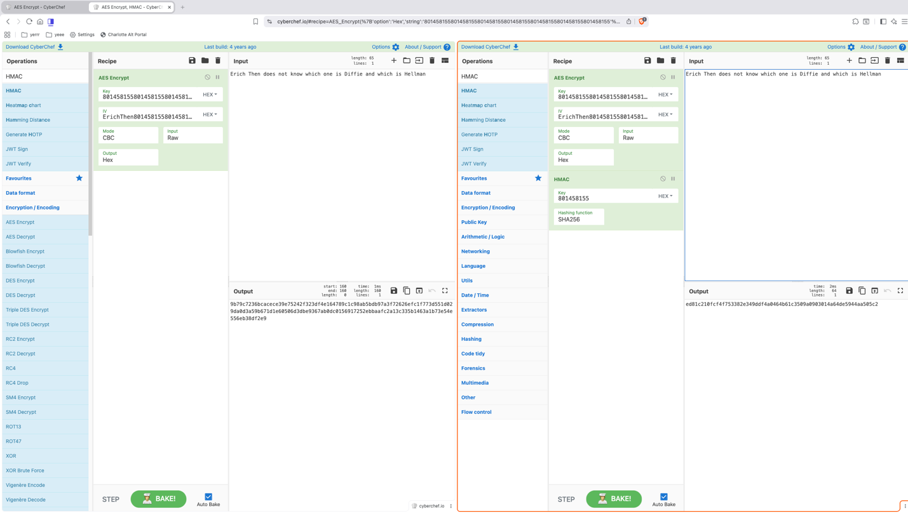
[CAPTION] Ciphertext of the input message (M) using K1 calculated and sent by Alice (C) on the left; the HMAC of M using K2 calculated and sent by Alice (H) on the right.
*Continued next page so things fit evenly

[SCREENSHOT] Bob’s side of communication
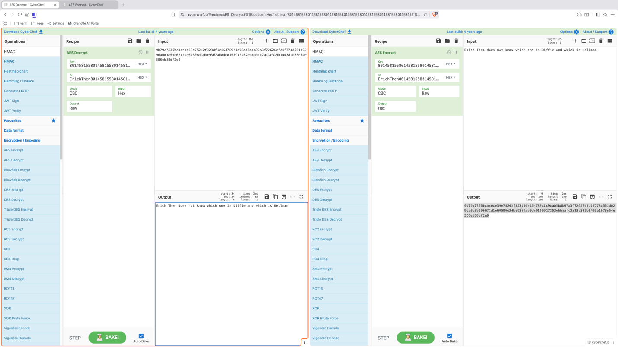
[CAPTION] Ciphertext of M using K1 (C) received by Bob and decrypted using K1, outputting the original plain text M. Right side not relevant to Bob’s I/O.
----
[CONFIDENTIALITY ANALYSIS]: Yes, the scheme provides confidentiality because M is encrypted using AES-CBC with secret key K1, so Eve cannot recover the plaintext without the key.
[INTEGRITY ANALYSIS]: No, the scheme does not provide full integrity protection because the HMAC is computed over M, not C. An attacker can modify the ciphertext C without changing H, leading to an incorrect decryption from Bob.
*Continued next page so things fit evenly

[SCHEME 3] -------------------------------
[SCREENSHOT] Alice’s side of communication
Note: Hashed M (input, highlighted), took output and appended to M, encrypted it (into C, ciphertext output)
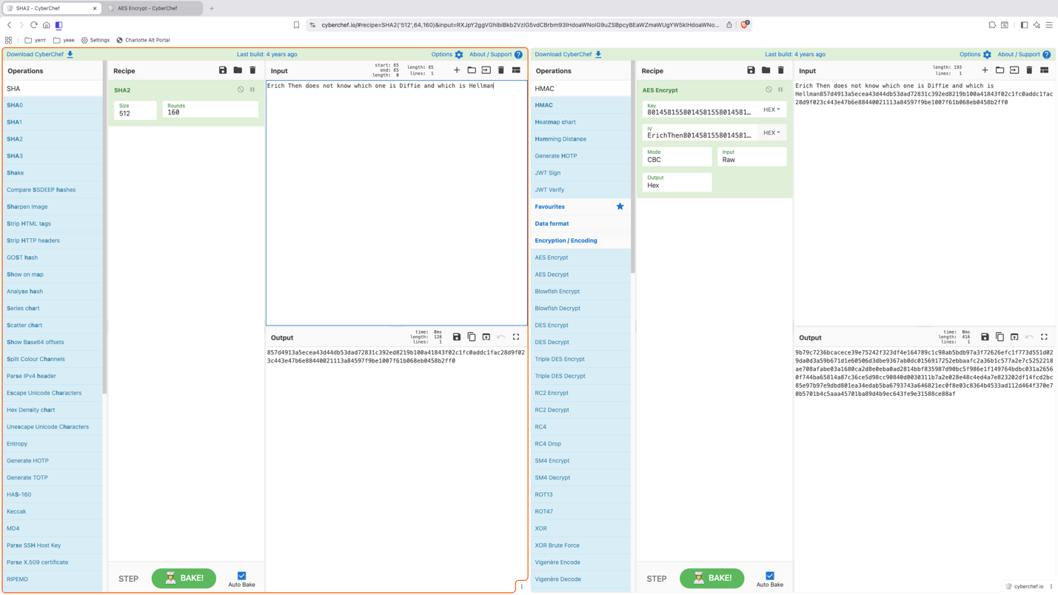
[CAPTION] Ciphertext of the input message concatenated with its hash (M || Hash(M)) using K1 calculated and sent by Alice (C).
*Continued next page so things fit evenly

[SCREENSHOT] Bob’s side of communication
