IMAGE PROCESSING TECHNIQUES
Assignment / Practical Record
Classical Filtering Techniques
Thresholding Techniques
Edge Detection Techniques
Name | Eric Jeevan A
Register Number | 312323243043
Department | B.Tech Artificial Intelligence and Data Science
Tools | Python, OpenCV, NumPy, Matplotlib, VS Code

GitHub Repository
https://github.com/ericjeevan4/Image_Processing_Techniques

1. AIM
To implement and demonstrate classical image processing techniques using Python and OpenCV, covering image filtering, thresholding, and edge detection, and to save the generated outputs for analysis.

2. OBJECTIVES
- To apply classical filtering methods for image smoothing and noise reduction.
- To convert a grayscale image into binary representations using different thresholding methods.
- To detect important boundaries and intensity changes using edge detection operators.
- To visualize and save the output produced by each technique.
- To organize the complete implementation and results in a GitHub repository.

3. SOFTWARE AND LIBRARIES USED
- Python 3.11.6
- OpenCV (cv2)
- NumPy
- Matplotlib
- Visual Studio Code
- GitHub

4. INPUT IMAGE
The same input image was used as the basis for the filtering, thresholding, and edge detection experiments. The image was loaded using OpenCV. For thresholding and edge detection, the image was converted to grayscale.

Figure 1. Input image (input.jpg).
The tested image dimensions were 800 × 1421 pixels with 3 color channels in the original image.

5. CLASSICAL FILTERING TECHNIQUES
Classical filtering operations modify pixel values using a neighborhood around each pixel. In this practical, four spatial filters were implemented: Mean, Gaussian, Median, and Bilateral filtering.

5.1 Mean (Average) Filter
The Mean Filter replaces a pixel with the average of the pixels in a specified neighborhood. It produces smoothing but can also reduce sharp edge details.

5.2 Gaussian Filter
The Gaussian Filter performs weighted smoothing using a Gaussian kernel. Pixels closer to the center of the kernel have greater influence on the output.

5.3 Median Filter
The Median Filter replaces a pixel with the median value of its neighborhood. It is commonly used to reduce impulse or salt-and-pepper noise while retaining useful boundaries.

5.4 Bilateral Filter
The Bilateral Filter performs smoothing while considering both spatial distance and intensity similarity. This helps preserve important edges during smoothing.

5.5 Filtering Output
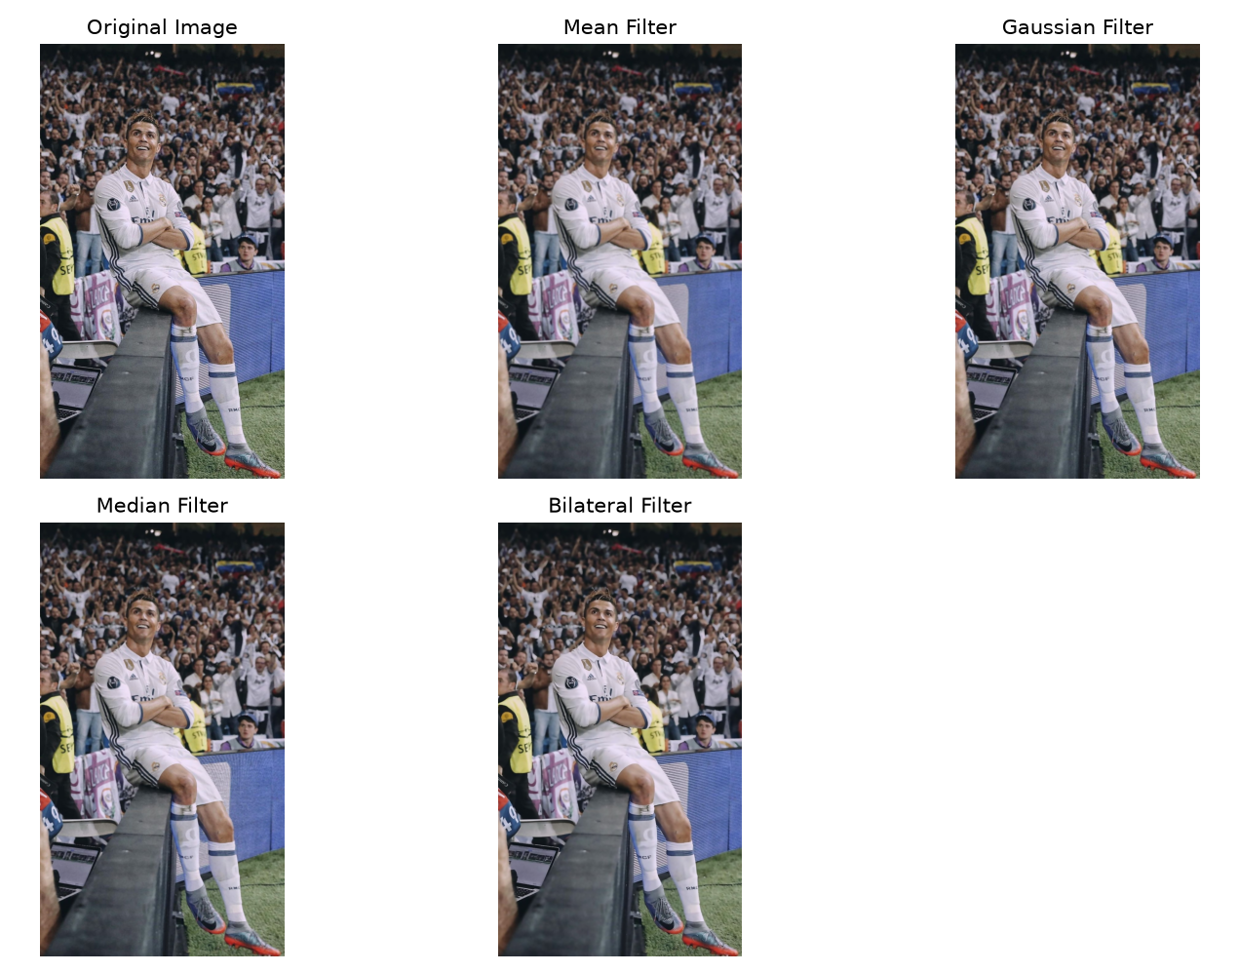
Figure 2. Original image and classical filtering results.
The generated filtering results show the visual effect of the four smoothing techniques. The corresponding output images were saved in the filtering/output directory.

6. THRESHOLDING TECHNIQUES
Thresholding separates pixels according to their intensity values. It is commonly used to create binary images and to simplify image regions for further processing.

6.1 Binary Thresholding
A fixed threshold value is applied. Pixels above the threshold are assigned the maximum intensity, while the remaining pixels are assigned zero.

6.2 Inverse Binary Thresholding
Inverse binary thresholding performs the opposite assignment of binary thresholding, producing the inverted binary representation.

6.3 Adaptive Mean Thresholding
Adaptive Mean Thresholding calculates a local threshold for each region using the mean of neighboring pixels. It can handle images with varying illumination.

6.4 Otsu's Thresholding
Otsu's method automatically determines a threshold from the image histogram. In this experiment, the calculated Otsu threshold value was 109.0.

6.5 Thresholding Output
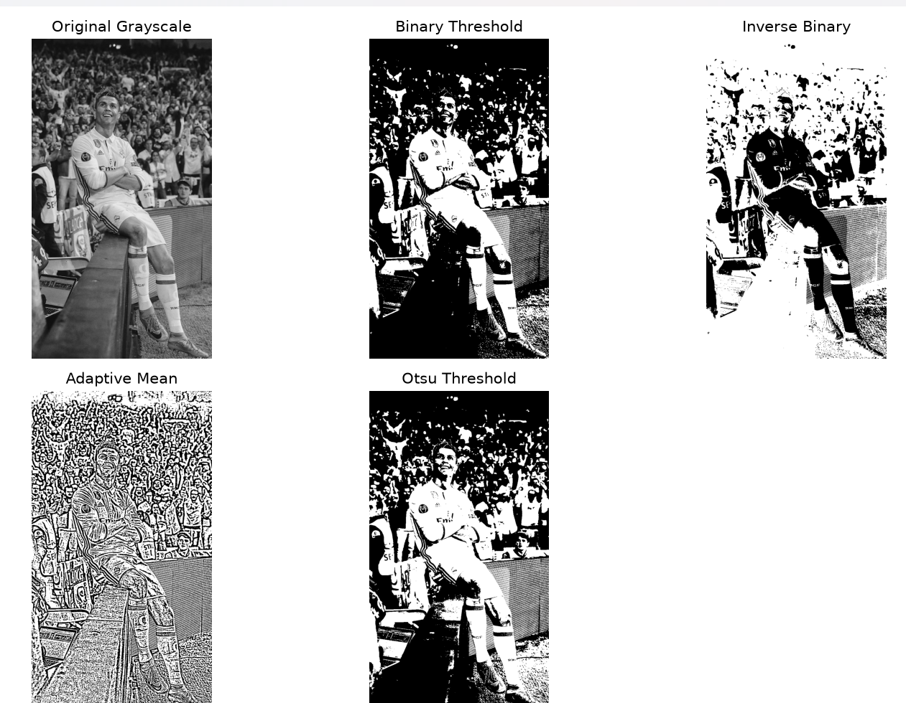
Figure 3. Grayscale image and thresholding results.
The thresholding results were saved in the thresholding/output directory as separate image files.

7. EDGE DETECTION TECHNIQUES
Edge detection identifies locations where image intensity changes significantly. These boundaries can represent object shapes, contours, and other important structures.

7.1 Sobel Edge Detection
The Sobel operator calculates intensity gradients in the horizontal and vertical directions and combines them to highlight edges.

7.2 Prewitt Edge Detection
The Prewitt operator uses horizontal and vertical convolution kernels to detect intensity changes and produce an edge representation.

7.3 Laplacian Edge Detection
The Laplacian operator uses the second derivative of image intensity to emphasize regions of rapid intensity change.

7.4 Canny Edge Detection
The Canny method performs a sequence of operations including noise reduction, gradient calculation, non-maximum suppression, and hysteresis thresholding to produce a thin edge map.

7.5 Edge Detection Output
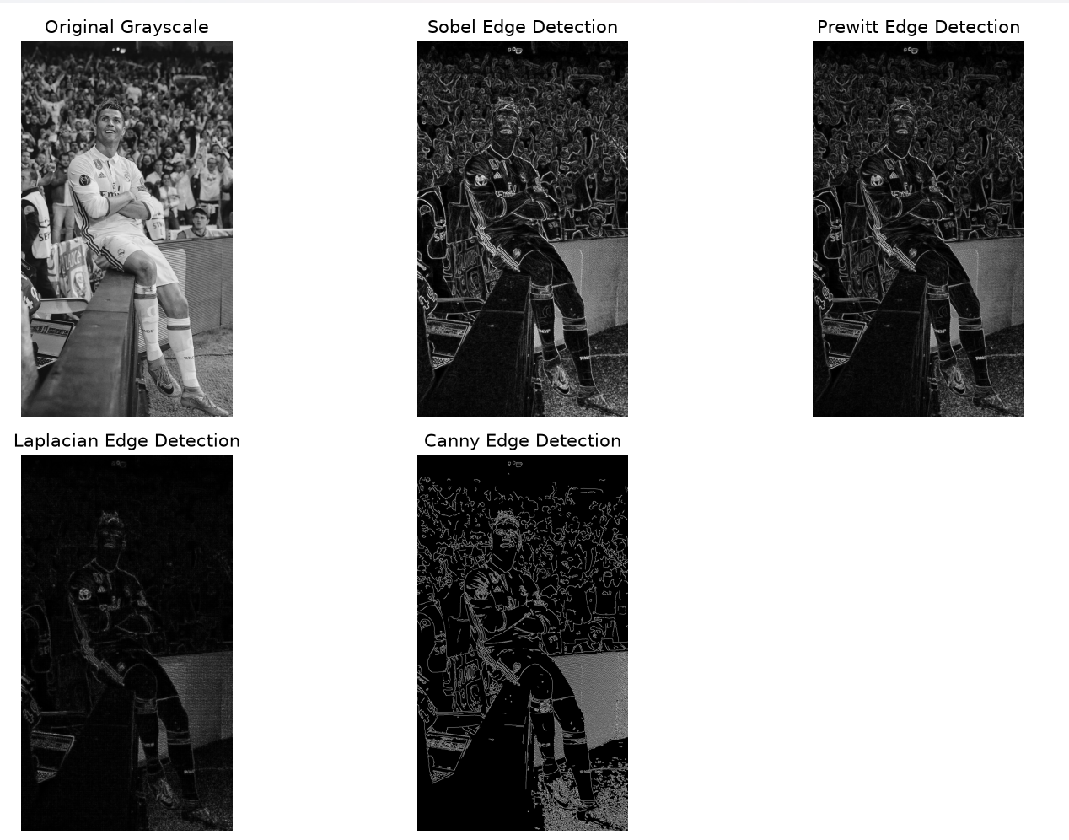
Figure 4. Grayscale image and edge detection results.
The generated edge maps were saved in the edge_detection/output directory.

8. OUTPUT FILES
Category | Technique | Output File
Filtering | Mean | mean_filter.jpg
Filtering | Gaussian | gaussian_filter.jpg
Filtering | Median | median_filter.jpg
Filtering | Bilateral | bilateral_filter.jpg
Thresholding | Binary | binary_threshold.jpg
Thresholding | Inverse Binary | binary_inverse.jpg
Thresholding | Adaptive Mean | adaptive_mean.jpg
Thresholding | Otsu | otsu_threshold.jpg
Edge Detection | Sobel | sobel_edges.jpg
Edge Detection | Prewitt | prewitt_edges.jpg
Edge Detection | Laplacian | laplacian_edges.jpg
Edge Detection | Canny | canny_edges.jpg

9. PROJECT STRUCTURE
Image_Processing_Techniques/
├── images/
│ └── input.jpg
├── filtering/
│ ├── classical_filters.py
│ └── output/
│ ├── mean_filter.jpg
│ ├── gaussian_filter.jpg
│ ├── median_filter.jpg
│ └── bilateral_filter.jpg
├── thresholding/
│ ├── thresholding.py
│ └── output/
│ ├── binary_threshold.jpg
│ ├── binary_inverse.jpg
│ ├── adaptive_mean.jpg
│ └── otsu_threshold.jpg
├── edge_detection/
│ ├── edge_detection.py
│ └── output/
│ ├── sobel_edges.jpg
│ ├── prewitt_edges.jpg
│ ├── laplacian_edges.jpg
│ └── canny_edges.jpg
├── main.py
└── README.md

10. RESULT
The three assigned categories—Classical Filtering Techniques, Thresholding Techniques, and Edge Detection Techniques—were implemented successfully using Python and OpenCV. The outputs were generated, displayed, and saved as separate image files.

11. CONCLUSION
The practical demonstrated how different image processing techniques affect an input image. Filtering was used for smoothing, thresholding for intensity-based separation, and edge detection for identifying important boundaries. The complete implementation and outputs were organized in the GitHub repository.
GitHub Repository:
https://github.com/ericjeevan4/Image_Processing_Techniques

