5-DOF-Arm Documentation
By Eric Oh
8/13/2026

Introduction:
The goal of this project is to fully develop a 5 degrees of freedom robotic arm that can accomplish a pick and place task.

Requirements:

Functional
- Five independently actuated rotational degrees of freedom.
- Complete a pick-and-place task: approach, grasp, transport, and release a target object.
- Design payload of 0.4 kg at the tool center point (TCP).
- 400 mm reach measured from the base yaw axis to the TCP.
- Capture teleoperated demonstrations and reproduce the task autonomously through imitation learning.

Mechanical
- Every joint must hold at least a 1.2x torque margin over its worst-case static holding torque.
- Link mass budget of 0.06 kg per link (carbon fiber tube plus printed clamps).
- Joint gearboxes must couple to one another without introducing an axial offset that creates a large parasitic moment.

Electrical
- All Five actuators share a common power rail and a single CAN-FD bus in a daisy-chain topology.
- Absolute rotary position feedback at every joint.
- Controller mounting must not interfere with motor body geometry or rotor magnet standoff.

Software
- Run on the LeRobot stack for demonstration recording, ACT policy training, and inference.
- Per-joint commissioning through the moteus tooling (calibration, position/velocity/torque control modes).

Mechanical Architecture:
The joint order are as follows:
Joint | Function | Notes
J1 | Base yaw | Rotates the entire arm about the vertical axis
J2 | Shoulder pitch | Highest-torque joint; drives L1
J3 | Elbow pitch | Drives L2
J4 | Forearm roll | Located at the elbow, not at the wrist
J5 | Wrist roll | Wrist assembly

Actuation:
The arm uses two actuator families. The three proximal joints, which carry the bulk of the load, use MJ5208 brushless motors driven by moteus r4.11 controllers through custom cycloidal reducers. The three distal wrist joints use SteadyWin GIM3505-8 integrated gearmotors driven by moteus-c1 controllers.

Joint | Motor | Controller | Reduction | Reducer type
J1 | MJ5208 | moteus r4.11 | 15:1 | Custom cycloidal
J2 | MJ5208 | moteus r4.11 | 30:1 | Custom cycloidal
J3 | MJ5208 | moteus r4.11 | 15:1 | Custom cycloidal
J4 | GIM3505-8 | moteus-c1 | 8:1 | Integrated planetary
J5 | GIM3505-8 | moteus-c1 | 8:1 | Integrated planetary

MJ5208 (J1-J3)
The MJ5208 is a brushless motor sold by mjbots, wound at 330 Kv and intended specifically for pairing with moteus controllers. It is a bare motor, so there are no gearbox and no encoder, which is why J1-J3 need custom cycloidal reducers and a separately mounted diametric magnet.
Parameter | Value
Peak torque | 1.7 N.m
Peak power | 600 W
Kv | 330 rpm/V
Maximum speed | 7500 RPM

GIM3505-8 (J4-J6)
The GIM3505-8 is an integrated 8:1 planetary gearmotor with an onboard 14-bit magnetic encoder. Because the wrist joints see far lower torque than the shoulder and elbow, an off-the-shelf integrated unit is used here rather than a custom reducer, which saves both design time and distal mass.
Manufacturer specifications (from the GDZ-driver planetary reduction motor selection table):
Parameter | Value
Gear ratio | 8:1
Gearbox type | Planetary, aluminum gears
Rated torque (output) | 0.67 N.m
Peak torque (output) | 1.79 N.m
Rated speed (output) | 230 RPM
Maximum speed (output) | 400 RPM
Rated voltage | 24 V
Operating voltage range | 12-40 V
Rated power | 36.72 W
Rated current | 1.53 A
Peak current | 3.99 A
Torque constant | 0.44 N.m/A (output-referenced)
Speed constant | 16.67 rpm/V (output-referenced)

Torque headroom at the wrist
The 0.67 N.m continuous rating is generous for this application. A 0.2 kg payload weighs 1.96 N, so it demands roughly 0.20 N.m at J5 for every 100 mm of offset between the J5 axis and the payload center of mass. J5 therefore stays inside its continuous rating out to about 340 mm of offset - far beyond anything the wrist geometry will produce. The wrist joints are not the constraint on this arm; the shoulder is.

Driver substitution: moteus-c1 in place of the GDZ34
The GIM3505-8 normally ships with a GDZ34 integrated driver. This design discards it in favor of the moteus-c1, so that all six joints run the same firmware, the same CAN-FD bus, and the same torque-control interface. That substitution means the motor must be characterized at the rotor rather than at the output, since the moteus-c1 commutates the rotor directly. Since the GDZ34 is being removed anyway, this protocol difference does not need to be bridged.

Integration between GIM3505-8 and moteus-c1
Integrating the GIM3505-8 motor with the moteus-c1 can be done by ordering the GIM3505-8 with an AS5047P encoder. This is the same encoder that is on the moteus-c1 controller. To connect the external AS5047P encoder with the moteus-c1, AUX2 must be used on the controller which can be seen below. The 3 phases on the controller can be connected to the 3 phases of the motor.
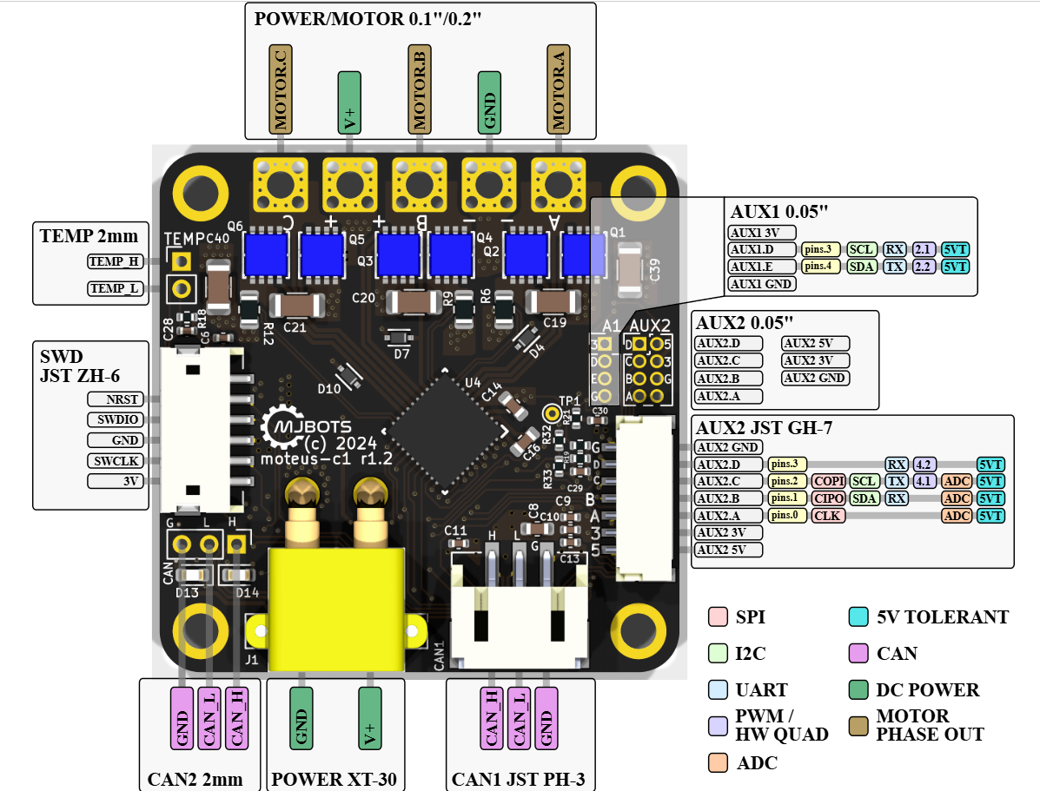

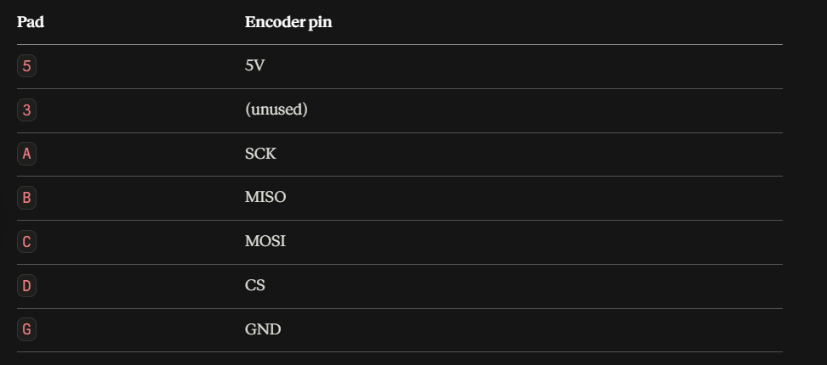
In addition, some configurations must be set through the moteus-c1 to turn off the encoder on the controller and read from the encoder on the GIM3505-8 motor. The following commands performed in the Moteus controller terminal support this change:
conf set aux1.spi.mode 1
conf set aux2.pins.0.mode 1
conf set aux2.pins.1.mode 1
conf set aux2.pins.2.mode 1
conf set aux2.pins.3.mode 2
conf set aux2.spi.mode 2
conf set aux2.spi.rate_hz 12000000
conf set motor_position.sources.0.aux_number 2
conf set motor_position.sources.0.type 1
conf set motor_position.sources.0.cpr 16384
conf set motor_position.sources.0.reference 0
conf set motor_position.commutation_source 0
conf set motor_position.output.source 0
conf set motor_position.rotor_to_output_ratio 0.125
conf write

Cycloidal Reducer Design:
Two reducer designs were developed: a 30:1 unit for the shoulder and a 15:1 unit built in two copies for the base yaw and elbow. Both share the same architectural pattern - twin cycloidal discs mounted 180 degrees out of phase to cancel the eccentric imbalance, a hex input shaft, ring rollers on pins, and an output roller pin circle.

30:1 Reducer (J2 - Shoulder)
Parameter | Value
Reduction ratio | 30:1
Ring diameter | 120 mm
Ring rollers | 31 rollers, 10 mm diameter (5 mm radius)
Camshaft diameter | 20 mm
Output pin circle | 80 mm
Output rollers | 8 rollers, 10 mm diameter
Cycloidal discs | 2 discs, 8 mm thick, 180 degrees apart
Eccentricity | 1.0 mm
Profile coefficient K1 | 0.52
Input | Hex shaft
Disc material | PLA or PETG (selection pending)
Assembly mass | ~1.32 kg including motor and controller

The cam assembly requires two eccentric bearings (one per disc) plus two support bearings in line with the input axis, so the eccentric loads are reacted on both sides rather than cantilevered.

15:1 Reducer (J1 - Base Yaw, J3 - Elbow)
Two identical units are being built from a common template.

Parameter | Value
Reduction ratio | 15:1
Ring rollers | 16 rollers, 10 mm diameter (5 mm radius)
Camshaft diameter | 10 mm
Output rollers | 6 rollers, 10 mm diameter
Cycloidal discs | 2 discs, 180 degrees apart
Disc center hole | ~20 mm
Output roller holes | ~12 mm
Input | 5 mm hex shaft
Cam | 3D printed

Electronics and Control:

Bus topology
All controllers sit on a shared power rail and a single CAN-FD daisy chain. Three moteus r4.11 controllers are wired into this chain for J1-J3; the three moteus-c1 controllers for the wrist join the same bus.
Parameter | moteus r4.11 (J1-J3) | moteus-c1 (J4-J6)
Voltage input | 10-44 V | 10-51 V
Peak phase current | 100 A | 20 A
Continuous phase current (uncooled) | 12 A | 5 A
Continuous phase current (cooled) | 32 A | 14 A
Peak electrical power | 900 W @ 30 V | 250 W @ 28 V
Mass | 14.2 g | 8.9 g
Dimensions | 46 x 53 mm | 38 x 38 x 9 mm
CPU | STM32G4 | STM32G4
Communications | 5 Mbps CAN-FD | 5 Mbps CAN-FD

Both boards run the same firmware image and use the same power, CAN, and AUX2 connectors, so the mixed r4.11 / c1 chain behaves as one homogeneous bus from the host's point of view.

Position feedback
- J1-J3: moteus-style on-axis magnetic encoder, using a diametric magnet mounted on the stator-side axle. This is the standard moteus rotor-position arrangement and keeps the sensing on the motor side of the reducer.
- J4-J6: the plan is to wire the GIM3505-8's own motor-side AS5047P to the moteus-c1, rather than using the AS5047P that is already onboard the c1. This sidesteps the magnet standoff problem described below, since the motor's factory encoder is already correctly spaced from its own rotor magnet.

Bring-up status
Currently at hardware bring-up: running moteus_tool --calibrate against an MJ5208 + moteus r4.11 pair on Windows. Calibration establishes the commutation offset and encoder mapping, and must be completed per motor-controller pair before any closed-loop position control.

Software and Learning Stack:
The arm targets imitation learning as its control approach rather than classical trajectory planning. The intended pipeline is:
- Record teleoperated demonstrations of the pick-and-place task.
- Train a policy on those demonstrations using the LeRobot stack.
- Run inference on the trained policy with the arm executing autonomously.
This choice drives several hardware requirements upstream: joints need smooth, backdrivable-feeling torque control for teleoperation, and the control loop needs consistent timing, which is why every joint runs a moteus controller with onboard closed-loop control rather than a step/direction driver.

Development and Test Log:
This section records the build, test, and integration work carried out between 20 August and 21 September 2026, covering the revision of the 30:1 reducer, the first build of the 15:1 reducer, reducer output-torque testing, full arm integration, and the first autonomous completion of the pick-and-place task. Entries are grouped by work phase and dated where a date was recorded.

30:1 Reducer Revision (J2) - 20 to 22 August 2026
The first version of the 30:1 reducer exhibited significant backlash. Two contributing causes were identified, and one design change was made against each:
- Disc-to-ring clearance. The cycloidal discs were reprinted slightly oversized to take up clearance between the disc profile and the ring rollers.
- Roller pin fit in the input wall. The input wall was reprinted with press-fit rather than loose-fit holes for the roller pins.
The loose-fit pin holes were considered the more significant cause. Under load, the cycloidal disc pushes against the roller bearings, and a loose hole allows the pin behind each bearing to shift slightly. On a change of direction, the disc therefore travels through that free play before it re-engages the rollers, which appears at the output as backlash.
On 21 August, most of the revised parts were printed and fit-tested. The following print compensations were established for the printer in use:
Feature | Setting | Result
Cycloidal disc profile | +0.1 mm outward offset | Best fit of the offsets tested
Input wall roller pin holes | 5 mm nominal (no offset) | Press fit on the 5 mm pins

After assembly on 22 August, backlash was noticeably lower than in the first version. This assessment was made by hand; backlash has not yet been measured quantitatively. Output torque was subsequently tested as described under Reducer Output Torque Testing below.

15:1 Reducer Build (J1, J3) - 22 August to 2 September 2026
Before printing, part identifiers were added to the CAD model to simplify assembly. The build then proceeded as follows:
Date | Activity | Finding / outcome
23 Aug | Printed the majority of the reducer parts. | The shoulder bolts that secure the outer walls were a very tight fit in the printed parts.
24 Aug | Completed the first full assembly. | The input shaft was difficult to turn, indicating excessive friction. The likely cause was a component of the input camshaft rubbing against the output flange.
25 Aug | Disassembled the reducer for inspection. | Revised the CAD to correct the fits and reprinted the affected parts.
26 Aug | Reassembled the reducer. | With the shoulder bolts fully tightened, the hex input shaft still bound. Loosening the shoulder bolts restored free rotation.

Reducer Output Torque Testing - early September 2026
Each configuration was tested by commanding a fixed input torque at the motor and measuring the resulting force at a known radius from the output axis. Output torque is the product of force and radius. The ideal output is the commanded input torque multiplied by the reduction ratio. The bare motor was tested first to establish a baseline.
Unit | Input torque (N.m) | Force (N) | Radius (m) | Output torque (N.m) | Ideal output (N.m) | Output / ideal
Bare motor | 0.20 | 3.0 | 0.075 | 0.225 | 0.20 | 1.13
15:1 reducer | 0.20 | 33.5 | 0.100 | 3.35 | 3.00 | 1.12
15:1 reducer | 0.10 | 15.5 | 0.100 | 1.55 | 1.50 | 1.03
30:1 reducer | 0.10 | 28.7 | 0.100 | 2.87 | 3.00 | 0.96

Interpretation. The bare motor produced about 12.5 percent more torque than was commanded. This indicates that the controller's torque estimate, which is derived from the configured torque constant, under-reports actual torque at this operating point, and it explains why the 15:1 results exceed the ideal. Dividing each reducer result by the baseline factor of 1.125 gives a corrected transmission ratio of approximately 0.99 for the 15:1 at 0.2 N.m, 0.92 for the 15:1 at 0.1 N.m, and 0.85 for the 30:1 at 0.1 N.m. The 30:1 reducer therefore shows the largest loss.
Limitations. Each value is a single static measurement, not a dynamic efficiency. The baseline was measured only at 0.2 N.m, so correcting the 0.1 N.m results assumes the same factor applies at the lower torque. All tests were run at low input torque relative to the continuous holding torques discussed under Actuation, so they do not yet confirm the J2 torque budget, but more so the efficiency of the custom gearboxes.

Arm Integration and Wiring - September 2026
Full assembly of the 5-DOF arm began after reducer testing. The main work items were:
- Structural parts. All printed parts were produced. The carbon fiber tube coupler printed poorly at first: the vertical hole for its M2.5 heat-set insert came out oblong. Adjusting the printer parameters and reducing the hole diameter in CAD produced a hole that fit the heated insert. The carbon fiber tubes were cut to length.
- Input shafts. The hex input shafts were cut to length with a rotary tool (Dremel).
- J1-J2 connector. The J1-J2 connector interfered with part of the J1 gearbox interface and was redesigned
- Power distribution. Custom soldered Y-splitter cables were made to daisy-chain power between the moteus r4.11 and moteus-c1 controllers.
- GIM3505-8 wiring. The phase leads of the 8:1 gearmotors were extended between 16 AWG and 26 AWG wire using solder joints and heat-shrink tubing. The encoder wires were re-crimped to the JST-GH connector profile required by the moteus-c1.
- Controller configuration. Each moteus-c1 was configured to read the external AS5047P encoder on AUX2 using the configuration listed under Integration between GIM3505-8 and moteus-c1.

CAN-FD Bus Debugging - 13 September 2026
Communication on the CAN-FD bus was intermittent: slightly pulling or pushing on the wiring was enough to break it. This pointed to faulty crimps and solder joints in the custom daisy-chain harness and its soldered JST-PH connectors.
The bus was checked with python -m moteus.moteus_tool -s, which reports every controller that responds on the bus. This confirmed whether all controllers along the chain could be reached. After the connectors were re-soldered and the faulty wires re-crimped, communication through the entire arm was consistently reliable.

End Effector and Final Assembly - 14 to 15 September 2026
An open-source gripper with an integrated camera was adopted as the end effector, and a custom connector was designed to mount it to the J5 actuator. The camera provides the visual input required for the learned policy. Gripper assembly and full assembly of the arm were completed on 15 September, and development of the robot controller framework in LeRobot began the same day.

Software Development and Policy Training - 16 to 21 September 2026
Software was developed in the following order:
- Tuned the PID gains of each joint.
- Set software joint limits.
- Implemented teleoperation, first with a keyboard and then with an Xbox controller.
- Practiced the pick-and-place task under Xbox-controller teleoperation.
- Recorded 30 demonstration episodes of the pick-and-place task.
- Trained an Action Chunking with Transformers (ACT) policy on the recorded demonstrations.
Training parameters: Batch Size 16 and 75k steps.
Evaluation parameter | Value
Policy | ACT
Training demonstrations | 30
Evaluation trials | 10
Successful trials | 9
Success rate | 90%

The trained policy completed the pick-and-place task autonomously in 9 of 10 trials. With a sample of ten trials, this result should be treated as preliminary.

Fabrication Constraints:
Everything in this design had to be buildable with what is available, which is a meaningful constraint on the mechanical design rather than an afterthought:
- 3D printer - all structural housings, cycloidal discs, cams, and clamps.
- Set screws - shaft and hub retention.
- Heat-set inserts - all threaded interfaces in printed parts (15 M5 inserts per 15:1 reducer).
Not available: epoxy bonding, machined inserts, or any subtractive machining. Every load path therefore must terminate either in a bearing, a heat-set insert, or a printed feature - which is the main reason the reducers use pins and rollers rather than pressed-in or bonded assemblies.

Supporting Documents:
Detailed numbers live in the project workbook, 5-DOF-Arm.xlsx, which contains:
- Torque Budget - per-joint worst-case holding torque, available torque, and resulting margin against the 1.2x threshold.
- BOM - full parts list with quantities and sourcing.

