STATS 20 Plot Scavenger Hunt!
Welcome, folks! For this discussion, we are flipping the script on your learning style! In this lesson, you’ll be tasked to go on a “coding” scavenger hunt for the plots you see before you!
For this session, you’ll be using a selected sample of the “Television Database” (tvdb.csv), providing 3000 observations of episodes from various television shows from all over the world. Within this dataset are the following variables:
id | Episode ID
ep_runtime | Length in minutes of the episode
genre | A condensed variable with the response categories: “commentary”, “limited series”, and “scripted”.
languages | Primary language of episode, by ISO 639-1 Language code (only 8 most-frequent languages reported:  en = English, es=Spanish, fr=French, ja=Japanese, ko=Korean, ru=Russian, tr=Turkish, zh=Chinese)
status | Whether a show is returning (still on), has ended, or was abruptly cancelled.
vote_average | Average Voting Score (Between 0 and 10).
vote_count | Number of votes recorded for an episode.

Your task this discussion is to look at the six plots below and attempt to recreate these plots completely, given the information provided. You can form groups of 1-4 (ideally at least 2) and work on trying to code these plots from scratch, and you can use any of the lecture notes, homeworks, or markdown files (so, open-Canvas, closed-internet otherwise – NO GENERATIVE AI ALLOWED!). You can also ask your TA, but those hints may not be the most useful!
[General Hint: You may want to check out the Color Palate Cheatsheet on BruinLearn ]
You have until 5 minutes before the class is over (45 minute after the hour) to work on these plots and will turn in your results/accomplishments at the end of the class for your “Exit Slip”.
THIS TIME Upload either the html or pdf file only (no .Rmd file needed) in the Discussions & Participation Section of the Modules tab in BruinLearn. Go to Discussion 11/6 and upload there to get your 1 point (Exit Slip).
For the student team who can answer the most questions correctly, you will receive two points (a bonus point) to be added to your Discussions and Participation Score!

Good luck, and have fun!!!!!!

(Plot A)
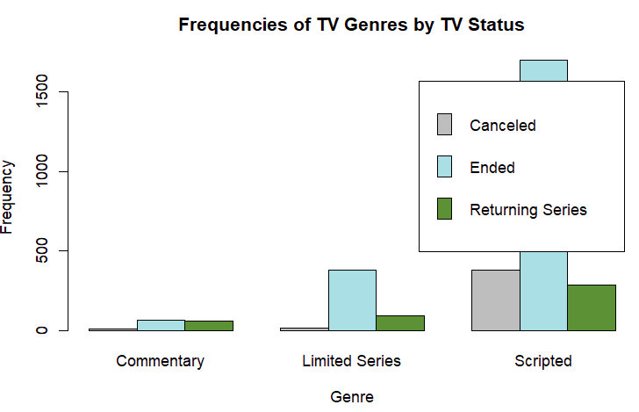
(Plot B)
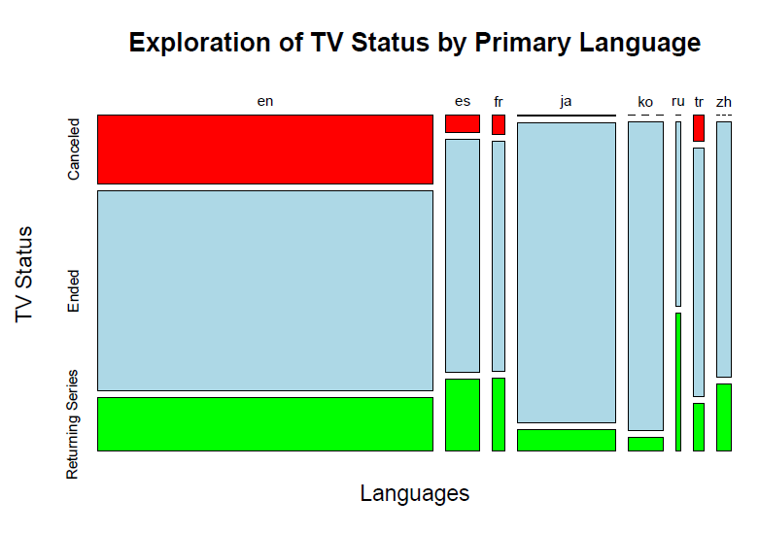
(Plot C)
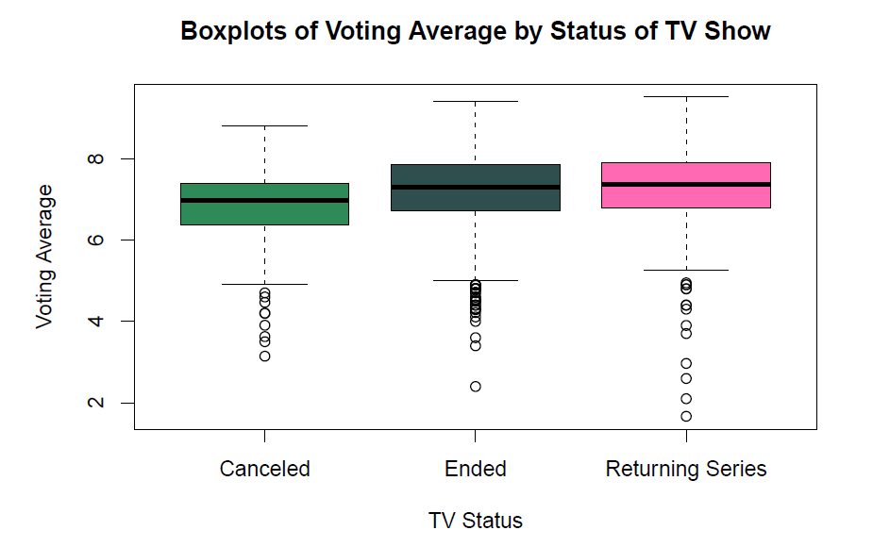
(Plot D)
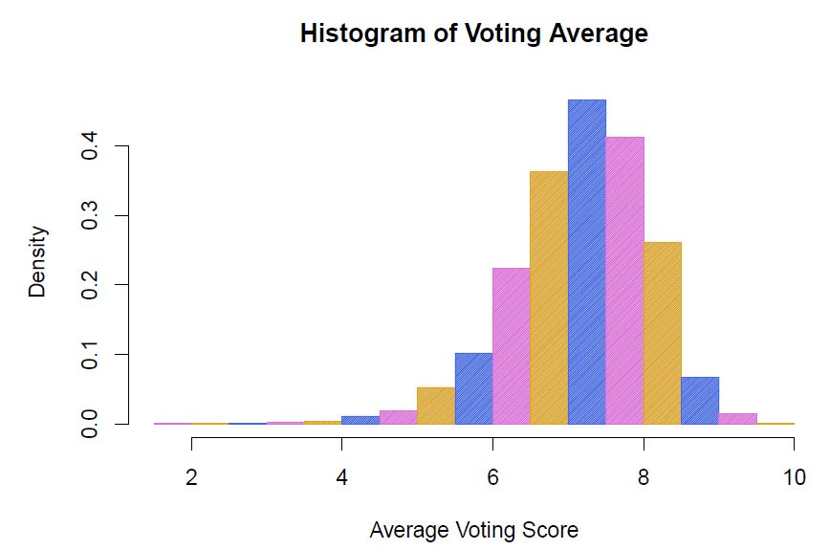
(Plot E) [Hint: it looks like we only have a subset of our data]
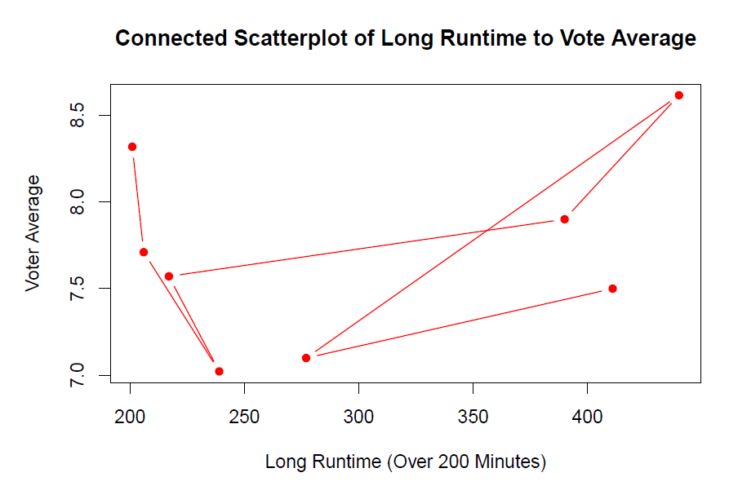
(Plot F) CHALLENGE PROBLEM


