**Introduction to Web Development**

**Site Map and Page Design - Milestone Two**

**Dr. Benjamin Yu**

**Elizabeth Lee**

**Eric Sy**

**Neda Jamalirad**

**Ryan Liang**

**Table of Contents**

**II. Site Map and Page Design**

* 1. Site Map………...…………………………………………………………………………... ....2
  2. Color Scheme… …………………………………………………………………………..........2
  3. Wireframes……………………………………………………………………………………..3
  4. Prints…………………………………………………………………………………………..13

**Appendix**

**I. Website Design**

* 1. Purpose and Goals…………………………………………………………………………...2
  2. Target Audience …………………………………………………………………………......2
  3. Content of Website ………………………………………………………………………….2
  4. Website Success Factors ………………………………………………………………....….2
  5. Critique and Comparison ………...……………………………………………………….…3
  6. Functional Requirements ……………………………………………………………………3
  7. Project Work Plan …………………………………………………………………………...3

###### **II. Site Map and Page Design**

**Site Map**



The website organization that we have decided to use is the hierarchical layout. The home page (red) and major sections (blue) comprise the navigation bar. Our target audience is the general public, so the goal is to make the design fluid and simple. We intentionally designed our website to be shallow; that is, all sections of the website can be reached with no more than two to three clicks. The cart and user sign-in/registration are not considered to be major sections, rather they are functional components that will also reside in the header so that they can be accessed at any time.

**Color Scheme**

The color palette that we will use is easy on the eyes. It exhibits less distracting tones to draw the user’s attention to images. The header and footer will be dark to emphasize the navigational tools while the content section will be lighter. It has a good contrast between text and background so that the writing is legible. Note that this color scheme follows the W3C WCAG 2.0 guidelines for large and small text!

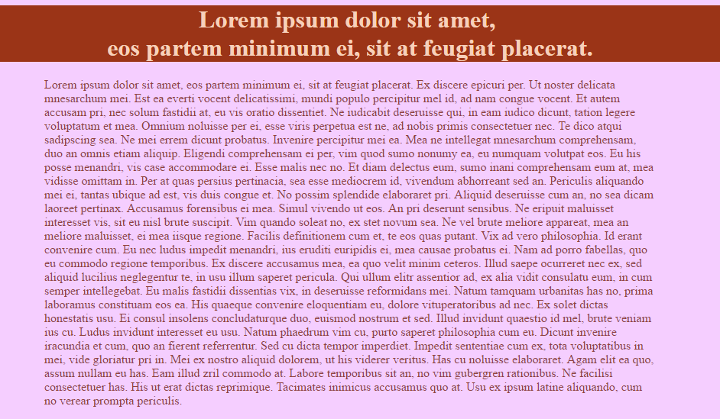

Note that this is used to represent the color scheme so the content is negligible. Body background: #F5CeFF; header background: #9B3417; body text color: #90423C; and header text color: #F7D0BB.

**Wireframes**

The features we have included may be ambitious. Whether or not this is outside of the scope of this class is yet to be determined. We will add and remove features as necessary, but the main components (Home, About Us, Products, Catering and Contact Us) are unlikely to undergo drastic changes. For a better quality image of the wireframes, please visit: <https://github.com/ericjsy/web-dev/tree/master/concept/wireframes>

**Home Page**

The goal of the home page is to quickly grab the attention of customers. We will do this by having the home page load to only the header and the slideshow. This acts like a cover page: it minimizes negative space, visually draws users in to our products and gives them the option to quickly select any page on the navigation bar. The navigation bar will be horizontal and in close proximity to make navigation easier. The header will auto-hide upon scrolling and re-appear if the user hovers over the top section of the page with their cursor. This feature is to help reduce clutter. Finally, we opted to go with a single column wireframe so that we are able to maximize the horizontal space for content.



**About Us**

The about us page will use as much of the content section as possible. We want there to be a good ratio between images and text. We are proud of our roots, accomplishments and contributors, so we do not want to be stingy with the amount of information here.



**Testimonials**

The sign of any good business is through customer testimonials. We would like to showcase the support of our valued customers on this page. Each testimonial will consist of an image, a block quote and a simple five-star rating. We will moderate this page (i.e. users will not directly upload a testimonial) and we will also update it periodically.



**Products**

The products page is the most important section of our website. The majority of space in the content section is allotted to a table of high quality images. Repetition is key; we want to entice users to the wide assortment of goods that we offer. When a user clicks on an image, the products page will darken and a page will overlay with an enlarged image and a description. On the left portion of the page, we would like to include a filter box to help the user sort through products seamlessly. If we are unable to implement this feature, we will divide the products into sub-sections (cakes, cupcakes, cookies, etc.) instead for organizational purposes.



**Catering**

The catering form is limited to text to help the user focus on their task and to complete the form as quickly and accurately as possible. We do not want this process to be frustrating so the form is partitioned into three clear sub-sections. The fields are in a logical, step-wise order, the required information is clearly indicated and the text boxes for user input are in close proximity.



**Contact Us**

The contact page will be concise. We will include additional information that would otherwise crowd the footer section. This page will also include a section for customers to give feedback. These critiques or compliments are what we will use as data to improve the business.



**Cart**

The cart is structured so that users can easily review the products that they wish to purchase and finalize their total purchases. All information is clearly indicated and a running total is calculated. Users can also add to the quantity of their products or remove the item altogether.



**Checkout**

We simply want to thank the customer for their purchase. The checkout page will notify the user that their transaction has been completed and that a confirmation email has been sent out with their order. We contemplated adding suggested products for their next visit, but eventually voted against it because it seemed to be overbearing.



**User Accounts**

The profile page is private and will allow the user to customize their information. We encourage users to utilize this page to make orders faster in the future.



**Prints**

The print-out pages will be content-oriented. It will only include the relevant information of each page. We excluded any hyperlinks including the navigation bar, cart and sign-in. We also excluded social media icons, drop-down menus and the ‘back to top’ button as these are all web-only features. We do not think they will be useful for a print out and will only take up excess space. Text and images are retained and the logo is always present.

**Appendix**

###### **I. Website Design**

**Purpose and Goals**

Our main purpose is to create a website for a fictional patisserie based in Metro Vancouver. As a small business, it is necessary that we invest in creating and maintaining a functional website. The advantages of a website tailored to customer needs are significant and will outweigh upkeep costs especially since none of the website hosting and design will be outsourced. Our website is not meant to replace our physical location; rather it will be of interest to a new customer-base.

In order to craft a website that is suitable for our customers, we considered long-term plans against short-term goals and accomplishments. In the short-term, our website will promote our brand and products. It will serve as an additional source of advertisement and will provide the exposure needed to maintain our competitive edge. In the long-term, we hope to build and improve customer relationships. By increasing the bakery’s popularity, we can gather more meaningful information through traffic analytics and customer feedback. This will help us understand our market, improve our services and continue to grow our business.

**Target Audience**

The target audience consists primarily of residents in the Greater Vancouver District. Since our business specializes in pastries and dessert items, we seek customers who prefer sweeter foods. Catering is available which allows our company to serve the Greater Vancouver District. There are also gluten-free, allergy-free, and organic products available for customers who have preferences and dietary restrictions.

**Content of Website**

The content of our website will consist largely of graphical elements and short textual descriptions of our products. We will also be including, but not limited to: a homepage, a products page, philosophy and a history about our company, testimonials, contact information, and a form for online membership registration. Visual content will be minimalistic in order to maximize the visual appeal of the website.

**Website Success Factors**

The success of our website will largely depend on the user’s experience. Firstly, the website and its products must be visually appealing. Presentation is key since first impressions will determine whether a customer will continue browsing. With a minimalistic design, users will not be overwhelmed by an abundance of information and can simply enjoy the overall experience. Customers are also likely to browse through our website similar to a menu so products must be eye-catching and visually appetizing. Secondly, the information should be clear and concise because our design choice limits the amount of space allocated to written sections. Lastly, the website must be intuitive. It must be functional across all platforms and the ease of access should be simple and effortless. All users should be able to purchase our products in approximately two to three clicks.

**Critique and Comparison**

After browsing several bakery websites, the first bakery that caught our attention was the Ugly Cake Shop. Initially, we were overwhelmed by the detail provided on the homepage and the navigation bar felt overcrowded. Each section heavily favors text and lacks consistency which detracts from the actual products. Furthermore, the center alignment was not preferred as the site felt congested without the use of negative space. Note that these flaws were not as prominent in the mobile version. Another aspect that we disliked was that a user was required to sign up in order to buy products. In contrast, content is easily accessible because the navigation bar directly scrolls to the desired section. Unlike other websites, one distinctive characteristic of this site was that it does not require extensive loading between pages.

Ugly Cake Shop - [http://www.uglycakeshop.sg](http://www.uglycakeshop.sg/)/

Overall, we preferred the website of St. Germain Bakery. The pictures of food are vibrant and captures the attention of its customers. There is a large emphasis on images rather than text and the static backdrop helps focus our attention. We also like the fluidity and design of the drop-down menus in the navigation bar and the slideshow. Despite this, the website is a little too conservative; the layout is clean, but rather unspectacular. They opt for a structured and rectangular look to their page whereas we prefer an abstract and minimalistic design. We also felt that content such as awards and hiring were not appropriate on the homepage and should be placed in its respective sub-pages. Unfortunately, the biggest problem is that the page does not scale well on some mobile browsers with sections either overlapping or cut off.

Saint Germain Bakery - <http://www.saintgermainbakery.com/>

**Functional Requirements**

To imitate a professional website, a catering order form and cart will be implemented so that users will be able to add and remove purchases. The users will be able to toggle and store previous dietary restriction filters upon registration. Furthermore, as the success of a business also depends on customer relationships, a testimonial and feedback section will be added. We will also include a gallery of our products for browsing purposes.

In the event that these functional requirements exceed the scope of this course, we have decided to focus our attention to user registration so that they may login and save preferences on their user account as well as comment on different products. Comments or critiques can be written in the feedback portion of the Contact Us page which will allow us to interact with our customers and improve the business.

**Project Plan**

We acknowledge that our group’s experience in web development varies. After many discussions, we agreed that we need to create both a professional and learning environment for each other to be successful. From an individual’s standpoint, our responsibilities include: 1) to keep up with lecture material; 2) to actively research information pertaining our website; and 3) to experiment with new code and features. We emphasize, however, that members can always confide in each other as an extra resource. From a collaboration standpoint, we have prioritized structure, organization and communication as marquee characteristics that our team must uphold. To help with this, we have appointed Ryan Liang as our leader because he has the most experience in programming.

We decided that we need to hold weekly meetings until the end of this project. This will ensure that we have adequate time to deal with unforeseeable delays or to implement improvements. During these meetings, each member is expected to prepare and present new content, ideas, documentation or changes to the team. In addition, we have decided to set personal deadlines for our website which will precede the due date of each milestone. If, for any reason, a group member is unable to provide the necessary work requested, the rest of the group will divide and complete the work so that the project is not postponed. All components of our project will be available through shareable mediums such as Google Drive and GitHub[1].

1. https://github.com/ericjsy/web-dev