**Milestone 3**

**URL**

**List of Items Completed for this Milestone**

Index.html

AboutUs.html

Cart.html

Catering.html

Checkout.html

Contact.html

Products.html

SignUp.html

Testimonials.html

Base.css

CSS page-specific styles

CSS print layouts

**Additional work (if any)**

Many of the navigation and fragment anchors link properly to their target destinations.

The fotorama on the index page scrolls between images

We have some JavaScript functionality, but not all: some required fields on the forms return an error message if the field is empty when the submit button is clicked.

**Key Issues Encountered in Building the Site**

We spent a long time making the page layouts responsive to different browser widths. We encountered many persistent problems with divs jumping out of container elements; but once we fixed the issue, we felt incredibly empowered.

**Deviations from Milestones 1 and 2**

After seeing the prototype page, we have opted to change the layout from fluid to fixed-width. Since our content is quite minimal, the text looks extremely sparse when stretched to the full page width on a wide screen. We have chosen to set the maximum width to 960px as this was the textbook’s recommended width for screens. Plus, we feel that having vertical stripes on either side focuses the viewers’ attention towards the content section.

Given the feedback from milestone 2, we have changed the colour scheme from analogous to monochromatic. This is due to the results from our A/B Testing, in which respondents favoured the monochromatic colour scheme over the analogous scheme we originally proposed. See the A/B testing section for more details.

In our original layout, we displayed the footer in 3 columns. Due to the size of the social media icons, we have decided to put them in a separate column, bringing the footer contents to four columns.

**Documentation of Work**

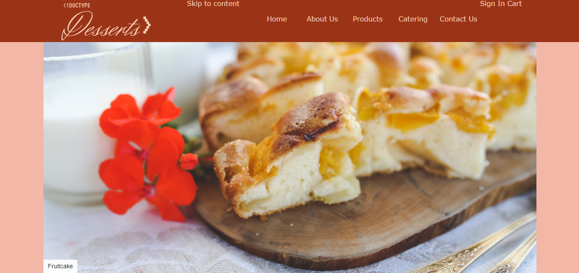

**The Front Page**

Above the fold on the front page is the header and the fotorama. The fotorama fills up most of the screen with attractive dessert images. All the text in the header (including the logo) is the same colour, and meets W3C WCAG 2.0 guidelines for large and small text. The navigation links, which are contained within the header, utilize block anchors to create the effect of clickable buttons. When the browser width shrinks, the header height increases and the navigation links move down to a new line.

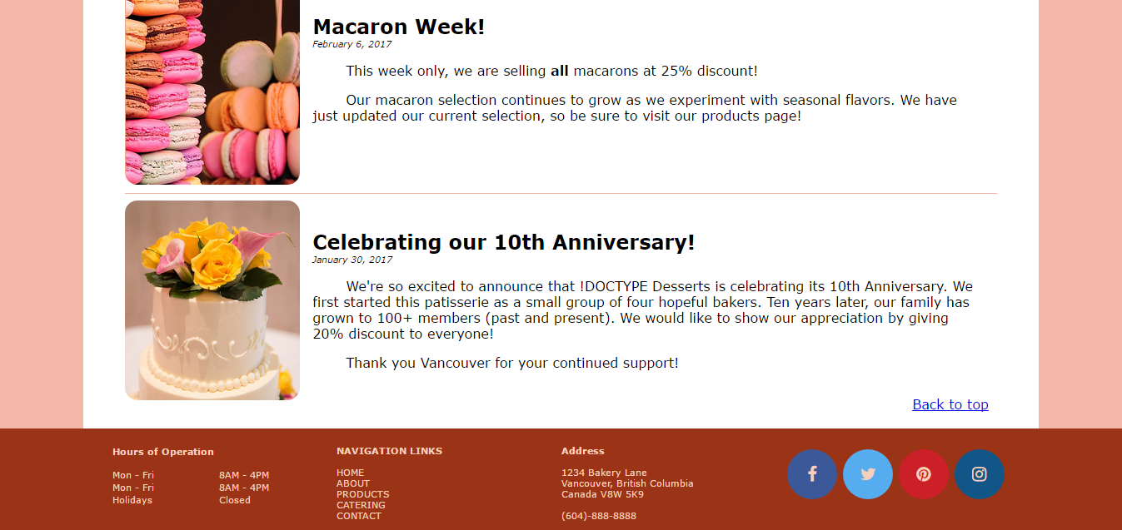For accessibility purposes, a “Skip to Content” link has been added to the header next to the logo. Using the tabindex property, we have made this link the first item highlighted when tabbing through the page.

Below the fold, we present news items and special events alongside attractive photos. In the bottom right corner, a “Back to Top” link offers an efficient alternative to scrolling back up.

At the bottom of the page is the footer. The colour scheme matches the header, (aside from the text size, which is smaller). In smaller browser widths, the four columns reduce to two, then one.

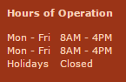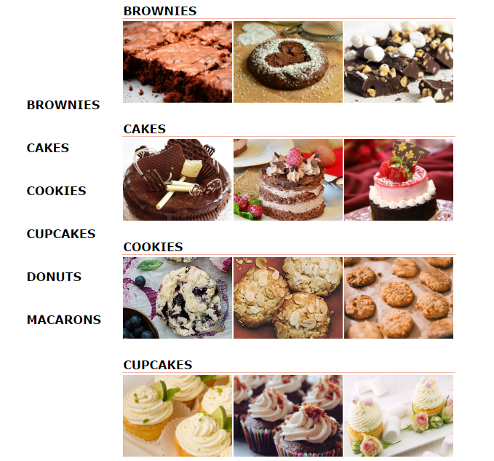

**Tables**

We have two tables on our site: the product listings on the Products page, and the Hours of Operation in the footer. Both utilize an invisible border. The table on the Products page is responsive, wrapping the data cells to the next line in smaller browser widths.

**Forms**

We have two pages that include form elements: Sign-up and Catering. The Sign-up page is styled similarly to sign-up pages found on other websites: signing up is done on the left, while logging into an existing account is done on the right. For the Catering page, we took into account the F-shaped reading pattern that was recognized in Jakob Nielson’s experiment and designed the form so that all elements lie in a single column.

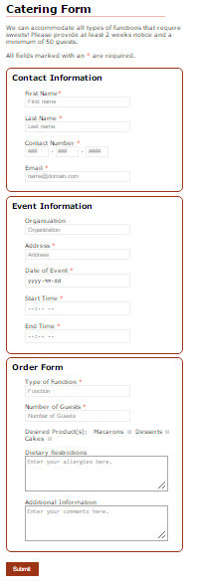

**Base.css**

Most of the styling in base.css applies to the header and footer (we have separate css stylesheets for page-specific styling). We have tried to apply styles so that the page is responsive to various browser widths. Therefore, the content width is not fixed in pixel values, but as a percentage of the browser width. The header and footer heights increase as browser width decreases to accommodate the items contained in them.

Due to vastly different layouts between pages (such as Contact Us versus About Us), each of the pages has an external style sheet containing page-specific styles. This allows us to float divs in different places as necessary.

**A/B Test**

In reviewing our web design, one aspect that we decided to test via A/B Testing was our color scheme. Choice A uses the colour scheme we proposed in Milestone 2. For choice B, we removed the purple colour and instead used a white background with black text for the content section. We stated in Milestone 1 that our target demographic is everyone; according to the textbook, neutral colors appeal to everyone, so we decided to add white to our design. The final design for choice B uses a red tint for the body background and white for the content background, while retaining the dark red colour for the header background.

We interviewed a total of 23 people (family, friends and colleagues) and the concensus was in favor of Type B (15/23). The most interesting result is the fact that the older demographic (6/6) unanimously selected the second version and explicitly cited legibility as the leading factor for their vote. Other compliments included the good use of white space as well as the added 'pop' that a white background gives to pictures and sections with color (text and logo in the header). Those who did not choose Type B explained that a pure white background can be too straining on the eyes. Although we attribute this to the brightness of their screens, it is a valid argument and have considered using other neutral colors, such as beige, as another test.

Figure Choice A of our A/B Test. This utilizes our original colour scheme proposed in Milestone 2.

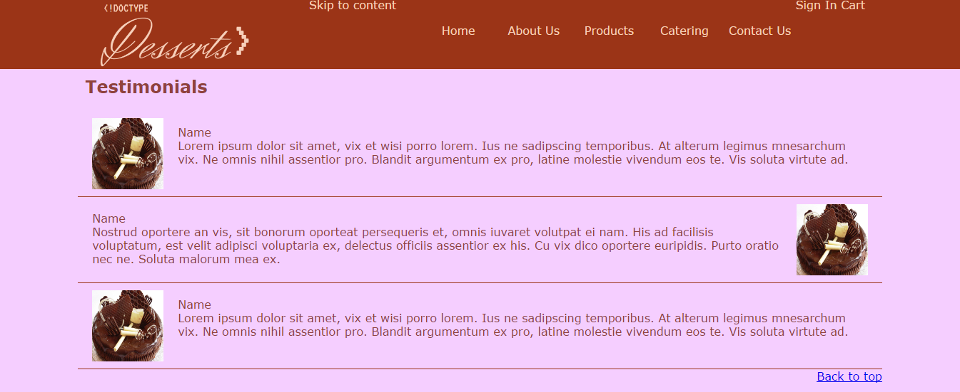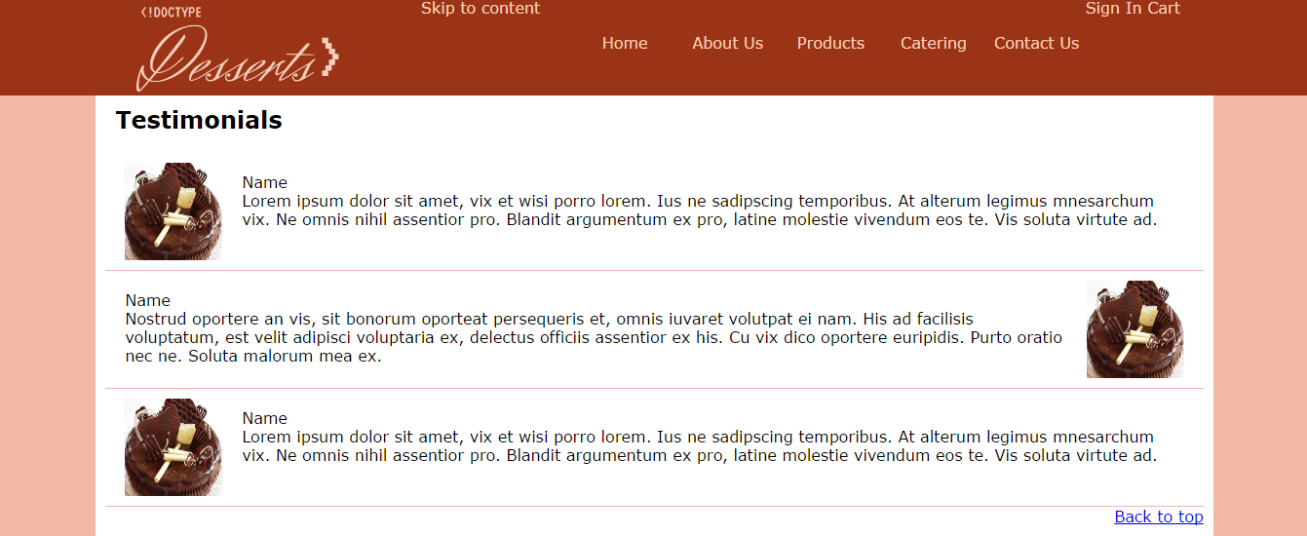

Figure Choice B of our A/B Test. A monochromatic design that includes black text on a white background for the content section.