Survival Analysis of Males in the U.S. with Prostate Cancer Based on Race and Ethnicity

Ranni Tewfik

2024-03-16

# 1. Introduction

Because of the discrepancies in the literature regarding the relationship between race/ethnicity and mortality among patients with prostate cancer, one of the motivations for this project is to better understand that relationship using a large national registry of prostate cancer patients. This project is different from what has already been done because other studies have used smaller sample sizes or have not included several racial and ethnic groups in the study population. Therefore, the research question for this project is: Among males diagnosed with prostate cancer, are race and ethnicity associated with time to all-cause mortality?

# 2. Methods

## 2.1 Data Source

The Surveillance, Epidemiology, and End Results (SEER) Program of the National Cancer Institute (NCI) provides information on cancer incidence and survival in the United States. SEER uses population-based cancer registries that cover about half of the national population. The SEER registries collect data on tumor site and morphology, stage at diagnosis, treatment, vital status, and patient demographics, including race and ethnicity. This project used the SEER*Stat software (version 8.4.2) to access the SEER 18 (2000-2018) Registry for data on 1,048,575 prostate cancer patients.

## 2.2 Project Design

This project investigated male patients with prostate cancer in the U.S. from 2000 to 2018. All ages and races/ethnicities were included in the study, however, only patients with localized, regional, or distant cancer stage at diagnosis were included. Patients with unknown/missing survival time were excluded.

## 2.3 Covariates

The main outcome of interest was all-cause mortality. The main exposure of interest was race/ethnicity, which included the following categories: “Non-Hispanic White”, “Non-Hispanic Black”, “Non-Hispanic Asian or Pacific Islander”, “Hispanic (all races)”, and “Other”. The other covariates, age at diagnosis and cancer stage at diagnosis, were categorical variables. The age groups were coded as “0-49 years”, “50-59 years”, “60-69 years”, “70-79 years”, and “≥ 80 years”. The categories for stage at diagnosis were “localized” (i.e., cancer is limited to where it originated), “regional” (i.e., cancer has spread to nearby lymph nodes, tissues, or organs), and “distant” (i.e., cancer has spread to distant body parts).

## 2.4 Statistical Analysis

All analyses were conducted using R software (version 4.3.1). Survival analysis was performed for Kaplan-Meier survival estimates and curves. Cox regression was used to compute adjusted hazard ratios and 95% confidence intervals. The Cox proportional hazards assumption was tested using log-log survival curves and extended Cox models for each covariate.

# 3. Results

This project included 776,196 males in the U.S. with prostate cancer from the SEER database. Of these, 540,057 (69.6%) were Non-Hispanic White; 526,468 (67.8%) were age 60-79 years at diagnosis; 629,222 (81.1%) had localized stage of prostate cancer at diagnosis; 401,176 (51.7%) had at least a college degree; and 490,476 (63.2%) had a family history of cancer (Table 1). The mean survival time for each ethnic group of prostate cancer patients ranged from 64 months (“Other”) to 78 months (“White”) (Table 1).

Warning: package 'here' was built under R version 4.3.2

here() starts at C:/Users/ranni/Desktop/MADA/Tewfik-MADA-project

Table 1. Study sample characteristics of males in the U.S. with prostate cancer by race and ethnicity.

| **Characteristic** | **Asian**, N = 37,168 | **Black**, N = 112,597 | **Hispanic**, N = 70,220 | **Other**, N = 16,154 | **White**, N = 540,057 |
| --- | --- | --- | --- | --- | --- |
| Age at diagnosis (years) | NA | NA | NA | NA | NA |
| 0-49 years | 566 (1.5%) | 5,830 (5.2%) | 2,272 (3.2%) | 506 (3.1%) | 11,989 (2.2%) |
| 50-59 years | 5,664 (15%) | 30,990 (28%) | 15,275 (22%) | 3,657 (23%) | 103,790 (19%) |
| 60-69 years | 14,724 (40%) | 46,626 (41%) | 28,269 (40%) | 6,557 (41%) | 218,550 (40%) |
| 70-79 years | 11,998 (32%) | 23,489 (21%) | 18,864 (27%) | 4,310 (27%) | 153,081 (28%) |
| 80+ years | 4,216 (11%) | 5,662 (5.0%) | 5,540 (7.9%) | 1,124 (7.0%) | 52,647 (9.7%) |
| Cancer stage at diagnosis | NA | NA | NA | NA | NA |
| Distant | 2,733 (7.4%) | 7,669 (6.8%) | 5,208 (7.4%) | 490 (3.0%) | 30,085 (5.6%) |
| Localized | 28,969 (78%) | 92,605 (82%) | 55,313 (79%) | 14,687 (91%) | 437,648 (81%) |
| Regional | 5,466 (15%) | 12,323 (11%) | 9,699 (14%) | 977 (6.0%) | 72,324 (13%) |
| Educational attainment | NA | NA | NA | NA | NA |
| college or higher | 19,241 (52%) | 58,406 (52%) | 36,207 (52%) | 8,338 (52%) | 278,984 (52%) |
| high school or less | 13,459 (36%) | 40,463 (36%) | 25,585 (36%) | 5,834 (36%) | 194,320 (36%) |
| some college | 4,468 (12%) | 13,728 (12%) | 8,428 (12%) | 1,982 (12%) | 66,753 (12%) |
| Family history of cancer | 23,368 (63%) | 71,355 (63%) | 44,362 (63%) | 10,166 (63%) | 341,225 (63%) |
| Survival time (months) | 74 (51) | 74 (49) | 72 (51) | 64 (51) | 78 (50) |
| Vital status | NA | NA | NA | NA | NA |
| 0 | 29,182 (79%) | 83,648 (74%) | 55,450 (79%) | 14,840 (92%) | 405,853 (75%) |
| 1 | 7,986 (21%) | 28,949 (26%) | 14,770 (21%) | 1,314 (8.1%) | 134,204 (25%) |

In assessing time to death (all-cause mortality), the overall 10-year survival was 68.5% (Figure 1). Non-Hispanic Black males had statistically significantly lower survival than other races and ethnicities across the full follow-up time (1-year = 95.7%; 5-year = 82.2%; 10-year = 66.1%) (Figure 2). Based on the log-log survival curves and extended Cox models, the proportional hazards assumption holds for all covariates (“Supplementary Material”).

Figure 1. Kaplan-Meier survival curves for males in the U.S. with prostate cancer.

knitr::include_graphics(here("results/figures/survivalcurve_total.png"))

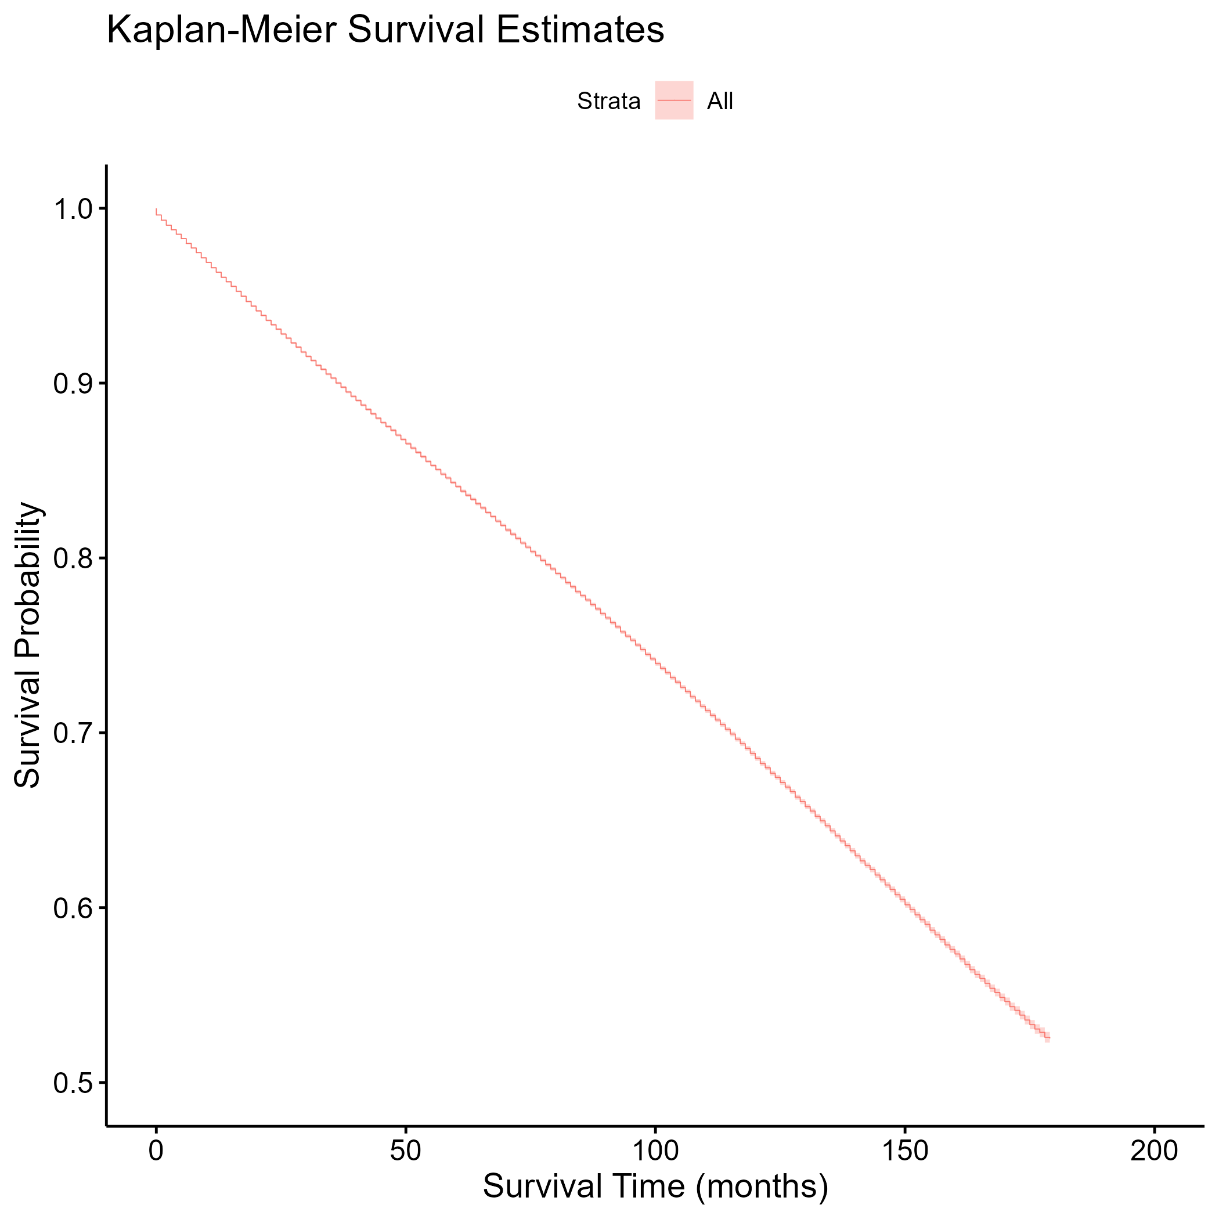

Figure 2. Kaplan-Meier survival curves for males in the U.S. with prostate cancer, stratified by race and ethnicity.

knitr::include_graphics(here("results/figures/survivalcurve_ethnicity.png"))

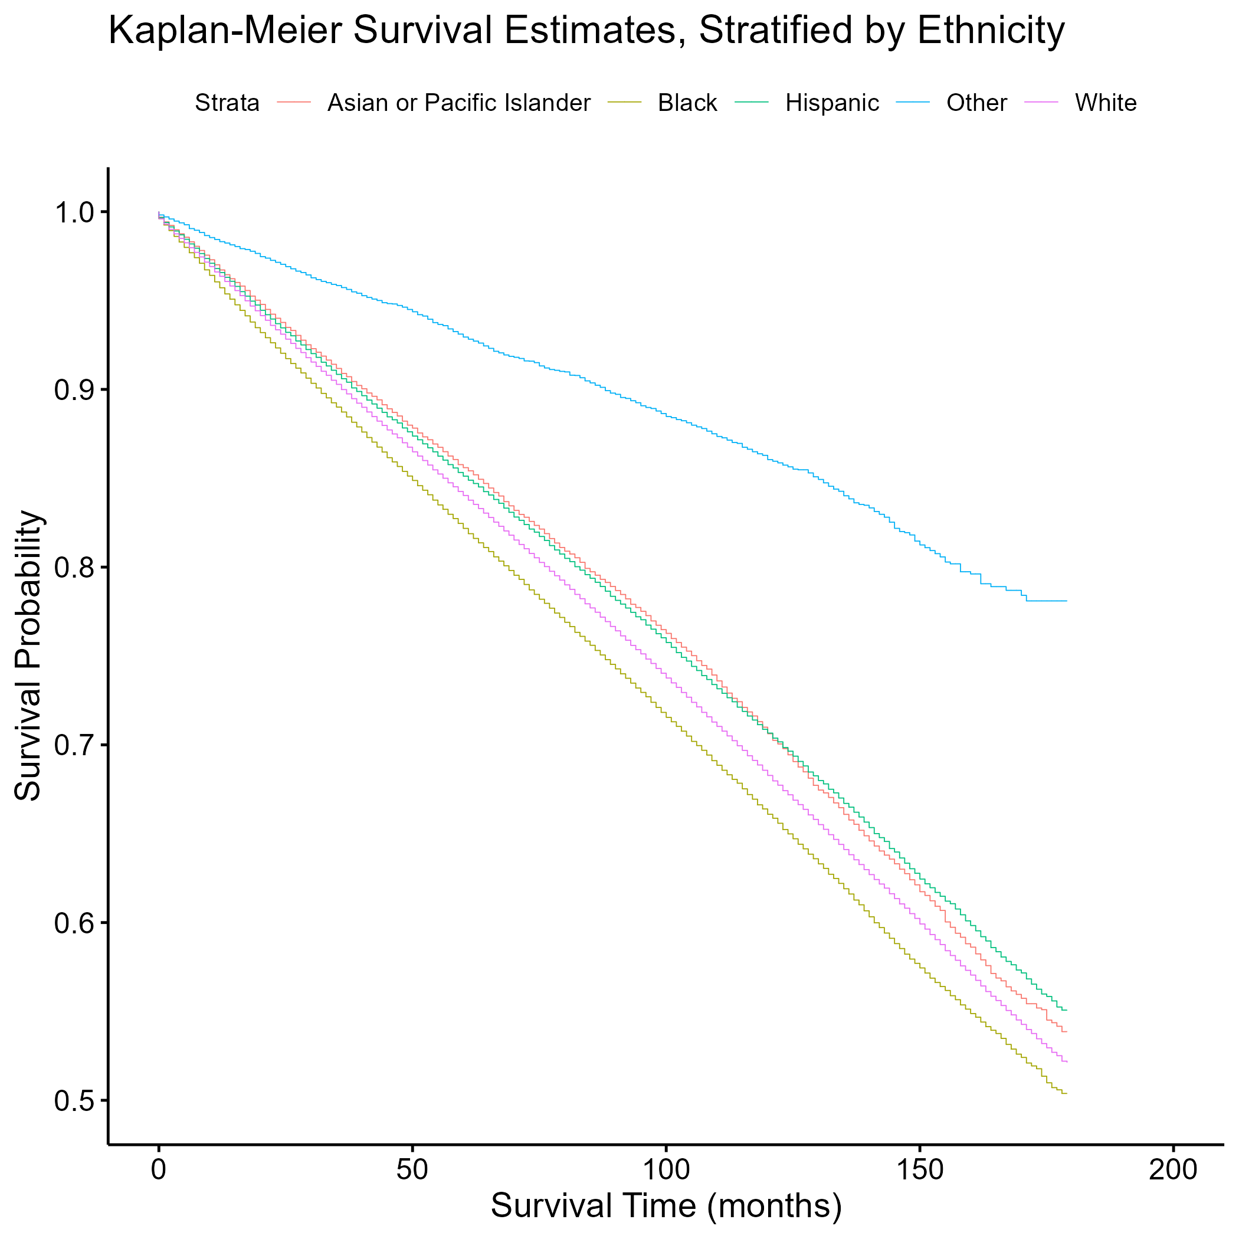

After adjustment for age and cancer stage at diagnosis, the rate of all-cause mortality was 1.32 times higher in Non-Hispanic Black males than Non-Hispanic White males (aHR = 1.32; 95% CI = 1.30 – 1.34) (Table 2). Compared to Non-Hispanic White males, the adjusted hazard ratios were less than 1.00 and statistically significant for males who were Non-Hispanic Asian/Pacific Islander, Hispanic, and other race/ethnicity (Table 2). Controlling for the other covariates, males older than 80 years at diagnosis (vs. males 0-49 years) had the highest adjusted hazard ratio for all-cause mortality among all age groups (aHR = 14.38; 95% CI = 13.70 – 15.09), and males with distant stage of prostate cancer (vs. localized stage) had a higher adjusted hazard ratio than males with regional stage (aHR = 7.27; 95% CI = 7.17 – 7.36) (Table 2).

Table 2. Adjusted hazard ratios and 95% confidence intervals for time to death (all-cause mortality) among males in the U.S. with prostate cancer (SEER database).

|  | Characteristic | Adjusted.hazard.ratio | X95..CI..lower. | X95..CI..upper. |
| --- | --- | --- | --- | --- |
| relevel(factor(ethnicity), ref = “White”)Asian | Asian | 0.7710781 | 0.7538515 | 0.7886984 |
| relevel(factor(ethnicity), ref = “White”)Black | Black | 1.3181728 | 1.3013971 | 1.3351648 |
| relevel(factor(ethnicity), ref = “White”)Hispanic | Hispanic | 0.9160922 | 0.9006471 | 0.9318021 |
| relevel(factor(ethnicity), ref = “White”)Other | Other | 0.4601053 | 0.4357671 | 0.4858028 |
| relevel(factor(agegroup), ref = “0-49 years”)50-59 years | 50-59 years | 1.4482922 | 1.3785081 | 1.5216089 |
| relevel(factor(agegroup), ref = “0-49 years”)60-69 years | 60-69 years | 2.5463864 | 2.4274974 | 2.6710980 |
| relevel(factor(agegroup), ref = “0-49 years”)70-79 years | 70-79 year | 5.7221279 | 5.4558116 | 6.0014440 |
| relevel(factor(agegroup), ref = “0-49 years”)80+ years | 80+ years | 14.3773894 | 13.7013153 | 15.0868235 |
| relevel(factor(stage), ref = “Localized”)Distant | Distant | 7.2662180 | 7.1714705 | 7.3622173 |
| relevel(factor(stage), ref = “Localized”)Regional | Regional | 1.0860275 | 1.0687881 | 1.1035450 |

# 4. Discussion

The results of this project show that compared to Non-Hispanic White males with prostate cancer, Non-Hispanic Black males had the highest rate of all-cause mortality among all races and ethnicities, controlling for age and cancer stage at diagnosis. This finding is in line with the data provided by the American Cancer Society, which reported that Black men 70-110% higher mortality rate for prostate cancer than White men overall in the U.S. Although the American Cancer Society study had a higher adjusted hazard ratio than our investigation, the conclusion is the same: Black males with prostate cancer have increased risk of all-cause mortality compared to other racial/ethnic groups. Also, older males and males with more extensive stage of prostate cancer had the highest rates of all-cause mortality, supporting the claim from the American Cancer Society that “your age and overall health… and other factors can also affect your outlook [regarding survival rates for prostate cancer].” This project establishes an increasing all-cause mortality hazard by age at diagnosis and by cancer stage at diagnosis.

## 4.1 Strengths

The strengths of this project are its large sample size, utilizing data from a national registry, as well as its inclusion of all major racial and ethnic groups in the U.S. Based on the result of the investigation, future research should focus on early diagnosis and treatment among Black males with prostate cancer, especially those who are older and with more extensive stage of cancer.

## 4.2 Limitations

One of the limitations of this project is the use of the SEER 18 registry, which only covers about 28% of the U.S. population. The study population may not be a representative sample of the target population, and certain sociodemographic groups may be excluded from the study, resulting in possible external validity problems. Also, the SEER 18 registry only provides data from 2000 to 2018. A longer follow-up time may have resulted in more accurate estimates of hazard ratios. This project examined all-cause mortality as the outcome of interest rather than cause-specific mortality, which provides a smaller sample size (i.e., small changes between comparison groups would not always register as statistically significant) and looks at death specifically caused by prostate cancer instead of death from any cause. This outcome may be more relevant to those with prostate cancer. Another constraint is the limited number of covariates, as few variables of interest were available in the SEER 18 registry. The use of more variables that help explain the association between race/ethnicity and mortality in males with prostate cancer, such as socioeconomic status and comorbidities, may have provided less biased effect sizes.

Note that this cited reference will show up at the end of the document, the reference formatting is determined by the CSL file specified in the YAML header. Many more style files for almost any journal [are available](https://www.zotero.org/styles). You also specify the location of your bibtex reference file in the YAML. You can call your reference file anything you like, I just used the generic word references.bib but giving it a more descriptive name is probably better.

# 5. References