Erick Perchez

80582912

Lab 1

**Introduction:** In this lab we were given two files containing recursive methods to draw squares and circles(respective to their own file). Then we were given four different groups of images to try to produce using the methods given to us.

**Proposed solution:** As soon as the file was shared, my first instinct was to open it to see how it looked. To nobody’s surprise, the code did not include comments so my next thinking process was to mess with the values and record the outcomes. This slowly gave me an understanding to what each of the methods did and what the variables could produce.

1. For the first challenge, the square collage, I centered the square to the origin using an array so I could play with positive and negative values and have them easily reflect to the other side by simply changing the +/- signs. Next, I figured out that I need to make the squares straight by messing with the method call that was given and found out it needed a weighed average of .5. Then I had to tackle each corner at a time so I started with the top right corner. I added 800 units to the overall coordinates then I multiplied it by the weighed average. This made the square shift up and right while also shrinking the square. I realized that I could just multiply the first square by -1 to get the bottom left square as it just needed to be mirrored. My next challenge was to change the coordinates in the parameters to shift the square to the top left. I decided to add 800 to the y axis and shrink it with the .5 value, then for the x axis I subtracted 800 units then shrunk it as well. For the bottom right I simply multiplied that square by -1 to mirror it.
2. For the second graph we had to replicate, concentric circles, I decided to just modify the center by the given ‘w’ factor(in the first case being .5, then .75, then .9 to better replicate the images given in the lab assignment). Since I could not multiply the center coordinates directly, I had to modify the first value then the second. In the recursive call I decided to multiply the radius by the ‘w’, resulting in a smaller radius each call.
3. The tree program forced me to use the square file and modify it to fit my needs. I initially had to give three plot points to an array. Those points made up an upside down v, then it was used as a parameter for the program. Initially I had to lower the shape by subtracting by the original size I had set to 1000 units to make the number rounding easier to trace. I divided the problem to two sides, the left tree and right tree. Afterwards, I divided the x axis of that initial plot by two to make sure the tree leaves do not touch. I then made a copy of the parameter array and modified the y axis of the right tree by subtracting it by the original size to expand the plots. I then modified the x axis by adding to the original size then dividing by 2 then again adding the original size. This made sure the tree leaves did not touch and pushed the plot to the right. I then made two recursive calls to call both the right side and left.
4. The final image to replicate seemed a lot harder than it was. I had to use the circle program to make five circles inside a center circle. I started with the right and left sides. First I divided the radius by the shrinking value(sVal; to shrink the circles) which was 3 (since three circles side by side could be placed inside the main circle) the multiplied by two. I then took the x axis and subtracted the value of the equation from the center point. For the right circle I did the same except I added the two values, the x axis and the equation value. These gave me the right and left circles. For the top and bottom circles I kept the x axis the same then I divided the radius by the shrinking value then multiplied it by two. Using that value I added (for the top circle, shifting the y axis up) a or subtracted (for the bottom circle shifting the y axis down) the y component of the center by that value. A similar thing was done for the bottom circle.

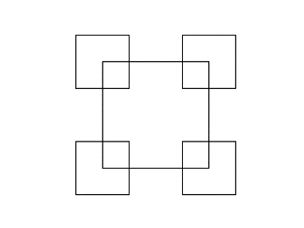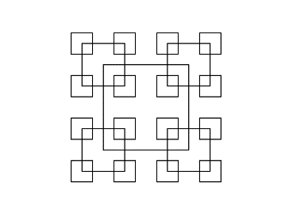**Experimental Results:** The outcomes of the programs were:

1. 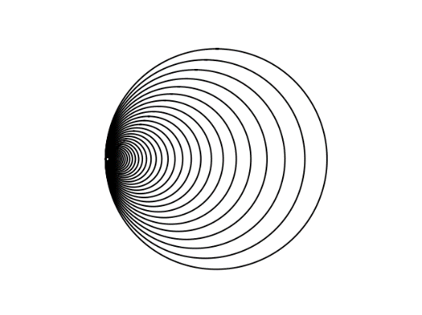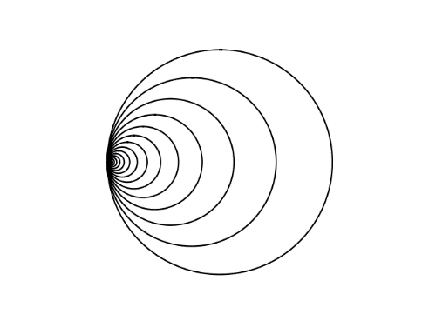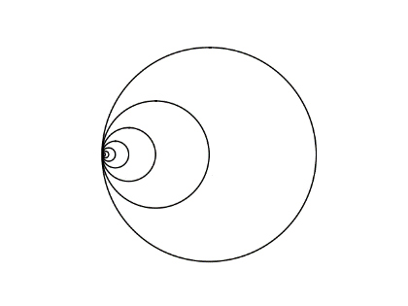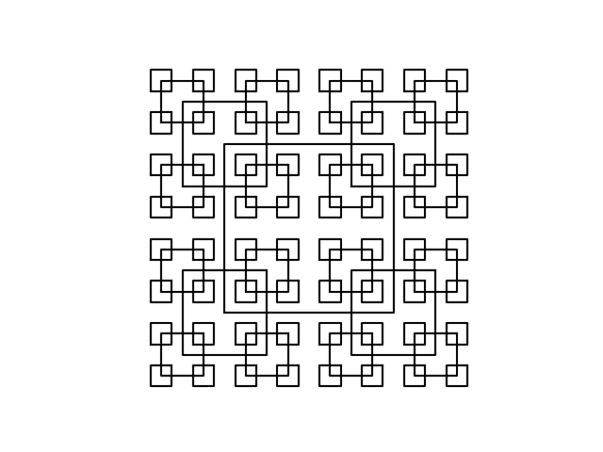Done with n = 4 n= 3 n=2
2. 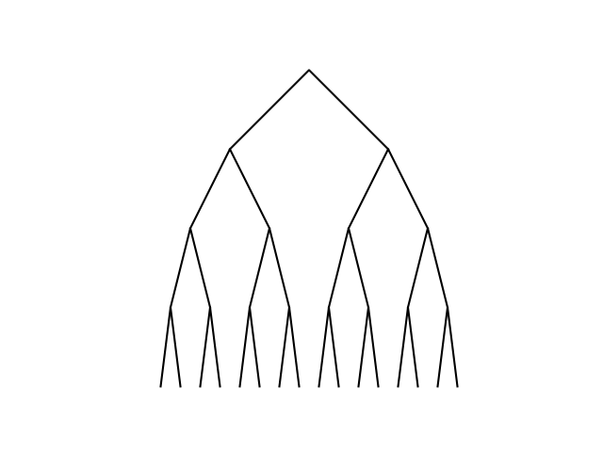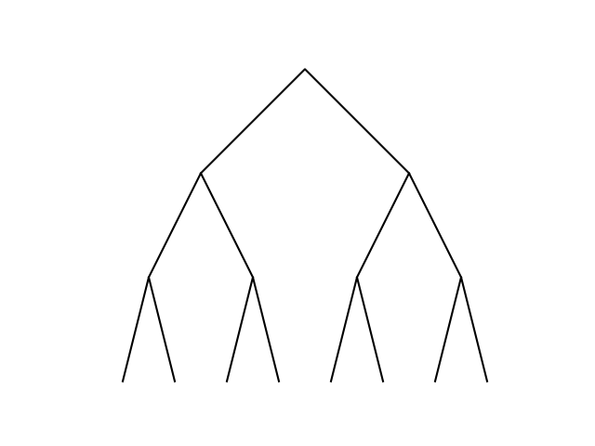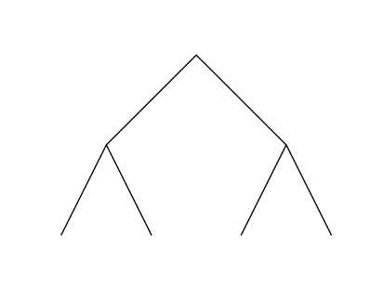Done with n =10 n=20 n=40
3. Done with n = 2 n=3 n=4
4. 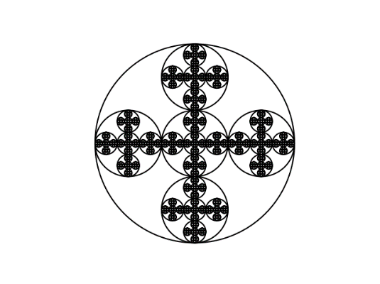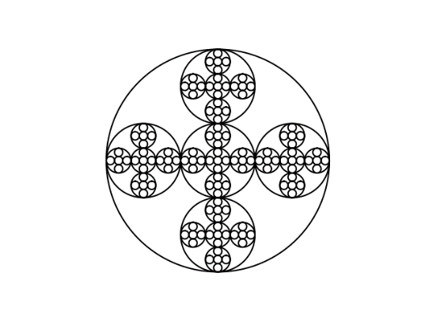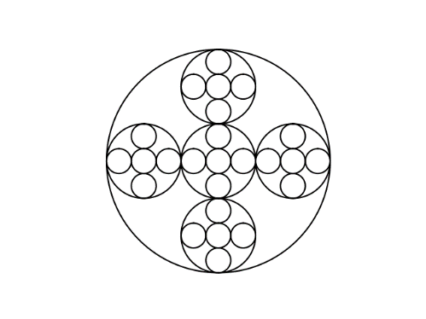Done with n = 3 n=4 n=5

**Conclusion:** I learned a lot on this lab. I learned to completely trust that a recursive call will work perfectly. I also learned to not get fixated on one way to solve a problem by trying multiple solutions.