sysc3020
Software Requirements Document

Name of the project/product: busy school periods app / group8
Date:
Version number: 02
Author: qiyang xia
Responsibilities of every author:
Key changes since last version:

Contents

- Introduction
- Functional Requirements
3. Non-Functional Requirements
3.1 Quality Requirements
3.1.2 Reliability Requirement
3.1.3 Performance Requirement
3.1.4 Support-ability Requirement
3.2 Constraints
3.2.1 Implementation Requirement
3.2.2 Interface Requirement
3.2.3 Operations requirements
3.2.4 Packaging requirements
3.2.5 Legal requirements
3.3 Risks and Open Issues
- Target environment
5. System Models
5.1 Identifying Actors
5.2 Identifying Scenarios
5.3 Identifying Use Cases
5.4 Detailed Use Cases
5.5 Use Case Diagram

6. Glossary

- Introduction

busy school periods app
The busy school periods app is the best friend for the students and the professors. Keep up-to-date with the school work,test, to-do's, member's information, and almost everything else you need during the school year. The busy school periods app is the school organizer that is easy to manage students’ itinerary, plan students’ study and so on.

2. Functional Requirements

Functional requirements describe the interactions between the system and its environment independent of its implementation. The environment includes the user and any other external system with which the system interacts.

The functional requirements for busy school periods app are listed as：
a.Keep track of all the upcoming work for the school year.
b.Record class times
c.Add partners to have quick access to their contact information.
d.Email link
e.Different color coded calendar remind the due time of school work(assignment,lab,test)
f.Tips for to-do's that member need to get done.
g.Keep track of your course information and teacher contact info.
h.Mark the location of a course on a map.
i.Alarm, the alarm of impending deadline
j.save curriculum immediately

3. Non-Functional Requirements

Non-functional requirements describe aspects of the system that are not directly related to the functional behavior of the system. Non-functional requirements include a broad variety of requirements that apply to many different aspects of the system, from usability to performance.

3.1 Quality Requirements
3.1.1 Usability Requirement
App system is friendly, clearly and easy to use

3.1.2 Reliability Requirement
No software fault should occur
• The system should not crash

3.13 Robustness Requirement
Save the data and restart immediately after failure

3.14 Safety Requirement
System need user’s information to log in

3.1.5 Performance Requirement
• The system should update the data every 5 seconds
• The system should be displayed within 2 seconds of user click
• The system should be displayed correctly according to the user selection

3.1.6 Support-ability Requirement
The system should be able to accept upgrades

3.2 Constraints

3.2.1 Implementation Requirement
All related software associated with the app

3.2.2 Operations requirements
Complies with the administration and the management of the system

3.2.3 Packaging requirements
Complies with the constraints on the installation media for setting up the software

3.3 Risks and Open Issues
Safety issues associated with system crashes
Security risks associated with the system environment
Rate of failure occurrence
Percentage of events causing failure
Mean time between failure
Time to restart after failure
Probability of data corruption on failure

4. Target environment
All users should be able to access the web browser supporting cookies, Java script,
and Java applets.
Administrator functions should not be available through the web

5. System Models
5.1 Identifying Actors
User(student)
A user is a person who uses busy school periods app. A user often has a user account and is identified by a user name. students can use app to click the study plan and other function,but have some different with professors.

User(Professor)
A user is a person who uses busy school periods app. A user often has a user account and is identified by a user name.professor have some Specific permissions such as add the test or list student.

RSS (Rich Site Summary)
Really Simple Syndication, uses a family of standard web feed formats to publish frequently updated information

Administrator
An Administrator is a person who is responsible for maintaining system. The duties may include ensuring that the web servers, hardware and software are operating correctly, generating and revising web pages, replying to user comments, and so on.

5.2 Identifying Scenarios
1.Scenario Name: user register
Participating actors: Mr. X user
Mr. Y Administrator
Communicates with System
Flow of events: User X has turn on busy school periods app by devise
User click on registration button
User is asked to pick category student or professor
User is asked to input a user name and password
Communicates with System save the information of user
The user is brought to welcome pop up message and he is on the homepage with the calendar
The administrator is monitoring the site

- Scenario Name: User opting for Time Line
Participating actors: Mr. X user
Mr. Y Administrator
Flow of events: User X has log in busy school periods app by devise
User X pick one school work
User X clicks on time line
User X clicks the appropriate time range
The app is displayed for that time
The administrator is monitoring the site

- Scenario Name: User Feedback for opinion
Participating actors: Mr. X user
Mr. Y Administrator
Flow of events: User X has log in busy school periods app by devise
User X clicks on feedback button
App output one window let user input message for feedback
The app is updated result
The administrator is monitoring the site

- Scenario Name: User get alert notification
Participating actors: Mr. X user
Mr. Y Administrator
Communicates with System
Flow of events: User X has log in busy school periods app by devise
User X use app in wrong way or meet other error
System output one window tell the user error and ask user to restart
User X pick restart button
System save the data and restart
System send the error report to the administrator
The administrator is monitoring the site

- Scenario Name: Administrator Generating Reports
Participating actors: Mr. Y Administrator
Flow of events: The Administrator generates reports based on usage, error messages, new registrations, etc.
The system pulls out the statistics
The administrator is monitoring the site and can print these reports or save them

5.3 Identifying Use Cases
Use case name: notify User
Participating actors: Initiated by System
Communicates with User
Monitored by Administrator
Flow of events: The system notifies users via email when their attempted registration is still incomplete after a configurable amount of time has passed
The administrator is monitoring the site
Entry condition: The system emails the user
Exit condition: The user receives a email generated by the system

//still have others need add after

5.4 Detailed Use Cases
//Use case name:
//Participating actors:
//Flow of events:
//Entry condition:
//Exit condition:
//Quality requirements:
•

5.5 Use Case Diagram
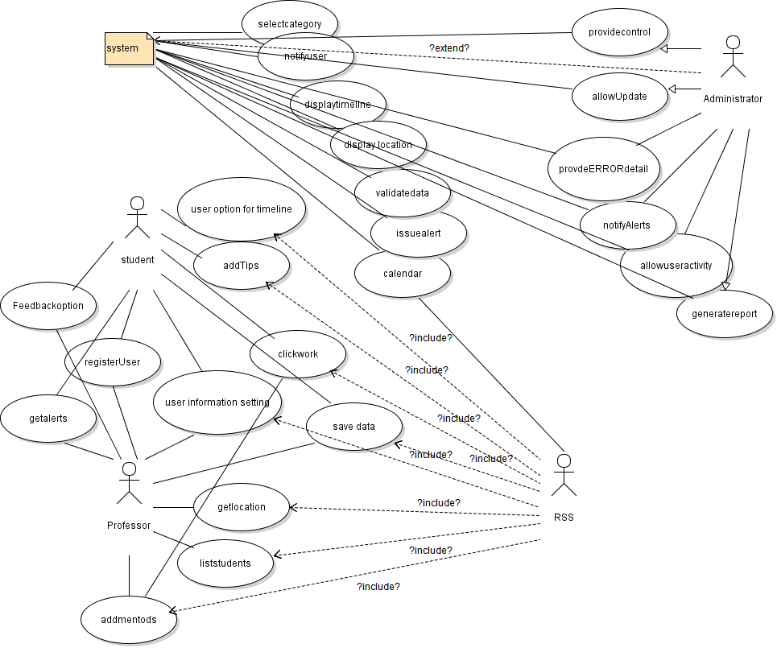

6. Glossary
Actor:
Audit:
Email:
Extend relationship:
Include relationship:
RSS Feed:
User:
Validate:

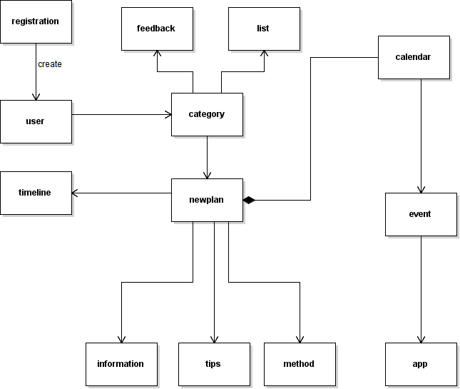

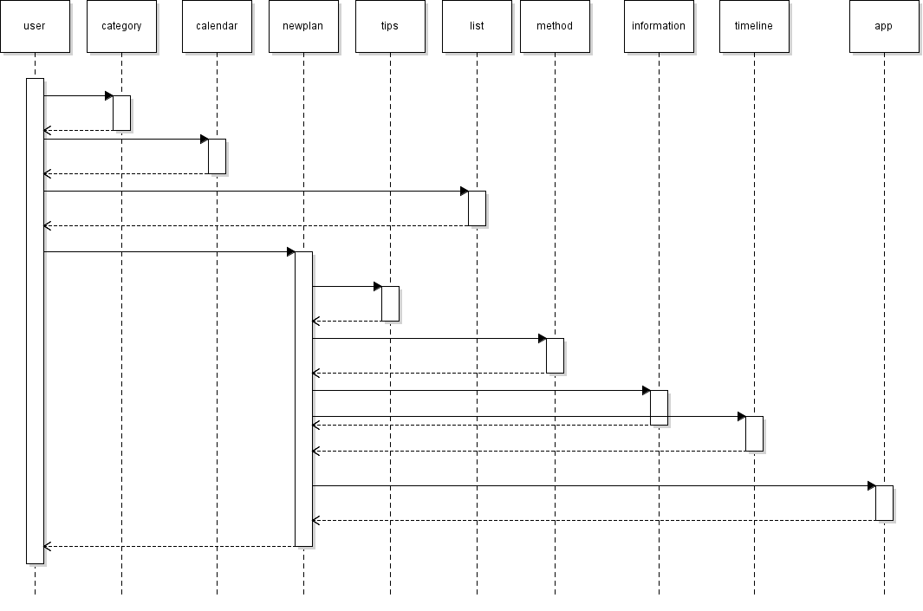

Team 8: Kad-Bay Vargas Erick; Sumido Glenn; Xia, Qi Yang; Qassoud Amin
project 5: busy school periods app

