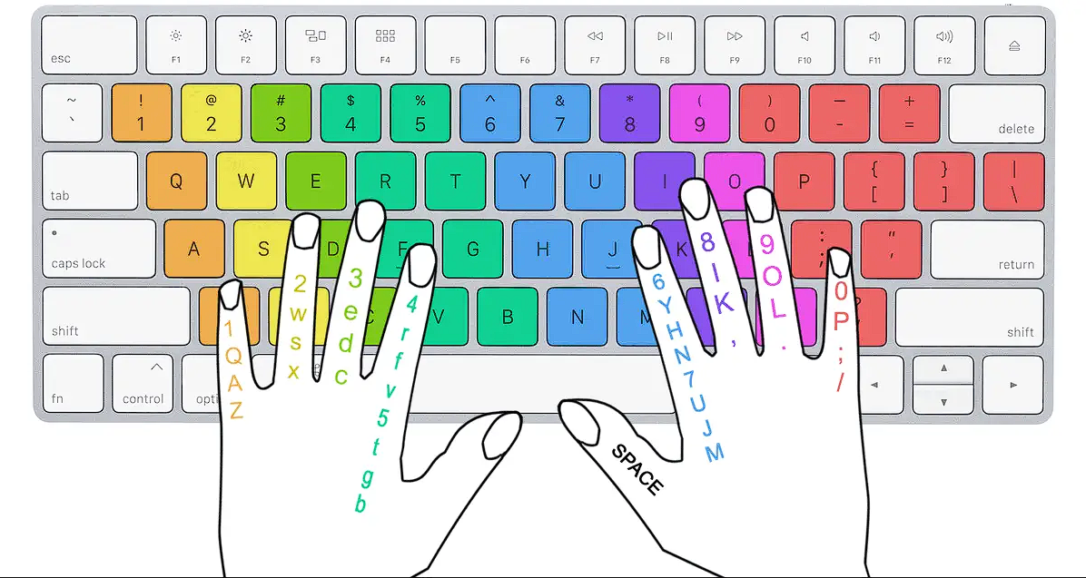

KEYBOARD FINGER POSITIONING

KEYBOARD

A keyboard is one of the primary [input devices](https://www.computerhope.com/jargon/i/inputdev.htm) used with a computer. Similar to an electric [typewriter](https://www.computerhope.com/jargon/t/typewriter.htm), a keyboard is composed of buttons used to create [letters](https://www.computerhope.com/jargon/l/letter.htm), [numbers](https://www.computerhope.com/jargon/n/number.htm), and [symbols](https://www.computerhope.com/jargon/s/symbol.htm), and perform additional functions. The following sections provide more in-depth information and answers to frequently asked questions about the keyboard.

Where should fingers be placed on the keyboard?

Your left-hand fingers should be placed over the A, S, D, and F keys, and the right-hand fingers should be placed over the J, K, L, and ; keys. These keys are considered the [home row keys](https://www.computerhope.com/jargon/h/hrk.htm). Your thumbs should either be in the air or very lightly touching the [spacebar](https://www.computerhope.com/jargon/s/spacebar.htm) key.

Other keyboard safety tips

While keeping your palms raised while typing, there are also other tips you can follow to help prevent carpal tunnel and pain while you type. Keep the following suggestions in mind every time you type.

* Keep your keyboard home row height as close to elbow level as possible.
* Center the [spacebar](https://www.computerhope.com/jargon/s/spacebar.htm) with your body.
* Do not angle or bend your wrists. While typing, keep your wrists elevated and as straight as possible.
* Avoid [hunt-and-peck typing](https://www.computerhope.com/jargon/h/huntandp.htm) as it causes strain on the neck from having to look down at the keyboard often.
* Don't use more force than needed to press the keys; you don't want to hit the keys, as it could lead to keyboard damage.
* When you're not typing, make sure to rest your arms and hands. However, never rest your arms, hands, or wrist on a sharp edge.
* Take a break from typing every 20 to 30 minutes. If you have a hard time remembering when to take a break, set a timer or drink water, forcing you to go to the bathroom more often.