Alfonso, Kent Harvey M. October 1, 2025
Barbecho, John Erick V.
Evangelista, Kim Harem M.

WEB-BASED ANALYTICS AND DECISION SUPPORT SYSTEM FOR THE ADMINISTRATION OF THE BARANGAYS IN MABINI BATANGAS
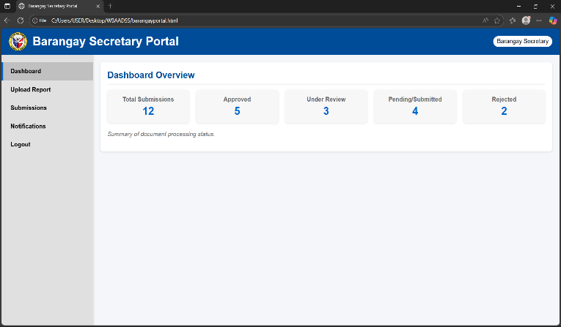
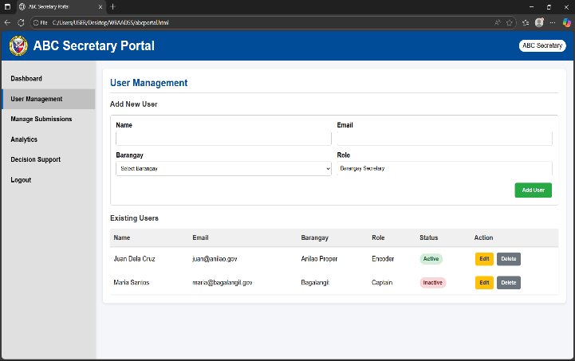

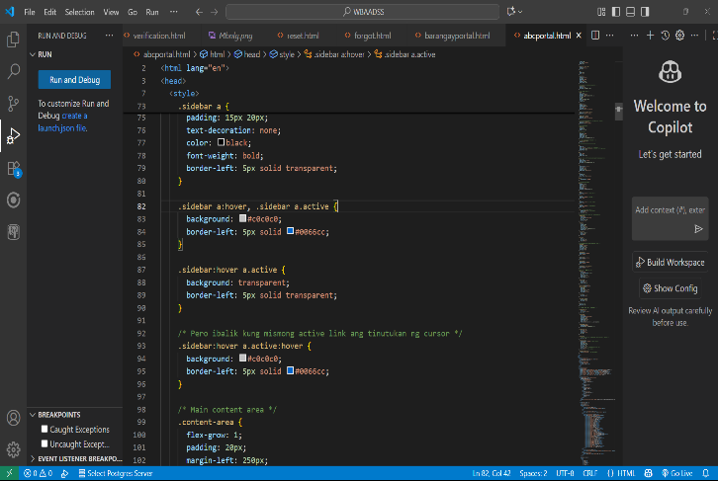
Were currently developing our front-end.

