Final Activity #1: Testing Techniques

Given #1: Equivalence and Boundary Value
Let’s consider the behavior of Order Pizza Text Box Below
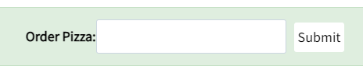
Pizza values 1 to 10 is considered valid. A success message is shown.
While value 11 to 99 are considered invalid for order and an error message will appear, “Only 10 Pizza can be ordered”
Here is the test condition
- Any Number greater than 10 entered in the Order Pizza field(let say 11) is considered invalid.
- Any Number less than 1 that is 0 or below, then it is considered invalid.
- Numbers 1 to 10 are considered valid
- Any 3 Digit Number say -100 is invalid.

- Provide the Boundary Value Table and Equivalence Partition Table

Example 2: Equivalence and Boundary Value
Following password field accepts minimum 6 characters and maximum 10 characters
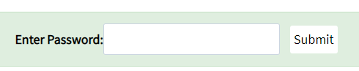
That means results for values in partitions 0-5, 6-10, 11-14 should be equivalent
Test Scenario # | Test Scenario Description | Expected Outcome
1 | Enter 0 to 5 characters in password field | System should not accept
2 | Enter 6 to 10 characters in password field | System should accept
3 | Enter 11 to 14 character in password field | System should not accept

- Provide the Boundary Value Table and Equivalence Partition Table

