What to Prepare

Activity for XML




Web browser, Sublime Text, and the XML File to be provided by the instructor in the Google Classroom.

What to do
Create an HTML web page that manages a Plant Catalog.
- Open the plant_catalog.xml using XML HTTP Request. (5 points)
- Display the plant catalog on a table. (5 points)
- When a plant is selected/clicked from the table, its data are displayed on input text boxes. (10 points)
- When the Save button is clicked, the plant's data are updated in the table. (10 points)

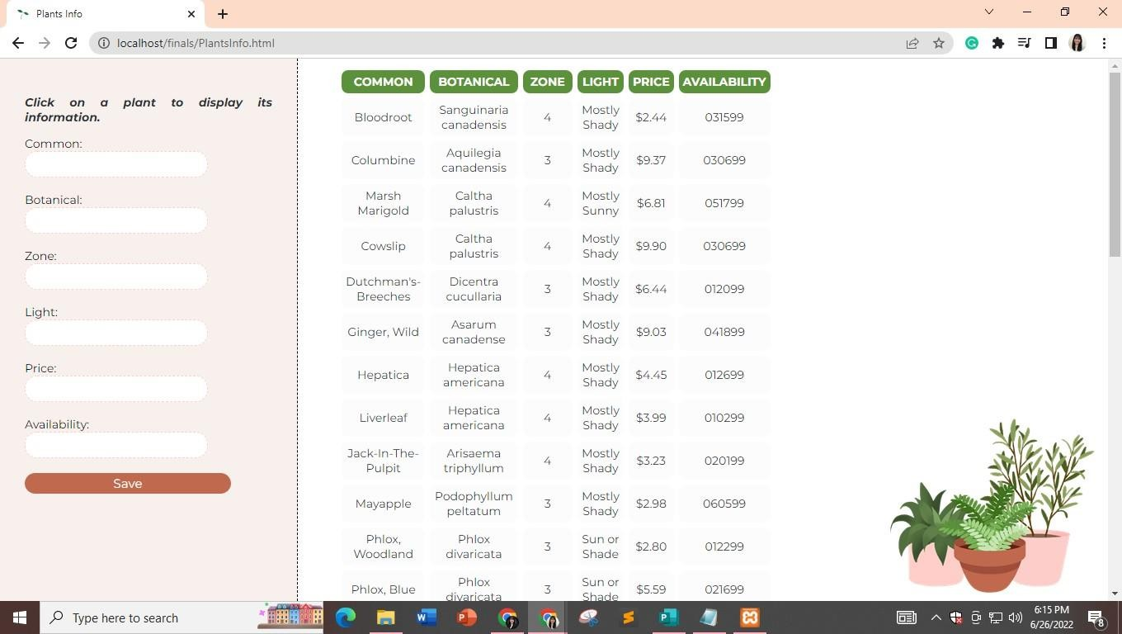
Sample Output

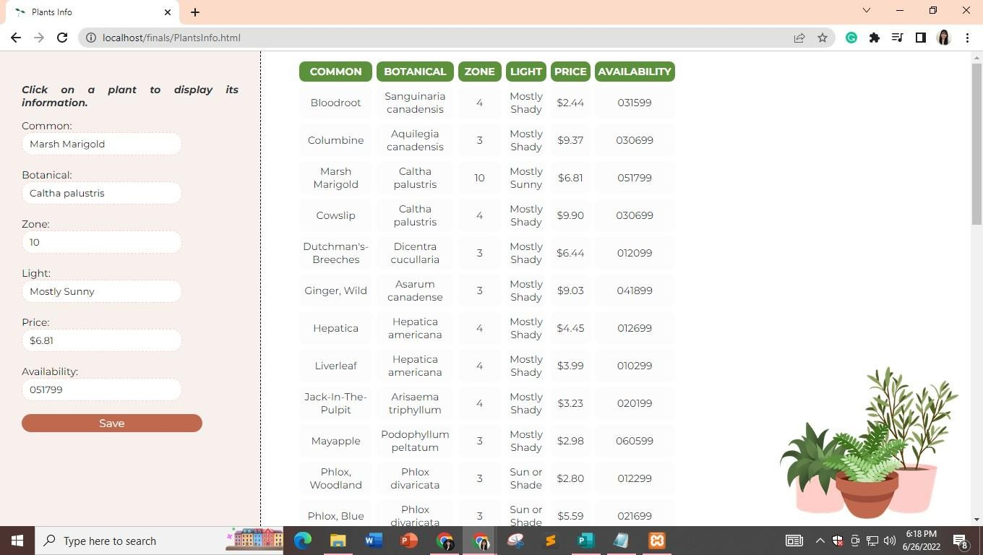


Clicking the Marsh Marigold displays its data on the sidebar.
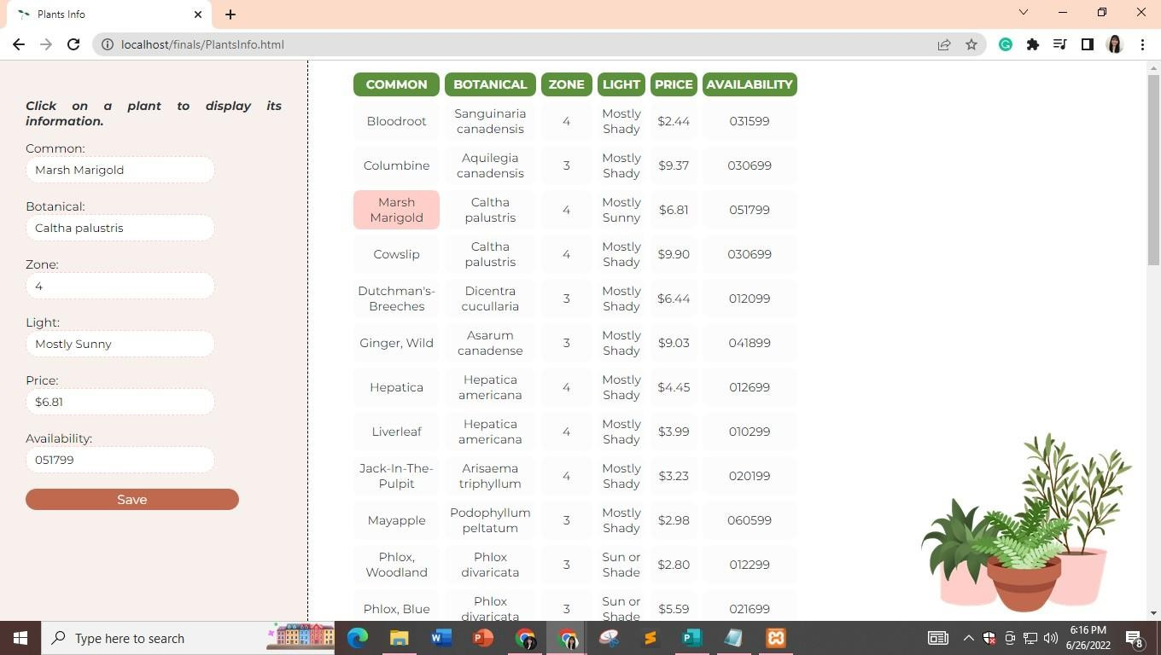
Let’s say we change the zone to 10. When the save button is clicked, the plant’s data are updated in the table.

