Gabriel C. Mendoza
BSIT – 3101 BA

- Which course has the highest average grade?
- Which gender performed better overall?
- How many students passed and how many failed?
- What can you conclude about the relationship between age and grade?
- If you were a teacher, how would you use this data to help improve student performance?

- The course with the highest average grade is BSCS.
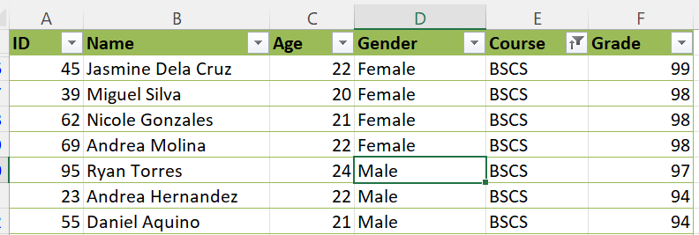
- The Female gender performed better overall.
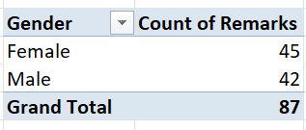
- 11 students Fail and 89 students passed, overall
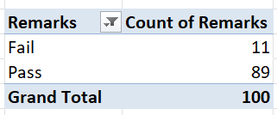
4. There is no significant relationship between a student's age and their grade. The very weak correlation suggests that being older or younger does not clearly affect how well a student performs in this group.
5. I would use the full set of student data, not just age and grade, to identify key areas for intervention. Since the age/grade relationship is weak, I'd focus on other factors.

