Email writing

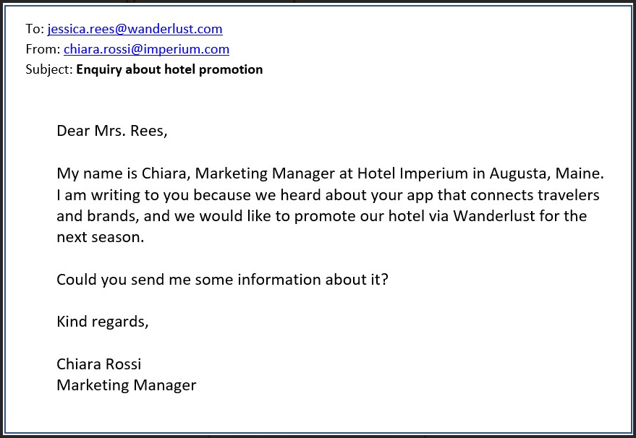

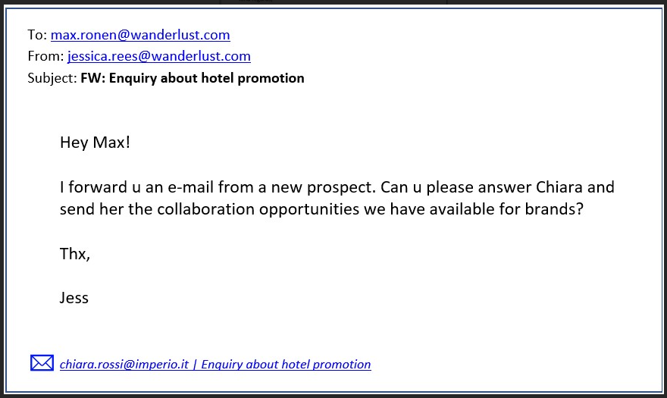

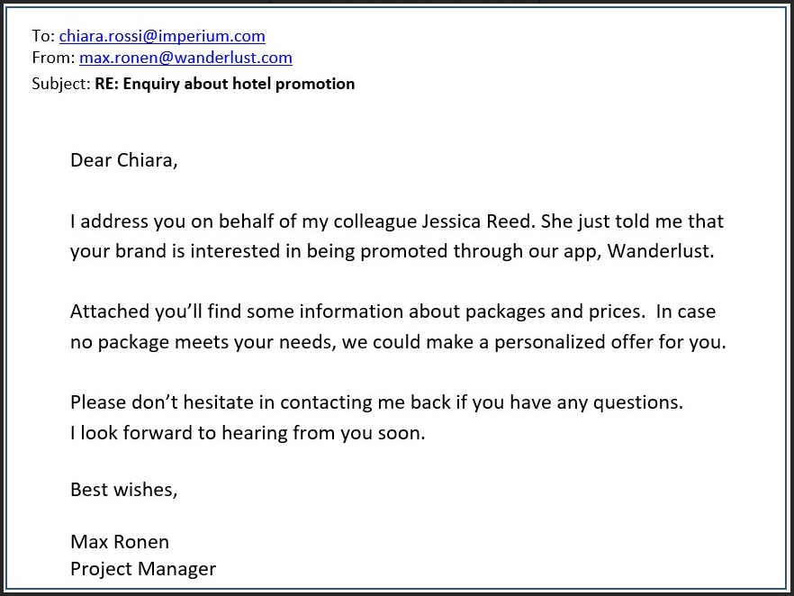

EXERCISE 2

Imagine you are Chiara Rossi. First, write an answer to Max’s email. Thank him for the information and tell him that your colleague Paul Weisz, a marketing technician, will contact him to explain the company’s special needs in order to get a personalized offer.

Then, write an e-mail to your colleague Paul. Ask him to contact Max and let him know about Imperium’s special needs.

Hey Max!

First of all, I’d like to thank you for the information attached.

I’m writing you because my colleague Paul Weiz, our marketing technician will contact you soon to explain our company’s special needs.

Best wishes,

Chiara Rossi,

Marketing Manager.

Hey Paul!

What’s up? I’m writing to ask you to send an email to Max to let him know what the Imperium’s needs are.

Ta very much.

Chiara Rossi,

Marketing Manager.

**REPORTING**

**What is CRUD and how to implement it on any database?**

**Introduction**

This report is written to provide a guide to apply CRUD (Create, Read, Update and Delete) on any database and a user guide. It shows an example of its implementation and finish with recomendations.

**Steps to follow**

**CREATE:** The process of create envolves creating tables and filling the fields with data.

**READ:** This section is what the user sees in their screen.

A typical example, the users have a web application where they can save movies. They can save the name, director, year and important information about the movie.

Then, you need to create the web design, starting with HTML, CSS and JavaScript, this section is the part the users will see in their screens. They don’t see the database, fields, etc. They only see the web design, this part is the Read of the CRUD.

**UPDATE:** Edit an existing object filling it with new data.

The user can edit a movie, changing its name, director or year and save the edit and this is the same movie but with updated information that is true at the time of the input, this is the Update section.

**DELETE:** The posibility of deleting any object created.

Finally, the user can delete a movie o all of them, and this is the last stage, the Delete.

**Conclusion**

CRUD is a very important process in data management and will help you manage your data efficiently.

To create the CRUD system ‘Project JSP’, the following steps were needed:

- First of all, you need to create a database.

- Fill the fields with data.

- The user can add new or more data.

In the part of Reading, this part is what the users see in their screens, all data organized. Name, Director or Year of the movie, TV Show, etc.

- In the stage of Update, this is when the user wants to change information of a movie previously created because maybe he saved a movie with wrong information.

And finally, the Delete stage. The user no longer wants to save the movie so he can delete the movie and the movie will be deleted from the database with all its information.

**Recomendations**