

**MATERIA:**

Sistemas Programables

**CARRERA:**

Ingeniería en Sistemas Computacionales

**PRESENTA:**

Erick Alejandro Ochoa González

**NOMBRE DEL MAESTRA:**

Ing. Levy Rojas Carlos Rafael

**PRACTICA:**

Semáforo/Arduino

**LEÓN, GUANAJUATO Periodo: Enero – Junio 2018**

***CÓDIGO FUENTE***

const int CAR_RED = 12; //red light of vehicular traffic initialized in 12

const int CAR_YELLOW = 11; //yellow light of vehicular traffic initialized in 11

const int CAR_GREEN = 10; //green light of vehicular traffic initialized in 10

const int PED_RED = 9; // red light of the pedestrian traffic initialized in 9

const int PED_GREEN = 8; // green light of the pedestrian traffic initialized in 8

const int BUTTON = 2; // button pin initialized in 2

int crossTime = 10000; //time alloyoud to cross

unsigned long changeTime; //time since BUTTON pressed

int state = LOW; //if is push button

/*

The method setup() configures the pin of the lights of the traffic lights to behave like an exit with the method pinMode()

Also the method digitalWrite() Write a HIGH or a LOW value to a digital pin.

*/

void setup() {

pinMode(CAR_RED, OUTPUT);

pinMode(CAR_YELLOW, OUTPUT);

pinMode(CAR_GREEN, OUTPUT);

pinMode(PED_RED, OUTPUT);

pinMode(PED_GREEN, OUTPUT);

pinMode(BUTTON, INPUT); // button on pin 2

digitalWrite(CAR_GREEN, HIGH);

digitalWrite(PED_RED, HIGH);

}

/*

The method loop()has two conditions, one that verifies if the button is pressed, if it is true the variable "state" takes the value of "high",

the second validation is responsible for verifying if the variable "satate" has the value of "high" and if the time that has passed since

the button was pressed in greater than 10 seconds

*/

void loop() {

if (digitalRead(BUTTON)) //Change of state is button is pressed

state = HIGH;

if (state == HIGH && (millis() - changeTime) > crossTime) {

changeLight();

state = LOW;

}

}

/*

The method changeLight is responsible for changing the lights of the traffic lights with the digitalWrite() method

*/

void changeLight() {

digitalWrite(CAR_GREEN, LOW); //green off

digitalWrite(CAR_YELLOW, HIGH); //yellow on

delay(2000); //wait 2 seconds

digitalWrite(CAR_YELLOW, LOW); //green off

digitalWrite(CAR_RED, HIGH); //yellow on

delay(2000); //wait 2 seconds

digitalWrite(PED_RED, LOW); //green off

digitalWrite(PED_GREEN, HIGH); //yellow on

delay(crossTime); //wait for

for (int i = 0; i < 10; i++) {

digitalWrite(PED_RED, HIGH); //Turn on red pedestrian traffic light

delay(250);//wait 250 milliseconds

digitalWrite(PED_GREEN, LOW);//Turn off green pedestrian traffic light

delay(250);//wait 250 milliseconds

}

digitalWrite(PED_RED, HIGH);//Turn on red pedestrian traffic light

delay(500);//wait 500 milliseconds

digitalWrite(CAR_YELLOW, HIGH);//turn on the yellow light of the traffic lights of the vehicles

digitalWrite(CAR_RED, LOW);//turn on the red light of the traffic lights of the vehicles

delay(1000);//wait 500 milliseconds

digitalWrite(CAR_GREEN, HIGH);//turn on the green light of the traffic lights of the vehicles

digitalWrite(CAR_YELLOW, LOW);//turn on the yellow light of the traffic lights of the vehicles

//record the time size last change of lights

changeTime = millis();

//then return to the my program loop

}

***DIAGRAMA DE CONFIGURACIÓN***

***Simulado:*** *Figura 1.1*

*Figura 1.2*

*Figura 1.3*

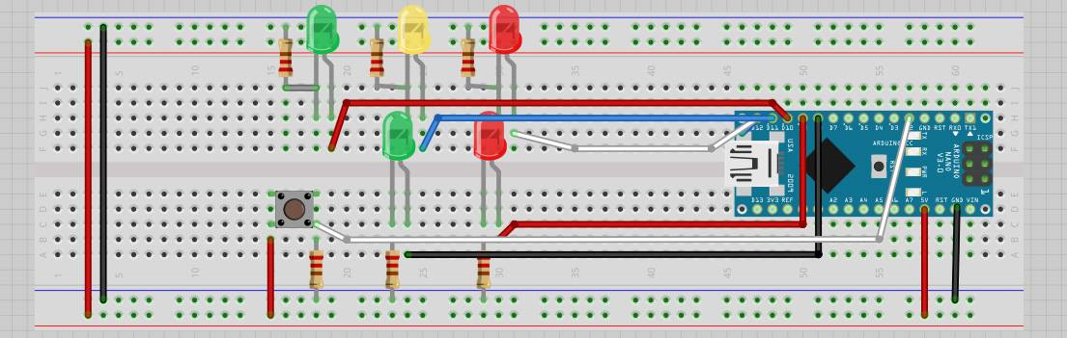

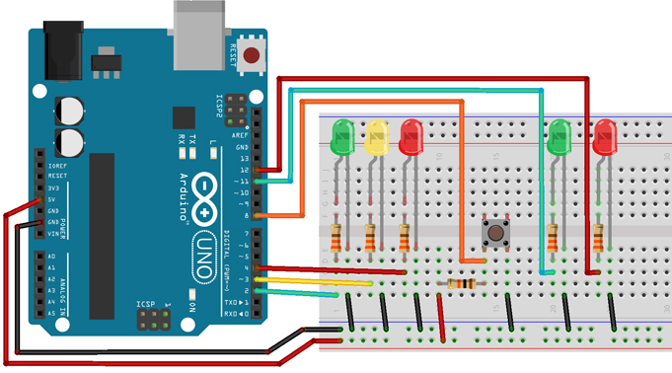*Figura 1.1*

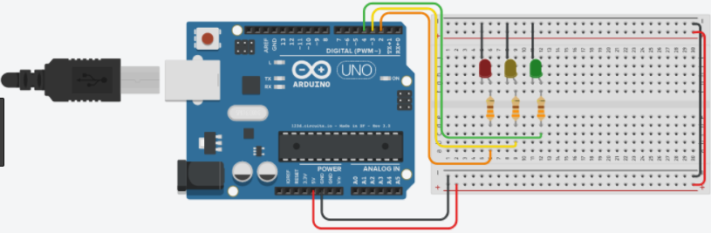*Figura 1.2*

*Figura 1.3*

***RESULTADOS***

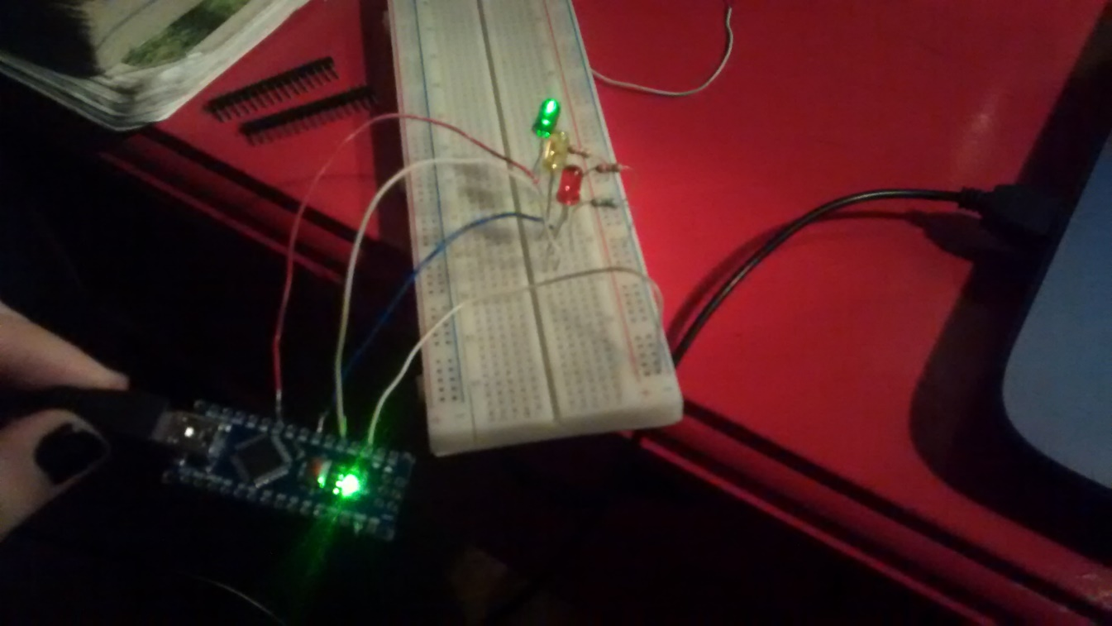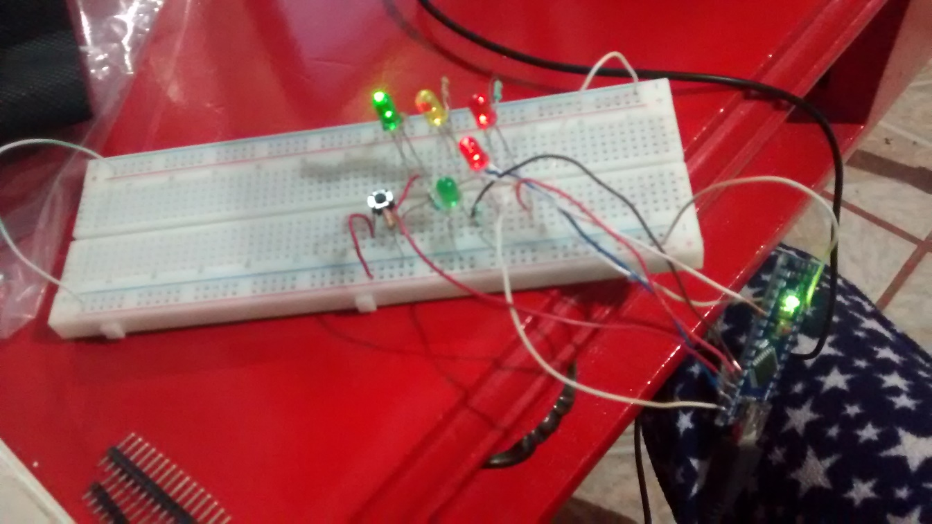

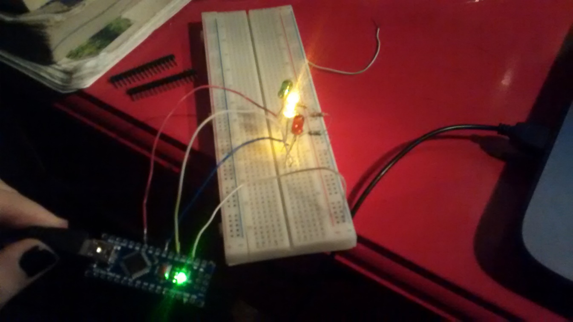

***CONCLUSIÓN***

* En esta actividad se implementó una simulación a escala de un semáforo vial, es decir tanto vehicular cómo peatonal en base a la funcionalidad que nos permite utilizar Arduino, es decir, con instrucciones sencillas en el código que se adaptan a las necesidades que podamos tener, con la implementación del Arduino con el programa previamente cargado y con complemento de una placa, en este caso protoboard, apoyado de leds y resistencias para una mejor práctica, se ensambló esta simulación de semáforo, funcionando de buena manera, apoyado específicamente de estas herramientas: 1 Arduino UNO, Protoboard, Led rojo 3mm, Led amarillo 3mm, Led verde 3mm, 3 resistencias de 220Ω, 1 push button y cables para conectar todo.