I approach the problem of modeling these historical datasets as a three-way maximization problem among three hypothetical quantities: fidelity, interoperability, and neutrality. In a perfect world, we would construct a data model that faithfully represents all of the original source data (fidelity), while providing a sufficient level of abstraction to marshall heterogeneous data in addressing research questions (interoperability), and yet do so without pre-supposing (and thereby limiting) what those research questions might be or adopting any particular view of the data (neutrality). By “view” I mean an external model through which a historical actor or a researcher makes sense of a dataset for some particular purpose. In practice, those three desiderata are often in tension. For example, achieving sufficient abstraction for interoperability often entails that we discard some of the specificity or structure of the source data. Neutrality is especially challenging in the context of historical research: whereas achieving neutrality is a problem of representing the fundamental nature of the concepts in a system (“neutral” with respect to actors’ or researchers’ views), one of the foundational assumptions of any historical project is that the concepts being investigated are subject to change. One way to mitigate the tension between neutrality and historicity is to divide the study of these historical data into two complementary problems: a qualitative analysis of actors’ views of data, and creating a structured and general representation of the data that supports those views. Maximizing neutrality and historicity in the latter case is a problem of choosing concepts that are stable over the time period in question, even if the specifics of their implementation (e.g. the terms and components of an insurance policy) might change.
The draft data model shown in Figure 1 is an example solution to the latter problem in the case of two historical datasets: the London Lives Fire Insurance Registers (1775-1776) and the Whipple Fire Reporter (1879 - ??). Classes colored green apply to both datasets, and those colored orange apply only to the Whipple Fire Reporter dataset. Figure 2 shows an example of a datum in the London Lives dataset, and Figure 3 shows an example of a datum in the Whipple dataset. The data in Figures 2 and 3 are complex data objects, in that they are comprised of many different concepts and attributes. In generating a model like the one shown in Figure 1, I attempt to unfold these complex data into more modular concepts by converting attributes of data into relationships among entities. For example, some of the attributes of the datum in Figure 2 can be pulled apart and represented as an association (an insurance policy) among an insurance company, an historical actor (Henry Oake), and a specific property at some location. Wherever practicable, I treat associations, activities, and events as distinct entities. Entities are named without regard to their relations. I use named relations (edges) to express the involvement of entities in those events or associations.

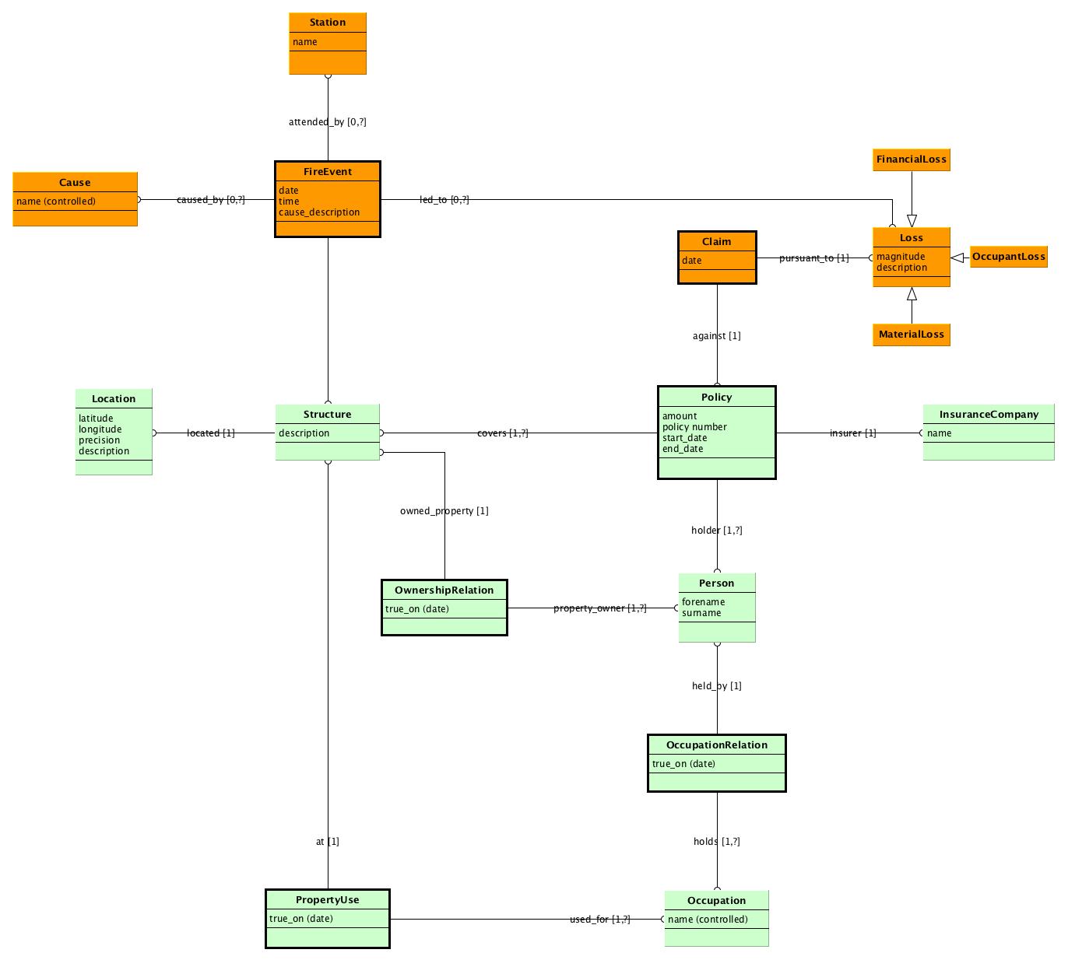
Figure 1. Example of a draft data model for the London Lives Fire Insurance Registers (1775-1776) and the Whipple Fire Reporter (1879 - ??) datasets. Classes colored green apply to both datasets, and those colored orange apply only to the Whipple Fire Reporter dataset. Associations, activities, and events (dark borders) are treated as distinct entities, and name relations express the involvement of other entities in those events. Open arrows indicate class inheritance; e.g. Loss has a variety of subclasses, all of which involve some magnitude and may have some qualitative description.

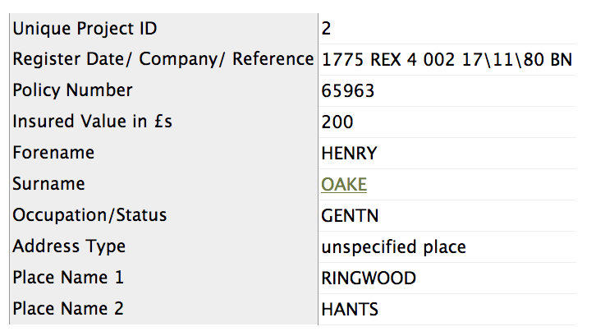
Figure 2. Datum in the London Lives Fire Insurance Registers (1775-1776) dataset.

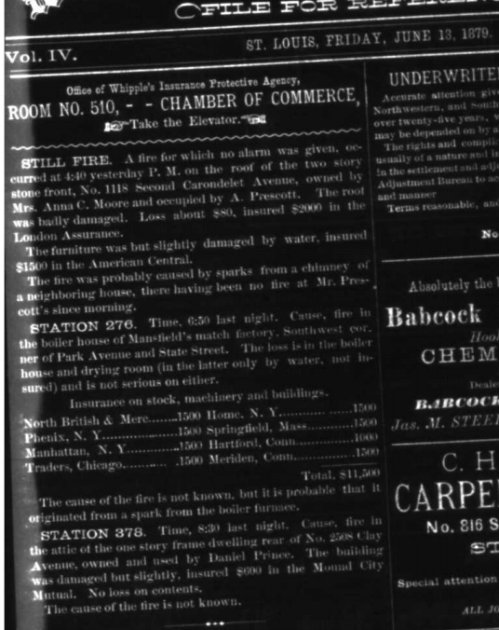
Figure 3. Datum in the Whipple Fire Reporter (1879 - ??) dataset.

