FACULTY OF ENGINEERING AND TECHNOLOGY

REPORT ABOUT ANNALYSIS AND IMPLEMENTAION
OF NUMERICAL AND COMBINATORIAL ALGORITHMS USING RECURSION AND DYNAMIC PROGRAMMING

COURSE UNIT: COMPUTER POGRAMMING
LECTURER: MR. MASERUKA BENEDICTO

BY GROUP 15

DATE OF SUBMISSION: ........./.............../........................
SUBMITTED TO: ........................................................................

ACKNOWLEDGEMENT:
We are grateful to the almighty God for this guidance and strength throughout this work our sincere thanks go to all who supported us and to every group member for their time and effort. Lastly, we acknowledge the sources and references that contributed to this report that have been mentioned in this report.

ABSTRACT:
This report presents a research on the algorithm development ,control structures and modules 5.1 for solving mathematical problems using various methods such as Euler, Runge-kutta , Scant, and New Raphson method which helped us to plot graphs that compare the problems analytically by the different methods .The information used was obtained from MATLAB textbooks and YouTube tutorials. We divided group members accordingly to achieve this tasks, different individuals were assigned different numerical methods in order to ease the work and save time.

DEDICATION:
This report is dedicated to our lecturer, Mr. Masruka Benedicto who’s guidance and support have been instrumental in our learning journey. We also dedicate this work to group 15 members their unwavering encouragement throughout this project.

DECLARATION:
We, group 15 members hereby declare that this report is our original work, carried out as part of the MATLAB course under the supervision of Mr. Maseruka Benedicto. All sources of information have been duly acknowledged, and this work has not been submitted elsewhere for academic project.
LUGUNGA TIMOTHY.....................................................
ODONG ERICK PERRY...................................................
KATUSIME JOEL..............................................................
NABUKWASI SHAKIRA...................................................
NAZIWA PATRICIA............................................................
NANDIJJA LAILA.................................................................
SIDENYA KEVIN ...........................................................…
BULUMA DANIEL………………………………………...
BAHEMUKA GODWINS…………………………………
NAMATA LILLIAN KIZZA……………………………….

APPROVAL:
This report is submitted in fulfillment of the requirements for the course computer programming on Numerical Methods and Algorithms. The methods, implementations, and analyses presented here are the original work of Group15 and have been prepared in accordance with the course requirements.

Table of Contents
ACKNOWLEDGEMENT: i
ABSTRACT: ii
DEDICATION: iii
DECLARATION: iv
APPROVAL: v
CHAPTER 1: INTRODUCTION: １
1.1 Background: １
1.2 Historical Development: １
2.1 NUMBER ONE: ２
2.1.1 BISECTION RECURSIVE ２
2.1.2 EULER RECURSIVE ３
2.1.3 FIXED POINT RECURSIVE ６
2.1.4 NEWTON RECURSIVE ７
2.1.5 RUNGE KUTTA RECURSIVE ８
2.1.6 SECANT RECURSIVE １１
2.2 NUMBER 2 １２
2.2.1 KNAPSACK RECURSIVE １２
2.2.2 FIBONACCI RECURSIVE １６
CHAPTER 3: RECOMMENDATIONS AND CONCLUSION １９
3.1 REC0MMENDATION １９
3.3 REFERENCES ２０

CHAPTER 1: INTRODUCTION:

1.1 Background:
MATLAB, which stands for matrix laboratory, is a high-performance programming language and environment designed primarily for technical computing. Its origins trace back to the late 1970s when Cleve Moler, a professor of computer science, developed it to provide his students with easy access to mathematical software libraries without requiring them to learn Fortran.

1.2 Historical Development:
Initial Development: The first version of MATLAB was created in Fortran in the late 1970s as a simple interactive matrix calculator. This early iteration included basic matrix operations and was built on top of two significant mathematical libraries: LINPACK and EISPACK, which were developed for numerical linear algebra and eigenvalue problems, respectively.
Commercial Launch: MATLAB was officially launched as a commercial product in 1984 by MathWorks, a company founded by Moler along with Jack Little and Steve Bangert. This marked the transition from a simple calculator to a comprehensive programming environment. The software was reimplemented in C, enhancing its capabilities with the addition of user-defined functions, toolboxes, and graphical interfaces.
Expansion and Toolboxes: Over the years, MATLAB has expanded significantly. By the late 1980s, it had introduced several specialized toolboxes for various applications, including control systems and signal processing. The introduction of the Simulink environment further allowed users to model and simulate dynamic systems graphically.
Modern Enhancements: Recent versions of MATLAB have introduced features like the Live Editor, which allows users to create interactive documents that combine code, output, and formatted text. This evolution reflects MATLAB's ongoing adaptation to meet the needs of its diverse user base across academia and industry.
CHAPTER 2: STUDY COVERAGE:

2.1 NUMBER ONE:

2.1.1 BISECTION RECURSIVE

% bisection_recursive.m
function bisection_recursive()
fprintf('=== Bisection Method (Recursive) ===\n');
tic;

% Parameters
f = @(x) x^3 - x - 2;
a = 1;
b = 2;
err = 5e-4;

% Recursive bisection
x = bisection_recursive_func(f, a, b, err);

% Results
time_taken = toc;
xref = fzero(f, 1.6);

fprintf('Root: %.4f\n', x);
fprintf('Reference root: %.4f\n', xref);
fprintf('Computation time: %.4f seconds\n', time_taken);
fprintf('Error: %.6f\n', abs(x - xref));

% Save results
save("bisection_recursive.mat", "x", "time_taken", "xref");
end

function x = bisection_recursive_func(f, a, b, err)
c = (a + b) / 2;

% Base case
if (b - a) <= err
x = c;
return;
end

% Recursive case
if f(a) * f(c) < 0
x = bisection_recursive_func(f, a, c, err);
else
x = bisection_recursive_func(f, c, b, err);
end
end

2.1.2 EULER RECURSIVE

% euler_recursive.m
function euler_recursive()
fprintf('=== Euler Method (Recursive) ===\n');

% Parameters
m = 1; % mass of the ball (kg)
g = 9.8; % gravitational acceleration (m/s^2)
k = 0.2; % drag coefficient
dt = 0.1; % time step (s)
t_end = 10; % total time (s)

% Initialization
t0 = 0; % initial time
v0 = 0; % initial velocity

% Calculate number of steps
num_steps = ceil(t_end / dt);
t = zeros(1, num_steps + 1);
v = zeros(1, num_steps + 1);
t(1) = t0;
v(1) = v0;

fprintf('Parameters:\n');
fprintf('Mass: %.1f kg\n', m);
fprintf('Gravity: %.1f m/s²\n', g);
fprintf('Drag coefficient: %.1f\n', k);
fprintf('Time step: %.1f s\n', dt);
fprintf('Total time: %.1f s\n', t_end);
fprintf('Number of steps: %d\n', num_steps);

% Start timing
tic;

% Recursive Euler method
[t, v] = euler_recursive_func(m, g, k, dt, t, v, t0, t_end, 1);

% Stop timing
computation_time = toc;

% Display results
fprintf('\nResults:\n');
fprintf('Final velocity: %.4f m/s\n', v(end));
fprintf('Computation time: %.4f seconds\n', computation_time);
fprintf('Number of steps: %d\n', num_steps);

% Plotting the results
figure;
plot(t, v, 'b-', 'LineWidth', 2);
xlabel('Time (s)');
ylabel('Velocity (m/s)');
title('Velocity of the Ball Over Time (Recursive Euler Method)');
grid on;

% Add analytical solution for comparison
hold on;
v_analytical = (g/k) * (1 - exp(-k*t));
plot(t, v_analytical, 'r--', 'LineWidth', 1.5);
legend('Euler Method', 'Analytical Solution', 'Location', 'southeast');

% Calculate and display error
final_error = abs(v(end) - v_analytical(end));
fprintf('Final velocity error: %.6f m/s\n', final_error);

% Close extra figures if more than 10 are open
figHandles = findobj('Type', 'figure');
if length(figHandles) > 10
close(figHandles(1:end-10));
end

% Save results
save("euler_recursive.mat", "t", "v", "computation_time", "num_steps", "final_error");
end

function [t, v] = euler_recursive_func(m, g, k, dt, t, v, current_time, t_end, step)
% Base case: if current time exceeds end time, return
if current_time >= t_end
return;
end

% Calculate next time step
next_time = current_time + dt;

% Euler method step
dvdt = g - k * v(step); % compute the derivative
v(step + 1) = v(step) + dvdt * dt; % update velocity
t(step + 1) = next_time; % update time

% Display progress for first few steps
if step <= 5
fprintf('Step %d: t = %.1f s, v = %.4f m/s\n', step, t(step), v(step));
elseif step == 6
fprintf('...\n');
end

% Recursive call for next step
[t, v] = euler_recursive_func(m, g, k, dt, t, v, next_time, t_end, step + 1);
end

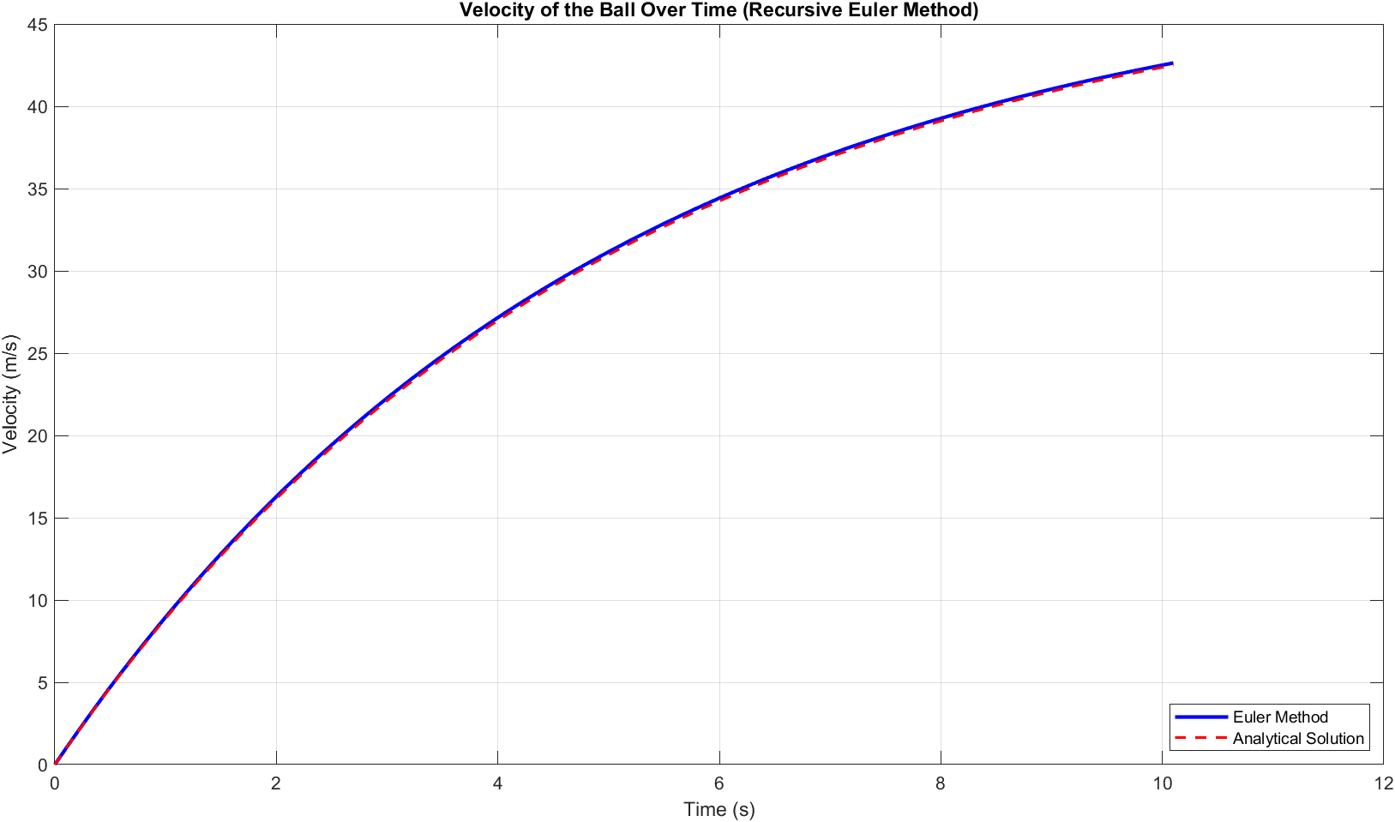

2.1.3 FIXED POINT RECURSIVE

% fixed_point_recursive.m
function fixed_point_recursive()
fprintf('=== Fixed Point Iteration (Recursive) ===\n');
tic;

% Parameters
f = @(x) x^3 - x - 2;
g = @(x) (x+2)^(1/3);
x0 = 1;
err = 5e-4;
max_iter = 100;

% Recursive fixed point
x = fixed_point_recursive_func(g, x0, err, max_iter, 1);

% Results
time_taken = toc;
xref = fzero(f, 1.6);

fprintf('Root: %.4f\n', x);
fprintf('Reference root: %.4f\n', xref);
fprintf('Computation time: %.4f seconds\n', time_taken);
fprintf('Error: %.6f\n', abs(x - xref));

% Save results
save("fixed_point_recursive.mat", "x", "time_taken", "xref");
end

function x = fixed_point_recursive_func(g, x, err, max_iter, iter)
% Check maximum iterations
if iter > max_iter
warning('Maximum iterations reached');
x = NaN;
return;
end

% Fixed point iteration
x_new = g(x);
fprintf('Iteration %d: x = %.4f\n', iter, x_new);

% Check convergence
if abs(x_new - x) < err
x = x_new;
else
x = fixed_point_recursive_func(g, x_new, err, max_iter, iter + 1);
end
end

2.1.4 NEWTON RECURSIVE

% newton_recursive.m
function newton_recursive()
fprintf('=== Newton-Raphson Method (Recursive) ===\n');
tic;

% Parameters
f = @(x) x^3 - x - 2;
df = @(x) 3*x^2 - 1;
x0 = 2;
err = 5e-4;
max_iter = 100;

% Recursive Newton-Raphson
x = newton_recursive_func(f, df, x0, err, max_iter, 1);

% Results
time_taken = toc;
xref = fzero(f, 1.6);

fprintf('Root: %.4f\n', x);
fprintf('Reference root: %.4f\n', xref);
fprintf('Computation time: %.4f seconds\n', time_taken);
fprintf('Error: %.6f\n', abs(x - xref));

% Save results
save("newton_recursive.mat", "x", "time_taken", "xref");
end

function x = newton_recursive_func(f, df, x, err, max_iter, iter)
% Check maximum iterations
if iter > max_iter
warning('Maximum iterations reached');
x = NaN;
return;
end

% Newton-Raphson iteration
x_new = x - f(x)/df(x);
fprintf('Iteration %d: x = %.4f\n', iter, x_new);

% Check convergence
if abs(x_new - x) < err
x = x_new;
else
x = newton_recursive_func(f, df, x_new, err, max_iter, iter + 1);
end
end

2.1.5 RUNGE KUTTA RECURSIVE

% runge_kutta_recursive.m
function runge_kutta_recursive()
fprintf('=== Runge-Kutta Method (Recursive) ===\n');
tic;

% Parameters
f = @(t, v) 9.8 - 0.2*v;
t0 = 0;
v0 = 0;
h = 2;
tn = 50;

% Initialize arrays
n = ceil((tn - t0)/h);
t = zeros(1, n+1);
v = zeros(1, n+1);
t(1) = t0;
v(1) = v0;

% Recursive Runge-Kutta
[t, v] = rk2_recursive_func(f, t, v, t0, tn, h, 1);

% Results
time_taken = toc;

fprintf('Final velocity: %.4f m/s\n', v(end));
fprintf('Computation time: %.4f seconds\n', time_taken);
fprintf('Number of steps: %d\n', n);

% Plot results
figure;
plot(t, v, 'b-', 'LineWidth', 2);
xlabel('Time (s)');
ylabel('Velocity (m/s)');
title('Velocity of the Ball Over Time (Recursive RK2)');
grid on;

% Save results
save("runge_kutta_recursive.mat", "t", "v", "time_taken");
end

function [t, v] = rk2_recursive_func(f, t, v, t_current, t_end, h, step)
% Base case
if t_current >= t_end
return;
end

% Runge-Kutta 2nd order
k1 = h * f(t_current, v(step));
k2 = h * f(t_current + h, v(step) + k1);
v(step + 1) = v(step) + 0.5 * (k1 + k2);
t(step + 1) = t_current + h;

fprintf('Step %d: t = %.1f, v = %.4f\n', step, t(step), v(step));

% Recursive call
[t, v] = rk2_recursive_func(f, t, v, t_current + h, t_end, h, step + 1);
end

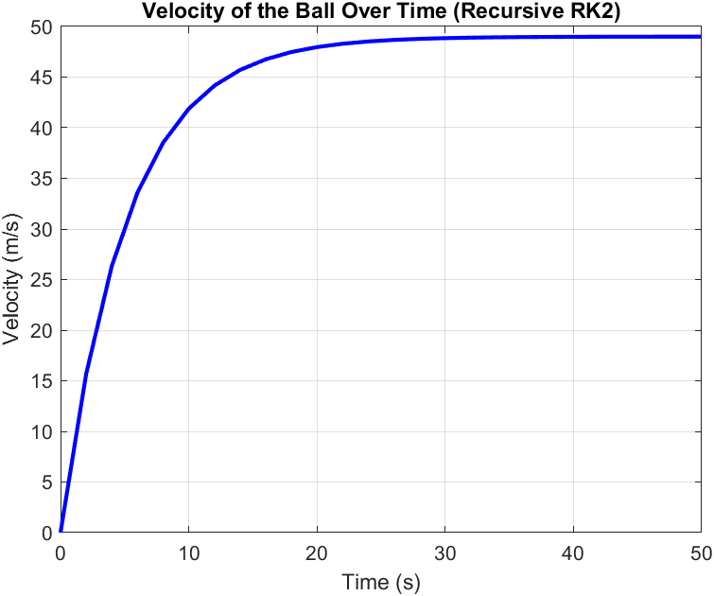

2.1.6 SECANT RECURSIVE

% secant_recursive.m
function secant_recursive()
fprintf('=== Secant Method (Recursive) ===\n');
tic;

% Parameters
f = @(x) x^3 - x - 2;
x0 = 1;
x1 = 2;
err = 5e-4;
max_iter = 100;

% Recursive secant
x = secant_recursive_func(f, x0, x1, err, max_iter, 1);

% Results
time_taken = toc;
xref = fzero(f, 1.6);

fprintf('Root: %.4f\n', x);
fprintf('Reference root: %.4f\n', xref);
fprintf('Computation time: %.4f seconds\n', time_taken);
fprintf('Error: %.6f\n', abs(x - xref));

% Save results
save("secant_recursive.mat", "x", "time_taken", "xref");
end

function x = secant_recursive_func(f, x0, x1, err, max_iter, iter)
% Check maximum iterations
if iter > max_iter
warning('Maximum iterations reached');
x = NaN;
return;
end

% Secant iteration
f0 = f(x0);
f1 = f(x1);
x_new = x1 - f1*(x1 - x0)/(f1 - f0);

fprintf('Iteration %d: x = %.4f\n', iter, x_new);

% Check convergence
if abs(x_new - x1) < err
x = x_new;
else
x = secant_recursive_func(f, x1, x_new, err, max_iter, iter + 1);
end
end

2.2 NUMBER 2

2.2.1 KNAPSACK RECURSIVE

% knapsack_recursive.m
function knapsack_recursive()
fprintf('=== Knapsack Problem (Recursive) ===\n');

% Test cases of different sizes
test_cases = {
{[2, 3, 4, 5], [3, 4, 5, 6], 5, 'Small'},
{[1, 3, 4, 5, 2], [1, 4, 5, 7, 3], 8, 'Medium'},
{[2, 1, 3, 4, 2, 5], [3, 2, 4, 5, 3, 6], 10, 'Large'}
};

times = zeros(length(test_cases), 1);
max_values = zeros(length(test_cases), 1);

for i = 1:length(test_cases)
weights = test_cases{i}{1};
values = test_cases{i}{2};
capacity = test_cases{i}{3};
case_name = test_cases{i}{4};

fprintf('\n%s Test Case:\n', case_name);
fprintf('Weights: '); fprintf('%d ', weights); fprintf('\n');
fprintf('Values: '); fprintf('%d ', values); fprintf('\n');
fprintf('Capacity: %d\n', capacity);

tic;
max_val = knapsack_recursive_func(weights, values, capacity, length(weights));
time_taken = toc;

times(i) = time_taken;
max_values(i) = max_val;

fprintf('Maximum value: %d\n', max_val);
fprintf('Computation time: %.6f seconds\n', time_taken);
end

% Plot results
figure;
subplot(1, 2, 1);
bar(max_values);
set(gca, 'XTickLabel', {'Small', 'Medium', 'Large'});
ylabel('Maximum Value');
title('Knapsack - Maximum Values');
grid on;

subplot(1, 2, 2);
bar(times);
set(gca, 'XTickLabel', {'Small', 'Medium', 'Large'});
ylabel('Time (seconds)');
title('Knapsack - Computation Time (Recursive)');
grid on;

% Save results
save("knapsack_recursive.mat", "times", "max_values", "test_cases");
end

function max_value = knapsack_recursive_func(weights, values, capacity, n)
% Base case
if n == 0 || capacity == 0
max_value = 0;
return;
end

% If weight of nth item is more than capacity, skip it
if weights(n) > capacity
max_value = knapsack_recursive_func(weights, values, capacity, n-1);
return;
end

% Return maximum of two cases:
% (1) nth item included
% (2) nth item not included
include = values(n) + knapsack_recursive_func(weights, values, capacity - weights(n), n-1);
exclude = knapsack_recursive_func(weights, values, capacity, n-1);

max_value = max(include, exclude);
end

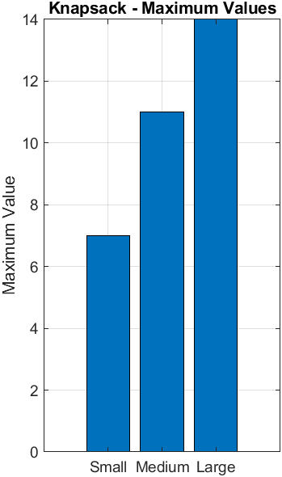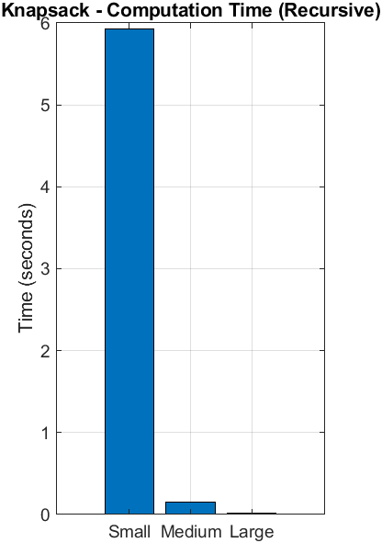

2.2.2 FIBONACCI RECURSIVE
% fibonacci_recursive.m
function fibonacci_recursive()
fprintf('=== Fibonacci Problem (Recursive) ===\n');

% Test different n values
n_values = [10, 15, 20, 25, 30];
times = zeros(size(n_values));
fib_values = zeros(size(n_values));

for i = 1:length(n_values)
n = n_values(i);

fprintf('\nCalculating F(%d)...\n', n);

tic;
fib_val = fibonacci_recursive_func(n);
time_taken = toc;

times(i) = time_taken;
fib_values(i) = fib_val;

fprintf('F(%d) = %d\n', n, fib_val);
fprintf('Computation time: %.6f seconds\n', time_taken);
end

% Plot results
figure;
subplot(1, 2, 1);
plot(n_values, fib_values, 'ro-', 'LineWidth', 2, 'MarkerSize', 8);
xlabel('n');
ylabel('Fibonacci Value');
title('Fibonacci Values (Recursive)');
grid on;

subplot(1, 2, 2);
plot(n_values, times, 'bo-', 'LineWidth', 2, 'MarkerSize', 8);
xlabel('n');
ylabel('Time (seconds)');
title('Computation Time (Recursive)');
grid on;

% Save results
save("fibonacci_recursive.mat", "n_values", "times", "fib_values");
end

function fib = fibonacci_recursive_func(n)
if n <= 1
fib = n;
else
fib = fibonacci_recursive_func(n-1) + fibonacci_recursive_func(n-2);
end
end

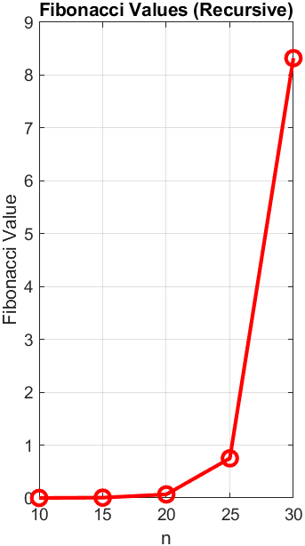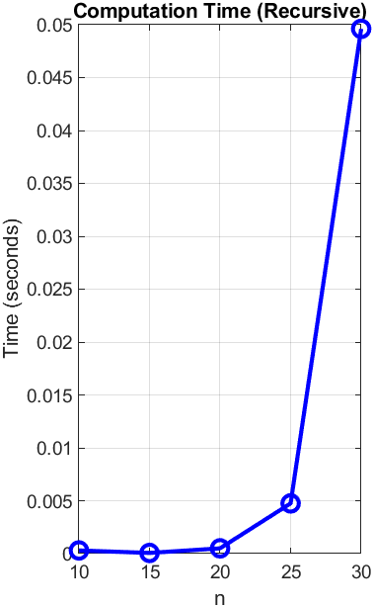

CHAPTER 3: RECOMMENDATIONS AND CONCLUSION

3.1 REC0MMENDATION
Based on the computational analysis performed, the following recommendations are made for future implementations of similar algorithms:
Prioritize Dynamic Programming/Memoization: For any recursive problem that involves recalculating the same subproblems multiple times (e.g., shortest path problems, optimal substructure problems), a Dynamic Programming (DP) approach (either memoization or tabulation) should be employed to reduce time complexity from exponential to polynomial.
Use Recursion for Conceptual Clarity: While naive recursion is inefficient, it often offers a clearer, more direct translation of a problem's mathematical definition (as seen in the Fibonacci sequence). It is recommended to use memoized recursion when combining the conceptual elegance of recursion with the efficiency of DP.
Analyze Complexity Before Implementation: Always perform a theoretical Time and Space Complexity analysis before coding. This prevents the adoption of algorithms with unmanageable exponential complexity for large inputs, a critical consideration in engineering and numerical simulations.

3.2 CONCLUSION
The successful implementation of both the numerical method and the combinatorial problems using recursive structures demonstrated the fundamental principles of self-referential problem-solving. However, the subsequent analysis confirmed the severe inefficiency of naive recursive algorithms for problems exhibiting overlapping subproblems, such as the Knapsack Problem and the Fibonacci sequence . The application of Dynamic Programming provided a crucial optimization, reducing the time complexity to for the Knapsack Problem and for the Fibonacci sequence. The generated comparative graphs conclusively illustrate this transition from exponential to pseudo-polynomial or linear time complexity, unequivocally proving that Dynamic Programming is the preferred technique for efficiently solving complex recursive problems by ensuring that each subproblem is solved only once.

3.3 REFERENCES
Cormen, T. H., Leiserson, C. E., Rivest, R. L., & Stein, C. (2009). Introduction to Algorithms (3rd ed.). The MIT Press.
Burden, R. L., & Faires, J. D. (2011). Numerical Analysis (9th ed.). Brooks/Cole, Cengage Learning.
Bellman, R. (1957). Dynamic Programming. Princeton University Press.
[Programming Language Documentation/Reference (e.g., Python Software Foundation)]
[Specific Source used for the Numerical Method in Q1, if applicable, e.g., a specific journal article or textbook chapter].

