Lab Guide

Topic Name

Date (January 1, 2019)

Sample Table of Contents

# LAB GuIDE OVerview

These labs are designed to complement your training, reinforcing the key concepts by applying and demonstrating what you learn in the presentation sessions. This lab guide is comprised of one or more labs. Each lab allows you to get first hands-on exposure working with “LAB Cloud” products using a demo environment, where you will see how key features and functionality are deployed in the software. Upon completion of each lab, a group review of the key takeaways will follow, tying back product content to the sales messaging and positioning.

## Labs

Description of business solution….

**Prerequisite**: Before starting these labs, you should have ….

**NOTE:** Content is driven by external factors such as user data entries and login date. As a result, what you see displayed in your environment may not exactly match with the lab screenshots. Screenshots are provided solely for illustrative purposes to help guide you through the user interface.

# Lab 1: Name of Lab

This is a lab that I will create

* Key features and functionality
* Built-in best practice predefined content
* Drivers and key performance indicators (KPIs)
* Ease of use with configuration wizards
* Planning and reporting needs in one centralized repository

**Note**: Be sure you are NOT connected to Oracle VPN when running the VM and performing the lab exercises.

## Lab 1: Name of LAB (followed by numbered action steps of the exercise, screenshots, and NOTEs).

1. Open…
   1. Optional…
2. Click….

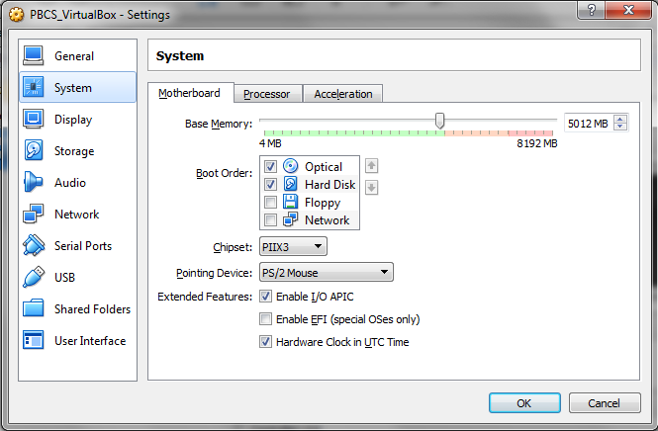

Figure 1.1

1. Enter…..
2. Close screen…..

**Note:** The following instructions cover general steps to back up demo content for most EPM Cloud services. Minor differences will exist with updates to the software. Steps and screenshots provided are based on EPM Version 16.09 User Interface and are provided solely for illustrative purposes.

# Lab 2: Name of Lab

Description and purpose of Lab 2….

## Lab 2: Name of LAB (followed by numbered action steps of the exercise, screenshots, and NOTEs).

1. Open…
2. Click….

# Appendix: Name of Appendix