|  |  |  |  |  |
| --- | --- | --- | --- | --- |
| **POLYTECHNIC UNIVERSITY OF THE PHILIPPINES**  **COLLEGE OF ENGINEERING**  **COMPUTER ENGINEERING DEPARTMENT**      TOTAL QUALITY IN COMPUTER ENGINEERING    Whistle Flashlight    TECHNICAL AND FUNCTIONAL  DOCUMENT    Section BSCOE 5-1D  Group No 3 | | | | |
| **NO** | **MEMBERS (Alphabetical Order)** | **CRITERIA** | **GRADE** |  |
| 1 | Cagomoc Niña Jaira Lael | Document Format Consistency (10%) |  |
| 2 | Calilung, Kristal |
| 3 | Kitts, Johndell | Complete TS Design, Components) (20%) |  |
| 4 | Macatangay senon jayson |
| 5 | Tan, Frederick | Complete TS Test Parameters and Procedures (20) |  |
| 6 |  |
| 7 |  | Complete FS on Procedures and Manuals) (10%) |  |
| 8 |  |
| 9 |  | Final Assembly Quality (40%) |  |
| 10 |  |
| **FINAL GRADE**      Instructor    **DR. LUTZ REYES**  2022 | | | |

|  |  |  |  |  |
| --- | --- | --- | --- | --- |
| **1. CHANGE RECORD:** | |  |  | |
| **Date** | **Author** | **DocVer** | **Change Reference** |  |
| 04-27-  2022 | * Cagomoc Niña   Jaira Lael   * Calilung,   Kristal   * Kitts, Johndell * Macatangay senon jayson * Tan, Frederick | Version  1.0 | Initial Draft |
| 05-31-2022 | - Kitts, Johndell S. | V2 | Components Used update (4.1 Detailed Description, 4.2 Overview, and 4.3.8 Flowchart) |
|  |  |  |  |
|  |  |  |  |
|  |  |  |  |
|  |  |  |  |
|  |  |  |  |
|  |  |  |  |
|  |  |  |  |
|  |  |  |  |
|  |  |  |  |
|  |  |  |  |
|  |  |  |  |
|  |  |  |  |
|  |  |  |  |
|  |  |  |  |
|  |  |  |  |
|  |  |  |  |
|  |  |  |  |
|  |  |  |  |
|  |  |  |  |
|  |  |  |  |
|  | | | |

|  |
| --- |
| **TECHNICAL SPECIFICATION DOCUMENT** |

|  |
| --- |
| 1. **INDIVIDUAL COMPONENTS:**      * 1. **Description:**     Whistle flashlight is a must-have product for everyone. It is easy to use and carry and this will help people in times of disaster by sending distress signals far away using the flashlight or distress sounds using a whistle.     * 1. **Features:**     It has a built in SOS distress signal  It is light and portable  It comes in many colors     * 1. **Applications:**     A survival tool for emergencies and disasters     * 1. **Components/Device Information:**     Flashlight  Whistle  SOS distress signal Circuitry |

**3.**

**DIAGRAMS**

**:**

*3.1.*

**Schematic Diagrams:**

*3.2.*

**Drawings and Wireframes:**

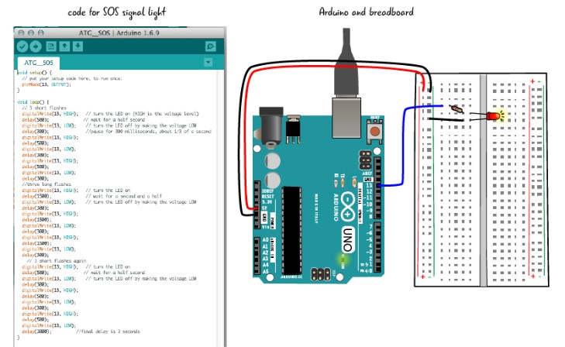

|  |
| --- |
|  |

|  |
| --- |
| 1. **COMPONENTS USED:**    1. **Detailed Description:**       1. Arduino Nano - compact, comprehensive, and breadboard-friendly board (Arduino Nano 3.x). It has similar capabilities to the Arduino Duemilanove, but comes in a different packaging.       2. Colored Wires (12 AWG stranded) - a flexible metallic conductor, usually insulated and used to convey electric current in a circuit, especially one composed of copper.       3. Casing – A cover or shell that protects or encloses something.       4. Concave Lens - A concave lens is one that has at least one inwardly curving surface. It is a divergent lens, which means that light rays refracted via it are stretched out.       5. Reflector - a piece of glass, metal, or other material that is used to reflect light in a certain direction       6. Lens Cap - Provides protection from scratches and minor collisions for the Lens.       7. Buttons - a simple switch mechanism to control some aspect of a machine or a process.       8. Batteries - a device that uses an electrochemical oxidation-reduction process to directly transfer chemical energy stored in its active components into electric energy.       9. Battery Contacts - are connected to the device's electrical circuitry by wire leads, resulting in an electrical connection when the terminals press against them.       10. Resistor - a passive two-terminal electrical component that implements electrical resistance as a circuit element.       11. XM-L2 LED 10W - When current travels through a semiconductor light source, it emits light.       12. Input tube – This where the air will be inputted for the whistle.       13. Chamber – This is for the chamber of whistle.       14. Corkball – This will give additional noise for the whistle.    2. **Overview:**       1. For the total physical product, Arduino Nano will be the brain of the flashlight it is responsible for making a signal of SOS, turning on and off, of flashlight. The Concave Lens will be used to make the LED light spread and stretched. There are two buttons that are connected to the casing which is the casing is the body of the product. The first button will be a switch for the flashlight to turn on or off, the other button is to automate S.O.S. signal that will turn on light 3 times rapidly, then turn on 3 times slowly, then turn on light 3 times rapidly. The casing will protect the components from the inside like Arduino. Battery will be the one that will give life for our product. Reflector will be used to make the flashlight bright in only one direction where the flashlight is pointed to. There is also a whistle that has input tube this is where the user will blow an air into it, Chamber will emit sounds with the corkball that will give additional alarming sound for the other people to notice.    3. **Feature Description:**       1. **Product Technical Spec**       2. **Product Dimension:**          1. **Top View:**          2. **Side View:**          3. **Internal View:**       3. **Printed Circuit Board Side View:**       4. **Screws - Side and Top View:**       5. **Components Technical Specification:**       6. **Detailed Step-by-Step Procedure:**          1. **Assembly Instruction:**          2. **Test instructions, Parameters and process for quality:**       7. **Time and Motion Activities:**       8. **Flow Chart:**  * + 1. **Quality Tools Used for Defect Monitoring**        1. **Defect List or Check List Summary**        2. **Fishbone Analysis for all Defects** |

|  |
| --- |
| **FUNCTIONAL SPECIFICATION DOCUMENT** |

|  |
| --- |
| 1. **EXTERNAL DETAILED DRAWING OF THE PRODUCT WITH PARTS:**            1. **FUNCTIONS OF EACH PARTS:**            1. **STEP BY STEP PROCEDURE ON HOW TO USE THE PRODUCT:**            1. **INDICATE MAINTENANCE PROCEDURES (IF ANY)** |

|  |  |  |  |  |  |  |  |  |  |  |  |  |  |  |  |  |  |  |  |  |  |  |  |  |
| --- | --- | --- | --- | --- | --- | --- | --- | --- | --- | --- | --- | --- | --- | --- | --- | --- | --- | --- | --- | --- | --- | --- | --- | --- |
| **9. SIGN OFF:** *(Signature of key sponsors, subject matter expert heads)*       |  |  |  |  | | --- | --- | --- | --- | | Name | Position | Signature | Date Signed | | Cagomoc, Jaira |  |  |  | | Calilung Kristal |  |  |  | | Kitts, Johndell S. | Product Designer |  | 05/31/2022 | | Macatangay, Senon |  |  |  | | Tan, Frederick |  |  |  | |

Technical Specifications & Functional Specifications Documents - Page