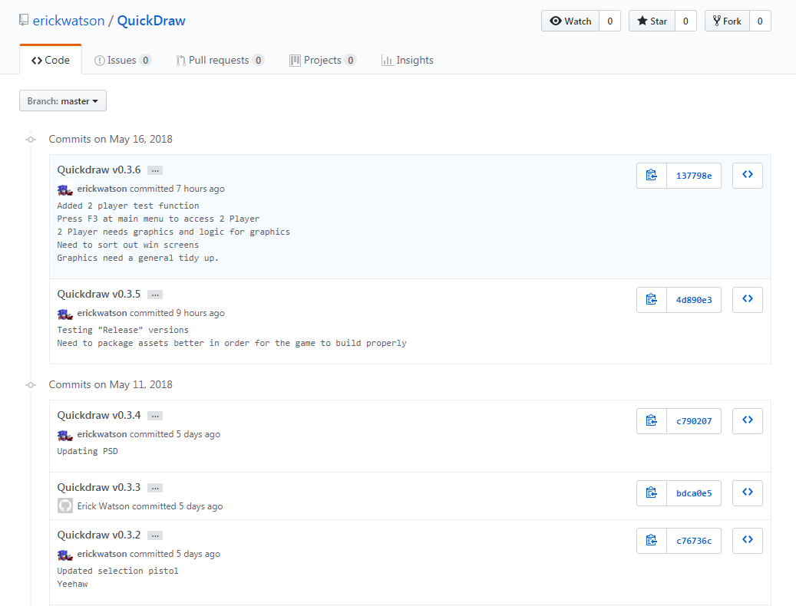

Playtesting:

Test the flow of the game and it’s difficulty.