Eric Layne

CSE40637 Data Science

Prof. Jiang

16 September 2018

Homework #1: Programming Assignment

**Data Description**

1:

zscore1 | max: 2.49201920212 min: -1.87002413385

zscore2 | max: 3.0907752483 min: -2.43394714191

zscore3 | max: 1.78583195363 min: -1.56757623428

zscore4 | max: 1.71309868604 min: -1.44954504204

**Data Visualization**

2-1:

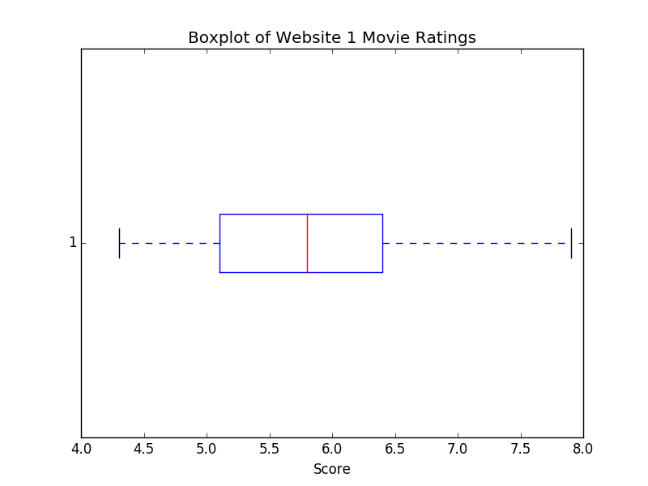

2-2:

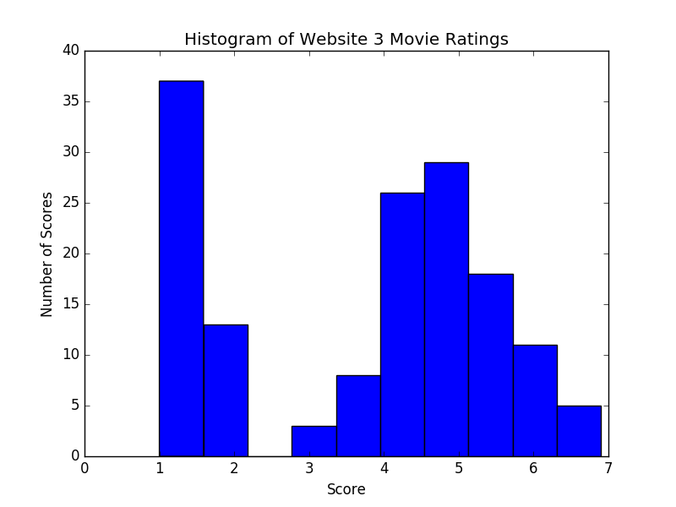

2-3:

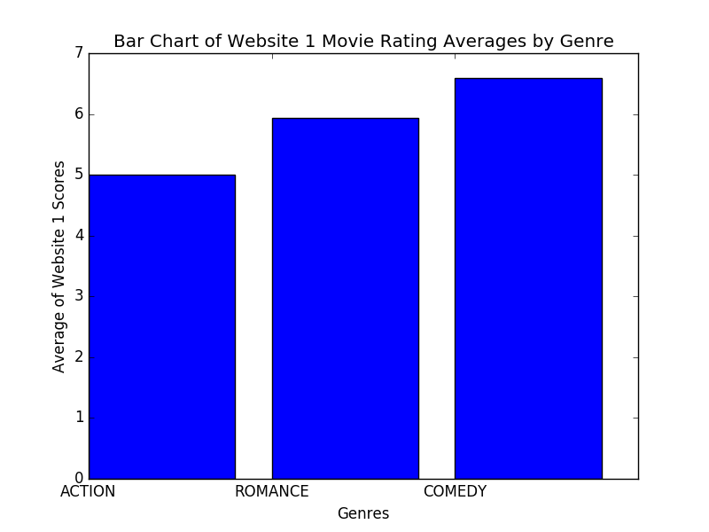

2-4:

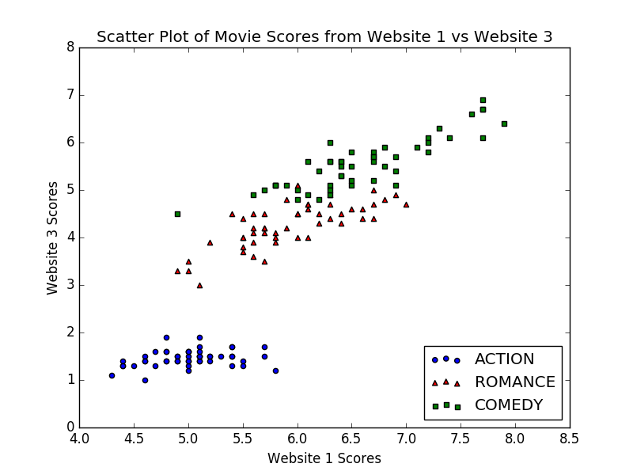

2-5:

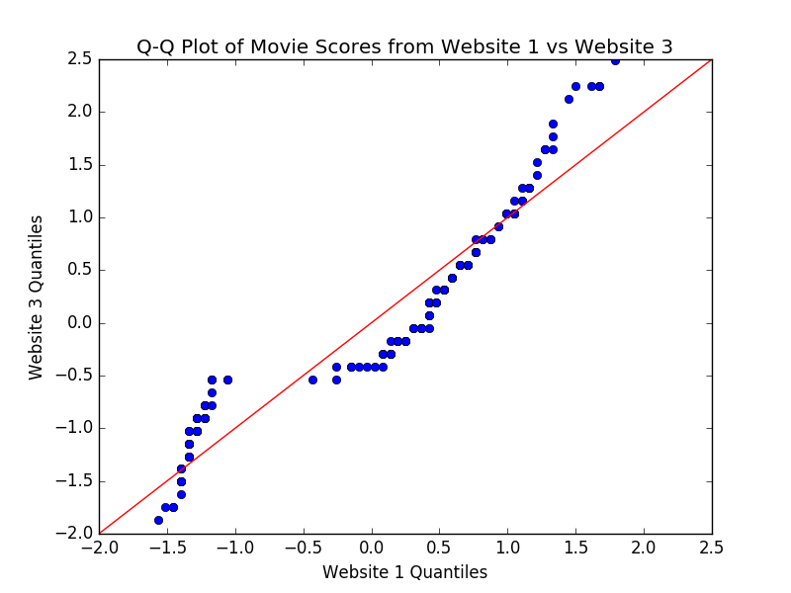

2-6:

KL Divergence of 1 compared to 3: 0.09013557003510739

KL Divergence of 3 compared to 1: 0.0747357693699291

3-1:

score1 score2 score3 score4

score1 0.685694 -0.042434 1.274315 0.515705

score2 -0.042434 0.189979 -0.329656 -0.121275

score3 1.274315 -0.329656 3.116278 1.294027

score4 0.515705 -0.121275 1.294027 0.579732

3-2:

score1 score2 score3 score4

score1 1.006711 -0.118359 0.877604 0.823432

score2 -0.118359 1.006711 -0.431316 -0.367883

score3 0.877604 -0.431316 1.006711 0.969207

score4 0.823432 -0.367883 0.969207 1.006711

3-3:

The results are not the same due to the z-score normalization. Converting the values to z-scores removes the variations in scoring between the different metrics. Analyzing the differences between normalized z-scores tells much more than the difference between arbitrary scoring where values might range depending on the metric used.

4-1:

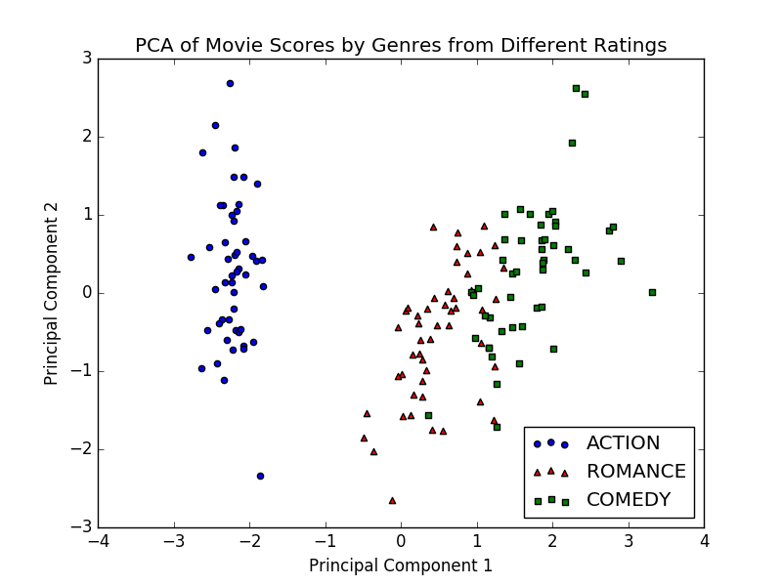

4-2:

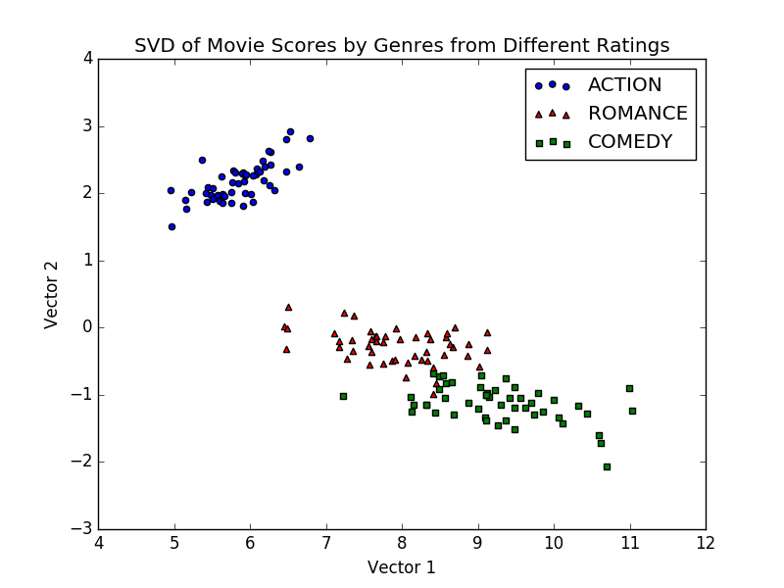

4-3:

PCA Eigenvalues:

[[ 0.52113894 -0.26919025 0.58044885 0.56482736]

[ 0.37703631 0.92342771 0.02416808 0.06738537]]

Top 3:

0.92342771

0.58044885

0.56482736

SVD Singular Values:

[95.96094362 17.75656516]

4-4:

My code did not work. My estimate is that it is neither.