

Functional Safety Concept Lane Assistance

**Document Version: [Version]**

**Template Version 1.0, Released on 2017-06-21**



# Document history

|  |  |  |  |
| --- | --- | --- | --- |
| Date | Version | Editor | Description |
| 12/2/2017 | 1.0 | Eric Lavigne | Initial Draft |
|  |  |  |  |
|  |  |  |  |
|  |  |  |  |
|  |  |  |  |

# Table of Contents

Document history

Table of Contents

Purpose of the Functional Safety Concept

Inputs to the Functional Safety Analysis

Safety goals from the Hazard Analysis and Risk Assessment

Preliminary Architecture

Description of architecture elements

Functional Safety Concept

Functional Safety Analysis

Functional Safety Requirements

Refinement of the System Architecture

Allocation of Functional Safety Requirements to Architecture Elements

Warning and Degradation Concept

# Purpose of the Functional Safety Concept

The purpose of a functional safety concept is to reduce risks to acceptable levels by providing a high-level design to meet safety goals as identified in HARA.

# Inputs to the Functional Safety Concept

## Safety goals from the Hazard Analysis and Risk Assessment

|  |  |
| --- | --- |
| **ID** | **Safety Goal** |
| Safety_Goal_01 | The oscillating torque to the steering wheel from the lane departure warning function shall be limited. |
| Safety_Goal_02 | The lane keeping assistance function shall be time limited and the additional steering torque shall end after a given time interval so that the driver cannot misuse the system for autonomous driving. |

## Preliminary Architecture

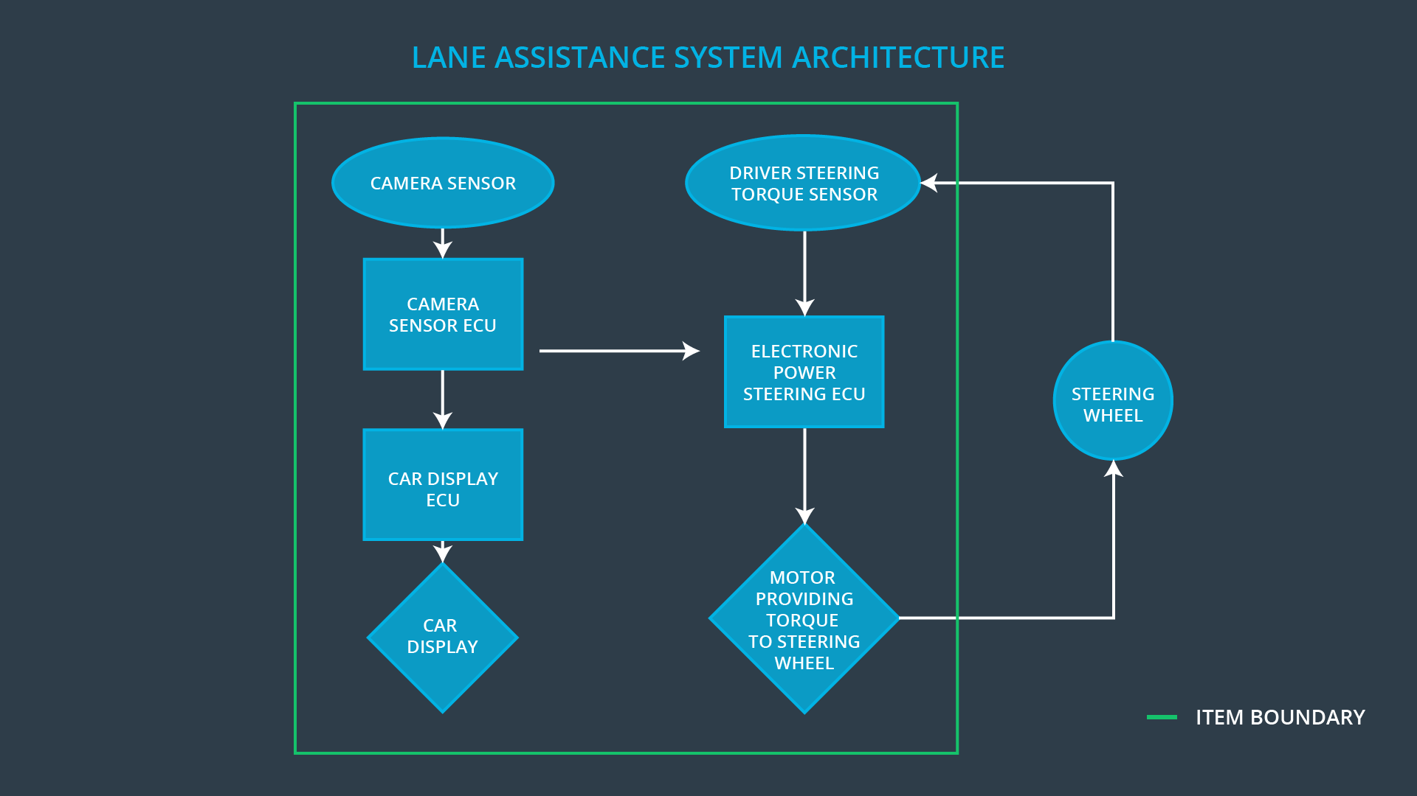

### Description of architecture elements

|  |  |
| --- | --- |
| **Element** | **Description** |
| Camera Sensor | The camera sensor reads in images from the road. |
| Camera Sensor ECU | The camera sensor ECU identifies when the vehicle has accidentally departed its lane and sends the appropriate messages to the Car Display ECU and the Electronic Power Steering ECU. (consider more detail on each of those messages) |
| Car Display | Shows the driver whether each lane assistance function is currently operating and warnings when a lane departure is in progress or when the lane keeping function will automatically disengage soon. |
| Car Display ECU | The car display ECU determines what information is displayed to the driver, including which lane assistance functions are currently operating and warnings about lane departure or impending disengagement of lane keeping. |
| Driver Steering Torque Sensor | The driver steering torque sensor determines how much torque the driver is applying to the steering wheel and sends that information to the electronic power steering ECU. This is needed primarily to make power steering work at all. In the lane assistance function, it can also be used to identify when the driver is attempting to override the lane assistance. |
| Electronic Power Steering ECU | The electronic power steering ECU determines the appropriate torque to apply to the steering wheel. This includes primarily amplification of torque applied by the driver, but also includes the primary behaviors of the lane assistance item: high-frequency variations for haptic feedback in the lane departure warning function and gentle turning for the lane keeping function. |
| Motor | The motor provides torque to the steering wheel to keep the car within its lane as part of the lane keeping function and applies high-frequency varying torque for haptic feedback as part of the lane departure warning function. |

# Functional Safety Concept

The functional safety concept consists of:

* Functional safety analysis
* Functional safety requirements
* Functional safety architecture
* Warning and degradation concept

## Functional Safety Analysis

|  |  |  |  |
| --- | --- | --- | --- |
| **Malfunction ID** | **Main Function of the Item Related to Safety Goal Violations** | **Guidewords (NO, WRONG, EARLY, LATE, MORE, LESS)** | **Resulting Malfunction** |
| Malfunction_01 | Lane Departure Warning (LDW) function shall apply an oscillating steering torque to provide the driver a haptic feedback | MORE | The lane departure warning function applies an oscillating torque with very high torque amplitude (above limit). |
| Malfunction_02 | Lane Departure Warning (LDW) function shall apply an oscillating steering torque to provide the driver a haptic feedback | MORE | The lane departure warning function applies an oscillating torque with very high torque frequency (above limit). |
| Malfunction_03 | Lane Keeping Assistance (LKA) function shall apply the steering torque when active in order to stay in ego lane | NO | The lane keeping assistance function is not limited in time duration which leads to misuse as an autonomous driving function. |

## Functional Safety Requirements

**[Instructions: Fill in the functional safety requirements for the lane departure warning ]**

Lane Departure Warning (LDW) Requirements:

|  |  |  |  |  |
| --- | --- | --- | --- | --- |
| **ID** | **Functional Safety Requirement** | **ASIL** | **Fault Tolerant Time Interval** | **Safe State** |
| Functional  Safety  Requirement  01-01 | The electronic power steering ECU shall ensure that the lane departure oscillating torque amplitude is below Max_Torque_Amplitude. | C | 50 ms | The LDW system will completely stop applying haptic feedback. Warning will display on dashboard informing driver of the fault. |
| Functional  Safety  Requirement  01-02 | The electronic power steering ECU shall ensure that the lane departure oscillating torque frequency is below Max_Torque_Frequency. | C | 50 ms | The LDW system will completely stop applying haptic feedback. Warning will display on dashboard informing driver of the fault. |

Lane Departure Warning (LDW) Verification and Validation Acceptance Criteria:

|  |  |  |
| --- | --- | --- |
| **ID** | **Validation Acceptance**  **Criteria and Method** | **Verification Acceptance**  **Criteria and Method** |
| Functional  Safety  Requirement  01-01 | Confirm that safety drivers can easily maintain control with the chosen Max_Torque_Amplitude. | Deliberately insert a software fault that causes a high torque amplitude, then verify that the lane departure detection function turned off and that an appropriate warning appeared on the dashboard. |
| Functional  Safety  Requirement  01-02 | Confirm that safety drivers can easily maintain control with the chosen Max_Torque_Frequency. | Deliberately insert a software fault that causes a high torque frequency, then verify that the lane departure detection function turned off and that an appropriate warning appeared on the dashboard. |

Lane Keeping Assistance (LKA) Requirements:

|  |  |  |  |  |
| --- | --- | --- | --- | --- |
| **ID** | **Functional Safety Requirement** | **ASIL** | **Fault Tolerant Time Interval** | **Safe State** |
| Functional  Safety  Requirement  02-01 | The electronic power steering ECU shall ensure that the lane keeping assistance torque is applied for only Max_Duration. | B | 500 ms | The LDW system will completely stop affecting the car steering. Warning will display on dashboard informing driver that lane keeping has stopped. |

Lane Keeping Assistance (LKA) Verification and Validation Acceptance Criteria:

|  |  |  |
| --- | --- | --- |
| **ID** | **Validation Acceptance**  **Criteria and Method** | **Verification Acceptance**  **Criteria and Method** |
| Functional  Safety  Requirement  02-01 | Confirm that the selected max_duration dissuades drivers from taking their hands off the wheel. | Validate that the lane keeping function turns off, with appropriate dashboard warning, when max_duration is exceeded. |

## Refinement of the System Architecture

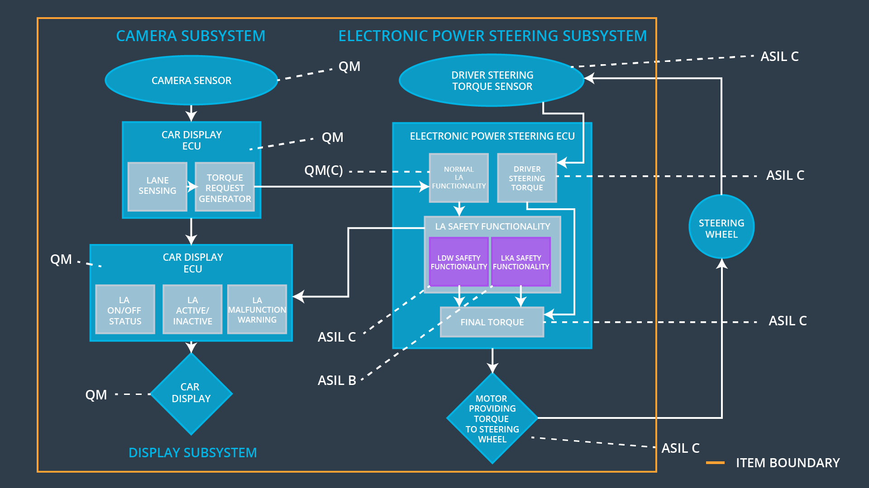

## Allocation of Functional Safety Requirements to Architecture Elements

|  |  |  |  |  |
| --- | --- | --- | --- | --- |
| **ID** | **Functional Safety Requirement** | **Electronic Power Steering ECU** | **Camera ECU** | **Car Display ECU** |
| Functional  Safety  Requirement  01-01 | The electronic power steering ECU shall ensure that the lane departure oscillating torque amplitude is below Max_Torque_Amplitude. | **X** |  |  |
| Functional  Safety  Requirement  01-02 | The electronic power steering ECU shall ensure that the lane departure oscillating torque frequency is below Max_Torque_Frequency. | **X** |  |  |
| Functional  Safety  Requirement  02-01 | The electronic power steering ECU shall ensure that the lane keeping assistance torque is applied for only Max_Duration. | **X** |  |  |

## Warning and Degradation Concept

|  |  |  |  |  |
| --- | --- | --- | --- | --- |
| **ID** | **Degradation Mode** | **Trigger for Degradation Mode** | **Safe State invoked?** | **Driver Warning** |
| WDC-01 | Turn off functionality. | Any malfunction | Yes | Warning indicator on dashboard |
| WDC-02 | Turn off functionality. | Any malfunction | Yes | Warning indicator on dashboard |